San Diego Gas & Electric Company’s
Quarterly Initiative Update

February 1, 2022

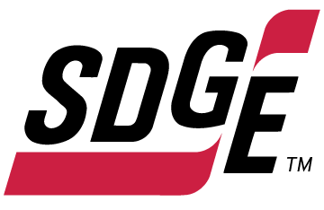
Pursuant to Wildfire Safety Division’s (WSD) Compliance Operational Protocols (Protocols), issued February 16, 2021, San Diego Gas & Electric Company (SDG&E) hereby provides SDG&E’s Quarterly Initiative Update (QIU) associated with its Wildfire Mitigation Plan (WMP) for the period October 1, 2021 to December 31, 2021 (Q4) of 2021. A copy of this report is being provided to the California Office of Energy Infrastructure Safety (OEIS) docket.
As directed by OEIS, SDG&E is submitting its QIU via SharePoint.

SDG&E’s Quarterly Initiative Update
SDG&E’s submission follows the structure of the provided QIU template. In preparation for future submissions, SDG&E requests OEIS review the template and update the section numbers to correspond to the reporting requirements of the 2021 WMP Update. Comments within the formula for the section field indicated the IOUs were not to update the referenced 2020 WMP section list. Therefore, SDG&E has reported its 2021 WMP Update programs and metric progress within the structure of the 2020 WMP sections, as allowed by the QIU template.
SDG&E has met the commitments set forth in the 2021 WMP Update for most initiatives. The Q4 QIU now utilizes the adjusted targets as set forth in the 2021 Change Order Report for four initiatives:
- Microgrids
- Resiliency Assistance Programs
- Lightning Arrestor Removal and Replacement
- Drone Assessments of Transmission Infrastructure
The four initiatives that did not meet the 2021 targets within ten percent have been marked as “Delayed” with explanations for the shortcomings in the “Corrective Actions if Delayed” column.

California Office of Energy Infrastructure Safety – Data Submission Procedures (July 27, 2021).

