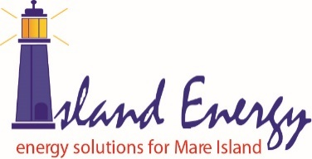

Subject: Wildfire Safety Advisory Board
POU Wildfire Mitigation Plan Review
Regarding: 2021 Plan Changes from Previous Years’ Submittal
Date: 27 August 2021

Interested WSAB Parties:
Pittsburg Power Company – Island Energy confirms that the only change to its 2021 Wildfire Mitigation Plan submittal from that of the previous years’ submittal was the change of the submittal date to 15 March 2021. No other updates or modifications were necessary.

Sincerely,

Douglas W. Buchanan

Douglas W. Buchanan
Power Company Manager
Pittsburg Power Company – Island Energy
995 Walnut Ave.
Mare Island Vallejo, CA 94592
(707) 562-5000

