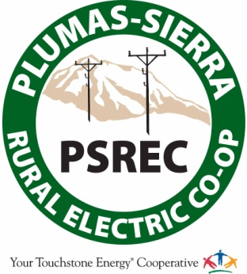

PLUMAS-SIERRA RURAL ELECTRIC COOPERATIVE
WILDFIRE MITIGATION PLAN
MAY 19 , 2021

TABLE OF CONTENTS
- Overview 4
  - Mission Statement 4
  - Purpose of the Wildfire Mitigation Plan 5
  - Organization of the Wildfire Mitigation Plan 5
- Objectives of the Wildfire Mitigation Plan 5
  - Minimizing sources of ignition 5
  - Resiliency of the electric grid 6
  - Minimizing unnecessary or ineffective Actions 6
- Roles and Responsibilities 7
  - Cooperative roles and Responsibilities 7
  - Coordination with Plumas-Sierra Telecommunications 8
  - Coordination with Communication Infrastructure Providers 9
  - Emergency Management 9
- Wildfire Risks and Drivers associated with design, construction, operation, and
maintenance 11
  - Particular Risks and Risk Drivers Associated with Topographic and Climatological Risk Factors 11
  - Enterprise wide Safety Risks 11
C. Changes to CPUC Fire Threat Map 12
- Wildfire Preventative Strategies 12
  - High-Fire-Threat District 12
  - Weather Monitoring 14
  - Design and Construction Standards 15
  - Vegetation Management 15
  - Inspections 16

  - FR3 Insulating Fluid 16
  - Workforce Training 17
  - Recloser Operational Training 17
  - De-energization 17
  - Tree Attachments (Legacy Attachments) 19
  - Proposed Service Requirements 20
- Community Outreach and Public Awareness 20
- Restoration of Service 21
- Evaluating the Plan 21
  - Metrics and Assumptions for Measuring Plan Performance 21
Metric 1: Fire Ignitions 21
Metric 2: Wires Down 22
  - Impact of Metrics on Plan 22
  - Monitoring and Auditing the Plan 22
  - Identifying and Correcting Deficiencies in the Plan 22
  - Monitoring the Effectiveness of Inspections, 23
- Independent Auditor 23
- Appendix 24
XI. References 24

I. OVERVIEW

A. MISSION STATEMENT

The Mission of Plumas-Sierra Rural Electric Cooperative (PSREC or the Cooperative) is to provide utility services with a high level of reliability for fair and reasonable costs. We are dedicated to operating safe and dependable electric and telecommunication services while striving to improve the quality of life for our member-owners and our local communities.

The Cooperative works aggressively and proactively to manage and mitigate the risk of wildfire while operating and maintaining its system. The outcome of this approach is diligent stewardship of customer/owner investment in the Cooperative as it continues to construct, maintain, and operate its electric distribution system in a manner that minimizes the risk of catastrophic wildfire posed by its electrical lines and equipment. The Cooperative has applied careful consideration in the development of broad strategies to mitigate utility-posed wildfire risks while remaining consistent with the intention of Senate Bill 901 (SB 901) and other regulatory requirements.

The Cooperative acknowledges the California Public Utility Commission (CPUC) Fire-Threat Map (FTM) and recognizes that a majority of The Cooperative’s power lines fall within Tier-2 designation, with a small portion in Tier-3. The Cooperative will continue normal operation in Tier-2 designated areas, while applying the Wildfire Mitigation Plan (WMP) to areas designated Tier-3. This methodology will be evaluated on an annual basis and adjustments made as new or substantive information becomes available.

The Cooperative will continually coordinate with local fire and safety officials in the development and subsequent annual review of this Plan.

B. PURPOSE OF THE WILDFIRE MITIGATION PLAN

This Wildfire Mitigation Plan (WMP or Plan) describes the measures the Cooperative takes to mitigate the threat of Cooperative equipment ignited wildfires. Included within the Plan is an explanation of various programs, practices, and procedures the Cooperative utilizes to comply with SB 901.

This Plan is subject to direct approval by the Cooperative’s Board of Directors and is implemented by the General Manager. This Plan complies with the requirements of Public Utilities Code Section 8387 for publicly owned electric utilities to prepare a wildfire mitigation Plan by January 1, 2020, and annually review it thereafter.

C. ORGANIZATION OF THE WILDFIRE MITIGATION PLAN

This Wildfire Mitigation Plan includes the following elements:

- Objectives of the Plan;
- Roles and responsibilities for executing the Plan
- Identification of key wildfire risks and risk drivers;
- Description of wildfire prevention strategies;
- Metrics for measuring performance of the Plan and identifying areas for improvement; and,
- Community outreach and education.

II. OBJECTIVES OF THE WILDFIRE MITIGATION PLAN
II. OBJECTIVES OF THE WILDFIRE MITIGATION PLAN

A. MINIMIZING SOURCES OF IGNITION

The primary goal of this Plan is to minimize the possibility the Cooperative’s facilities may be an original or contributing, however unlikely, source of ignition. The Cooperative has evaluated the system improvements, operational procedures, and training that can help to meet this objective. Further, the Cooperative is updating best management practices to reflect its commitment to sensible system management and will explore new opportunities each year for improving the efficacy of the Plan.

The Cooperative utilizes the California Public Utility Commission (CPUC) state-wide Fire Threat Map (Map) adopted January 19, 2018 (Exhibit A), in addition to informational fire threat maps from other State of California Government agencies to inform and aid in the development of this Plan and its subsequent updating. The CPUC Map designates a majority of the Cooperative’s service territory as Tier-2; while identifying a minor portion of the system (LaPorte Road) as Tier 3 (extreme). There is also a percentage (Sierra Valley and the Highway 395 Corridor from Doyle to Susanville) identified as Tier 1, or exempt from the High-Fire-Threat-District (HFTD).

B. RESILIENCY OF THE ELECTRIC GRID

Along with creating a WMP, the Cooperative realizes the opportunity to improve resiliency by hardening the system. System resiliency is defined by the National Infrastructure Advisory Council as the ability to reduce the magnitude and/or duration of disruptive events. As part of the development of this Plan, the Cooperative assesses new industry practices and technologies that may reduce the likelihood of a disruption in service or improve the timeline for restoration of service.

To accomplish this, the Cooperative utilizes heavy-loading construction design standards per the Rural Utility Service (RUS) guidelines. The Cooperative’s facilities are designed to withstand sustained heavy wind, and snow and ice loading. The Cooperative also utilizes FR3 insulating fluid, current limiting fuses, electronic reclosers, and has real-time monitoring via Supervisory Control And Data Acquisition (SCADA) to all substations. Aggressive vegetation management continues to be a high priority, among other operational practices.

C. MINIMIZING UNNECESSARY OR INEFFECTIVE ACTIONS

The final goal for this Plan is to measure the effectiveness of specific mitigation strategies as they apply to the Cooperative. Where a particular action, program, or protocol is determined to be unnecessary or ineffective, the Cooperative will evaluate whether modification or replacement is suitable. This approach will also help determine if more cost-effective measures would produce the same or better results.

III. ROLES AND RESPONSIBILITIES

A. PSREC WMP ROLES AND RESPONSIBILITIES

Manager of Engineering and Operations
District Manager
Member and Energy Services Manager

PSREC
Member-Owners
Board of
Directors
General
Manager

The Cooperative utilizes a Board/General Manager reporting hierarchy. Board members are elected by Cooperative member-owners to rotating three-year terms, representing constituents across the Cooperative’s seven-district service territory. The Board President and Vice President are in title; these positions are nominated and appointed by the Board annually. The Board is responsible for adoption of all policy and delegates the operational implementation of policy to the General Manager.

The General Manager has full operational authority of the Cooperative and operates as the Chief Executive, reporting directly to the Board. The General Manager provides direction and management to all Cooperative staff while implementing Board adopted policy.
The Manager of Engineering and Operations and the Member and Energy Services Manager serve as the Cooperative’s public liaisons to outside agencies as well as responding to requests for information, including proactively providing public awareness outreach and emergency information. The Manager of Engineering and Operation will assume the WMP operational authority of the General Manager in the absence of the General Manager.

The Manager of Engineering and Operations oversees the daily electric utility operations, including; construction; maintenance; energy control; fleet; vegetation management; and other ancillary daily duties. The Electric Operations Manager maintains functional management of assigned divisions within the Electric Utility and reports to the General Manager.

Cooperative staff have the following responsibilities regarding fire prevention, response and investigation:

- Conduct work in a manner that will minimize potential fire dangers;
- Take all reasonable and practicable actions to prevent and suppress fires resulting from the Cooperative’s electric facilities;
- Coordinate with Federal, State, and Local fire management personnel to ensure that appropriate preventative measures are in place;
- Immediately report fires, pursuant to specified procedures;
- Take corrective action when observing or having been notified that fire protection measures have not been properly installed or maintained;
- Ensure compliance with relevant Federal, State, and industry standard requirements;
- Ensure that wildfire data is appropriately collected; and
- Maintain adequate training programs for all relevant employees.

B. COORDINATION WITH PLUMAS-SIERRA TELECOMMUNICATIONS

Plumas-Sierra Telecommunications (PST) is a subsidiary of the Cooperative, providing broadband Internet service to approximately 2,800 customers. When PSREC operations could, or, are known to impact Internet service, PSREC and PST staff will coordinate so as to mitigate, or where practicable, eliminate the impact to electric and/or broadband service continuity. PSREC staff will collaborate proactively with PST staff to coordinate planned outages and communicate as quickly as possible during emergency power outages that impact one or both operations. This emergency notification will be extended to Emergency Services organizations and businesses.

C. COORDINATION WITH COMMUNICATION INFRASTRUCTURE PROVIDERS

Communications providers in The Cooperative’s service territory are notified of planned outages via phone, email, and available text alert service. Additionally, during emergency operations, Cooperative staff update the customer-facing information website dashboard at https://www.psrec.coop/ and all Cooperative Social Media outlets.

D. EMERGENCY MANAGEMENT

In an emergency, PSREC is classified as a local governmental agency.1 PSREC has planning, communication, and coordination obligations pursuant to the California Office of Emergency Services’ Standardized Emergency Management System (SEMS) Regulations,2 adopted in accordance with Government Code section 8607. The SEMS Regulations specify roles, responsibilities, and structures of communications at five different levels: field response, local government, operational area, regional, and state.3 Pursuant to this structure, PSREC regularly coordinates and communicates with the relevant safety agencies as well as other relevant local and State agencies.

1 As defined in Cal. Gov. Code § 8680.2.
2 19 CCR § 2407.
3 Cal. Gov. Code § 2403(b):
- “Field response level” commands emergency response personnel and resources to carry out tactical decisions and activities in direct response to an incident or threat.
- “Local government level” manages and coordinates the overall emergency response and recovery activities within their jurisdiction.
- “Operational area level” manages and/or coordinates information, resources, and priorities among local governments within the operational area and serves as the coordination and communication link between the local government level and the regional level.
- “Regional level” manages and coordinates information and resources among operational areas within the mutual aid region designated pursuant to Government Code §8600 and between the operational areas and the state level. This level along with the state level coordinates overall state agency support for emergency response activities.
- “State level” manages state resources in response to the emergency needs of the other levels, manages and coordinates mutual aid among the mutual aid regions and between the regional level and state level, and serves as the coordination and communication link with the federal disaster response system.

The Cooperative will support Emergency Operation Center (EOC) operations, when requested by an emergency manager representing local or State agencies. Support could include the exchange of information, supplying resources, or staffing an EOC.
Under the SEMS structure, a significant amount of preparation is done through advanced planning at the county level, including the coordination effort of public, private, and nonprofit organizations. The Cooperative’s service territory resides in Lassen, Plumas, Sierra, and Washoe (Nevada) Counties. The Operational Area includes local and regional organizations that bring relevant expertise to the wildfire prevention and recovery planning process. These participants include:

- Director of Emergency Services;
- City of Portola (or designee);
- City of Loyalton (or designee);
- City of Susanville (or designee);
- Local Law Enforcement
- Local Volunteer Fire Departments
- Plumas National Forest (or designee);
- Lassen National Forest (or designee);
- Tahoe National Forest (designee);
- California Department of Forestry & Fire Protection (or designee);
- Pacific Gas & Electric (or designee);
- Nevada Energy (or designee);
- Liberty Energy (or designee);
- Northern California Power Agency (NCPA); and
- Such others as the Board requests be in attendance.

Pursuant to the SEMS structure, the Cooperative participates in training exercises with its counterparts both in field drills and tabletop exercises.

The Cooperative is also a member of the California Utility Emergency Association, which plays a key role in ensuring communications between utilities and emergency responders during emergencies.

IV. WILDFIRE RISKS AND DRIVERS ASSOCIATED WITH DESIGN, CONSTRUCTION, OPERATION, AND MAINTENANCE

A. PARTICULAR RISKS AND RISK DRIVERS ASSOCIATED WITH TOPOGRAPHIC AND CLIMATOLOGICAL RISK FACTORS

Climate change is expected to cause increased temperatures, drier conditions, and insect outbreaks in the decades to come, all of which will likely increase the risk of wildfires, especially in the western United States. Because wildfire risk is tied to higher temperatures, drought, and flooding, comprehensive resilience planning for multiple impacts is critical for communities.

Within the Cooperative’s service territory and the surrounding areas, the primary wildfire risks are the following:

- Extended drought;
- Vegetation type;
- Vegetation Density;
- Weather
- High Winds;
- Terrain;
- Tree mortality;
- Lack of early fall precipitation (changing weather patterns; or, climate change)
- Fire History

PSREC is divided into distinct “North” and “South” service territories, which each present unique challenges and potential for wildfire. The North end is situated in high-elevation desert, comprised of mostly shrub-like vegetation such as sage brush, bitter brush, and juniper. This area also experiences high wind speeds throughout the year, which can attribute to fast-moving wildland fires. The South end is situated in thick mixed conifer forest, in steep, mountainous terrain. Specifically, the Highway 70 corridor from Quincy to Beckwourth. This area on the South End of the system, which contains the only Tier 3 designation on the FTM, is the area of greatest concern for PSREC, as it could potentially affect the transmission feed from PG&E at the Quincy 1 substation.

B. ENTERPRISEWIDE SAFETY RISKS

The Cooperative will use a methodical approach to address/mitigate enterprise safety risks. This approach will utilize Risk Factor Analysis (RFA). RFA is a process to identify and manage potential risks that could undermine core business functions, threaten business continuity or impact recovery. The Cooperative has recently deployed Protection Zone Management (PZM) to aid in identifying areas of elevated risk. RFA will be used to qualitatively analyze safety risks, which include:

- Unavailability, or limited power supply of Pacific Gas and Electric’s (PG&E) transmission (Interconnection at Quincy substation)
- Unavailability, or limited power supply of NV Energy/Sierra Pacific’s alternate transmission feed (Marble substation)
- Loss of Internet connectivity;
- Loss of radio communications;
- Loss of cellular communications;
- Impacts of system de-energization;
- Impacted roadways limiting movement of personnel and equipment; and
- Impacted roadways limiting access to Cooperative facilities (Headquarters, various substations or alternate generation sites).

C. CHANGES TO CPUC FIRE THREAT MAP

The Cooperative does not recommend any changes to the CPUC state-wide Fire Threat Map, adopted January 19, 2018, at this time. Future changes in Cooperative knowledge or recommendations going forward will be communicated as required by statute. However, The Cooperative’s main transmission source is PG&E’s 60 kV line, which lies in a small portion of Tier-3 designated area, which is located in urban landscape. In the event of a PG&E Public Safety Power Shutoff (PSPS) in that area, the majority of The Cooperative’s members could be adversely affected.

V. WILDFIRE PREVENTATIVE STRATEGIES

A. HIGH-FIRE-THREAT DISTRICT

The Cooperative participated in the development of the California Public Utilities Commission’s (CPUC) Fire-Threat Map, 4 which designates the HFTD. In the map development process The Cooperative served as a territory lead, and worked with Cooperative staff and local fire officials to identify areas of the Cooperative’s service territory which are at an elevated or extreme risk of power line ignited wildfire. The Cooperative incorporated the High-Fire-Threat District (HFTD) into its construction, inspection, operation, maintenance, repair, and vegetation management practices.

4 Adopted by CPUC Decision 17-12-024.

B. WEATHER MONITORING

The Cooperative monitors current and forecasted weather data from a variety of sources including:

- The National Oceanic and Atmospheric Administration (NOAA);
- United States National Weather Service (NWS);
- United States Forest Service Wildland Fire Assessment System;
- National Fire Danger Rating System;
- National Interagency Fire Center – Predictive Services for Northern and
Southern California;
- Internal knowledge of local conditions; and,
- The Cooperative will evaluate the cost and benefit of new technologies where practicable.

Each day, the Cooperative will assign one of four operating conditions based on the relevant weather data and knowledge of local conditions:

- Normal: During normal conditions, no changes are made to operations or work procedures.

- Elevated: During elevated fire-risk conditions, Cooperative staff will perform normal work with an elevated level of observation for environmental factors that could lead to an ignition.

- Extreme: During extreme fire-risk conditions, the Cooperative may delay routine work on energized primary lines (12.47kV and 69kV). The Cooperative may perform necessary work to preserve facilities or property. Extreme weather is defined as: weather phenomena that are at the extremes of the historical distribution and are rare for a particular place and/or time, especially severe or unseasonal weather. Such extremes include severe thunderstorms; severe snowstorms; ice storms; blizzards; flooding; high winds; or heat waves.

- Red Flag: If the National Weather Service declares a Red Flag Warning (RFW) for any portion of the Cooperative’s service territory, the Cooperative will delay all routine work on energized primary lines (12.47kV & 69kV). The Cooperative may perform necessary work to preserve facilities or property.

C. DESIGN AND CONSTRUCTION STANDARDS

Cooperative electric facilities are designed and constructed to meet or exceed relevant Federal, State, and industry standards. The Cooperative treats State of California, General Order 95 (GO 95) as a guiding standard for design and construction of overhead electrical facilities. The Cooperative meets or exceeds all standards in GO 95 and constructs its facilities consistent with a “heavy-loading” district as defined by the CPUC (Exhibit B). As a result of this approach, the Cooperative’s system is hardened and more resilient to extreme weather events than systems that do not build to a heavy-loading district.

The Cooperative monitors trends in materials, technology and work methods to evaluate prudent operational changes to enhance the efficacy of wildfire mitigation.

D. VEGETATION MANAGEMENT

The Cooperative meets or exceeds minimum industry standard(s) for vegetation management practices. For distribution level facilities, the Cooperative meets: (1) Public Resources Code section 4292; (2) Public Resources Code section 4293; (3) GO 95 Rule 35 (Exhibit C); and (4) the GO 95 Appendix E Guidelines to Rule 35 (Exhibit D). These standards require significantly increased clearances in a HFTD area. The time-of-trim guidelines do not establish a mandatory standard, but instead provide guidance to utilities. The Cooperative will use specific knowledge of growing conditions and tree species to determine the appropriate time-of-trim clearance in each circumstance.

The Cooperative has developed a comprehensive Vegetation Management Plan (VMP) that complies with the aforementioned statues. In addition, the VMP is subject to updates from time-to-time as practices and technology evolve.

The Cooperative employs an in-house timber feller, three contract vegetation management crews and has a registered forester on staff. The Cooperative performs tree trimming and clearing year-round, except during times of inclement weather. Additionally, The Cooperative has begun to reclaim right-of-way access roads in order to perform maintenance along with creating quicker response for emergency responders.

(Vegetation management practices within the Cooperative’s service territory are governed by: Public Resource Code 4292; Public Resource Code 4293; and, California General Order 95, Rule 35.)

E. INSPECTIONS

The Cooperative meets or exceeds the minimum inspection requirements provided in CPUC GO 165, Table 1 (Exhibit E) and CPUC GO 95, Rule 18 (Exhibit F). Pursuant to these rules, the Cooperative inspects electric facilities in the High-Fire-Threat District more frequently than its counterparts in non-HFTD areas. Additionally, Cooperative staff use their knowledge of the specific environmental and geographical conditions to determine when areas may require more frequent inspections. The Cooperative utilizes GO 95 and GO 165 as its guiding document, as part of a robust asset management/maintenance program. The Cooperative has also recently deployed two new programs to assist with system-wide inspections: an un-manned aircraft (drone) program to inspect facilities, especially in remote and rugged service territory, and Protection Zone Management (PZM), which archives inspections of system protection equipment, helping to mitigate problems before they arise.

The Cooperative’s goal is to ensure that all inspections performed within its service territory are complete before the beginning of the historic fire season. The Cooperative meets or exceeds the minimum inspection requirements provided in CPUC GO 165, Table 1 (Exhibit E) and CPUC GO 95, Rule 18 (Exhibit F). Pursuant to these rules, the Cooperative inspects electric facilities in the High-Fire-Threat District more frequently than its counterparts, typically by June 1. The Cooperative monitors drought conditions and other relevant factors throughout the year to determine if inspections should be completed on an adjusted timeline.

If Cooperative staff discovers a facility in need of repair that is owned by an entity other than the Cooperative, the Cooperative will notify the facility owner in writing, as well as notify the agency having jurisdiction.

F. FR3 INSULATING OIL

Envirotemp FR3 fluid is a dielectric insulator (cooling oil) that is a natural ester derived from vegetable oils. FR3 has an extremely high flashpoint, in excess of two times (360 degrees Celsius) that of its traditional mineral oil counterpart. With the exception of pad-mounted switchgear, the Cooperative has integrated a requirement for all new oil insulated equipment, including: transformers (pole-bolted and pad-mounted); substation transformers; and substation voltage regulators, to contain FR3 fluid. Staff will evaluate the appropriateness of FR3 insulating oil in its future procurement of pad-mounted switchgear.

G. WORKFORCE TRAINING

The Cooperative has developed rules and complementary training programs for its workforce to reduce the likelihood of an ignition. All field staff will be: trained in the content of the WMP; trained in proper use and storage of fire extinguishers; required during pre-job briefings to discuss the potential(s) for ignition, environmental conditions (current and forecasted weather that coincides with the duration of work for the day); and identify the closest fire extinguisher.

Any ignition will be reported to management for follow-up.

H. RECLOSER OPERATIONAL PRACTICE

Extreme Weather Events (Non-RFW)

The Cooperative may disable automatic reclosing functions at Cooperative substations during extreme weather (non-RFW) events. An extreme weather event is defined as: weather phenomena that are at the extremes of the historical distribution and are rare for a particular place and/or time, or especially severe or unseasonal weather. Such extremes include, but are not limited to severe thunderstorms; high winds; heat waves; severe snowstorms; ice storms; blizzards; or flooding.

Other operational factors may be considered when evaluating the appropriateness of disabling reclosers.

RFW Events

During RFW events, the Cooperative will disable all automatic reclosing function for all Automatic Circuit Reclosers (ACRs or reclosers) on its system. This ensures there will be no circuit reclosing during RFW conditions (i.e. one-shot operation).

I. DEENERGIZATION

The Cooperative, due to its location from 3,000 to 6,000 feet elevation, experiences severe winter weather including blizzards and atmospheric rivers. It is not uncommon for these extreme weather events to include rain, snow, and ice, and winds in excess of 100 miles per hour. For these reasons, the Cooperative’s overhead electric system is built to a heavy-loading construction standard.

In evaluating the efficacy of a PSPS, the Cooperative considered many factors, including: heavy-loading construction standards which are hardened to withstand high wind, snow loading, and ice formation; the offset between when the Cooperative’s overhead electric distribution system experiences its most severe weather threats (i.e. severe winter storm(s) and the weather conditions during red-flag warnings (i.e. typically in late Summer/Fall with only moderate weather threats); and the potential negative impacts to fire response, water supply, public safety, and emergency communications should a fire occur while the Cooperative de-energized a portion or all of its system.

During red flag warnings however, which again occur in late Summer/Fall, the winds that accompany these events are typically a fraction of what the Cooperative’s overhead electric distribution system experiences in the winter and what our predominately pine forests can withstand. During red flag warnings, the most likely cause of wildfire ignition is lightning strikes, transportation, illegal fireworks, or recreation.

At this time The Cooperative is not mandated to implement a Public Safety Power Shutoff (PSPS) program. However, we feel it is prudent to monitor high risk areas within our service territory that have been designated Tier-2 by the CPUC. When extreme weather conditions are forecasted the Cooperative will dispatch personnel to the field to monitor high risk areas, and conditions will also be monitored remotely via SCADA and office personnel. In the event of extreme weather conditions, The Cooperative has identified the parameters in Table 1 as a quantitative threshold for a potential PSPS.

Table 1. Updated Quantitative Thresholds
Region | ERC | Wind Gust (mph)* | FWI*
Quincy Substation to Beckwourth Substation | >92nd percentile | >40 mph | >50
Beckwourth Substation to Leavitt Substation | >92nd percentile | >45 mph | >60
*6 hour average

Based on these thresholds, some areas may not experience any PSPS event in a non-drought year like 2019. It is worthwhile to note that actual frequency and duration of these events may vary due to variability in weather conditions from one year to another especially during drought years. In summary, the Cooperative is currently managing the PSPS process based on the above thresholds in Table 1 as they balance a reasonable risk profile of last resort mitigation measure with customer service interruptions.

While the Cooperative is willing to take whatever steps are necessary to protect our community and the public that we serve, the risks and potential consequences of initiating a PSPS are significant and extremely complex. Foremost concerns include: potential loss of water supply to fight wildfires due to loss of production wells and pumping facilities, negative impacts to emergency response and public safety due to the historic disruptions in Internet and cell phone service during periods of extended power outages, and the loss of key community infrastructure and operational efficiency that occurs during power outages.

Based on the above considerations, the risks of implementing a PSPS program seem to far outweigh the chances that the Cooperative’s electric overhead distribution system would cause a catastrophic wildfire. The Cooperative, on a case-by-case basis, has historically and will continue to consider de-energizing a portion of its system in response to a known public safety issue or in response to a request from an outside emergency management/response agency. Any de-energizing will be performed in coordination with local partner agencies. The Cooperative will also monitor the evolution of PSPS implementation by other California electric utilities to continue to refine its evaluation of this important topic.

J. TREE ATTACHMENTS (LEGACY ATTACHMENTS)

The Cooperative has legacy attachments to trees that consist of: service drop(s); secondary conductor(s); or, security lighting. Although these installations were permitted pursuant to 14 CCR §1257, the Cooperative does not engage in this practice for new installations.

Cooperative staff is in the process of developing a recommendation and operational practices to address these legacy attachments. The inclusive recommendation will consider the following:

- Pursuant to 14 CCR §1257, the Cooperative will inspect these installations on a periodic basis;
- Limbing of a tree used as an attachment point(s) will be consistent with 14 CCR §1257;
- The Cooperative may audit tree attachments on a periodic basis

K. PROPOSED SERVICE REQUIREMENTS

Since circa 1995, Cooperative code has required most new or reconstructed developments to take service from the Cooperative via an underground system; however, exceptions do exist in current Cooperative Code. The Cooperative seeks to minimize the installation of overhead power lines where practicable and will therefore, recommend an underground requirement for all electric services and consider the following:

- The Cooperative will not attach to trees for any reason;
- The Cooperative may consider a cost-sharing program for customers that desire to convert an existing overhead service to an underground service; and
- Customer(s) receiving service via legacy tree attachment(s) can request the Cooperative to remove tree attachment and place a utility pole at the Cooperative’s expense.

VI. COMMUNITY OUTREACH AND PUBLIC AWARENESS

As the local electric and Internet utility, the Cooperative has robust community outreach and marketing programs to effectively communicate with our customers and community. The Cooperative is active in the community, attending dozens of community events each year. During its annual meeting, the Cooperative staffs booths, has staff available to interact with the community, and delivers power, Internet, and member programs directly to our members. This includes providing information on the Cooperative’s Vegetation Management Program, free de-energizing of customers’ overhead service connections to allow them to clear defensible space while working safely, and educating the community on the Cooperative’s overall efforts to respond to catastrophic wildfires.

The Cooperative also has robust marketing and communication efforts leveraging its website (www.psrec.coop), social medial (Facebook/Twitter), bill stuffers, print ads, and digital marketing. The Cooperative is a regular advertiser in Feather Publishing’s newspapers, as well as the Sierra Booster, Ruralite Magazine and local JDX radio.

Regarding fire-related community outreach, the Cooperative has been very active promoting the Vegetation Management Program; including the recent regulatory changes increasing the vegetation clearances. The Cooperative sends out an annual bill insert to all customers along with information on the website, social media, digital media, print advertising, and radio.

VII. RESTORATION OF SERVICE

Although the Cooperative has not activated a PSPS operational practice, if an outside emergency management/emergency response agency request a power shutdown, or if the Cooperative elects to de-energize segments of its system due to extreme weather, Cooperative staff will patrol the affected portions of the system with boots on the ground and also with the drone before the system can be re-energized. Suspect equipment or distribution lines that cannot be patrolled will remain de-energized. In addition, system performance abnormalities will be monitored via the Cooperative’s SCADA system.

VIII. EVALUATING THE PLAN

A. METRICS AND ASSUMPTIONS FOR MEASURING PLAN PERFORMANCE

The Cooperative will track two metrics to measure the performance of this Plan: (1) number of fire ignitions; and (2) wire down events within the service territory.

METRIC 1: FIRE IGNITIONS

For purposes of this metric, a fire ignition is defined as follows:

- The Cooperative facility was associated with the fire;
- The fire was self-propagating and of a material other than electrical;
- The resulting fire traveled greater than one linear meter from the ignition point; and
- The Cooperative has knowledge that the fire occurred.

In future Wildfire Mitigation Plans, the Cooperative will provide the number of fires that occurred that were less than 10 acres in size. Any fires greater than 10 acres will be individually described.

METRIC 2: WIRES DOWN

The second metric is the number of wire-down events within the Cooperative’s service territory. For purposes of this metric, a wire-down event includes any instance where primary distribution conductor falls to the ground or on to a foreign object, defined as: any object not specifically an asset of the Cooperative (i.e. phone, cable, trees, etc.).
The Cooperative will not normalize this metric by excluding unusual events, (i.e. severe storms, car versus pole incidents, or snow unloading). However, the Cooperative will supplement this metric with a qualitative description of any such unusual events.

B. IMPACT OF METRICS ON PLAN

The Cooperative anticipates relatively limited data will be gathered through these metrics, particularly in the initial years. Therefore, it will be difficult to draw meaningful conclusions based on this data. The Cooperative will evaluate modifying these metrics or adding additional metrics in future years as more data becomes available and situational awareness continues to improve.

C. MONITORING AND AUDITING THE PLAN

This Wildfire Mitigation Plan is subject to review by the Cooperative’s Board of Directors. The Cooperative will present this Plan to its Board on an annual basis. Additionally, a qualified independent evaluator will present a report on this Plan to the Cooperative’s Board, annually.

The Manager of Engineering and Operations, or designee, will at least, on a semi-annual basis, update the General Manager regarding the Plan’s implementation, identified deficiencies or recommendations for updating.

D. IDENTIFYING AND CORRECTING DEFICIENCIES IN THE PLAN

Achieving a robust, all-encompassing plan to mitigate wildfire risk is the primary objective of this document. Staff have the role of vetting current procedures and recommending changes or enhancements to build upon non-optimized strategies in the Plan. Either due to unforeseen circumstances, regulatory changes, emerging technologies, or other rationales, deficiencies within the Plan will be sought out and reported to the Board in the form of an updated Plan on an annual basis.

The Manager of Engineering and Operations, or their designee, will be responsible for spearheading discussions on correcting deficiencies when updating the Plan for its annual presentation to the Board. All stakeholders are empowered to suggest improvement opportunities, including, but not limited to: field crews; management; auditors; fire safety professionals; and, members of the public.

E. MONITORING THE EFFECTIVENESS OF INSPECTIONS

The Cooperative currently utilizes General Orders 95 (GO95) and 165 (GO165), respectively, as its guide to inspect its system. Field staff routinely patrol the service territory and corrects deficiencies as they are encountered. The Cooperative tracks deficiencies that are repaired upon discovery within its Geographical Information System (GIS) and consistent with the guidelines of GO 95 and 165, respectively. Further, for deficiencies that cannot be repaired upon discovery, they are assigned a priority level. The repairs are defined as Level 1 (highest), Level 2 (moderate), or Level 3 (lowest) as defined by GO 95, Rule 18 (Exhibit F), with the discovery, remedy and supporting documentation being tracked within the Cooperative’s Geographical Information System (GIS).

Cooperative staff will report as part of its annual WMP presentation to the Board, the number of deficiencies found; the number of deficiencies repaired within the defined priority timeline and the number of outstanding deficiencies that were not repaired within the defined timeline.

IX. INDEPENDENT AUDITOR

Public Utilities Code section 8387(c) requires the Cooperative to contract with a qualified independent evaluator with experience in assessing the safe operation of electrical infrastructure to review and assess the comprehensiveness of this Plan. The independent evaluator must issue a report to be posted on the Cooperative’s website. This report must also be presented to the Cooperative’s Board at a public meeting.

The Cooperative will utilize a process consistent with Cooperative Purchasing Code. Additional considerations will include: relevant industry experience; similar work for other municipal utilities or special Cooperatives; recognized expertise in line construction and maintenance; responsiveness; and familiarity with applicable California statues (i.e. GO 95, GO 165, PRC 4292 & 4293, etc.).

The Cooperative will submit its draft report to an independent auditor and the auditor’s findings will be presented to the Board at a regular Board meeting.

X. APPENDIX

Exhibit A – California Public Utilities Commission Fire Threat Map, Adopted January 19, 2018 Exhibit B – California Public Utilities Commission, Heavy loading Cooperative Map
Exhibit C – California Public Utilities Commission, General Order 95, Rule 35 Exhibit D – California Public Utilities Commission, General Order 95, Appendix E
Exhibit E – California Public Utilities Commission, General Order 165, Table 1, Distribution Inspection cycles
Exhibit F – California Public Utilities Commission, General Order 95, Rule 18

XI. REFERENCES

14CCR § 1257
March 26, 2019 Memorandum, RE: Disabling of Automatic Circuit Reclosers (ACRs) March 26, 2019 Memorandum, RE: Hotline Work during Extreme Weather or RFW Events
March 26, 2019 Memorandum, RE: Mandatory Reporting Requirements – Fire Ignition March 26, 2019 Memorandum, RE: Mandatory Reporting Requirements – Wire Down March 26, 2019 Memorandum, RE: Re-Energization of Lines
March 26, 2019 Memorandum, RE: Tree Attachments Public Resources Code section 4292
Public Resources Code section 4293
Public Utilities Code Section 8387
State of California, General Order 95
State of California, General Order 165
Vegetation Management Plan (VMP)

EXHIBIT A
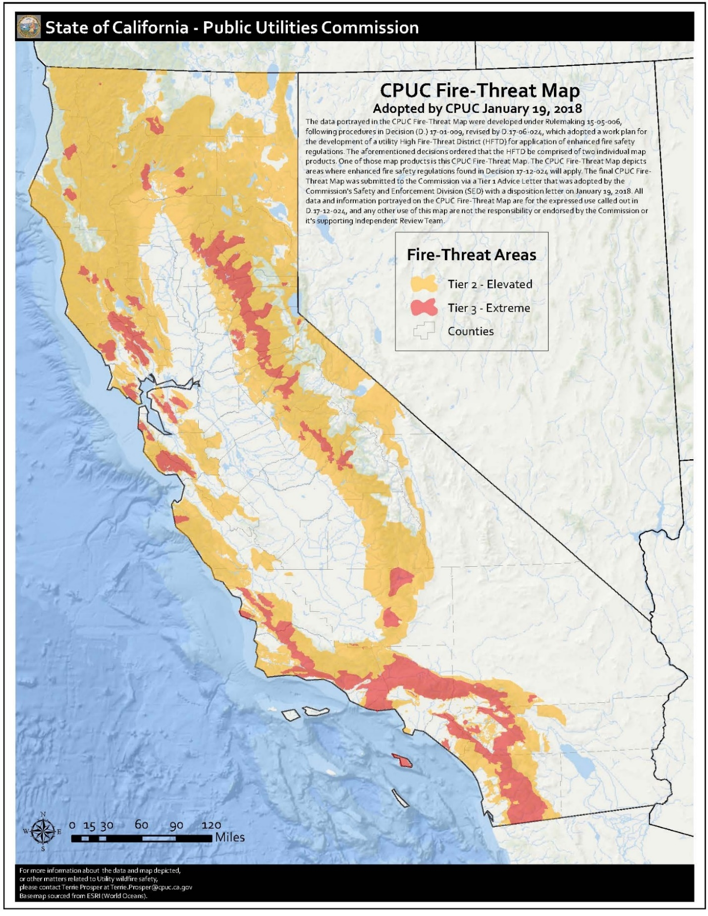

EXHIBIT B
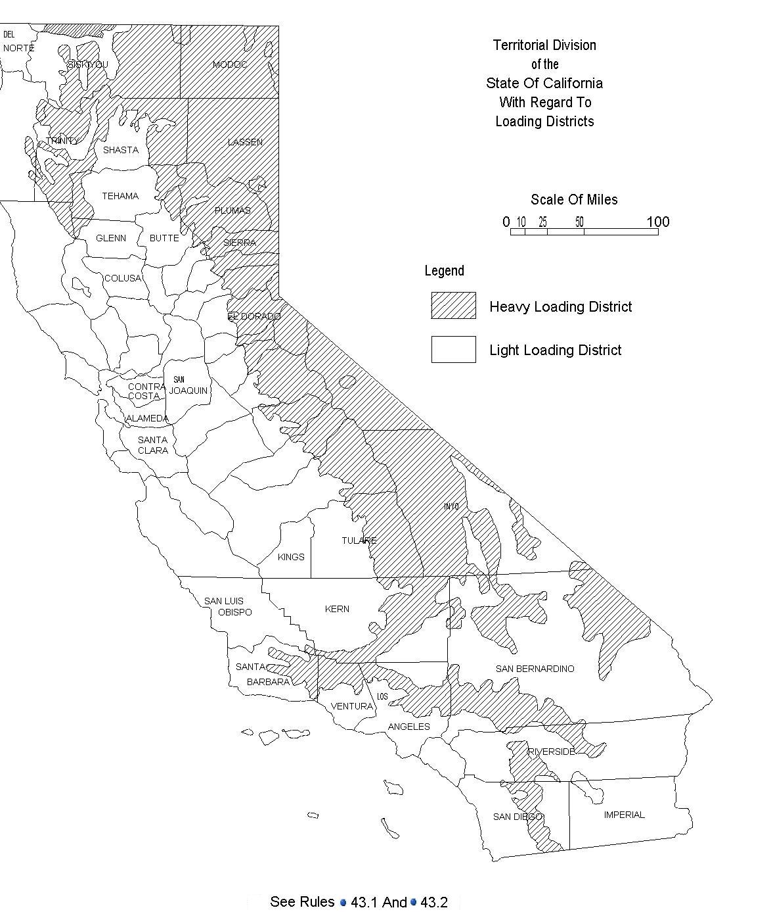

EXHIBIT C

General Order 95

Section III

Requirements for All Lines

35 Vegetation Management

Where overhead conductors traverse trees and vegetation, safety and reliability of service demand that certain vegetation management activities be performed in order to establish necessary and reasonable clearances the minimum clearances set forth in Table 1, Cases 13 and 14, measured between line conductors and vegetation under normal conditions, shall be maintained. (Also see Appendix E for tree trimming guidelines.) These requirements apply to all overhead electrical supply and communication facilities that are covered by this General Order, including facilities on lands owned and maintained by California state and local agencies.

When a supply or communication company has actual knowledge, obtained either through normal operating practices or notification to the company, that dead, rotten or diseased trees or dead, rotten or diseased portions of otherwise healthy trees overhang or lean toward and may fall into a span of supply or communication lines, said trees or portions thereof should be removed.

Communication and electric supply circuits, energized at 750 volts or less, including their service drops, should be kept clear of vegetation in new construction and when circuits are reconstructed or repaired, whenever practicable. When a supply or communication company has actual knowledge, obtained either through normal operating practices or notification to the company, that its circuit energized at 750 volts or less shows strain or evidences abrasion from vegetation contact, the condition shall be corrected by reducing conductor tension, rearranging or replacing the conductor, pruning the vegetation, or placing mechanical protection on the conductor(s). For the purpose of this rule, abrasion is defined as damage to the insulation resulting from the friction between the vegetation and conductor. Scuffing or polishing of the insulation or covering is not considered abrasion. Strain on a conductor is present when vegetation contact significantly compromises the structural integrity of supply or communication facilities. Contact between vegetation and conductors, in and of itself, does not constitute a nonconformance with the rule.

Note: Revised January 13, 2006 by Decision No. 05-01-030, August 20, 2009 by Decision No. 09-08-029 and January 12, 2012 by Decision No. 12-01-032

EXCEPTIONS:

(1) Rule 35 requirements do not apply to conductors, or aerial cable that complies with Rule 57.4-C, energized at less than 60,000 volts, where trimming or removal is not practicable and the conductor is separated from the tree with suitable materials or devices to avoid conductor damage by abrasion and grounding of the circuit through the tree.
(2) Rule 35 requirements do not apply where the supply or communication company has made a “good faith” effort to obtain permission to trim or remove vegetation but permission was refused or unobtainable. A “good faith” effort shall consist of current documentation of a minimum of an attempted personal contact and a written communication, including documentation of mailing or delivery. The written communication may include a statement that the company may seek to recover any costs and liabilities incurred by the company due to its inability to trim or remove vegetation. However, this does not preclude other action or actions from demonstrating “good faith”. If permission to trim or remove vegetation is unobtainable and requirements of exception 2 are met, the company is not compelled to comply with the requirements of exception 1.
(3) The Commission recognizes that unusual circumstances beyond the control of the utility may result in nonconformance with the rules. In such cases, the utility may be directed by the Commission to take prompt remedial action to come into conformance, whether or not the nonconformance gives rise to penalties or is alleged to fall within permitted exceptions or phase–in requirements.
Note: Revised November 6,1992 by Resolution No. SU–15, September 20, 1996 by Decision No. 96–09–097 and January 23, 1997 by Decision No. 97–01–044.

(4) Mature trees whose trunks and major limbs are located more than six inches, but less than the clearance required by Table 1, Cases 13E and 14E, from primary distribution conductors are exempt from the minimum clearance requirement under this rule. The trunks and limbs to which this exemption applies shall only be those of sufficient strength and rigidity to prevent the trunk or limb from encroaching upon the six–inch minimum clearance under reasonably foreseeable local wind and weather conditions. The utility shall bear the risk of determining whether this exemption applies, and the Commission shall have final authority to determine whether the exemption applies in any specific instance, and to order that corrective action be taken in accordance with this rule, if it determines that the exemption does not apply.

Note: Added October 22, 1997 by Decision No. 97–10–056

EXHIBIT D

General Order 95

Appendix E

Clearance of Poles, Towers and Structures from Railroad Tracks

The following are guidelines to Rule 35 .

The radial clearances shown below are recommended minimum clearances that should be established, at time of trimming, between the vegetation and the energized conductors and associated live parts where practicable. Reasonable vegetation management practices may make it advantageous for the purposes of public safety or service reliability to obtain greater clearances than those listed below to ensure compliance until the next scheduled maintenance. Each utility may determine and apply additional appropriate clearances beyond clearances listed below, which take into consideration various factors, including: line operating voltage, length of span, line sag, planned maintenance cycles, location of vegetation within the span, species type, experience with particular species, vegetation growth rate and characteristics, vegetation management standards and best practices, local climate, elevation, fire risk, and vegetation trimming requirements that are applicable to State Responsibility Area lands pursuant to Public Resource Code Sections 4102 and 4293.

Voltage of Lines | Case 13 of Table 1 | Case 14 of Table 1
Radial clearances for any conductor of a line operating at 2,400 or more volts, but less than 72,000 volts | 4 feet | 12 feet
Radial clearances for any conductor of a line operating at 72,000 or more volts, but less than 110,000 volts | 6 feet | 20 feet
Radial clearances for any conductor of a line operating at 110,000 or more volts but less than 300,000 volts | 10 feet | 30 feet
Radial clearance for any conductor of a line operating at 300,000 or more volts | 15 feet | 30 feet

Note: Added November 6, 1992 by Resolution SU–15 and revised September 20, 1996 by Decision No. 96–09–097 , August 20, 2009 by Decision No. 09-08-029, January 12, 2012 by Decision No. 12-01-032, December 21, 2017 by Decision 17-12-024.

EXHIBIT E

General Order 165
Table 1

Distribution Inspection Cycles (Maximum Intervals in Years)

 | Patrol |  | Detailed |  | Intrusive
 | Urban | Rural | Urban | Rural | Urban | Rural
Transformers
Overhead | 1 | 2¹ | 5 | 5 | --- | ---
Underground | 1 | 2 | 3 | 3 | --- | ---
Pad mounted | 1 | 2 | 5 | 5 | --- | ---
Switching/Protective Devices
Overhead | 1 | 2¹ | 5 | 5 | --- | ---
Underground | 1 | 2 | 3 | 3 | --- | ---
Pad mounted | 1 | 2 | 5 | 5 | --- | ---
Regulators/Capacitors
Overhead | 1 | 2¹ | 5 | 5 | --- | ---
Underground | 1 | 2 | 3 | 3 | --- | ---
Pad mounted | 1 | 2 | 5 | 5 | --- | ---
Overhead Conductor and Cables | 1 | 2¹ | 5 | 5 | --- | ---
Street lighting | 1 | 2 | x | x | --- | ---
Wood Poles under 15 years | 1 | 2 | x | x | --- | ---
Wood Poles over 15 years which have not been subject to intrusive inspection | 1 | 2 | x | x | 10 | 10
Wood poles which passed intrusive inspection | --- | --- | --- | --- | 20 | 20

(1) Patrol inspections in rural areas shall be increased to once per year in Extreme and Very High-Fire-Threat Zones in the following counties: Imperial, Los Angeles, Orange, Riverside, Santa Barbara, San Bernardino, San Diego, and Ventura. Extreme and Very High-Fire-Threat Zones are designated on the Fire and Resource Assessment Program (FRAP) Map prepared by the California Department of Forestry and Fire Protection’s Fire and Resource or the modified FRAP Map prepared by San Diego Gas & Electric Company (SDG&E) and adopted by Decision 12-01-032 in Phase 2 of Rulemaking 08-11-005.The fire threat map is to be used to establish approximate boundaries and Utilities should use their own expertise and judgment to determine if local conditions require them to adjust the boundaries of the map.

Note: This General Order does not apply to cathodic protection systems associated with natural gas facilities.

Note: For the purpose of implementing the patrol and detailed inspection intervals in Table 1 above, the term “year” is defined as 12 consecutive calendar months starting the first full calendar month after an inspection is performed, plus or minus two full calendar months, not to exceed the end of the calendar year in which the next inspection is due.

EXHIBIT F

General Order 95

Section I

General Provisions

18 Reporting and Resolution of Safety Hazards Discovered by Utilities

For purposes of this rule, “Safety Hazard” means a condition that poses a significant threat to human life or property.

A. Resolution of Safety Hazards and General Order 95 Nonconformances

(1) a) Each company (including utilities and CIPs) is responsible for taking appropriate corrective action to remedy Safety Hazards and GO 95 nonconformances posed by its facilities.

b) Upon completion of the corrective action, the company’s records shall show, with sufficient detail, the nature of the work, the date, and the identity of persons performing the work. These records shall be preserved by the company for at least ten (10) years and shall be made available to Commission staff upon 30 days’ notice.

c) Where a communications company’s or an electric utility’s actions result in GO nonconformances for another entity, that entity’s remedial action will be to transmit a single documented notice of identified nonconformances to the communications company or electric utility for compliance.

(2) a) All companies shall establish an auditable maintenance program for their facilities and lines. All companies must include a timeline for corrective actions to be taken following the identification of a Safety Hazard or nonconformances with General Order 95 on the company’s facilities.

The auditable maintenance program shall prioritize corrective actions consistent with the priority levels set forth below and based on the following factors, as appropriate:

· Safety and reliability as specified in the priority levels below;
· Type of facility or equipment;
· Location, including whether the Safety Hazard or nonconformance is located in the High Fire-Threat District;
· Accessibility;
· Climate;
· Direct or potential impact on operations, customers, electrical company workers, communications workers, and the general public.

There shall be 3 priority levels.

(i) Level 1:

· Immediate safety and/or reliability risk with high probability for significant impact.
· Take action immediately, either by fully repairing the condition, or by temporarily repairing and reclassifying the condition to a lower priority.

(ii) Level 2:

· Variable (non-immediate high to low) safety and/or reliability risk.
· Take action to correct within specified time period (fully repair, or by temporarily repairing and reclassifying the condition to a lower priority).

Time period for correction to be determined at the time of identification by a qualified company representative, but not to exceed: (1) six months for nonconformances that create a fire risk located in Tier 3 of the High Fire-Threat District; (2) 12 months for nonconformances that create a fire risk located in Tier 2 of the High Fire-Threat District; (3) 12 months for nonconformances that compromise worker safety; and (4) 59 months for all other Level 2 nonconformances.

(iii) Level 3:

· Acceptable safety and/or reliability risk.
· Take action (re-inspect, re-evaluate, or repair) as appropriate.

b) Correction times may be extended under reasonable circumstances, such as:

· Third party refusal
· Customer issue
· No access
· Permits required
· System emergencies (e.g. fires, severe weather conditions)

(3) Companies that have existing General Order 165 auditable inspection and maintenance programs that are consistent with the purpose of Rule 18A shall continue to follow their General Order 165 programs.

B. Notification of Safety Hazards

If a company, while performing inspections of its facilities, discovers a safety hazard(s) on or near a communications facility or electric facility involving another company, the inspecting company shall notify the other company and/or facility owner of such safety hazard(s) no later than 10 business days after the discovery. To the extent the inspecting company cannot determine the facility owner/operator, it shall contact the pole owner(s), who shall be responsible for promptly notifying the company owning/operating the facility with the safety hazard(s), normally not to exceed five business days after being notified of the safety hazard. The notification shall be documented and such documentation must be preserved by all parties for at least ten years.

Note: Each pole owner must be able to determine all other pole owners on poles it owns. Each pole owner must be able to determine all authorized entities that attach equipment on its portion of a pole.

Note: Added August 20, 2009 by Decision No. 09-08-029 and revised January 12, 2012 by Decision No. 12-01-032, December 21, 2017 by Decision No. 17-12-024.

D.J. Wuebbles et al., Climate Science Special Report: Fourth National Climate Assessment, (Washington, DC: U.S. Global Change Research Program, 2017)

