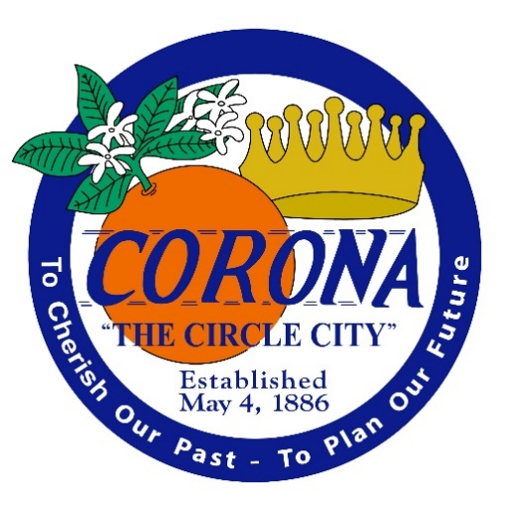

City of Corona

department oF water and Power

2021 Electric Utility

Wildfire Mitigation Plan

Version 2.0

June 16, 2021

Table of contents
I. Overview 1
A. Policy Statement 1
B. Purpose of the Wildfire Mitigation Plan 1
C. Organization of the Wildfire Mitigation Plan 1
II. Objectives of the Wildfire Mitigation Plan 2
III. Roles and Responsibilities 2
A. Utility Governance Structure 2
B. Wildfire Prevention 3
C. Wildfire Response and Recovery 3
D. Emergency Management System 4
IV. Wildfire Risks and Drivers associated with design, construction, operation, and maintenance 7
A. Particular Risks and Risk Drivers Associated With Topographic and Climatological Risk Factors 7
B. Enterprisewide Safety Risks 7
V. Wildfire Preventative Strategies 8
A. High fire threat district 8
B. Design and Construction Standards 8
C. Vegetation Management 9
D. Inspections 9
E. Reclosing Policy 9
F. Deenergization 9
VI. Restoration of Service 10
VII. Evaluating of the Plan 11
A. Metrics and Assumptions for Measuring Plan Performance 11
Metric 1: Fire Ignitions 11
B. Impact of Metrics on Plan 12
C. Monitoring and Auditing the Plan 12
D. Identifying and Correcting Deficiencies in the Plan 12
E. Monitoring the Effectiveness of Inspections 12
VIII. Independent Auditor 12
IX. Exhibits 12
Exhibit A 12
Exhibit B 14

Overview

Policy Statement
The City of Corona Department of Water and Power’s (CDWP) overarching goal is to provide safe, reliable, and economic electric service to its local community. In order to meet this goal, CDWP constructs, maintains, and operates its electrical lines and equipment in a manner that minimizes the risk of catastrophic wildfire posed by its electrical lines and equipment.

Purpose of the Wildfire Mitigation Plan
CDWP’s electric supply system is located nearly 100% underground in conduit and vaults. Historically, undergrounded electric lines have not been associated with catastrophic wildfires. The undergrounding of electric lines serves as an effective mitigation measure to reduce the potential of power-line ignited wildfires. Based on a review of local conditions and historical fires, CDWP has determined that its electrical lines and equipment do not pose a significant risk of catastrophic wildfire.
Despite this low risk, CDWP takes appropriate actions to help its region prevent and respond to the increasing risk of devastating wildfires. In its role as a public agency, CDWP closely coordinates with other local safety and emergency officials to help protect against fires and respond to emergencies. In its role as a utility, CDWP follows all applicable design, construction, operation, and maintenance requirements that reduce safety risks associated with its system. This Wildfire Mitigation Plan describes the safety-related measures that CDWP follows to reduce its risk of causing wildfires.

Organization of the Wildfire Mitigation Plan
This Wildfire Mitigation Plan included the following elements:
- Objectives of the plan;
- Roles and responsibilities for carrying out the plan;
- Identification of key wildfire risks and risk drivers;
- Description of wildfire prevention, mitigation, and response strategies and programs;
- Metrics for evaluating the performance of the plan and identifying areas for improvement;
- Review and validation of the plan; and
- Timelines.

Objectives of the Wildfire Mitigation Plan
The primary goal of this Wildfire Mitigation Plan is to describe CDWP’s existing programs, practices, and measures that effectively reduce the probability that CDWP electric supply system could be the origin or contributing source for the ignition of a wildfire. To support this goal, CDWP regularly evaluates the prudent and cost-effective improvements to its physical assets, operations, and training that can help reduce the risk of equipment-related fires.
The secondary goal of this Wildfire Mitigation Plan is to improve the resiliency of the electric grid. As part of the development of this plan, CDWP assesses new industry practices and technologies that will reduce the likelihood of an interruption (frequency) in service and improve the restoration (duration of outage) of service.

Roles and Responsibilities

Utility Governance Structure
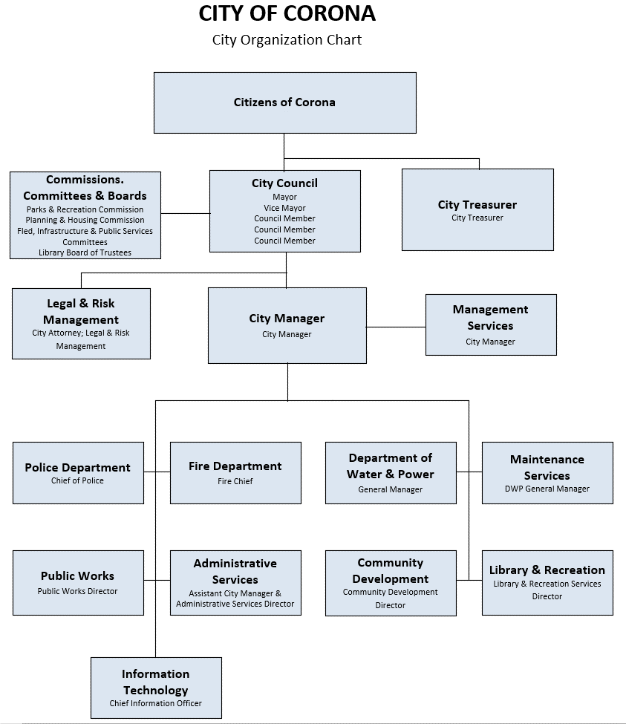

The City of Corona is a general law city that operates under a Council-Manager form of government. The City is governed by a five-member City Council. The Five Council Members (3 Council Members, a Vice Mayor and the Mayor) are elected by district to four-year terms. The Mayor and/or Vice Mayor are not directly elected to the position rather, Council members are appointed the positions for a one-year term, the Vice Mayor progresses to the position of Mayor. Volunteer Commissions and Boards, as well as Citizen Advisory Committees help guide the Council in its decisions. Commissioners are citizen volunteers, appointed by the City Council. The Council appoints the City Manager, who oversees the daily operations of the City. The General Manager manages the Electric Utilities under the general direction of the City Manager.

WILDFIRE PREVENTION
CDWP staff, in partnership with its maintenance and operations provider (Contracted Services) and Engineering Provider (Contracted Services) is responsible for electric facility design, maintenance, and inspection, including vegetation management. The City facilities are nearly 100% underground with the exception of only 3 poles spanning approximately 78 linear feet, with a total of roughly 105 linear feet of overhead cable, including the dive to underground cable.
in the entire system (Exhibit A). These poles are where the City transitions power from SCE to one of our WDATs. This site is located in one of the City’s Treatment Plant facilities outside of any wildfire threat areas. Although CDWP’s electrical distribution system is nearly 100% underground, CDWP follows best practices to prevent ignition of wildfires from its equipment. These items include:
- Performs routine maintenance of all distribution facilities.
- Conducts seasonal weed abatement to maintain standard clearances at at-risk sites.
- Operate system in a manner that will minimize potential wildfire risks.
- Take all reasonable and practicable actions to minimize the risk of a catastrophic wildfire caused by CDWP electric facilities.
- Coordinate with federal, state, and local fire management personnel as necessary or appropriate to implement CDWP’s Wildfire Mitigation Plan.
- Coordinate with City Emergency Operations Center to disseminate safety warnings, emergency public information, and evacuation notices to local residents.
- Immediately report fires, pursuant to existing CDWP practices and the requirements of this Wildfire Mitigation Plan.
- Take corrective action when the staff witnesses or is notified that fire protection measures have not been properly installed or maintained.
- Comply with relevant federal, state, and industry standard requirements, including the industry standards established by the California Public Utilities Commission.

WILDFIRE RESPONSE AND RECOVERY
CDWP’s distribution system is monitored remotely through a Supervisory Control and Data Acquisition (SCADA) system networked to all substations and circuits. CDWP field staff utilize hard line telephones, cellular telephones, and portable radios to communicate with internal and external stakeholders during an outage or emergency. CDWP’s SCADA system auto-generate notifications to field, office, and administrative staff. CDWP has On-Call contractual service as well City staff to respond in Emergency situations to facilities to expedited field response times and recovery from severe storms, natural disasters, or mass outages.
The City of Corona maintains a two-way (LF, HF, VHF, and UHF) mobile and base stations for communications enhanced by repeater system to extend the coverage area. This includes three Full Simulcast repeater sites and two receive only sites in the 700/800 MHz Public Safety band. The Fire Department uses the City owned VHF Conventional Simulcast radio system. The Police Department operates on the Riverside County wide PSEC system, 700/800 P-25 Phase II TDMA. The PSEC system has one site within the city limits with three other sites that contribute to the City’s coverage. The Fire Battalion Chief vehicles are also equipped with PSEC radios on the PD talk groups. As a fail-over the PD can also revert to the City’s VHF system. The City VHF system has four simulcast channels, two dedicated for Fire’s use and two for the Police and other’s use. The PSEC system is a trunked system and Corona PD has ten Talk Groups assigned to it.
The City of Corona owns one satellite phone kept in the EOC. Corona PD Does have an Amateur Radio user group they work with under Civil Emergency circumstances, which operates on ham radio frequencies in support of governmental emergency communications. The Frequencies can augment existing systems and establish communication links with otherwise inaccessible areas. They are also capable of sending live video and audio from an incident site to our City’s emergency operations center via the ham radio.
At the county level, a Riverside County Emergency Operations Center (EOC) talk group is programmed into the Omniquest radio and is used to communicate with EOCs within Riverside County during a disaster or emergency. The City of Corona is currently in the purchasing phase to regain the connectivity to access the Low Band Western Riverside County Disaster Net radios to communicate with all EOCs within Riverside County during a disaster or emergency. This system uses low frequency bands and access to several back up channels in case of an outage.
CDWP adheres to California Public Utility Commission GO 95, 165, and 174 for all system infrastructure inspection, maintenance, and reporting.
City of Corona Fire Department’s Emergency Management Division maintains a Local (City-wide) Hazard Mitigation Plan identifying potential wildland fire hazards and mitigation strategies and is in the beginning stages of developing a Community Wildfire Protection Plan that will also address fire hazards and potential mitigation strategies.
All City staff are trained to report to the appropriate City Department any code violations, hazards and/or safety concerns they come across within the City Limits.

Emergency Management System
As a local governmental agency, CDWP adheres to the National Incident Management System (NIMS). CDWP has planning, communication, and coordination obligations pursuant to the California Office of Emergency Services’ Standardized Emergency Management System (“SEMS”) Regulations, adopted in accordance with Government Code section 8607. The SEMS Regulations specify roles, responsibilities, and structures of communications at five different levels: field response, local government, operational area, regional, and state. Pursuant to this structure, CDWP annually coordinates and communicates with the relevant safety agencies as well as other relevant local and state agencies. When activated, CDWP serves as the Infrastructure & Utilities Branch under the Operations Section Chief as part of the City of Corona’s Emergency Operations Center. In the event the incident centered on CDWP facilities, CDWP would serve as the Operations Section Chief
The Emergency Operation Center activation procedures, levels, section and position specific roles and responsibilities are outlined in the City of Corona’s Emergency Operation Plan. CDWP participates in training and exercising to the plan.
As a member of the Riverside County Operational Area a significant amount of preparation is done through advanced planning at the local county level, including the coordination of effort of public, private, and nonprofit organizations. Riverside serves as the Operational Area and is guided by the California Office of Emergency Services, Southern Region. The Operational Area includes local and regional organizations that bring relevant expertise to the wildfire prevention, active situation and recovery planning processes. These participants include:

Agency/ Dept. | Mailing Address | Contact | Phone | Fax
AMR American Medical Response | 879 Marlborough Ave. Riverside, CA. 92507 |  | 951.782.5234 | 951.782.5617
AMR American Medical Response | 879 Marlborough Ave. Riverside, CA. 92507 | Dispatch | 877.267.6622 | 951.782.5605
Communications Providers in Corona
Internet |  | AT&T- Managed Internet Service | 888.613.6330, prompts 3 & 2
 |  | Impulse Advanced Communications | 800.456.5800
Land Lines |  | AT&T | 562.618.1221
Internet Phone Service |  | Impulse Advanced Communications | 800.456.5800
Cable Service in Corona | 17777 Center Court Dr, Suite 800  Cerritos, CA 90703 | Spectrum Cable | Office: 562.677.0310  Cell: 714.715.3581
Cell Service |  | Verizon | 951.473.7551
 |  | AT&T | 562.618.1221
City of Corona: Fire/Office of Emergency Management | 735 Public Safety Way, Corona, CA 92880 | Emergency Management Program Manager | 951.415.8071 | 951.736.2497
City of Corona: Utility | 755 Public Safety Way, Corona, CA 92880 | General Manager | 951.736.2477 | 951.736.2455
City of Corona: Special Districts | 400 S. Vicentia Ave., Corona, CA 92882 | Division Manager- Public Works | 951.817.5765 | 951.279.3627
City of Corona: Fire Dept. | 735 Public Safety Way, Corona, CA 92880 | Fire Chief | 951.279.3536 | 951.736.2497
City of Corona: Police Dept. | 730 Public Safety Way, Corona, CA 92880 | Police Chief | 951.817.5787
City of Corona: Traffic & Transportation | 400 S. Vicentia Ave., Corona, CA 92882 | Public Works | 951.736.2266
City of Corona: Facilities Management | 755 Public Safety Way, Corona, CA 92880 | Division Manager | 951.736.2443
US Forest Service: Cleveland National Forest Corona Fire Station | 1148 E 6th St, Corona, CA 92879 |  | 951.371.1004
Caltrans Corona Yard | 842 El Sobrante Rd., Corona, CA 92879 | Facility Supervisor | Office: 951.272.0628 Cell: 951.314.3630
Corona Norco Unified School District | 2820 Clark Avenue, Norco, CA 92860 | Maintenance Supervisor | 951.736.5000
Corona Regional Hospital | 800 S. Main St., Corona, CA 92882 | Facilities | 951.737.4343
Riverside County: Dept. of Environmental Health | 4065 County Circle Riverside, CA. | Deputy Director | 951.358.5172 | 951.358.5017
Riverside County: Dept. of Environmental Health | 4065 County Circle Riverside, CA. | Supervising Environmental Health Specialist | 951.358.5172 | 951.358.5017
Riverside County: Dept. of Environmental Health | 800 S. Sanderson Ave. #200, Hemet, CA. 92545 | Supervising Environmental Health Specialist | 951.766.2824
Riverside County: Emergency Management Department | 4210 Riverwalk Pkwy  Riverside, CA 92505 | Duty Officer | 951.312-5167
Riverside County: Fire Department | 210 W. San Jacinto Ave. Perris, CA 92570 | Dispatch | 951-940-6948

Pursuant to the SEMS structure, CDWP participates in training exercises. Training exercises include workshops, tabletop exercises, and field drills. A sample of topics covered include; earthquake safety, disaster response & management, active shooter, and NIMS/SEMS/ICS compliance.
The City of Corona has specific Mutual Aid Agreements with local cities and agencies such as Riverside County, Riverside City, Orange County, Chino and the US Forest Service. The City of Corona is a participant in the California Disaster and Civil Defense Mutual Aid Agreement which allocates state resources to cope with any type of disaster.

Wildfire Risks and Drivers associated with design, construction, operation, and maintenance

Particular Risks and Risk Drivers Associated With Topographic and Climatological Risk Factors
With all but 3 poles spanning approximately 78 linear feet, with a total of roughly 105 linear feet of overhead cable, including the dive to underground cable, and located outside of any identified high fire area maps (Exhibit B), CDWP’s service territory is located underground, the primary risk drivers for wildfire are the following:
- Water Inundation
- Earthquake Weather
- Electrical Storms

Enterprisewide Safety Risks

Water Inundation - There are three types Water Inundation can occur in the Corona Service area: watercourses, ponding and sheet flow. Inundation within defined watercourses occurs within drainage channels and natural Water shed areas. Ponding occurs when water flow is obstructed from following its natural or intended course. Sheet flow occurs when capacities of defined watercourses are exceeded, and water flows over broad areas.

Known flood-prone area as noted in the City’s maintenance files, include the Bedford Canyon Wash crossing at Temescal Canyon Road between Cajalco Road and Breezy Meadow Lane. The Bedford Wash is an extensive combination of natural water course and manmade containment channels that extends from a point west in the Cleveland National Forest flowing in an easterly direction into the Temescal Wash. Debris flows resulting from excessive water inundation overwhelms the Channel at the Temescal Canyon Road Bridge crossing, resulting in the water and debris flows breaching the bridge and flooding the area, including a critical reach of the electrical system.

Earthquake profile - There are three major faults/fault zones that directly affect the City of Corona. They are the southern section of the San Andreas Fault, the Elsinore Fault Zone, and the San Jacinto Fault Zone. The Elsinore Fault Zone is the closest fault to City of Corona, as it runs adjacent to the City boundaries approx. 10 miles from the southernmost section to the Western most point of the City Boundaries. The San Jacinto Fault Zone which is the next closet located approximately 25 miles northeast of the City of Corona. The San Andreas Fault Zone is located approximately 35 miles northeast of the City and was the fault that had the largest earthquake to occur within 100 miles of Corona was the 7.3 magnitude Landers earthquake in 1992.
The City of Corona could be affected by large earthquakes occurring in many parts of Southern California. However, the degree to which the earthquakes are felt, and the damages associated with them may vary. At risk from earthquake damage are critical facilities, buildings, bridges, highways and roads; Electric Distribution Lines; sewer, water, and natural gas pipelines; earth dams; petroleum pipelines; and private property located in the city. The relative or secondary earthquake hazards, which are liquefaction, ground shaking, amplification, and earthquake-induced landslides, can be just as destructive as the earthquake.

Electrical Storms – the City location has shown to be susceptible to Micro-Climate Storms consisting of high winds and frequent lighting activity, particularly in the Canyon area located in the vicinity of Temescal Canyon Road and Cajalco Road. The high winds in this area do not impact the City’s Service area as the CDWP system is 100% underground there but, it does impact the SCE Distribution Lines feeding the area. The lighting is always a concern with transformer and switchgear being housed in the steal enclosures.

Wildfire Preventative Strategies

High fire threat district
CDWP directly participated in the development of the CPUC’s Fire-Threat Map, which designates a High-Fire Threat District. In the map development process, CDWP coordinated with Southern California Edison Company (SCE) and determined that because CDWP’s system is nearly 100% undergrounded, that SCE would serve as territory lead for the region served by CDWP. CDWP has incorporated the High Fire Threat District into its construction, inspection, maintenance, repair, and clearance practices, where applicable.

design and Construction Standards
CDWP’s electric facilities are designed and constructed to meet or exceed the relevant federal, state, or industry standard. CDWP treats CPUC General Orders (GO) 95 and 128 as a key industry standard for design and construction standards for overhead and underground electrical facilities. CDWP meets or exceeds all standards in GO 95 and GO 128. Additionally, CDWP monitors and follows, as appropriate, the National Electric Safety Code. CDWP constructs, maintains, and operates its electrical lines and equipment in a manner that will minimize the risk of wildfire posed by those electrical lines and equipment.

Vegetation Management
CDWP meets or exceeds the minimum industry standard vegetation management practices. For distribution-level facilities, CDWP complies with NERC FAC-003-4, where applicable. For distribution level facilities, CDWP meets: (1) California Public Resources Code section - PRC §4292; (2) California Public Resources Code section - PRC §4293; (3) GO 95.

Inspections
CDWP meets or exceeds the minimum inspection requirements provided in CPUC GO 165 and CPUC GO 95, Rule 18. Pursuant to these rules, utilities inspect electric facilities in the Hight Fire Threat District more frequently than the other areas of its service territory. As described above, CDWP currently does not have any overhead powerlines located within or near the High-Fire Threat District within the CPUC’s Fire Threat Map. However, CDWP staff uses their knowledge of the specific environmental and geographical conditions of CDWP’s service territory to determine if any particular areas require more frequent inspections.
If CDWP staff discovers a facility in need of repair that is owned by an entity other than CDWP, CDWP will issue a notice to repair to the facility owner and work to ensure that necessary repairs are completed promptly.

Reclosing Policy
CDWP has no Reclosers deployed in its electrical system as the system is nearly 100% underground.

Deenergization
CDWP has the authority to preemptively shut off power due to fire-threat conditions, however, this option will only be used in extraordinary circumstances. Due to the extreme minimal risk of CDWP’s electrical supply facilities causing a power-line ignited wildfire, CDWP is not adopting specific protocols for de-energizing and customer notification for any portions of its electric distribution system. CDWP will re-evaluate this determination in future updates to this Wildfire Mitigation Plan

Restoration of Service

As expressed previously, the CDWP’s electric distribution system is nearly 100% underground. However, the City system is interconnected with SCE’s transmission and distribution systems, much of which is overhead and exposed to wind, rain and lightning. This is our primary source of vulnerability to potential electrical service interruptions during rain and wind storms such as the ones that can be triggered by El Nino and Micro Climate conditions. The City’s underground electric distribution systems have not been constructed with redundant sources of feeds. This makes the City system highly susceptible outages in these conditions and dependent upon SCE for restoration of those lines.

Preparation in advance of predicted storms: Since, as discussed in the introduction, our primary trouble source during storms is outages on SCE’s transmission and distribution lines, many of which are overhead, we will patrol, to the extent practical, SCE’s primary interconnect lines for any potential trouble spots including but, not limited to broken tree limbs or other vulnerabilities. We will also double check the loading conditions of our underground lines to satisfy ourselves that System is capable of serving the electric load of our customers in an event.

Our underground system will be patrolled in advance of storms for any open trenches or excavations at construction sites to minimize water intrusion into the underground system. Although the underground system is designed to operate under such conditions, small pinholes in splices or cable can cause problems, including possible electrical shorts/faults, that can interrupt service to customers. Likewise, after the storm, each underground vault, manhole or other structure will be inspected for water intrusion and pumped, when necessary, in accordance proper utility practice and environmental guidelines.
All vehicular equipment, man-lifts, tools and appurtenances will be thoroughly inspected for proper operation. All operating personnel are on standby to address any issue resulting from weather related events.
The CDWP Operations and the Call Center will be appropriately staffed for handling of trouble calls from customers and dispatching to field personnel.
Outage support includes:
• City Out Map Management
• Field Dispatching
• Customer Callbacks
Response Prioritization:
• First Priority: Response to imminent threats to life and/or public property
• Second Priority: Removals of immediate hazards (fallen trees, power poles, etc.)
• Third Priority: Clearing of arterial roadways
• Fourth Priority: Maintenance of traffic control/closures to prevent potential accidents
• Fifth Priority (Post Storm Activity): Follow-up work such as addressing storm-related potholes and residual clean-up of all streets that have remained in a "passable and drivable" state
Referral Protocol:
• Flooding of structures on private property-
IF flows are from City owned facilities - Maintenance and Operations will be dispatched to address
If private property - Residents will be advised to call 911 for Fire Department assistance
Facilities associated with other government agencies (RCFCD) or private utilities will be referred to appropriate agencies/company
• All storm related issues involving streets, curbs and gutters, sidewalks, residential trees in the right of way, catch basins, and miscellaneous drainage facilities will be referred to the City’s Maintenance and Operations Division.
During EOC activation period, all routine maintenance programs and requests will be suspended and deferred.

Evaluating of the Plan

Metrics and Assumptions for Measuring Plan Performance
CDWP will track two metrics to measure the performance of this Wildfire Mitigation Plan: (1) number of fire ignitions; and (2) wires down within the service territory.

Metric 1: Fire Ignitions
For purposes of this metric, a fire ignition is defined as follows:
- CDWP facility was associated with the fire;
- The fire was self-propagating and of a material other than electrical and/or communication facilities;
- The resulting fire traveled greater than one linear meter from the ignition point; and
- CDWP as knowledge that the fire occurred.
In future Wildfire Mitigation Plans, CDWP will provide the number of fires that occurred that were less than 10 acres in size. Any fires greater than 10 acres will be individually described.

Metric 2: Wires Down
The second metric is the number of distribution and transmission wires downed within CDWP’s service territory. For purposes of this metric, a wire(s) down event includes any instance where an electric transmission or primary distribution conductor falls to the ground or on to a foreign object. CDWP will divide the wires down metric between wires down inside and outside of the High Fire Threat District.
CDWP will not normalize this metric by excluding unusual events, such as severe storms. Instead, CDWP will supplement this metric with a qualitative description of any such unusual events.

Impact of Metrics on Plan
In the initial years, CDWP anticipates that there will be relatively limited data gathered through these metrics. However, as the data collection history becomes more robust, CDWP will be able to identify areas of its operations and service territory that are disproportionately impacted. CDWP will then evaluate potential improvements to the plan.

Monitoring and Auditing the Plan
The Wildfire Mitigation Plan and any updates will continue to be presented and adopted by CDWP’s City Council on an annual basis.

Identifying and correcting Deficiencies in the Plan
Based on the recommendations of its City Council, CDWP will correct any identified deficiencies.

Monitoring the effectiveness of inspections
CDWP reviews and evaluates its system reliability indices to monitor inspection and maintenance efforts. SAIDI, SAIFI, CAIDI, and MAIFI systems statistics are recorded, tracked and evaluated with respect to SCE transmission interruptions vs. City distribution interruptions to its customers for internal reliability.
CDWP’s utility maintenance management system (NexGen Asset Management System) is used to collect all data subject to GO165. All maintenance and inspection efforts are recorded and tracked in NexGen for the City electric distribution facilities. Maintenance history for each piece of equipment is being archived in NexGen. Additionally, CDWP’s substation inspections and maintenance program complies with GO174 guidelines as well as manufacturer specifications, standards, and recommendations. CDWP performs inspections of all substation and systems components including recording and analysis of all alarms, heat signatures, fluid levels, meters, fuses, contacts, cable connections, breaker settings, etc.

Independent Auditor
Public Utilities Code section 8387(c) requires CDWP to contract with a qualified independent evaluator with experience in assessing the safe operation of electrical infrastructure to review and assess the comprehensiveness of this Wildfire Mitigation Plan. The independent evaluator must issue a report that is posted to CDWP website. This report must also be presented to CDWP’s City Council at a public meeting.
The City of Corona Fire Department conducted the qualified independent evaluator review and presented their findings to the City Council and Wildfire Safety Advisory Board as a separate action from the CDWP Wildfire Mitigation Plan in compliance with the 2020 submittal.

Exhibits
Exhibit A
City of Corona DWP Owned Overhead Electrical Lines and Equipment Locations
The only Corona owned overhead lines and equipment in the system are located within the fence line of the Corona Department of Water and Power’s Waste Water Treatment Plant #2 at 652 Harrison Street. The overhead lines and equipment consist of 3 poles spanning approximately 78 linear feet, with a total of roughly 105 linear feet of overhead cable, including the dive to underground cable.

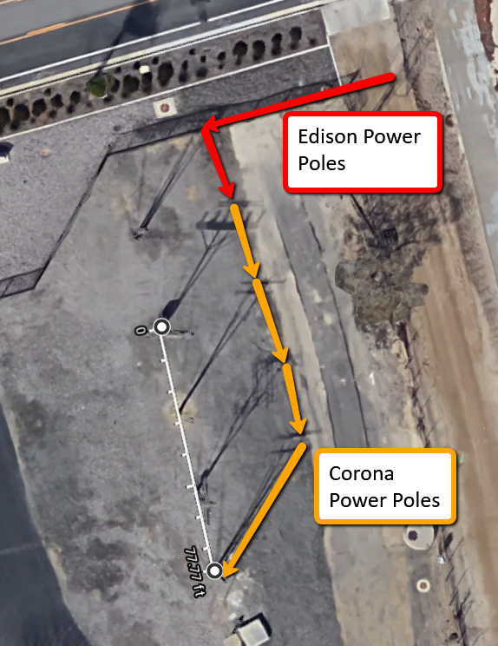
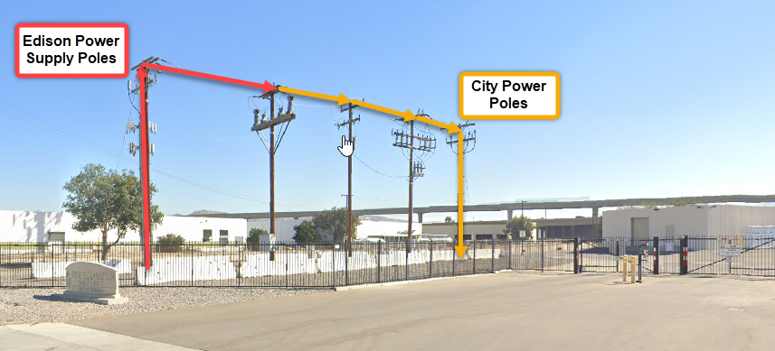

Exhibit B
City of Corona DWP Owned Overhead Electrical Lines and Equipment Locations to Fire Shape Maps

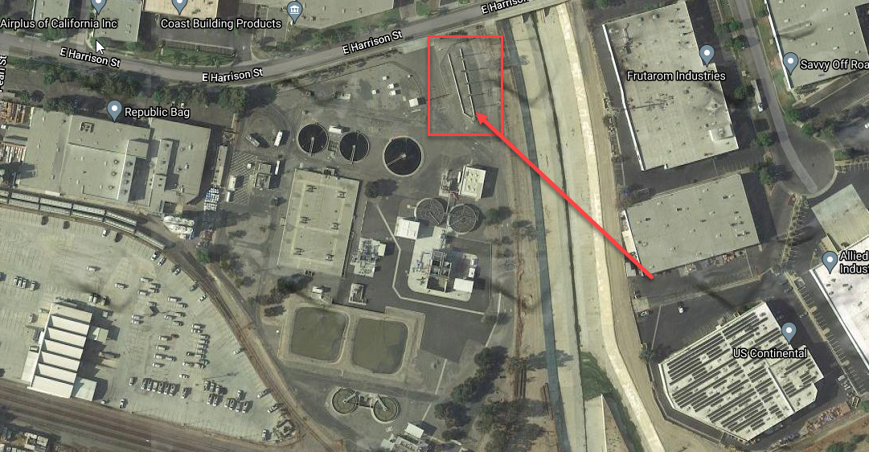

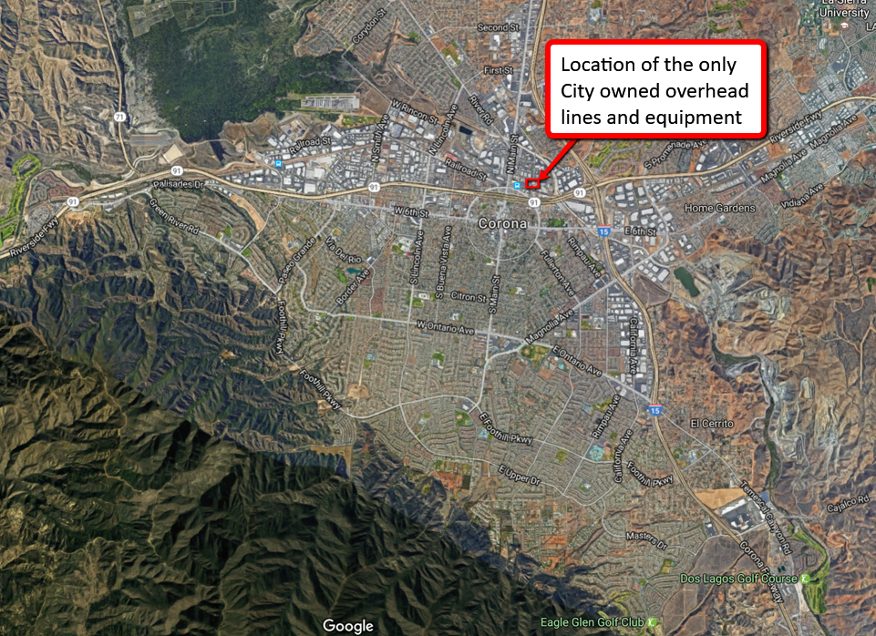
Located outside the Shape A(Green) and B (Blue) Map - Final – Corona Coverage

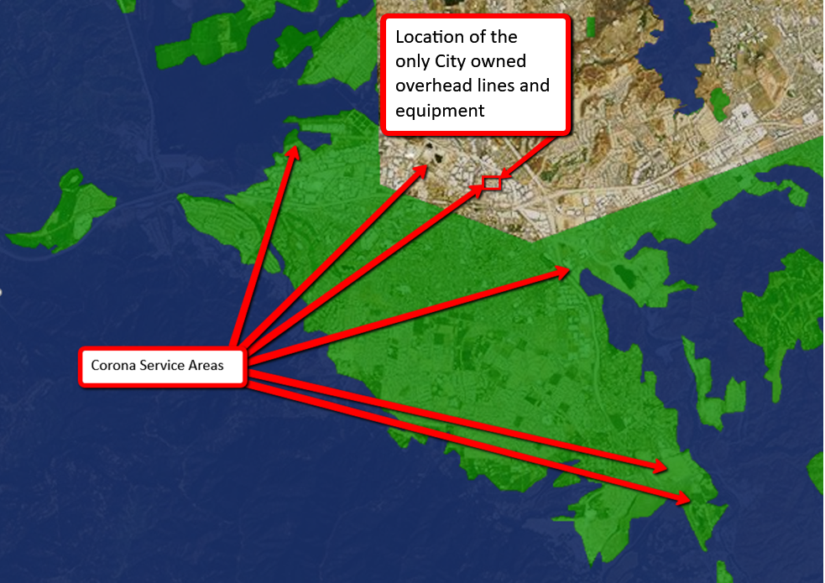
CPUC Statewide Fire Threat Map

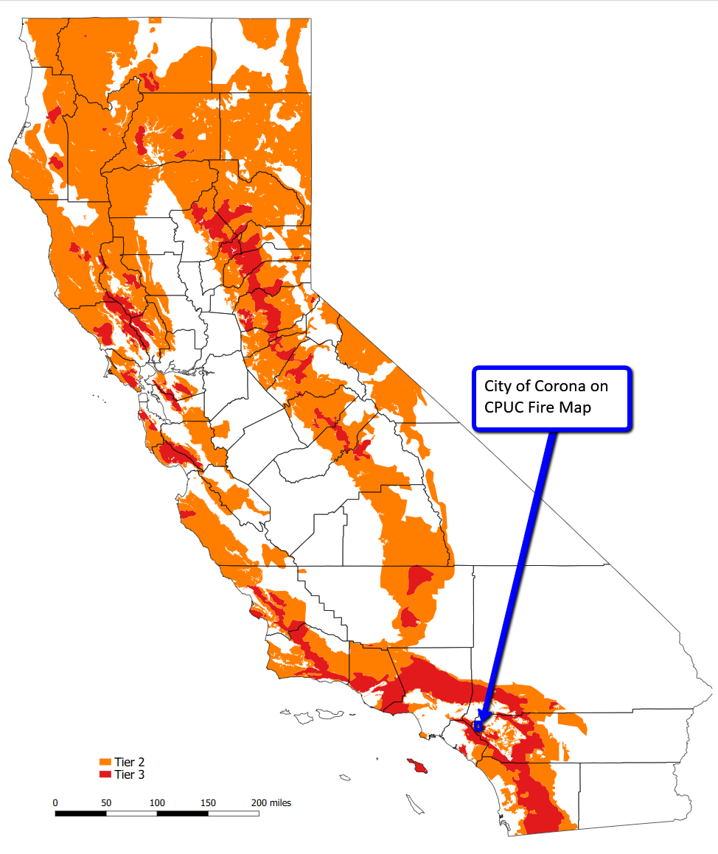

As defined in Cal. Gov. Code § 8680.2.
19 CCR § 2407.
Cal. Gov. Code § 2403(b): (1) “Field response level” commands emergency response personnel and resources to carry out tactical decisions and activities in direct response to an incident or threat. (2) “Local government level” manages and coordinates the overall emergency response and recovery activities within their jurisdiction. (3) “Operational area level” manages and/or coordinates information, resources, and priorities among local governments within the operational area and serves as the coordination and communication link between the local government level and the regional level. (4) “Regional level” manages and coordinates information and resources among operational areas within the mutual aid region designated pursuant to Government Code §8600 and between the operational areas and the state level. This level along with the state level coordinates overall state agency support for emergency response activities. (5) “State level” manages state resources in response to the emergency needs of the other levels, manages and coordinates mutual aid among the mutual aid regions and between the regional level and state level, and serves as the coordination and communication link with the federal disaster response system.
Adopted by CPUC Decision 17-12-024.

