Needles Public Utility Authority

Wildfire

Mitigation

Plan

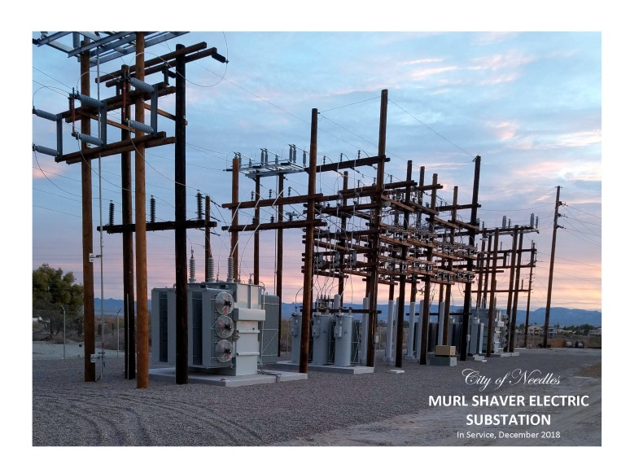
VERSION 2.0 June 15, 2021

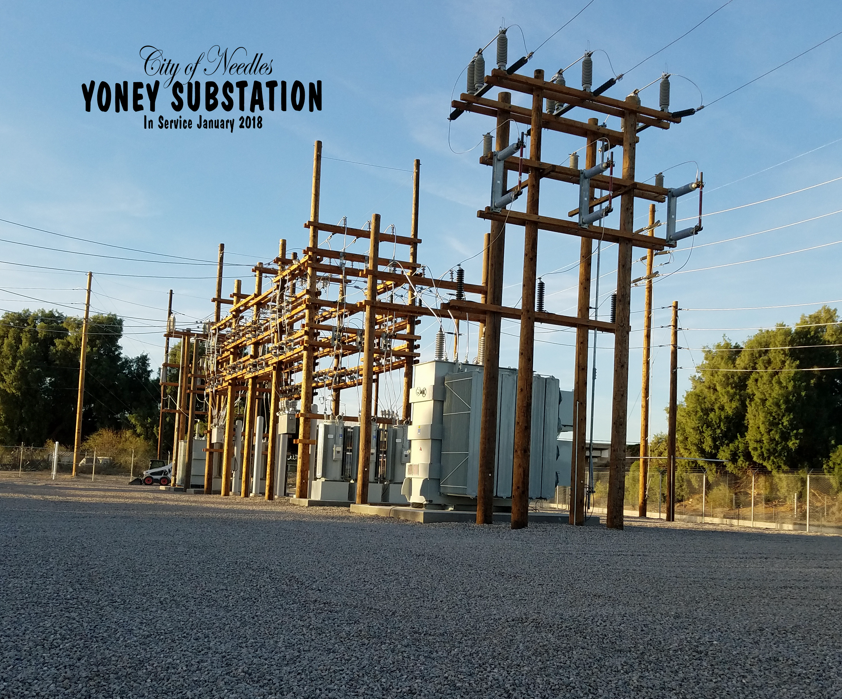

Table of contents
I. Overview 1
A. Policy Statement 1
B. Purpose of the Wildfire Mitigation Plan 1
II. Objectives of the Wildfire Mitigation Plan 2
A. Minimizing Sources of Ignition 2
B. Resiliency of the Electric Grid 2
C. Identifying Unnecessary or Ineffective Actions 2
III. Roles and Responsibilities 3
A. Utility Governance Structure 3
B. WILDFIRE PREVENTION 4
C. WILDFIRE RESPONSE AND RECOVERY 5
D. Coordination with Water Utilities/Department 5
E. Coordination With Communication Infrastructure Providers 5
F. Standardized Emergency Management System 6
IV. Wildfire Risks and Drivers associated with design, construction, operation, and maintenance 7
A. Particular Risks and Risk Drivers Associated With Topographic and Climatological Risk Factors 7
B. Enterprisewide Safety Risks 7
C. CPUC Fire Threat MaP 8
D. High fire threat district 8
E. Weather Monitoring 9
F. design and Construction Standards 9
G. Vegetation Management 9
H. Inspections 11
I. Workforce training 11
J. Reclosing Policy 11
K. Deenergization 11
1. Impacts to public safety 12
2. Customer Notification Protocols 12
V. Community Outreach and Public Awareness 12
VI. Restoration of Service 12
11. Evaluating of the Plan 13
A. Metrics and Assumptions for Measuring Plan Performance 13
Metric 1: Fire Ignitions 13
Metric 2: Wires Down 13
B. Metrics For 2021 Plan 13
C. Impact of Metrics on Plan 14
D. Monitoring and Auditing the Plan 14
E. Identifying and correcting Deficiencies in the Plan 14
F. Monitoring the effectiveness of inspections 14

Overview

Policy Statement
The Needles Public Utility Authority (NPUA) overarching goal is to provide safe, reliable, and economic electric service to its local community. In order to meet this goal, NPUA constructs, maintains, and operates its electrical lines and equipment in a manner that minimizes the risk of catastrophic wildfire posed by its electrical lines and equipment.

Purpose of the Wildfire Mitigation Plan
This Wildfire Mitigation Plan describes the range of activities that the NPUA is taking to mitigate the threat of power-line ignited wildfires, including its various programs, policies, and procedures. This plan is subject to direct supervision by the Board of Public Utilities and the Needles Public Utility Authority and is implemented by the NPUA’s Electric Supervisor. This plan complies with the requirements of Public Utilities Code section 8387 for publicly owned electric utilities to prepare a wildfire mitigation plan by January 1, 2020, and annually thereafter.
The NPUA is a department within the City of Needles. The NPUA Fire Prevention plan is focused on addressing and minimizing potential wildfire-related risks to public health, safety and welfare. The Fire Prevention plan reflects a broad range of activities performed not only by the electric department by through the City of Needles organization. The NPUA’s Fire Prevention plan begins with operation, maintenance, inspection, and repair activities aimed at significantly reducing the potential for NPUA’s electric facilities to become a source of ignition for a fire. The electric department continues to;
- Clear transmission lines of all trees and vegetation;
- Perform regular inspections all distribution and transmission lines;
- Repair and replacement transformers that could potential cause a risk;
- Coordinate vegetation removal through the City of Needles Parks and Recreation Department if an area is determined outside of the electric easements.
Through performing inspections and maintenance, the information gathered will be used to help fire agencies, and other fire-responders to determine the appropriate actions if a wildfire occurs by understanding the surround area.
The NPUA continues to monitor all fires within and surrounding its service territory both inside California and outside in Arizona and Nevada.
This Wildfire Mitigation Plan included the following elements:

- Objectives of the plan;
- Roles and responsibilities for carrying out the plan;
- Identification of key wildfire risks and risk drivers;
- Description of wildfire prevention, mitigation, and response strategies and programs;
- Community outreach and education;
- Metrics for evaluating the performance of the plan and identifying areas for improvement;
- Review and validation of the plan; and
- Timelines.

Objectives of the Wildfire Mitigation Plan

Minimizing Sources of Ignition
The primary goal of this Wildfire Mitigation Plan is to minimize the probability that NPUA’s transmission and distribution system may be the origin or contributing source for the ignition of a fire. The NPUA has evaluated the prudent and cost-effective improvements to its physical assets, operations, and training that can help to meet this objective. The NPUA has implemented those changes consistent with this evaluation.

Resiliency of the Electric Grid
The secondary goal of this Wildfire Mitigation Plan is to improve the resiliency of the electric grid. As part of the development of this plan, NPUA assesses new industry practices and technologies that will reduce the likelihood of an interruption (frequency) in service and improve the restoration (duration) of service.

Identifying Unnecessary or Ineffective Actions
The final goal for this Wildfire Mitigation Plan is to measure the effectiveness of specific wildfire mitigation strategies. Where a particular action, program component, or protocol is determined to be unnecessary or ineffective, the NPUA will assess whether a modification or replacement is merited. This plan will also help determine if more cost-effective measures would produce the same or improved results.

Roles and Responsibilities

Utility Governance Structure

The City of Needles (Needles) is a charter city of the State of California located on the eastern border of California. Through the Needles Public Utilities Authority (NPUA), a component unit of the City, the City owns the Public Utilities Department. The Department consists of three Divisions Electric, Water, and Wastewater.
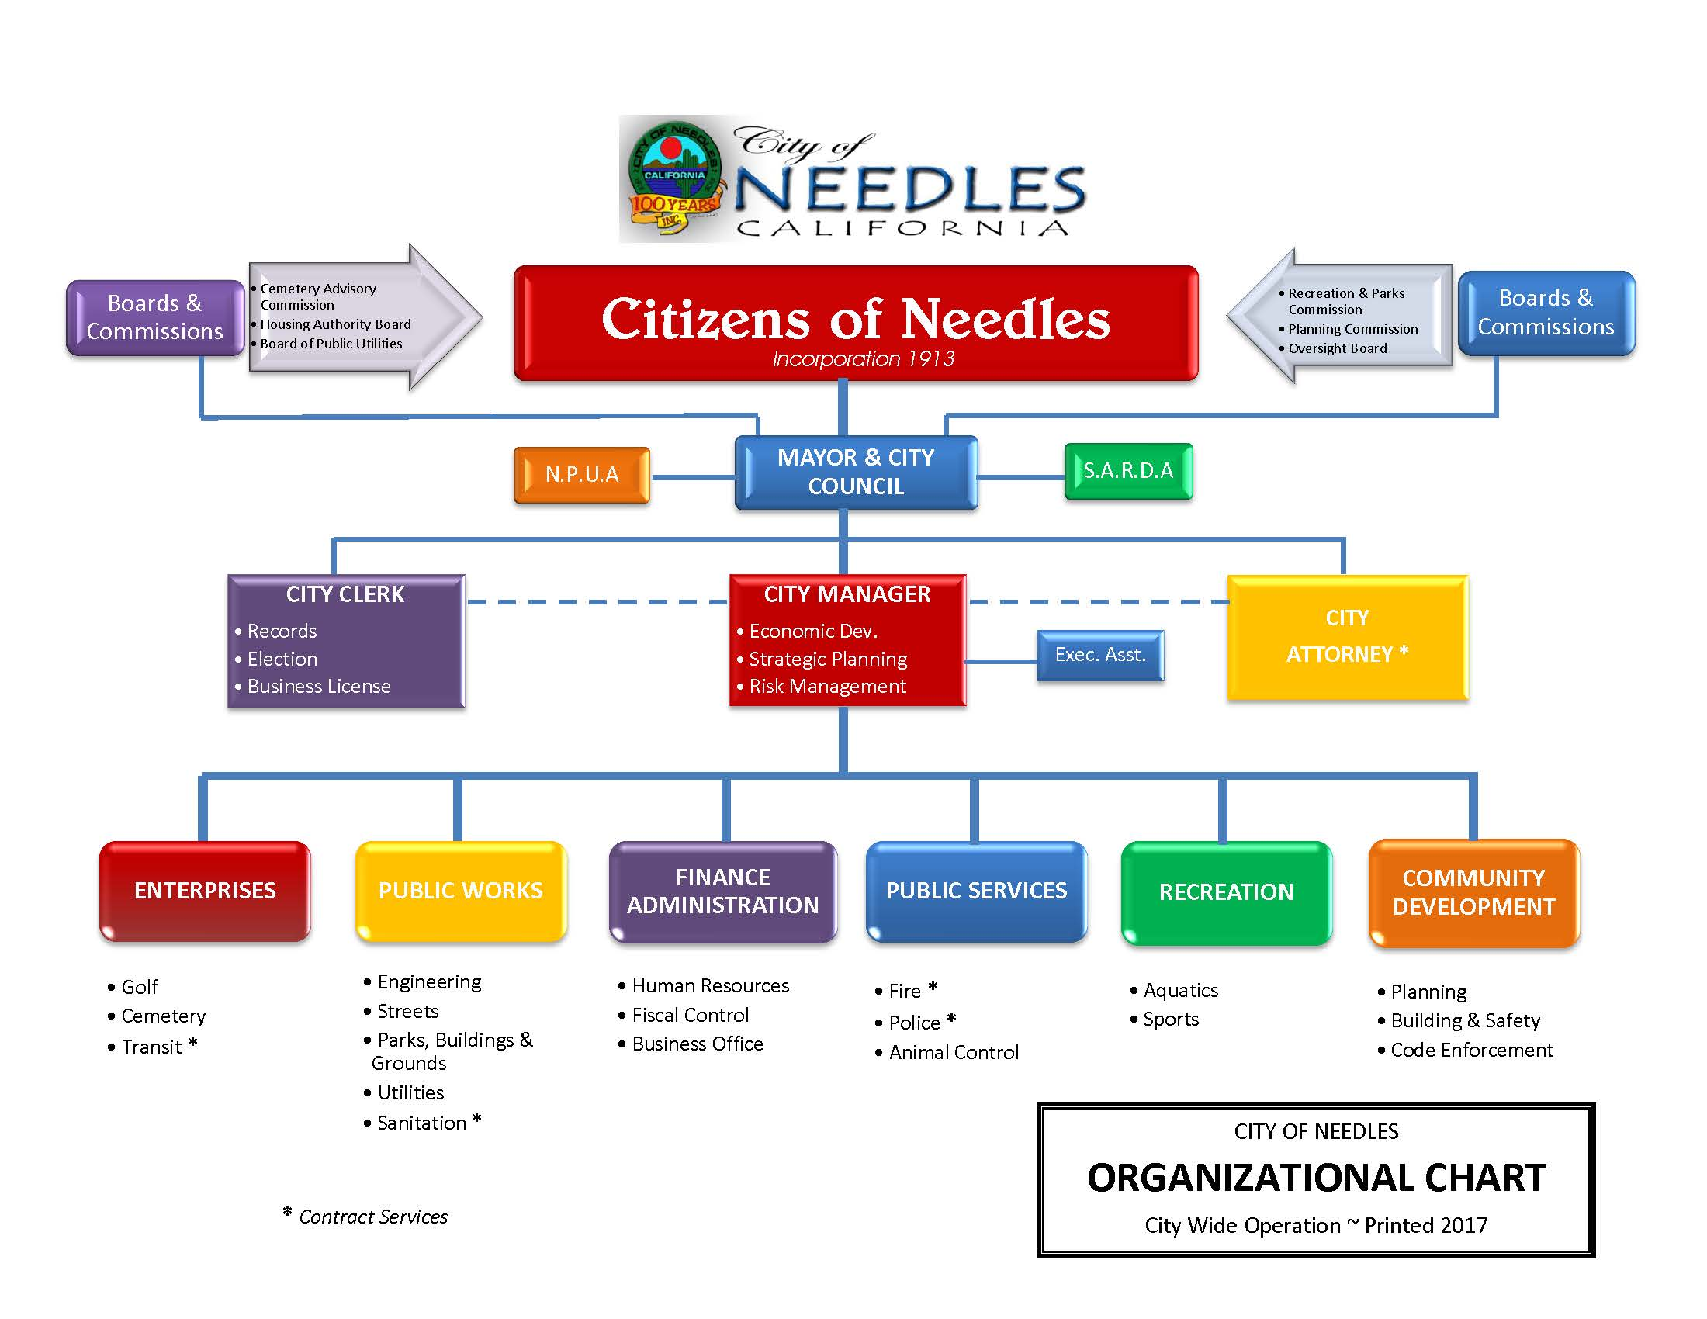

The electric distribution system serving the City was originally owned by the Needles Gas and Electric Company. The Needles Gas and Electric Company was purchased by the predecessor to CP National in 1930. On January 10, 1983, the City purchased the electric distribution system from CP National. However, pursuant to a management agreement, CP National continued to operate the system until July 1990. The City has operated the electric distribution system since that time.
The City’s primary interest in purchasing the electric distribution system from CP National stemmed from a change in Federal law in 1982, relating to the sale of hydroelectricity power from federal projects. Under the revised regulations, inexpensive federal hydroelectricity power from the U.S. Bureau of Reclamation’s Parker-Davis Project (Hoover Dam), located on the Colorado River, became available to municipally owned utilities. The City’s electorate authorized the issuance of revenue bonds to finance the acquisition of the electric distribution system from CP National.
The City provides electric service to the City and contiguous areas from the Nevada state line, south of Laughlin, Nevada, to the vicinity of Topock, Arizona. Needles’ peak electric demand is 22.41 MW (as of August 2018) and services approximately 3,000 customers.

WILDFIRE PREVENTION

The electric department is under direct supervision from the Assistant Utility Manager and City Manager, there is one Power Line Supervisor, three power line techs, two Apprentice Lineman and one Warehouse Manager. The electric department is responsible to:
- Operate system in a manner that will minimize potential wildfire risks.
- Take all reasonable and practicable actions to minimize the risk of a catastrophic wildfire caused by NPU electric facilities.
- Coordinate with federal, state, and local fire management personnel as necessary or appropriate to implement NPUA’s Wildfire Mitigation Plan.
- Immediately report fires, pursuant to existing POU practices and the requirements of this Wildfire Mitigation Plan.
- Take corrective action when the staff witnesses or is notified that fire protection measures have not been properly installed or maintained.
- Comply with relevant federal, state, and industry standard requirements, including the industry standards established by the California Public Utilities Commission.
- Collect and maintain wildfire data necessary for the implementation of this Wildfire Mitigation Plan.
- Provide regular training programs for all employees having obligations for implementation of this Wildfire Mitigation Plan.

WILDFIRE RESPONSE AND RECOVERY
The City’s communication strategy is structured so that all stakeholders receive accurate, timely and consistent information, with the overall message of safety first, for the public, employees and contractors.
When an emergency occurs, the electric departments supervisor will be responsible for communicating with the City Manager/Utilities Manager, customers, employees and contractors to set expectation and address emergency issues. This information will be provided through various communication channels such as company phone(s) and radios.
If business operations or households are disrupted, customers expect to know how long they will be impacted. Thus, estimated restoration times will be developed, monitored, adjusted and communicated to all stokeholds as the information becomes available.

Coordination with Water Utilities/Department
During declared emergencies, the electric department is responsible for coordinating efforts and sharing information with neighboring utilities relative to the out of service and damaged critical infrastructure.
During an event, the electric department will perform the following functions;
- Share information and prioritize restoration efforts relative to utility critical infrastructure that is out of service.
- Notify the water department of the downed communication wires.

Coordination With Communication Infrastructure Providers
During declared emergencies, the electric department is responsible for coordinating efforts and sharing information with neighboring telecommunications utilities relative to the out of service and damaged critical infrastructure.
During an event, the electric department will perform the following functions;
- Share information and prioritize restoration efforts relative to utility critical infrastructure that is out of service.
- Coordinate with the appropriate telephone and cable company to set poles; and
- Notify the telephone and cable companies of downed communication wires.

Standardized Emergency Management System
As a local governmental agency, NPUA has planning, communication, and coordination obligations pursuant to the California Office of Emergency Services’ Standardized Emergency Management System (“SEMS”) Regulations, adopted in accordance with Government Code section 8607. The SEMS Regulations specify roles, responsibilities, and structures of communications at five different levels: field response, local government, operational area, regional, and state. Pursuant to this structure, NPUA annually coordinates and communicates with the relevant safety agencies as well as other relevant local and state agencies.
Under the SEMS structure, a significant amount of preparation is done through advanced planning at the county level, including the coordination of effort of public, private, and nonprofit organizations.
NPUA is a member of the California Utility Emergency Association, which plays a key role in ensuring communications between utilities during emergencies.

Wildfire Risks and Drivers associated with design, construction, operation, and maintenance

Particular Risks and Risk Drivers Associated With Topographic and Climatological Risk Factors
Within NPUA’s service territory and the surrounding areas, the primary risk drivers for wildfire are the following:
- Extended drought;
- Vegetation type;
- Weather;
- High winds;
- Changing Weather Patterns (Climate Change)

Enterprisewide Safety Risks
Western Area Power Administration (WAPA) delivers energy to the City of Needles on a 69KVA transmission line. The distribution line crosses the river in town at 3240 Needles Hwy, the firehouse switchyard. The City of Needles also has a back 69KVA Line that comes from the Nora McDowell Substation located 15 miles north of Needles.
Electric energy is delivered to the City at two substations. Needles #1 Substation has two banks located on Eagle Pass Road in the downtown area of the City. Bank #1 has a base rating of 7.5MVA and a 65 foot rise and force air rating of 9.3MVA.
The second substation, Bush Street Substation, has a base rating of 10MVAand a 65 foot rise with a forced air rating of12MVA. The Bush Substation serves the west end of town.
The existing substations can handle current peak load requirements of 15,200 kilowatts. From the substations approximately 86 miles of distribution circuits deliver power at 12,000 volts to distribution transformers where the power is reduced to the voltages required by the individual customer’s needs. The City electric department provides single phase, 60 Hertz, at one standard voltage (120/240 or 120/208 as may be selected by customers subject to availability at the premises).
While the NPUA makes improvements to the system annually, the main focus for the utility is ground clearance.

CPUC Fire Threat MaP
The NPUA is not located within the CPUC Fire Threat Map and therefor is not located within an elevated hazard for the ignition of potential wildfires.
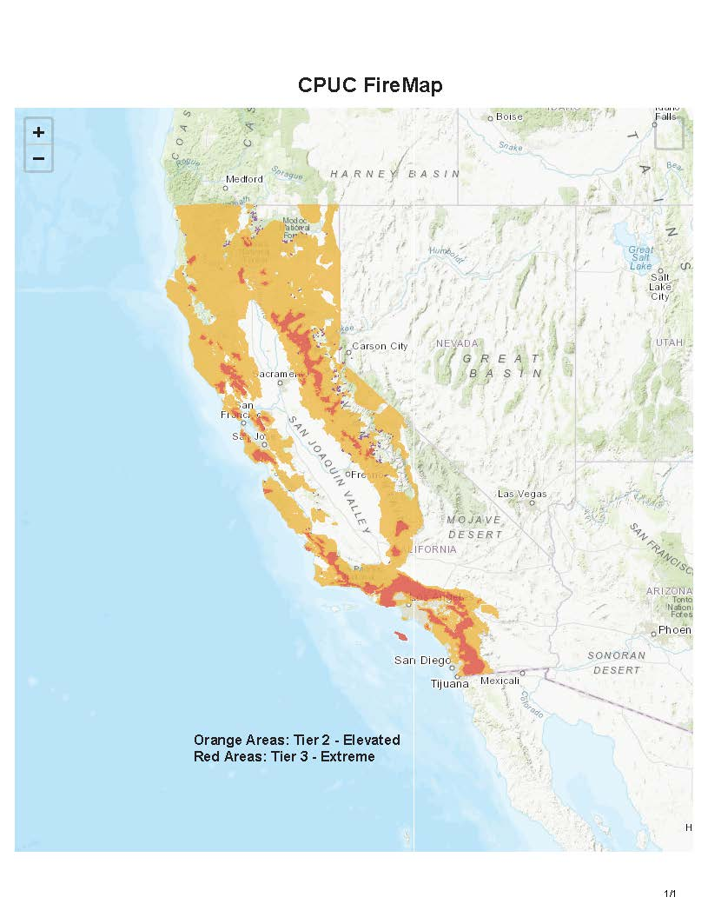

High fire threat district
NPUA directly participated in the development of the California Public Utilities Commission’ s (CPUC) Fire-Threat Map, which designates a High-Fire Threat District. In the map development process, NPUA served as a territory lead, and worked with utility staff and local fire & government officials to identify the areas of NPUA’s service territory that are at an elevated or extreme risk of power line ignited wildfire. NPUA has incorporated the High Fire Threat District into its construction, inspection, maintenance, repair, and clearance practices, where applicable.

Weather Monitoring
NPUA monitors current and forecasted weather data from a variety of sources including:
- United States National Weather Service
- United States Forest Service Wildland Fire Assessment System
- National Fire Danger Rating System
- National Interagency Fire Center – Predictive Services for Northern and Southern California.
NPUA assigns one of four operating conditions based on the relevant weather data and knowledge of local conditions:
- Normal: During normal conditions, no changes are made to operations or work policy.

- Elevated: During elevated fire-risk conditions; it must be determined by the Fire Coordinator and/or meteorologist that the burn environment has become conducive for wildfires within he NPUA service territory.

- Extreme: During extreme fire-risk conditions, it must be determined by the Fire Coordinator and/or meteorologist that due to the conditions of high winds, low relative humidity, and the burn environment will create critical fire weather conditions;

- Red Flag: If the National Weather Service declares a Red Flag Warning for any portion of the NPUA’s Service.

design and Construction Standards
NPUA’s electric facilities are designed and constructed to meet or exceed the relevant federal, state, or industry standard. The NPUA treats CPUC General Order (GO) 95 as a key industry standard for design and construction standards for overhead electrical facilities. NPUA meets or exceeds all standards in GO 95. Additionally, NPUA monitors and follows as appropriate the National Electric Safety Code.

Vegetation Management
NPUA meets or exceeds the minimum industry standard vegetation management practices. For transmission-level facilities, NPUA complies with NERC FAC-003-4, where applicable. For both transmission and distribution level facilities, NPUA meets: (1) Public Resources Code section 4292; (2) Public Resources Code section 4293; (3) GO 95 Rule 35; and (4) the GO 95 Appendix E Guidelines to Rule 35. These standards require significantly increased clearances in the High Fire Threat District. However, as noted above, no part of NPUA’s service territory includes any part of the High Fire Threat District. The recommended time-of-trim guidelines do not establish a mandatory standard, but instead provide useful guidance to utilities. NPUA uses specific knowledge of growing conditions and tree species to determine the appropriate time of trim clearance in each circumstance.

GO 95, Rule 35, Table 1
Case | Type of Clearance | Trolley Contact, Feeder and Span Wires, 0-5kv | Supply Conductors and Supply Cables, 750 - 22,500 Volts | Supply Conductors and Supply Cables, 22.5 - 300 kV | Supply Conductors and Supply Cables, 300 - 550 kV (mm)
13 | Radial clearance of bare line conductors from tree branches or foliage | 18 inches | 18 inches | ¼ Pin Spacing | ½ Pin Spacing
14 | Radial clearance of bare line conductors from vegetation in the Fire-Threat District | 18 inches | 48 inches | 48 inches | 120 inches

Appendix E
Guidelines to Rule 35
The radial clearances shown below are recommended minimum clearances that should be established, at time of trimming, between the vegetation and the energized conductors and associated live parts where practicable. Reasonable vegetation management practices may make it advantageous for the purposes of public safety or service reliability to obtain greater clearances than those listed below to ensure compliance until the next scheduled maintenance. Each utility may determine and apply additional appropriate clearances beyond clearances listed below, which take into consideration various factors, including: line operating voltage, length of span, line sag, planned maintenance cycles, location of vegetation within the span, species type, experience with particular species, vegetation growth rate and characteristics, vegetation management standards and best practices, local climate, elevation, fire risk, and vegetation trimming requirements that are applicable to State Responsibility Area lands pursuant to Public Resource Code Sections 4102 and 4293.
Voltage of Lines | Case 13 | Case 14
Radial clearances for any conductor of a line operating at 2,400 or more volts, but less than 72,000 volts | 4 feet | 12 feet
Radial clearances for any conductor of a line operating at 72,000 or more volts, but less than 110,000 volts | 6 feet | 20 feet
Radial clearances for any conductor of a line operating at 110,000 or more volts, but less than 300,000 volts | 10 feet | 30 feet
Radial clearances for any conductor of a line operating at 300,000 or more volts | 15 feet | 30 feet

Inspections
The NPUA meets or exceeds the minimum inspection requirements provided in CPUC GO 165 and CPUC GO 95, Rule 18. Pursuant to these rules, NPUA inspects electric facilities in the High Fire Threat District more frequently than the other areas of its service territory. Additionally, NPUA staff uses their knowledge of the specific environmental and geographical conditions to determine when areas outside of the High Fire Threat District require more frequent inspections.
If NPUA staff discovers a facility in need of repair that is owned by an entity other than NPUA, NPUA will issue a notice to repair to the facility owner and work to ensure that necessary repairs are completed promptly.
NPUA monitors drought conditions and other relevant factors throughout the year to determine if inspections should be completed on a shorter timeframe.

Workforce training
NPUA has implemented work rules and complementary training programs for its workforce to help reduce the likelihood of the ignition of wildfires. The NPUA inspects power lines and other electrical equipment during potential risk times.

Reclosing Policy
The NPUA does not have SCADA controlled reclosers, two qualified linemen reclose or close the distribution system. Lockout, tagout safety procedures are followed.

Deenergization
The NPUA has the authority to preemptively shut off power due to fire-threat conditions; however, this option will only be used in extraordinary circumstances. The NPUA will make a case-by-case decision to shut off power based on the following considerations:
- Red Flag Warnings issued by the National Weather Service for fire weather zones that contain NPUA circuits;
- NPUA staff assessments of local conditions, including wind speed (sustained and gust), humidity and temperature, fuel moisture, fuel loading and data from weather stations;
- Real-time information from staff located in areas identified as at risk of being subject to extreme weather conditions;
- Input from San Bernardino County fire experts and vegetation experts;
- Input from local and state fire authorities regarding the potential consequences of wildfires in select locations;
- Alternative ways to reroute power to affected areas;
- Awareness of mandatory or voluntary evacuation orders in place;
- Expected impact of de-energizing circuits on essential services;
- Other operational considerations to minimize potential wildfire ignitions, including the blocking of reclosers on the identified circuit(s);
- On-going fire activity throughout NPUA’s territory and California;
- Ability to notify customers;
- Notifications to local governments and public officials; and
- Potential impacts to communities and customers

Impacts to public safety
The following is a listing off facilities which are special considerations of the public safety during a power outage;
- Hospitals and Emergency Medical Facilities;
- Emergency Shelters and Cooling Centers;
- Fire, Police, Paramedics and Rescue Facilities;
- Emergency Management Offices;
- Water and Wastewater Facilities;
- Critical Utility and Communication Facilities;
- Mass Transit (BNSF, Airport);
- Critical Flood Control Structures; and
- Fort Mojave Indian Tribe Hazardous Mitigation Facility.
In the event of a wildfire and potential outages those accounts, the Priority Restoration Group will be notified of a potential impact first.

Customer Notification Protocols
The NPUA takes priority in providing notification to all customers who are affected by a power outage. The NPUA will establish a dispatch center at City Hall offices to provide real time information to the customers such as;
- Effective area(s); and
- Estimated restoration time.

Community Outreach and Public Awareness
When a wildfire is mobilized, the City Manager/Utilities Manager branches to provide public awareness through the following;
- Issuing a wildfire press release;
- Arranging media interviews and press conferences, as necessary;

Restoration of Service
Restoring power after a major storm or wildfire is a complex task that must be completed quickly and safely. A speedy restoration requires significant communication, along with skilled line workers. The process for restoration is:
- The electric department establishes a command post at the nearest substation to the affected area
- An inspection is conducted from the substation out to the affected area
- Crews inspect the affected area and create a damage assessment
- The restoration team ensures the line is deenergized and grounded
- Replacement of damaged material such as conductors, transformers, insulators is the damaged area
- The effected circuit is re-energized
- Households in isolated are re-energized
- Crews will remain at the command post for one-hour following the full restoration to ensure all circuits are on
- Dispatch will call the crew is calls are reported for no power
- Crews may be dispatched to individual homes to reset the breaker

Evaluating of the Plan

Metrics and Assumptions for Measuring Plan Performance
NPUA tracks two metrics to measure the performance of this Wildfire Mitigation Plan: (1) number of fire ignitions; and (2) wires down within the service territory.

Metric 1: Fire Ignitions
For purposes of this metric, a fire ignition is defined as follows:
- NPUA facility was associated with the fire;
- The fire was self-propagating and of a material other than electrical and/or communication facilities;
- The resulting fire traveled greater than one linear meter from the ignition point; and
- NPUA has knowledge that the fire occurred.
For this metric, NPUA will provide the number of fires that occurred that were less than 10 acres in size. Any fires greater than 10 acres will be individually described.

Metric 2: Wires Down
The second metric is the number of distribution and transmission wires downed within NPUA’s service territory. For purposes of this metric, a wires-down event includes any instance where an electric transmission or primary distribution conductor falls to the ground or on to a foreign object. NPUA will divide the wires down metric between wires down inside and outside of the High Fire Threat District. NPUA will not normalize this metric by excluding unusual events, such as severe storms. Instead, NPUA will supplement this metric with a qualitative description of any such unusual events.

Metrics For 2021 Plan
The metrics for calendar years 2019 and 2020 are the following:
Year | Fire Ignitions | Wires Down Events
2019 | 0 | 3
2020 | 0 | 3

Impact of Metrics on Plan
In the initial years, NPUA there will be relatively limited data gathered through these metrics. However, as the data collection history becomes more robust, NPUA will be able to identify areas of its operations and service territory that are disproportionately impacted. NPUA will then evaluate potential improvements to the plan.

Monitoring and Auditing the Plan
This Wildfire Mitigation Plan will be presented to the Board of Public Utilities (BPU), Needles Public Utilities Authority (NPUA) and the City Council. BPU will present this plan to Needles Public Utility Authority on an annual basis.
The NPUA will perform an annual audit which will review all parts of the Wildfire Mitigation Plan, as well as a review of both pending and completed maintenance work identified within the NPUA’s service territory. As well as verifying overhead and underground facilities that were inspected in the previous year.

Identifying and correcting Deficiencies in the Plan
Upon finding any deficiencies in performance against the plan or need for improvement in the Plan itself, the NPUA will be responsible for correcting the deficiencies.

Monitoring the effectiveness of inspections
NPUA’s third part verifier will review various aspects of the risk reduction measure of part of this Wildfire Mitigation Plan. Depending on the quality of performance and value received from the third-part entity, the process may be expanded further to additional potential risk reduction measures.

As defined in Cal. Gov. Code § 8680.2.
19 CCR § 2407.
Cal. Gov. Code § 2403(b): (1) “Field response level” commands emergency response personnel and resources to carry out tactical decisions and activities in direct response to an incident or threat. (2) “Local government level” manages and coordinates the overall emergency response and recovery activities within their jurisdiction. (3) “Operational area level” manages and/or coordinates information, resources, and priorities among local governments within the operational area and serves as the coordination and communication link between the local government level and the regional level. (4) “Regional level” manages and coordinates information and resources among operational areas within the mutual aid region designated pursuant to Government Code §8600 and between the operational areas and the state level. This level along with the state level coordinates overall state agency support for emergency response activities. (5) “State level” manages state resources in response to the emergency needs of the other levels, manages and coordinates mutual aid among the mutual aid regions and between the regional level and state level, and serves as the coordination and communication link with the federal disaster response system.
Adopted by CPUC Decision 17-12-024.

