2021 WILDFIRE
MITIGATION PLAN

Date: July, 2021
Project: SV19-004
Revision: V1

Table of Contents
Table of Contents i
Table of Tables vi
Table of Figures vi
1 Introduction 1
1.1 Mission 2
1.2 Purpose of the Plan 2
1.3 Objectives of the WMP 5
2 SVEC Background and Mission Statement 7
2.1 SVEC Profile and History 7
2.2 The Service Area 7
2.3 The Electric System 9
2.4 Goals and Objectives 9
3 Overview of SVEC’s Fire Prevention Strategies 11
3.1 Timeframes of Preventative Strategies and Programs 12
4 Risk Analysis and Risk Drivers 15
4.1 Enterprise Risk Assessment (ERM) 15
4.2 Enterprise Safety and Wildfire Risk 17
4.3 Climate Change 18
4.4 Fire Risk Drivers 19
4.4.1 Foreign Contact 19
4.4.2 Equipment Failure 20
4.4.3 Wire to Wire Contact/Contamination 20
4.4.4 Risk Factors Associated with Topography and Climate 20
4.4.5 Geographical Risk Factors 21
4.4.6 Lightning 21
4.4.7 Red Flag Warning Conditions 21
4.4.8 Other Potential Risk Factors 22
4.5 Key Risk Impacts 22
4.5.1 Design, Construction, Operation and Maintenance 23
5 SVEC’s Asset Overview 25
5.1 Fire Threat Assessment in SVEC Service territory 25
6 Wildfire Prevention Strategy and Programs 35
6.1 T&D Operational Practices 37
6.1.1 De-energization 37
6.1.2 Fire Precautionary Period 37
6.1.3 Recloser Operational Practices 38
6.2 Infrastructure Inspections and Maintenance 38
6.2.1 Ground Patrols and Inspection 39
6.2.2 Wood Pole Intrusive Inspections 39
6.2.3 Transmission and Distribution Line Inspections 40
6.2.4 Substation Inspections 43
6.3 Vegetation Management 44
6.3.1 Annual Pole Clearing Program 45
6.3.2 Vegetation Inspection and Maintenance 45
6.3.3 SVEC Tree Trimming and Removal Guidelines 45
6.3.4 SVEC Priorities 46
6.3.5 Hazard Trees 46
6.3.6 Ground Level Vegetation Clearance and Removal 47
6.3.7 ROW Trimming Specifications 48
6.3.8 Clear Cut ROW Specifications 48
6.3.9 Chipping Brush and Removal of Lumber or Firewood 49
6.3.10 Slash Treatment 49
6.3.11 Herbicide Applications 50
6.3.12 T&D System Vegetation Management Standards 50
6.3.13 SVEC/Contractor Tools and equipment 50
6.4 Fire Mitigation Construction 51
6.4.1 Non-Expulsion Current Limiting Fuses 51
6.4.2 Defensible Space Requirements 52
6.5 Pilot Projects 52
6.5.1 Drone Inspection Program 52
6.5.2 GIS Mapping 52
6.6 Workforce Training 53
7 Emergency Response 55
7.1 Preparedness and Response Planning 55
7.1.1 Community Outreach 56
7.1.2 Standardized Emergency Management System (SEMS) 56
7.1.3 Emergency Precautions 57
7.2 Coordination with Stakeholders 59
7.2.1 Stakeholder Assets 59
7.2.2 Emergency Level Definitions 60
7.2.3 Work Crew Communications 60
7.2.4 CodeRED and IPAWS Alerts 61
7.2.5 Public Agency and Customer Communications 61
7.3 Actions Taken to Support Customers During and After A Wildfire 62
7.3.1 Facilitating Billing Adjustments 62
7.3.2 Extending Payment Plans 63
7.3.3 Suspending Disconnection and Nonrepayment Fees 63
7.3.4 Waiving of Extension Fees 63
7.4 Restoration of Service 63
7.4.1 Service Restoration Process 64
8 Performance Metrics and Monitoring 65
8.1 Plan Accountability 65
8.1.1 Operating Unit Responsibility 65
8.2 Performance Metrics 67
8.2.1 Metrics and Assumptions for Measuring WMP Performance 67
8.2.2 Programmatic Metrics 68
8.3 Monitoring and Auditing of the WMP 69
8.3.1 Accountability 70
8.3.2 Identify Deficiencies in the WMP 71
8.3.3 Monitor and Audit the Effectiveness of Inspections 72
8.3.4 Written Processes and Procedures 72
8.4 Programmatic QA/QC processes 73
8.4.1 Distribution System Inspections 73
8.4.2 Vegetation Management (VM) 73
9 Independent Evaluation, Public Comment and Board Presentation 75
9.1 Plan Approval Process 75
9.1.1 Independent Evaluation 75
9.1.2 Public Comment 75
9.1.3 Board Presentation 76
Appendix A: Definitions 77
Appendix B: Reference for Definitions 81
Appendix C: Emergency Plan Response Plan 83
Appendix D: PRC 4428, 4442, 4443, 4292 95
Appendix E: R.O.W Clearing Guide, Tree Trimming Guide & Herbicide Applications Guide 99
Appendix F: Defensible Space Requirements - PRC 4291 113
Appendix G: Acronym Glossary 117
Appendix H: Independent Evaluation 119
Appendix I: Public Comments 121

Table of Tables
Table 1 Plan Compliance with PUC Division 4.1, Ch. 6 [8387] 3
Table 2 Mitigation Programs/Activities 12
Table 3 Asset Description 25
Table 4 Overview of SVEC's T&D Assets in CPUC Tiers 27
Table 5 Activities That Address Wildfire Risk Factors 36
Table 6 Inspection Program Summary 39
Table 7 Inspection Areas 40
Table 8 Sheriff’s Office / Dispatch Center 58
Table 9 Forest Service Facilities / Personnel Emergency Notification List 58
Table 10 SVEC Emergency Preparedness and Response Stakeholder List 59
Table 11 Accountability of Plan Implementation 66
Table 12 Metrics 67
Table 13 Programmatic Metrics 69

Table of Figures
Figure 1. SVEC California, Oregon and Nevada Service Area 8
Figure 2. SVEC Enterprise Risk Management Process 15
Figure 3. 5-Step Risk Assessment Process 16
Figure 4. Wildfire Risk Bow Tie Analysis 17
Figure 5. SVEC Service Territory Area Vicinity Map 28
Figure 6. High Level Map of SVEC Assets in California HTFD 29
Figure 7. SEVC Assets in Oregon within Fire Risk Areas 30
Figure 8. SVEC Assets in Nevada Within Fire Threat Areas 31
Figure 9. Modoc County Fire Hazard Severity Zones in State Responsibility Areas 32
Figure 10. Lassen County Fire Hazard Severity Zones in State Responsibility Area 33
Figure 11. Pole Clearing Requirements 47
Figure 12. SVEC Management Structure 71

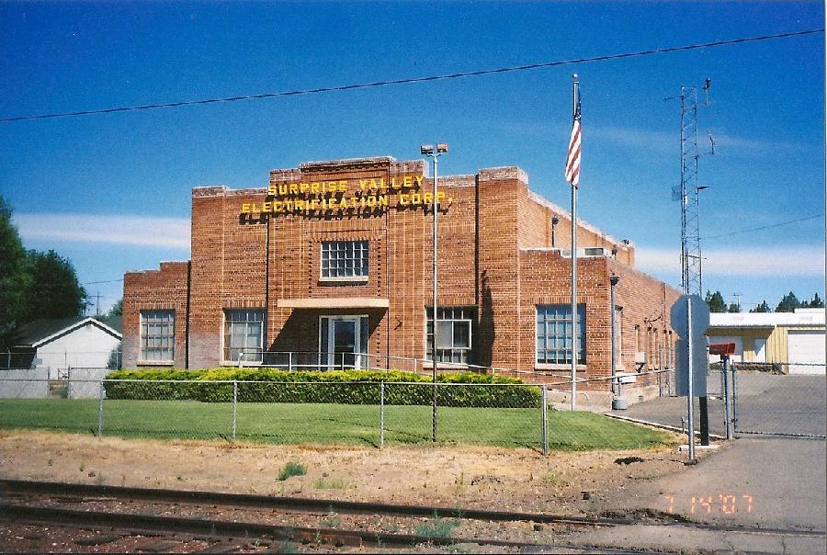

Introduction
The state of California has experienced some of the most devastating and catastrophic wildfires in the nation’s history. Due to the fatalities and damage resulting from the catastrophic wildfires, the state of California signed Senate Bill (SB) No. 901 into law on September 21, 2018. This bill amended Public Utilities Code (PUC) section 8387, requiring every local publicly owned electricity utility to prepare a Wildfire Mitigation Plan (WMP). To safeguard their electrical systems and communities, utilities are now required to implement a WMP to comply with the state’s Public Utility Code Division 4.1, Chapter 6, Section 8387 by January 1, 2019. Section 8387 requires every publicly-owned electrical utility (POU) or electrical cooperative to construct, maintain and operate its electrical facilities and equipment in ways that minimize the risk of wildfire posed by those facilities and equipment to be adopted by January 1, 2020 and annually thereafter.

Fire mitigation has been an integral part of Surprise Valley Electrification Corporation’s (SVEC’s) operational practices for years and SVEC has several existing policies, programs and procedures in place that directly or indirectly manage or reduce this risk. Over time, SVEC has adopted additional fire mitigation programs to adjust to changes in fire-related conditions as well as technological advances and improved operational practices. SVEC continues to evaluate and implement new technologies and operating practices to further mitigate the potential for ignitions and to better respond to high wildfire risk conditions.
The strategies, programs and activities included in this WMP, with associated goals and metrics are an effective approach to reduce fire-related risk for SVEC’s customers in the near term and will allow for refinement and improvement over time. As new information is obtained and experience is gained by implementing the mitigation programs in this WMP, SVEC will assess, evaluate and enhance its wildfire risk mitigation strategies. This plan will also describe vegetation management, asset inspection and maintenance, recloser setting protocols, communication plans as well as the restoration of service process. Plan ownership, performance metrics and deficiency identification are included, as well as the plan audit and approval process.

Mission
SVEC’s Board of Directors has established the following mission and vision statement: “SVEC’s purpose is to exceed our customer expectations in terms of cost, reliability, safety, customer convenience and satisfaction”. To this end, SVEC employs construction, maintenance and operational practices that minimizes any risks of catastrophic wildfire posed by its electrical system.

Purpose of the Plan
This Plan describes SVEC’s strategies and programs to mitigate the threat of electrical equipment ignited wildfires. It addresses the unique features of SVEC’s service area such as topography, weather, infrastructure, grid configuration and potential wildfire risks. This plan is subject to direct supervision by SVEC’s Board of Directors and primary responsibility for its implementation resides with the Member Service Manager. Ultimate accountability for the plan resides with the General Manager. This plan meets or exceeds the requirements of PUC section 8387 for publicly owned electric utilities to prepare a WMP. Table 1 (pages 3 to 5) outlines the WMP’s code compliance with 8387 and the corresponding sections within the plan.
Table 1 Plan Compliance with PUC Division 4.1, Ch. 6 [8387]

PUC  § 8387(b) | DESCRIPTION | PLAN SECTION NUMBER
(2) (A) | An accounting of the responsibilities of persons responsible for executing the plan. | 8.1, 8.1.1
(2) (B) | The objectives of the wildfire mitigation plan. | 1.2, 1.3
(2) (C) | A description of the preventative strategies and programs to be adopted by the local publicly owned electric utility or electrical cooperative to minimize the risk of its electrical lines and equipment causing catastrophic wildfires, including consideration of dynamic climate change risks. | 3, 3.1
(2) (D) | A description of the metrics the local publicly owned electric utility or electrical cooperative plans to use to evaluate the wildfire mitigation plan’s performance and the assumptions that underlie the use of those metrics. | 8.2.1
(2) (E) | A discussion of how the application of previously identified metrics to previous wildfire mitigation plan performances has informed the wildfire mitigation plan. | 8.2.1
(2) (F) | Protocols for disabling reclosers and deenergizing portions of the electrical distribution system that consider the associated impacts on public safety, as well as protocols related to mitigating the public safety impacts of those protocols, including impacts on critical first responders and on health and communication infrastructure. | 6.1.1, 6.1.3
(2) (G) | Appropriate and feasible procedures for notifying a customer who may be impacted by the deenergizing of electrical lines. The procedures shall consider the need to notify, as a priority, critical first responders, health care facilities and operators of telecommunications infrastructure. | 7.2.5
(2) (H) | Plans for vegetation management. | 6.3 – 6.3.13
(2) (I) | Plans for inspections of the local publicly owned electric utility’s or electrical cooperative’s electrical infrastructure. | 6.2 - 6.2.4.2
PUC  § 8387(b) | DESCRIPTION | PLAN SECTION NUMBER
(2) (J) | List that identifies, describes and prioritizes all wildfire risks and drivers for those risks, throughout the local publicly owned electric utility’s or electrical cooperative’s service territory. The list shall include, but not be limited to both of the following: | 4
(2) (J) (i) | Risks and risk drivers associated with design, construction, operation and maintenance of the local publicly owned electric utility’s or electrical cooperative’s equipment and facilities. | 4.5.1
(2) (J) (ii) | Risks and risk drivers associated with topographic and climatological risk factors throughout the different parts of the local publicly owned electric utility’s or electrical cooperative’s service territory. | 4.5.2,4.5.3
(2) (K) | Identification of any geographic area in the local publicly owned electric utility’s or electrical cooperative’s service territory that is a higher wildfire threat than is identified in a commission fire threat map, and identification of where the commission should expand a high fire threat SVEC based on new information or changes to the environment. | 5.1
(2) (L) | A methodology for identifying and presenting enterprise-wide safety risk and wildfire-related risk. | 4.1
(2) (M) | A statement of how the local publicly owned electric utility or electrical cooperative will restore service after a wildfire. | 7.4,7.4.1
(2) (N) | A description of the processes and procedures the local publicly owned electric utility or electric cooperative shall use to do all of the following. | 8.3
(2) (N) (i) | Monitor and audit the implementation of the wildfire mitigation plan. | 8.3.1
(2) (N) (ii) | Identify any deficiencies in the wildfire mitigation plan or its implementation and correct those deficiencies. | 8.3.2

PUC  § 8387(b) | DESCRIPTION | PLAN SECTION NUMBER
(2) (N) (iii) | Monitor and audit the effectiveness of electrical line and equipment inspections, including inspections performed by contractors that are carried out under the plan, other applicable statutes or commission rules. | 8.3.3
(3) | The local or publicly owned electric utility or electrical cooperative shall present each wildfire mitigation plan in an appropriately noticed public meeting. The local or publicly owned electric utility or electrical cooperative shall accept comments on its wildfire mitigation plan from the public, other local and state agencies and interested parties, and shall verify that the WMP complies with all applicable rules, regulations, and standards as appropriate. | 9.1.2
(3) (C) | The local publicly owned electric utility or electrical cooperative shall contract with a qualified independent evaluator with experience in assessing the safe operation of electrical infrastructure to review and assess the comprehensiveness of its wildfire mitigation plan. The independent evaluator shall issue a report that shall be made available on the internet web site of the local publicly owned electric utility or electrical cooperative and shall present the report at a public meeting of the local publicly owned electric utility’s or electrical cooperative’s governing board. | 9.1.1

Objectives of the WMP
The main objective of the WMP is to implement an actionable plan that will create increased reliability and safety while minimizing the probability that SVEC assets may be the origin or contributing factor in the ignition of a wildfire. The plan embraces safety, prevention, mitigation and recovery programs that are consistent with State of California Law. As part of the development of the Plan, SVEC assessed new industry practices and technologies that will reduce the likelihood of an interruption in service and reduce the duration of an outage.
The plan also addresses policies related to customer outreach and assistance programs, communications with local agencies and service restoration after a disaster event.
The secondary objective is to measure, through the annual evaluation of the matrix, the effectiveness of the specific wildfire mitigation strategies as they apply to SVEC. Where a particular action, program component, or protocol is determined to be unnecessary or ineffective, SVEC will assess whether modification or replacement is suitable.
Included within this Plan are the various programs, practices and procedures that SVEC utilizes to comply with PUC section 8387, which requires publicly owned electric utilities to prepare a Wildfire Mitigation Plan by January 1, 2020. After January 1, 2020, a local publicly owned utility or electrical cooperative shall submit the plan to the California Wildfire Safety Advisory Board on or before July 1, 2020 of each year. Each local publicly owned electric utility and electrical cooperative shall update its plan annually and submit the update to the California Wildfire Safety Advisory Board by July 1st of each year. At least once every three years, the submission shall be a comprehensive revision of the plan.
PUC section 8387(c) requires SVEC to contract with a qualified independent evaluator with experience in assessing the safe operation of electrical infrastructure to review and assess the comprehensiveness of this WMP.
SVEC shall accept comments on its WMP and the third-party assessment from the public, other local and state agencies and interested parties, in an appropriately noticed public meeting and shall verify that the WMP complies with all applicable rules, regulations and standards as appropriate.

SVEC Background and Mission Statement

SVEC Profile and History
The Surprise Valley Electrification Corporation (SVEC) is a private, non-profit electric cooperative founded in 1937 and energized in 1938 to provide reliable electric service to the member-owners at the lowest rates possible. Originally the service area included the rural areas of Modoc and Lassen County, California. The newly energized lines brought electricity to 809 customers in Surprise Valley, Canby, Adin, Lookout and the area known as Westside near Lakeview, Oregon.
The original 1938 system was energized with power generated from three diesel generators located in the building that is now the SVEC business office. Since that time the utility’s service area has grown to include service to members in Oregon and the northwest corner on Nevada in Washoe County. Because SVEC’s service area now extends into Lake County, Oregon, which is within the service boundary of the Bonneville Power Administration (BPA), Surprise Valley is the only California co-op that can purchase wholesale electricity from that federal power agency.
Power for the co-op members is derived from hydroelectric, nuclear, and has now advanced to developing energy from the its own geothermal power plant in Paisley, Oregon.
As a utility cooperative, SVEC is governed by a seven-member popularly elected Board of Directors that determines policy and appoints the General Manager who is responsible for SVEC’s overall management and operations. SVEC owns, operates and has ownership interests that are critical to maintaining the flow of power from generating facilities through the transmission lines to SVEC’s service area.

The Service Area
SVEC operates out of offices located in Alturas California, the seat of Modoc County. SVEC transmits and distributes electricity within a 7,650 square-mile territory that includes Summer Lake Oregon, south to Ravendale, CA, west to Day, CA and east to Vya, NV. The utility does not serve the down-town areas of Alturas, Lakeview, Cedarville and New Pine Creek, as these are covered by Pacific Power. SVEC’s electric system supplies power to 6,572 meters with a total annual retail load of approximately 125 million kilowatt hours (kWh) for the year ending December 31, 2019. SVEC’s annual peak load has averaged 34 Megawatts (MW) over the last three years. Approximately one-third of the California service area is shared with Pacific Power.
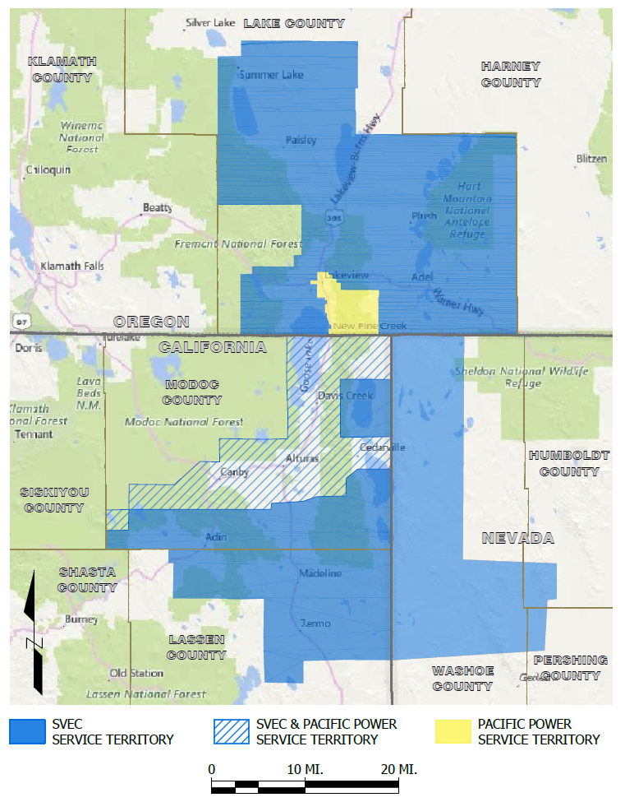
Figure 1. SVEC California, Oregon and Nevada Service Area

The Electric System
SVEC owns and operates an electric system that includes transmission and distribution facilities. SVEC provides approximately 85% clean hydroelectric power to its customers purchased from BPA. Other sources include nuclear and geothermal.
SVEC has 227 miles of transmission line, 1,759 miles of distribution line and 172 miles of underground line. Power is purchased from BPA and supplied to 20 SVEC bulk power substations through a 69 kilovolt (kV) transmission system and is distributed throughout parts of Modoc and Lassen Counties in California, Lake County in Oregon and Washoe County in Nevada via a 24.9/14.47 kV and 12.47/7.2 kV distribution system. Although the Nevada portion of the service area extends into Humboldt and Pershing Counties, SVEC does not have any assets in these areas. Power is supplied via two separate supply transmission lines. The distribution system is comprised of 69 kV substations with overhead and underground distribution circuits. SVEC owns and operates one geothermal plant located in Paisley, OR.

Goals and Objectives
For more than eighty years, SVEC has provided safe, reliable and affordable electricity, excellent customer service, community value, innovation and environmental leadership to its customers.
The Board has adopted a set of Strategic Directions (SDs) with related metrics, which it considers essential in the continued success of the organization and its service to its customers. These include safety, reliability, competitive rates, enterprise risk management (ERM), customer relations, environmental leadership and resource planning. The Strategic Directions are used as a guide in the decisions made about SVEC’s policies and operations. The Board continually reviews and refines these guidelines to make sure it meets its customer’s energy needs both now and in the future.
Some of the general elements in SVEC’s business strategy are:
- Voluntary and Open Membership: Cooperatives are voluntary organizations, open to all persons able to use their services and willing to accept the responsibilities of membership, without gender, social, racial, political or religious discrimination.
- Democratic Member Control: Cooperatives are democratic organizations controlled by their members, who actively participate in setting policies and making decisions. The elected representatives are accountable to the membership. In primary cooperatives, members have equal voting rights (one member, one vote) and cooperatives at other levels are organized in a democratic manner.
- Members’ Economic Participation: Members contribute equitably to, and democratically control, the capital of their cooperative. At least part of that capital is usually the common property of the cooperative. Members usually receive limited compensation, if any, on capital subscribed as a condition of membership. Members allocate surpluses for any or all the following purposes: developing the cooperative, possibly by setting up reserves, part of which at least would be indivisible; benefiting members in proportion to their transactions with the cooperative; and supporting other activities approved by the membership.
- Autonomy and Independence: Cooperatives are autonomous, self-help organizations controlled by their members. If they enter into agreements with other organizations, including governments, or raise capital from external sources, they do so on terms that ensure democratic control by their members and maintain their cooperative autonomy.
- Education, Training and Information: Cooperatives provide education and training for their members, elected representatives, managers and employees so they can contribute effectively to the development of their cooperatives. They inform the general public, particularly young people and opinion leaders, about the nature and benefits of cooperation.
- Cooperation Among Cooperatives: Cooperatives serve their members most effectively and strengthen the cooperative movement by working together through local, national, regional and international structures.
- Concern for Community: While focusing on member needs, cooperatives work for the sustainable development of their communities through policies accepted by their members.
- Risk management: Maintain an Enterprise Risk Management (ERM) program designed to act as an early warning system to monitor changes in, and the emergence of, risks that could impact SVEC’s business objectives.

Overview of SVEC’s Fire Prevention Strategies
The proposed wildfire preventative strategies can be categorized into five main mechanisms that
align with SVEC’s best practices. Together, the five components create a comprehensive wildfire preparedness and response plan with a principal focus on stringent construction standards, fire prevention through system design, proactive operations and maintenance programs, and specialized operating procedures and staff training.
- Design & Construction: SVEC’s design and construction consist of system, equipment, infrastructure design and technical upgrades. These practices aim to improve system hardening to prevent contact between infrastructure and fuel sources to minimize the risk of SVEC’s systems become a source of ignition.
- Inspection & Maintenance: SVEC’s inspection and maintenance strategies consist of diagnostic activities as well as various methods of maintaining and ensuring all equipment and infrastructure is in excellent working condition. This includes adopting section PRC 4292: 1254 Minimum Clearance Provisions (Appendix D).
- Operational Practices: This includes day-to-day actions taken to mitigate wildfire risks and to ensure preparedness in high-risk situations, such as dry and windy climatological conditions and Red Flag Warning days.
- Situational & Conditional Awareness: This component consists of methods to improve system visualization and awareness of environmental conditions. The practices in this category aim to provide tools to improve the other components of the plan. For example, SVEC monitors local weather stations and Cal-Fire websites to enhance situational awareness.
- Response & Recovery: This strategy consists of SVEC’s procedures in response to wildfire, de-energization and other emergency events. This component aims to formalize protocols for these situations for thorough and efficient communications, emergency response and recovery.
Table 2 on pages 14 to 15 provides a summary of SVEC’s programs and activities that support wildfire prevention and mitigation, along with a timeframe for implementation.

Timeframes of Preventative Strategies and Programs
The components described above have several strategies and programs, most of which have already been implemented. Some are situational and are not limited to any timeframe. Some programs are scheduled to be completed over several years, while others are in the evaluation or proposal stages. Targets, scheduled timeframes and programmatic metrics can be found in Chapter 8. The strategies and programs below fall into one or more of the five implementation timeframes:
- A: Currently implemented
- B: Implemented before the upcoming fire season
- C: Completed annually or on schedule per relevant code
- D: In evaluation stage
- E: Implemented on as-needed basis/protocols in place
- * Ongoing program with no defined completion date

Table 2 Mitigation Programs/Activities
DESIGN AND CONSTRUCTION | TIMEFRAME
Underground distribution lines | A*
Non-expulsion equipment on circuits on high fire threat areas | A*
Install overhead wire inter-phase spacers to reduce wire to wire contact | A
INSPECTION AND MAINTENANCE
T&D line patrols inspections | C
Transmission line ground patrols | C
T&D wood pole intrusive inspections | C
T&D vegetation right-of-way maintenance | C
T&D pole clearing program | C
Distribution system line patrols and detailed inspections | C
OPERATIONAL PRACTICES
Coordination with Cal-Fire in tree clearing operations | A
T&D system vegetation management program | C
OPERATIONAL PRACTICES (continued)
Work procedures and training for persons working in locations with elevated fire risk conditions | A
Safety and physical security protection teams | A
Increased staff for line and vegetation management crews in preparation of wildfire | B
Existing relationship with local government and fire safety councils | A
Increased community outreach/wildfire safety awareness | B
SITUATIONAL/CONDTIONAL AWARENESS
Coordinate and collaborate with Fire Safe Councils and County Office of Emergency Services to prepare for Red Flag Warnings (RFW) and high fire risk events | B
Contractor/staff safety training and orientation for T&D vegetation management work | A
Weather monitoring | E
RESPONSE AND RECOVERY
Public safety Power protocols | E
Critical event communications process and procedures | A
Line patrols prior to re-energization | A
Customer assistance programs for post disaster recovery | E

THIS PAGE INTENTIONALLY LEFT BLANK

Risk Analysis and Risk Drivers
In order to establish a baseline understanding of the risks and risk drivers involved, SVEC looked at all aspects of SVEC’s exposure to fire related hazards. Although there are inherent risks in the operation of an electric utility, it is possible to put in place strategies and processes to better plan and manage them. Enterprise Risk Management is one tool to assist in anticipating and managing risks, as well as considering how multiple risks can present even greater challenges. The overall goal is to determine the residual risk level after all mitigation factors have been applied to the initial inherent risk.

Enterprise Risk Assessment (ERM)
The ERM is not a periodic “Risk Assessment” but an ongoing and forward-looking management discipline that allows SVEC to analyze risks on a continual basis and adapt to changing conditions. The key or critical risks affect the entire community and are interrelated, and thus, are managed holistically and with a structured approach. Figure 3, on the following describes the objective of each of each step.
Figure 2. SVEC Enterprise Risk Management Process

Figure 3. 5-Step Risk Assessment Process

The Risk Assessment process begins with the General Manager (GM), Line Superintendent (LS), key staff and stakeholders working together to collect information on all potential and perceived risks. Relevant local plans, such as the Lassen and Modoc County Community Wildfire Protection Plans and the Modoc County Hazard Mitigation Plan were reviewed for additional data. A Vulnerability and Risk Assessment study was completed by SVEC as a separate document, and is provided in Appendix C. The risks, risk drivers, key risk impacts, mitigations, SVEC policies, controls and procedures were analyzed and potential outcomes identified. A root cause analysis was conducted using a commonly used risk assessment tool known as the bow-tie method framework. This method provides a visual representation of the causal relationships between the key risk drivers, trigger event, outcomes and impacts to SVEC and the community at large. The bow-tie framework takes into consideration the key impacts to SVEC’s reputation, public and employee safety, financial liability, operations, reputation and property damage.

Enterprise Safety and Wildfire Risk
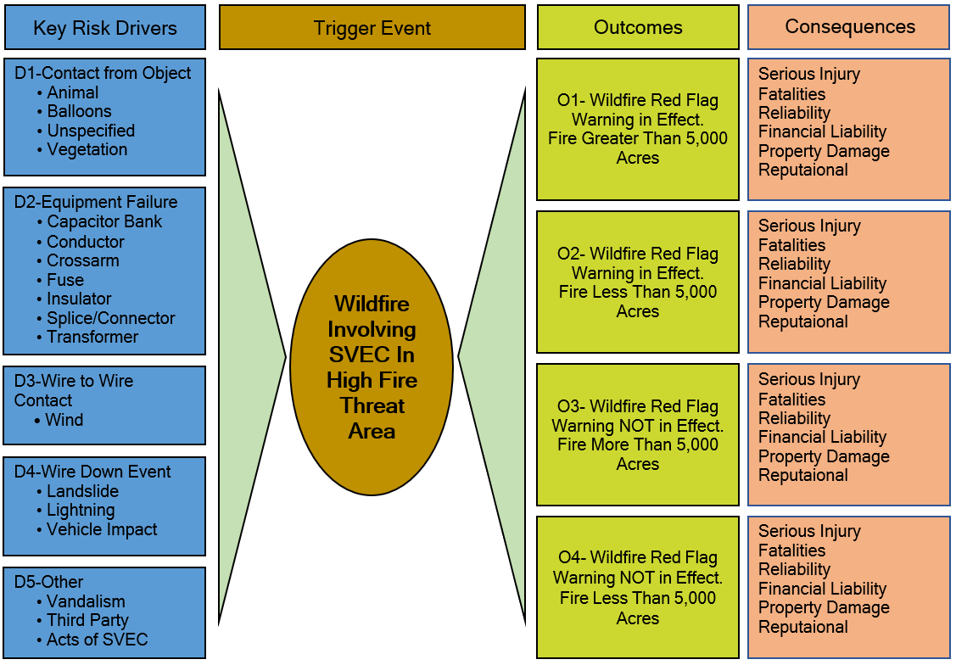
SVEC does not have a history of starting wildfires where SVEC owned equipment was involved. The following list included in the bowtie diagram below focuses on hypothetical causes of powerline sparks that could potentially start a fire. The bowtie analysis below aims to identify the key root cause/risk drivers and exposure to impacts from a wildfire and identify the possible consequences. Figure 4 displays the risk bowtie, which summarizes the assessment process.
Figure 4. Wildfire Risk Bow Tie Analysis

Climate Change
The fourth California Climate Change Assessment has concluded that climate change will make forests more susceptible to extreme wildfires. One study has found that the frequency of fires over 25,000 acres would increase by nearly 50% and that the average area burned would increase by 77% by the end of the century if greenhouse gas levels continue to rise. Increasing temperatures and rising sea-levels will have direct impacts on public health and infrastructure. Drought, coastal and inland flooding and wildfire will continue to affect people’s livelihoods and local economies.
In SVEC’s service territory climate cycles range from abnormally dry years to moderate drought, these droughts can last for several years in a row. The most recent California drought lasting from December of 2011 to March of 2019. Although the dry spell ended in 2019, after many consecutive dry years several species of trees seem to now have root fungus, adding to the overall tree mortality rate. Additionally, these droughts stressed trees are more susceptible to bark beetle infestations.
For decades, SVEC has designed its electrical system with the primary goal of providing safe, reliable and affordable power. These designs stem from many decades of engineering experience and the adoption of emerging technologies. SVEC’s design practices continue to advance with the addition of newer safety and reliability-related technologies. As part of this advancement, it is important to understand and adapt to the new normal and the challenges climate change brings. The greater intensity and year-round frequency of fire danger is driving the need for further evolution, hardening and strengthening of the grid-particularly as portrayed in the High Fire-Threat District (HFTD) Map of SVEC’s service territory.
The State of California Public Utilities Commission (CPUC) has designated approximately one half of SVEC’s California service territory as Tier 2, with no areas designated Tier 3.
According to the Modoc County Fire Safe council, the climate in Modoc County is typical of Great Basin high desert with warm dry summers and cold dry winters. Due to Modoc county’s broad and open plateau at an elevation of 4,000 feet, summer winds can become strong and the humidity can drop well below 10% from 30%-40%, creating a serious fire hazard for the county and surrounding neighboring counties. The normal fire season extends from June through mid-October, with July, August, and September being the peak fire season period. Many fires in this area are started by equipment or lightning. Much of the vegetation in and around the county is irrigated in the summer which provides a measure of protection for nearby communities. Due to the presence of flammable grass, sagebrush and trees, wind-driven wildfires can threaten ranch buildings and outlying homes. The forested areas north of Lookout, north and east of Davis Creek, south and east of Likely and many other areas scattered through the county have had a history of large fires.

Fire Risk Drivers
SVEC staff evaluated other utilities’ fire causes and applied its own field experience to determine the key potential risk drivers. Seven categories were identified as potential for causing powerline sparks and ignitions:
- Foreign Contact
- Equipment/Facility Failure
- Wire to Wire Contact/Contamination
- Phase Spacing
- Vehicle Impact
- Other
SVEC staff identified the following drivers associated with each category. These are discussed below but may not be limited to the following:

Foreign Contact
As is the case for most electrical utilities, most overhead powerlines are installed with bare wire conductor on insulated structures. The benefits of this type of conductor is that it is much lighter and easier to work with, as well as a much more cost-effective method of delivering energy compared to insulated/covered wire. The downside to bare wire is its susceptibility to contact from foreign objects such as wildlife, vegetation and third-party equipment. Protection equipment is utilized to isolate faults, but there are time delays associated with circuit breakers, reclosers and fuses. These time delays are not fast enough, in many cases, to prevent all sparks prior to tripping. Ejected molten metal, sparks or burnt foreign objects can potentially ignite any fuels in the vicinity of the fault. Vehicles leaving the roadway and contacting a pole is a common source of faults. Such an impact with poles or guy wires can break poles and/or crossarms, creating enough stress on the conductors to break them. The results can be ground contact, potentially emitting sparks.

Equipment Failure
There are a many reasons equipment failure can occur during its service life. Most equipment requires regular maintenance for optimal performance. Even though SVEC’s qualified personnel perform regularly scheduled inspection and maintenance on all system equipment, internal defects that are not visible or predictable can be the cause of destructive equipment failure resulting in ejection of sparks and/or molten metal. The failure of components such as hot line clamps, connectors and insulators can result in wire failure and wire to ground contact. Transformers and capacitor banks can have internal shorts potentially resulting in the ejection materials which could be a fire source.

Wire to Wire Contact/Contamination
High wind events and storms are potential causes of wire-to-wire contact referred to as contamination. Conductors can sway under these conditions, and if extreme, wire-to-wire contact can occur. When two or more energized conductors encounter each other, they will generally emit sparks or cause breakers to trip, emitting sparks and ejecting material. A vehicle impacting a pole, livestock rubbing on guy wires are also potential causes for contamination. Certain processes of re-energization of conductors can cause a “galloping” condition which may result in contamination.

Risk Factors Associated with Topography and Climate
Within SVEC’s service territory and the surrounding areas, the following are additional risk drivers for wildfire:
- Severe Drought
- Vegetation Type
- High Winds
- Tree Mortality
- Lightning
- Red Flag Warning Conditions
Portions of the service area have steep and rugged terrain with thick vegetation and a high tree mortality rate. These factors, along with ongoing drought conditions, makes it more vulnerable to wildfire than areas with less extreme topography. This can make access to remote sections of some distribution lines very difficult and time consuming. Fire-fighting activities in this type of terrain are also much more challenging.

Geographical Risk Factors
The lack of reliable cell phone coverage in the service area could contribute to a delay in reporting wildfires or other immediate hazards by the general public.

Lightning
Twenty million lightning strikes hit the ground in the U.S. every year. When lightning hits a power line, the surge of electricity can cause a flashover and the appropriate corrective action depends on how flashover occurred.
A back flashover occurs when a lightning strike hits a shield wire or a tower structure. When this happens, current flows in both directions and down the tower into the ground, developing a voltage on the crossarm is enough to flash over the insulator string. A backflash is typically caused by large strike currents, high tower surge impedances (tall towers) and/or high footing resistance. One of the most common causes of a transformer explosion is a lightning strike forcing an overload. Damage to wires or equipment elsewhere in the electrical grid can also cause too much electricity to flow into the transformer, causing it to explode.

Red Flag Warning Conditions
The National Weather Service issues Red Flag Warnings (RFW) & Fire Weather Watches to alert fire departments of the onset, or possible onset of critical weather and dry conditions that could lead to rapid or dramatic increases in wildfire activity. An RFW is issued for weather events which may result in extreme fire behavior that will occur within 24 hours. A Fire Weather Watch is issued when weather conditions could exist in the next 12-72 hours. An RFW is the highest alert. While an RFW is in effect, SVEC crews working in remote sites limit hot work such as welding, grinding and cutting. Vegetation Management (VM) and line crews have fire suppression equipment on-site, including water backpacks, shovels and fire rakes. Work crews conduct tail-gate meetings to confirm the location and readiness of the fire suppression equipment. Designated staff assigned as a fire-watch remain on site for up to three hours to ensure a fire doesn’t start after work crews leave a remote or high-risk area. The LS in in charge of tracking weather conditions and monitoring RFW alerts.

Other Potential Risk Factors
Construction projects by non-SVEC crews are another possible cause of ignition. Boom trucks working near power lines can contact conductors causing a fault. Digging without first locating power lines is another hazard, as SVEC has approximately 172 miles of underground distribution lines in its service area. These situations would most likely not be the source of an uncontrolled wildfire, as this type of event would be observed and responsive actions immediately taken.
SVEC employs a properly trained and well-informed workforce. Switching, construction and maintenance activities are performed daily. The tools and vehicles can be sources of sparks or ignition as well. For example, driving a vehicle over dry grass/brush can cause the dry grass/brush to ignite when contacting hot surfaces. For these reasons, SVEC vehicles are equipped with fire suppression equipment and SVEC staff are trained to respond to fires and in the proper use of fire suppression equipment. Tailgate meetings are held before work to discuss the potential for fire and to confirm the location and condition of on-board fire suppression equipment.

Key Risk Impacts
Aforementioned risks, have many possible outcomes. The list below outlines some of the worst-case scenarios and consequences:
- Personal injuries or fatalities to the public, employees and contractors
- Damage to public and/or private property
- Damage and loss of SVEC owned infrastructures and assets
- Impacts to reliability and operations
- Damage claims and litigation costs, as well as fines from governing bodies
- Damage to SVEC’s reputation and loss of public confidence

Design, Construction, Operation and Maintenance
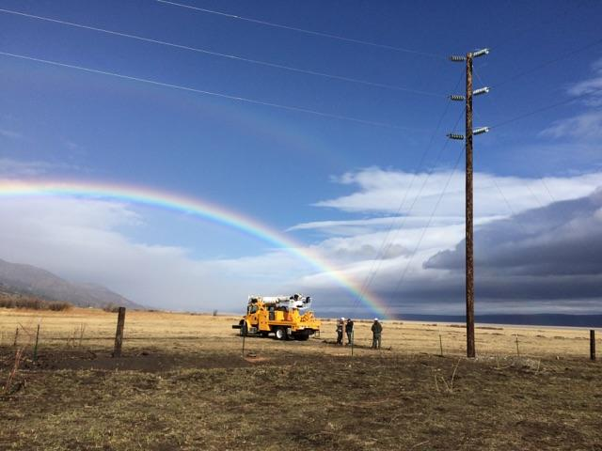
Some of the risks and risk drivers associated with design, construction, operation and maintenance of SVEC’s equipment and facilities is the age of infrastructure and location of assets in fire risk areas. The use of expulsion type fuses as well as mineral oil used in transformers are other examples. SVEC is in the on-going process of replacing expulsion type fuses with non-expulsion fuses in high fire threat areas. The demand for this equipment is very high, due the widespread use in many electric utilities with operations in high fire threat areas. SVEC has replaced approximately 5-10% of their fuses with the CAL-Fire exempt fuses and will continue the replacement program moving forward.

THIS PAGE INTENTIONALLY LEFT BLANK

SVEC’s Asset Overview
Power is provided to SVEC customers by way of bulk substations, overhead transmission line, overhead and underground distribution line assets. The utility has its headquarters office and an equipment storage facility located in Alturas, CA. Table 3 depicts a high-level description of SVEC’s T&D assets.
ASSET CLASSIFICATION | ASSET DESCRIPTION
Transmission Line Assets | Approximately 227 miles of conductor, transmission structures and switches at 69 kilovolt (kV).
Distribution Line Assets | Approximately 1,931 miles of overhead (OH) and underground (UG) conductor, underground cabling, transformers, voltage regulators, capacitors, switches, lined protective devices operating at or below 24.9 kV.
Substation Assets | Major equipment such as power transformers, voltage regulators, capacitors, reactors, protective devices, relays, open-air structures, switchgear and control houses in twenty substation facilities.
Table 3 Asset Description

Fire Threat Assessment in SVEC Service territory
SVEC provided input in the development of the CPUC’s Fire-Threat Map, which the Commission adopted on January 19, 2019. This map identifies Statewide High Fire Threat Districts (HFTD). The HFTD map has been incorporated into the construction inspection, maintenance, repair and clearance practices, where applicable.
Based on SVEC’s knowledge of historic wildfire events, the existing environment and current information, SVEC believes that the HFTD map appropriately identifies the level of wildfire risks within SVEC’s service territory. SVEC will continue to evaluate factors that may indicate the CPUC should modify the HFTDs. The CPUC Fire-Threat map identifies Tier 3 (extreme fire risk), Tier 2 (elevated fire risk) and areas outside of the HFTD. SVEC has no assets located within Tier 3 of the HFTDs.
Oregon and Nevada Public Utility Commissions have not yet produced HFTD maps such as the one created by California Public Utilities Commission (CPUC).The majority of SVEC’s service area is very rural and sparsely populated, serving farming operations in Modoc and Lassen County. The in-town areas of Alturas are served by Pacific Power and fall under the jurisdiction of the Pacific Corps WMP.
Table 4 provides a high-level breakdown of the various T&D assets within SVEC’s service area in relation to the CPUC threat level tiers.
Figure 5 depicts SVEC’s service territory area in California, Oregon and Nevada.
Figure 6 depicts a high level map of SVEC assets in HFTDs per the CPUC Fire-Threat Map.
Figure 7 depicts Oregon SVEC assets overlaid on the U.S. Forest Service Overall Wildfire Risk Map. Overall Wildfire Risk is the product of the likelihood and consequence of wildfire on all mapped highly valued resources and assets combined. This dataset considers the likelihood of wildfire greater than 250 acres (likelihood of burning), the susceptibility of resources and assets to wildfire of different intensities, and the likelihood of those intensities. The data values reflect a range of impacts from a very high negative value, where wildfire is detrimental to one or more resources or assets (for example, structures, infrastructure, early seral stage and/or sensitive forests), to positive, where wildfire will produce an overall benefit (for example, vegetation condition/forest health, wildlife habitat).
Figure 8 depicts SVEC assets in the Nevada service area with Division of Forestry wildfire risk overlay.
Figures 9 and 10, pages 32 and 33 displays the State Responsibility Areas (SRA) for Modoc and Lassen County. SRAs are recognized by the Board of Forestry and Fire Protection as areas where Cal Fire is the primary emergency response agency responsible for fire suppression and prevention.
Assets |  | Total | Outside HFTD |  |  |  | Tier 2 |  |  | Tier 3
 |  | Line-miles | Line-miles |  | % |  | Line-miles |  | % | Line-miles |  | %
69 kV OH Transmission |  | 227 | 167 |  | 74 |  | 60 |  | 26 | 0 |  | 0
24.9 kV OH  Distribution |  | 218 | 158 |  | 72 |  | 60 |  | 28 | 0 |  | 0
12.47 kV OH  Distribution |  | 1,541 | 1,222 |  | 79 |  | 319 |  | 21 | 0 |  | 0
24.9 kV UG Distribution |  | 6.80 | 6.58 |  | 97 |  | 0.22 |  | 3 | 0 |  | 0
12.47 kV UG Distribution |  | 165 | 140 |  | 85 |  | 25 |  | 15 | 0 |  | 0
Total OH  Transmission |  | 227 | 167 |  | 74 |  | 60 |  | 26 | 0 |  | 0
Total OH  Distribution |  | 1,759 | 1,380 |  | 78 |  | 379 |  | 22 | 0 |  | 0
Total UG Distribution |  | 172 | 147 |  | 85 |  | 25.22 |  | 15 | 0 |  | 0
Total Substations |  | 20 | 18 |  | 90 |  | 2 |  | 10 | 0 |  | 0
Table 4 Overview of SVEC's T&D Assets in CPUC Tiers
As shown in Table 4 above, SVEC’s OH and UG Distribution assets are located primarily outside of the HFTDs. There are a total of 464.22 OH and UG T&D line-miles located within the Tier 2 (Elevated Threat) HFTD, with 1,694 line-miles located outside the HFTDs. There are no SVEC assets located in a Tier 3 HFTD (Extreme Fire Threat).

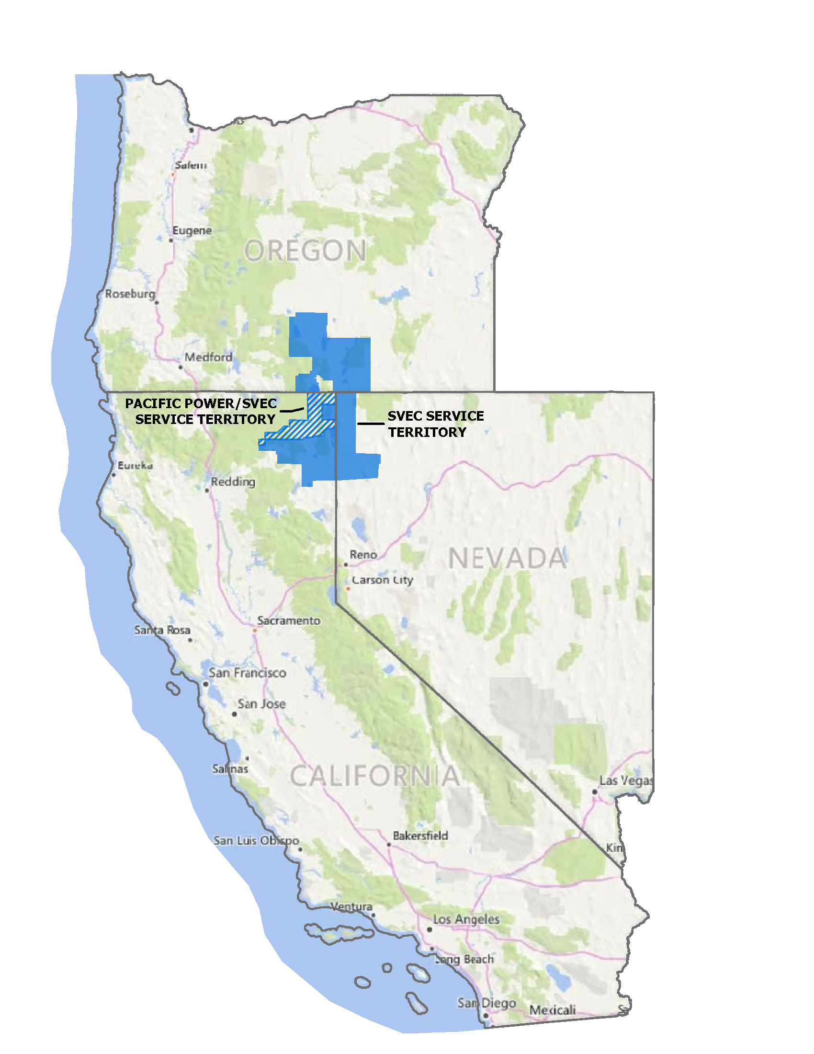
Figure 5. SVEC Service Territory Area Vicinity Map

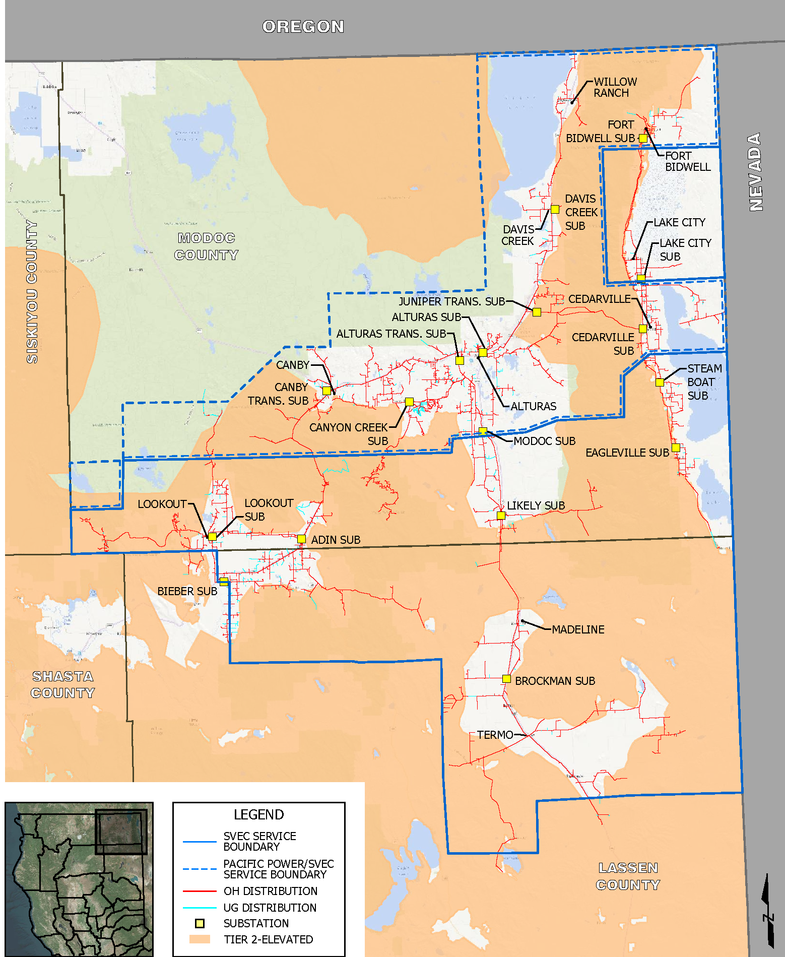
Figure 6. High Level Map of SVEC Assets in California HTFD
Figure 7. SEVC Assets in Oregon within Fire Risk Areas
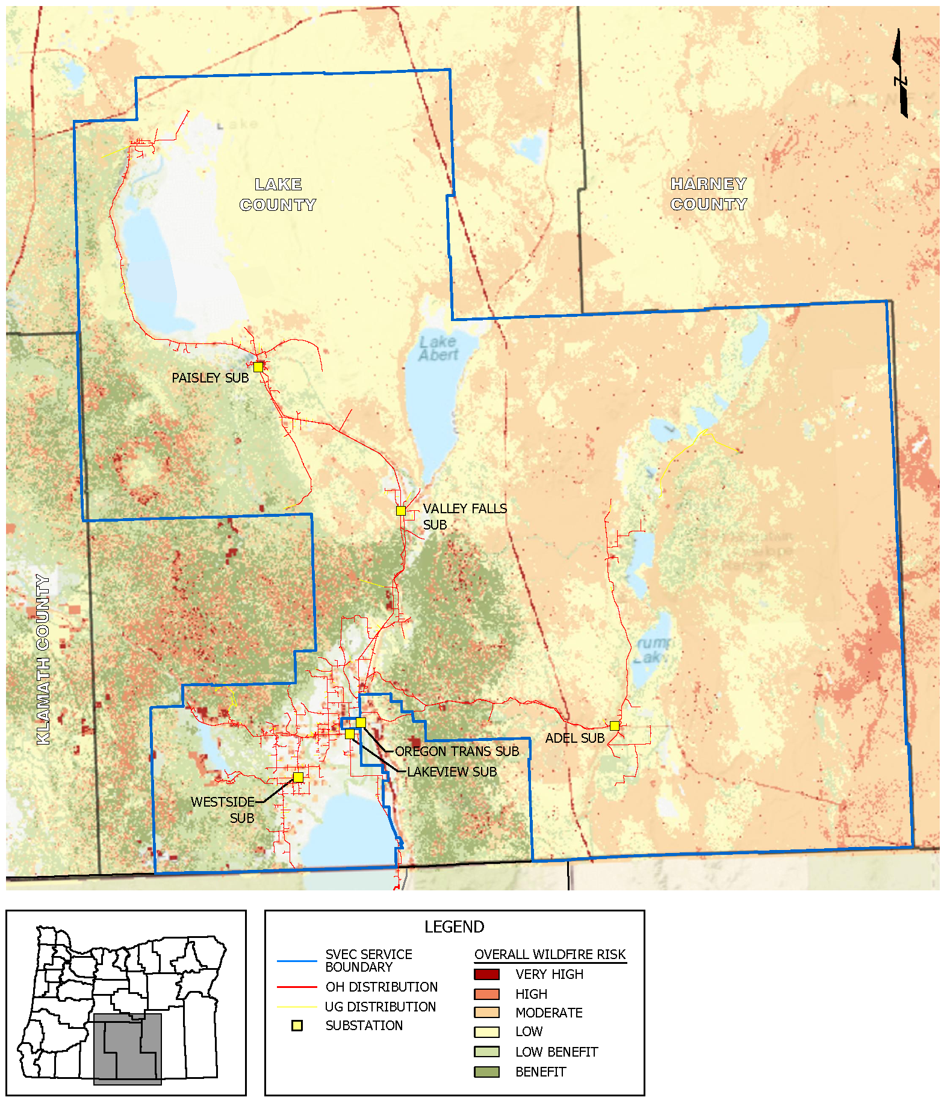

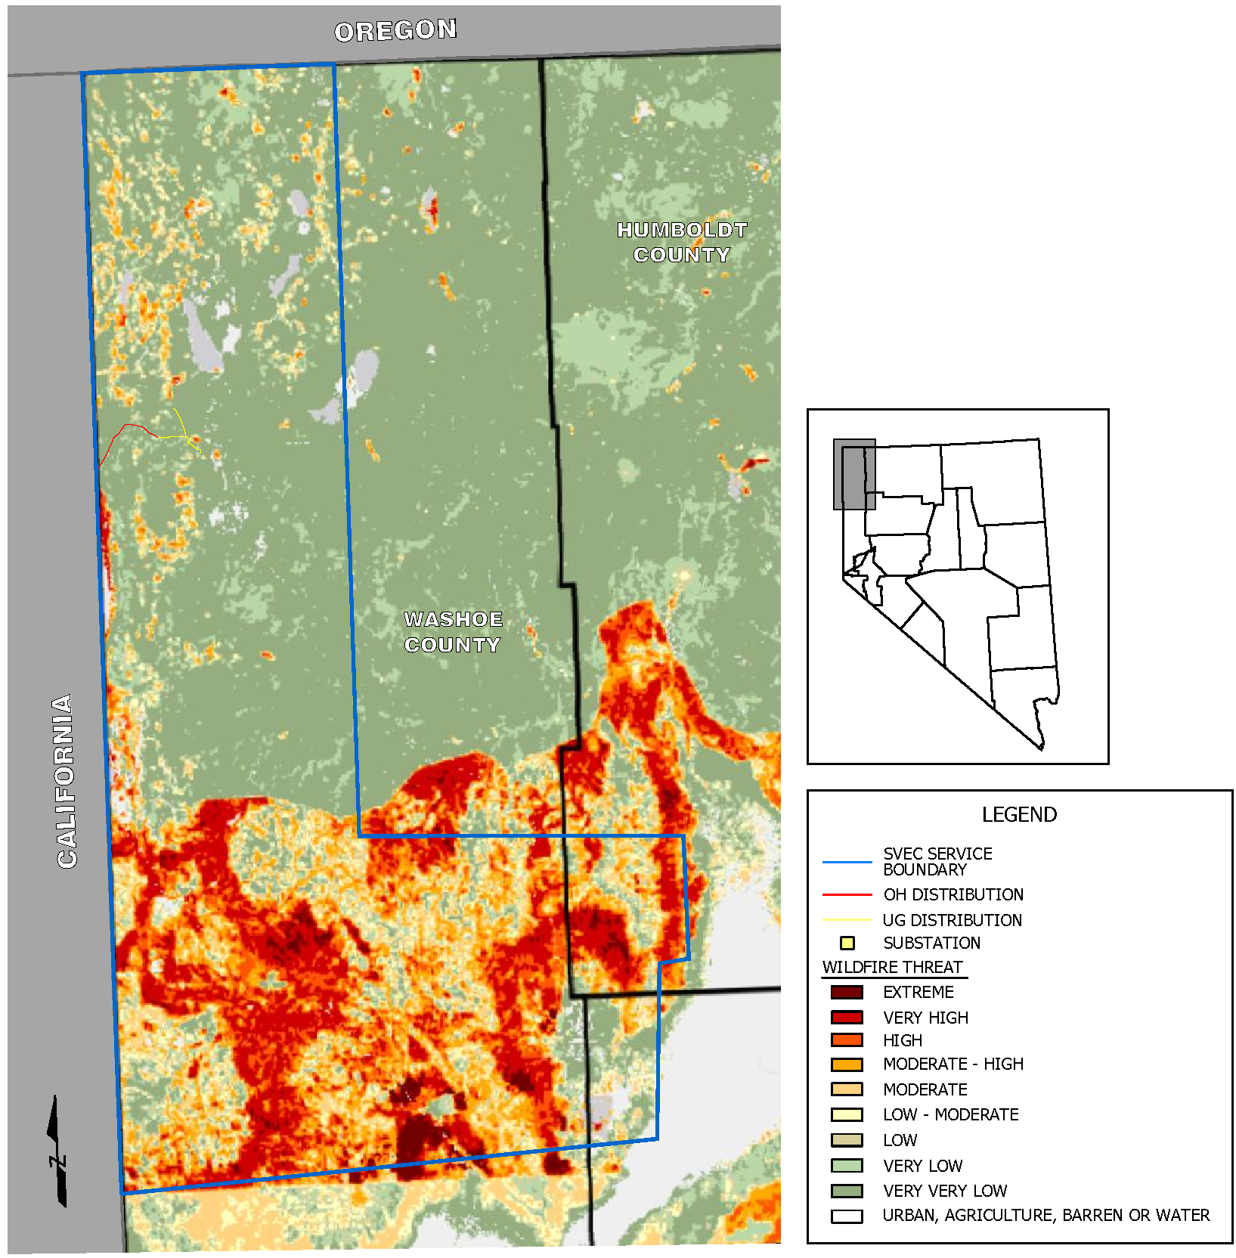
Figure 8. SVEC Assets in Nevada Within Fire Threat Areas

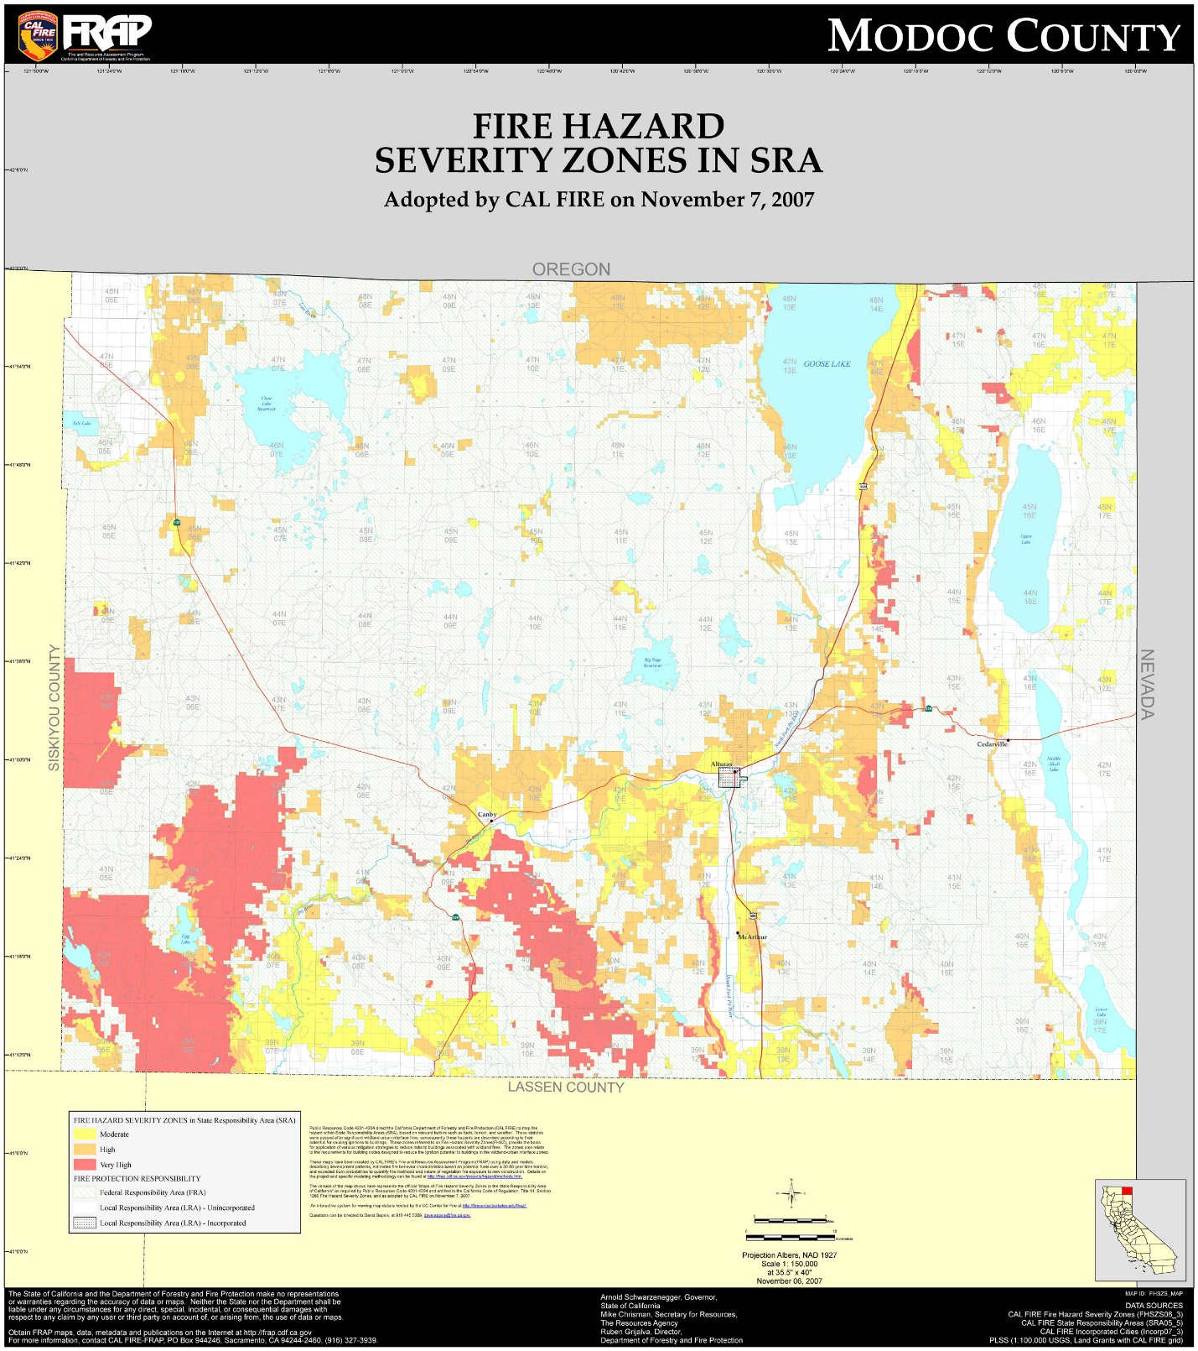
Figure 9. Modoc County Fire Hazard Severity Zones in State Responsibility Areas
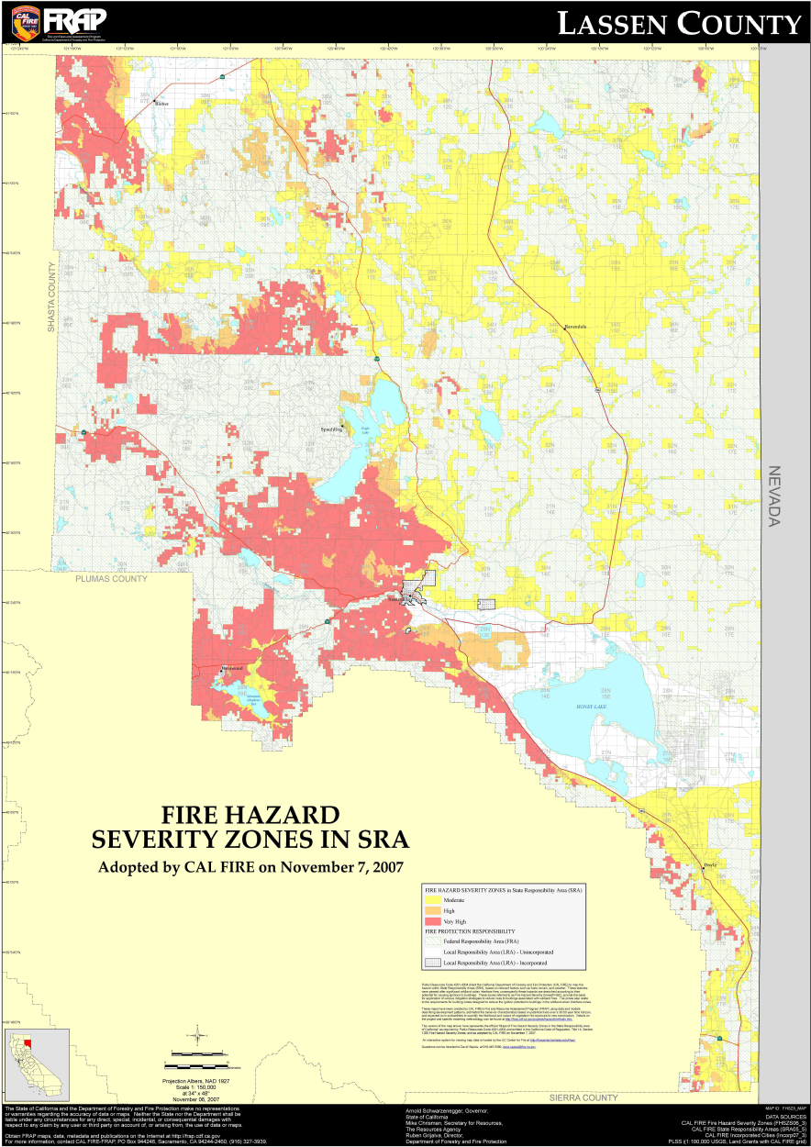
Figure 10. Lassen County Fire Hazard Severity Zones in State Responsibility Area

THIS PAGE INTENTIONALLY LEFT BLANK

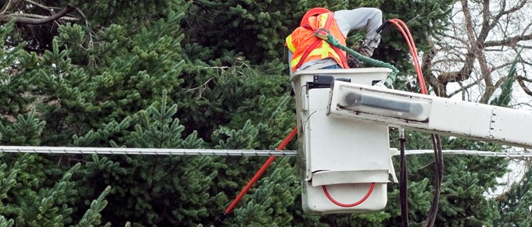

Wildfire Prevention Strategy and Programs
This WMP was built upon a sound foundation, as SVEC has been proactive in implementing measures to address potential wildfire risks for many years. The Plan outlines existing fire mitigation efforts and identifies new processes SVEC will employ moving forward.
In general, this WMP describes certain programs that SVEC will attempt to complete on an accelerated basis in order to mitigate wildfire risks as quickly as possible. However, many of the programs are multi-year and programmatic in nature, i.e., there is a startup period with limited initial implementation followed by full implementation that expands as processes and methods mature.
Regular ground inspections of all facilities, including core testing of the wood poles are another part of the preventive maintenance program. SVEC is currently looking into adopting an aerial patrol program utilizing an SVEC owned drone employing infrared (IR) technology, along with high resolution photography.
There are protocols in place for disabling automatic reclosers and for de-energizing lines to protect public safety. Some of the conditions that factor into these protocols may include: RFWs, forecasted temperatures above 100, winds exceeding design standards and low humidity.
Several of SVEC’s strategies and programs in use now are not limited to any timeframe, and are instead situational, and based on certain real-world events, such as Red Flag Warnings (RFW) and other high fire-risk conditions. These conditions are predominantly weather and vegetative fuel-related and not associated with time periods (e.g., in 2020, or within 5 years). Similarly, SVEC’s emergency preparedness and response plans, post-incident recovery, restoration and remediation activities and programs to support customers impacted by a wildfire are event-driven and are not timeframe-dependent. SVEC’s operational practices are also not time-dependent and certain practices are triggered by RFWs and other high fire risk conditions. Additionally, these practices are updated as SVEC gains new information and adopts improved practices. Furthermore, all administrative-related programs such as risk analyses, performance metrics and monitoring of this WMP will be performed at regular or annual intervals.
Table 5 lists the activities that address key wildfire risk factors.
RISK FACTOR | ACTIVITY
Fuel Source | - Vegetation Management/Pole Clearing  - Fuels Reduction  - Line Inspections  - ROW Maintenance
Wire to Wire Contact | - National Weather Service monitoring  - Inter-phase line spacing
Contact from Objects | - Animal/bird guards  - Raptor nest relocation  - Increased vegetation clearances
Equipment Failure | - Routine maintenance  - Focused design and construction standards to reduce ignition sources  - Transmission and distribution line detailed inspections and annual patrols  - Non-expulsion fuses and arrestors  - Intrusive pole testing  - De-energizing of lines during certain conditions
Other | - SVEC worker/contractor education on fire ignition sources  - Fire watch up to 3 hours after work completion in high risk areas  - Tailgate meetings prior to field work
Table 5 Activities That Address Wildfire Risk Factors

T&D Operational Practices

De-energization
Public Safety Power Shutoffs (PSPS) are a recent development in the strategies used by electric utilities to help keep people and communities safe. However, the risks and potential consequences of initiating a PSPS are significant and extremely complex. SVEC believes that the risks of implementing a PSPS far outweigh the chances that SVEC’s electric overhead distribution system would cause a catastrophic wildfire. Therefore, SVEC does not intend to implement a PSPS on its system. Pacific Power, with whom SVEC share a portion of the service area, have indicated in their plan that any PSPS conducted on their system will not affect SVEC customers.

Fire Precautionary Period
For the purposes of this document, the Fire Precautionary Period shall be April 1st to December 1st of any year.
During this Fire Precautionary Period SVEC and Contractor crews shall:
- Abide by the requirements of this WMP and be responsible for patrolling and preventing fires caused by vegetation management activities.
- Take all steps necessary to prevent their employees, subcontractors and their employees from starting fires not required in completion of their activities and shall be responsible for preventing all fires set directly or indirectly as a result of their operations.
- Permit and assist with periodic testing and inspection of required fire equipment. Operators shall certify compliance with specific fire precautionary measures in this WMP, before beginning operations during the Fire Precautionary Period and shall update such certification when operations change.
- Smoking shall not be permitted during fire season, except in a barren area or in an area cleared to mineral soil at least three feet in diameter. Under no circumstances shall smoking be permitted during the Fire Precautionary Period while employee is operating equipment or walking or working in grass and woodlands.
- Equipment service areas, parking areas and gas and oil storage areas shall be cleared of all flammable material for a radius of at least 10-feet unless otherwise specified.

Recloser Operational Practices
There are 70-80 reclosers on various distribution lines in SVEC’s system. SVEC does not typically disable automatic reclosing functions at SVEC Substations and in the field due to weather related conditions. Prior to line work or clearing operations, the reclosers are set to the “one-shot” alternate setting blocking the reclosing function. To disable, SVEC personnel will physically go to each recloser and reset.

Infrastructure Inspections and Maintenance
SVEC performs multiple time-based inspections on its T&D facilities. Inspection plays an important role in wildfire prevention. Recognizing the hazards of equipment that operate high voltage lines, SVEC maintains a formal inspection and maintenance program for distribution, transmission and substation equipment. SVEC currently patrols its system regularly and is increasing the frequency of inspections. The following sections outline practices for inspections of SVEC assets.
General Order (GO) 165 contains inspection requirements for electric distribution and transmission facilities, excluding those facilities contained in a substation. Summary of SVEC inspection schedule is shown in Table 6 on the following page.
GO 165 defines three levels of inspections:
- Patrol inspection: A simple visual inspection of applicable utility equipment and structures designed to identify obvious structural problems and hazards. Patrol inspections may be carried out in the course of other company business.
- Detailed inspection: Individual pieces of equipment and structures are carefully examined, visually and through use of routine diagnostic testing, as appropriate, and (if practical and if useful information can be so gathered) opened and the condition of each rated and recorded.
- Intrusive inspection: Involving the movement of soil, taking samples for analysis, and/or using more sophisticated diagnostic tools beyond visual inspections or instrument readings.

Table 6 Inspection Program Summary
ASSET  CLASSIFICATION | INSPECTION TYPE | FREQUENCY
Overhead Transmission | Patrol Inspection | Annually
 | Detailed Inspection | Every five years
 | Intrusive Pole Test | After 15 years/every 20 years thereafter
 | Hold Down Inspection | Polymer/glass: Annually  Glass only: Every two years
Overhead Distribution | Patrol Inspection | Annually
 | Detailed Inspection | Every five years
 | Intrusive Pole Test | After 15 years/every 20 years thereafter
Underground Distribution | Patrol Inspection | Annually
 | Detailed Inspection | Every three years
Substation | Visual Inspection | Monthly
 | Detailed Inspection | Annually

Ground Patrols and Inspection
SVEC has a detailed system patrol process complying with GO 165 requirements, which includes annual patrols for most system infrastructure. Manual inspections include both system and vegetation patrols. SVEC monitors vegetation during its system patrols and directs a contractor to conduct additional inspections and vegetation management.

Wood Pole Intrusive Inspections
For wood poles over 15 years in age, an intrusive inspection is conducted.
Intrusive inspections require sample material be taken for analysis. Wood poles are subjected to an intrusive test to determine and identify problems such as rot and decay. Wood poles over 15 years old, which have not been subject to intrusive inspections are to receive intrusive testing and retested within a maximum interval of 20 years. SVEC tested 111 poles on the 69 kV transmission line beginning at the Austin Substation to the Likely & Brockman substations from July 1, 2018 to June 30, 2019. This is 21% of SVEC’s entire 69 kV system in California.

Transmission and Distribution Line Inspections
Inspections of the overhead transmission, overhead and underground electric distribution system are performed on a cycle to ensure that all equipment is inspected on a regular schedule. Inspections and maintenance are performed employing measures which are intended to protect the worker, general public and the reliability of the system. The inspection cycles are designed to ensure safety and reliability and are based on standards found in CPUC GO-95, GO-128 and GO-165.
All inspections are performed by qualified personnel. System equipment that is found in need of maintenance or repair is categorized depending on the severity of the condition. Repairs are done in order of rating per GO 95.
A record of the inspections and maintenance performed will be submitted to the LS and maintained by the appropriate office personnel.

AREA | NUMBER OF DISTRIBUTION POLES | NUMBER OF TRANSMISSION POLES
Area 1: Big Valley | 6,000+ | 550+
Area 2: Surprise Valley | 4,000+ | 600+
Area 3: Alturas-Madeline | 12,000+ | 850+
Total number of poles | 22,000+ | 2,000+
Table 7 Inspection Areas

Detailed Line Inspections
Detailed Line Inspections (DLI) consist of walking and driving to inspect of all SVEC poles. Some of the system is in rugged terrain with difficult access due to the direct alignments the distribution lines were built on. Binoculars are used to detect and evaluate damage to above ground components. Poles are given a “sound” test to detect decaying or rotten wood.

Inspectors are looking for:
- Mechanical damage
- Loose hardware
- Guy wire and anchor condition
- Disconnects and fuse holder condition
- Insulators and conductor condition
- Condition of transformers and reclosers
- Ground conductors and moldings
- Pole ID signs and other minor hardware
- Raptor nests
DLIs are performed on a five-year schedule on all overhead distribution equipment and pad mounted equipment, and every three years on underground equipment.

Line Patrols
Patrolmen look for obvious signs of defects, structural damages, broken hardware, sagging lines and vegetation clearance issues. Any anomalies found are addressed based on severity of the defect. Line patrols are performed annually on all distribution lines and equipment.

Instruction to Inspectors
The Preventive Maintenance Plan is designed to provide safe reliable service. The plan is based on sound industry principles and practices. Maintenance work shall be prioritized considering the most urgent need due to compromised safety and reliability.
The inspector will document the condition of the overhead and underground systems, recording defects, deterioration, violations, safety concerns or any other conditions that require attention on the inspection tags. Focus of the inspection shall be on any hazards that could affect the integrity of the system or the safety of line workers and the general public.
Inspection tags (overhead & underground) will be prioritized and issued as follows:
- Priority # 1 – Immediate hazard:
Conditions that may affect the integrity of the system or present a hazard to workers or the general public. All Priority #1 tags will be responded to immediately and appropriate action taken until the hazardous condition is remedied.
- Priority # 2 – Non-emergency repair condition:
Conditions that require maintenance that can be scheduled to maintain the integrity of the system. Priority #2 tags will be prioritized by urgency and will be scheduled to have appropriate repairs made to correct the condition within a year where practicable.
- Priority # 3 – Non-emergency repair condition:
Conditions that do not present a situation that could jeopardize the safety of the system, line workers and the general public. Priority #3 tags will be submitted by the inspector with the time interval recommended. In the judgment of the inspector, work will be scheduled to be completed within two years.

Satisfactory Conditions
Facilities that are found to be within standards and do not require maintenance will be checked off on the patrol sheets and filed for future reference. Completed Maintenance tags will be kept in a file for five years, tags not completed will be placed in a follow-up file to be reviewed until maintenance is performed.

Standards for Record-Keeping and Reporting
General Instructions: If the condition of the system being inspected is satisfactory no further documentation is needed. Conditions other than satisfactory are imported and a list of poles with deficiencies is generated for the Senior Estimator who will generate a work order.
The inspector collects the following information at the time of inspection:

- Item inspected
- Name of inspector
- Date of inspection
- Location of asset
- Feeder/circuit name
- Facility ID (Pole #)
- Damaged (yes/no)
- Work order priority #1,2,3
- Notes regarding damage (if applicable)
- Pole clearing required (yes/no)
- Vegetation notes (if applicable)
- Height of pole
- Joint owner facility

GO 165 also establishes records retention requirements for each level of inspection. The utility must retain records of patrol and detailed inspections for ten years and must retain records of intrusive inspections for the life of the pole.

Substation Inspections
The Preventive Maintenance plan provides for regular inspections of substations. Qualified personnel will use prudent care while performing inspections following all required safety rules to protect themselves, other workers, the general public and the reliability of the system.
SVEC performs various inspections on substations to ensure safety and reliability. SVEC inspections meet or exceed standards in CPUC GO 174. A “Detailed” inspection shall be defined as one where individual piece of equipment and structures are carefully examined visually and through use of routine diagnostic test, as appropriate. If practical and useful information can be gathered, equipment opened and the condition of each piece of equipment rated and recorded.
- Substations shall be visually inspected once a month and a detailed inspection performed annually.
- All overhead line equipment shall be visually inspected once a month and a detailed inspection performed annually.

Visual Inspection
Substation inspectors visit each SVEC substation to visually inspect the facility and all equipment within. A visual inspection is a simple quick look at the system to assure that there are no obvious structural problems, hazards or tree trimming requirements.
The inspectors look for:
- Broken or loose hardware
- Vandalism or damage to any equipment
- Oil or gas leaks
- Perimeter fence security
- Condition of the buss
- Insulators and other hardware
- Condition of the control house
- Conditions of the poles/structures and lines exiting the substation
- Condition of the disconnects and fuses for signs of damage and connectivity

Detailed inspection
A detailed inspection of substation assets are performed annually and includes all items listed in section 6.2.4.1 as well as mechanical damage to any component including, but not limited to:
- Insulators /Bushing/Arrestors
- Risers and Conduits
- Transformers
- Reclosers
- Batteries
- Capacitor Bank
- Circuit Breakers
- Fire Detection and Suppression System (Where Applicable)
- Grounding System
- Voltage Regulators
Similar inspections are performed on pad-mounted equipment and equipment installed below grade in vaults or building basements. Underground system vaults, transformers and switch cabinets etc., will be opened and closely inspected. While the detailed inspections are required every 3-5 years, depending on the equipment, SVEC perform these inspection on an annual basis. For Detailed inspections, utilities’ records must specify the condition of inspected equipment, any problems found and a scheduled date for corrective action. For this type of inspections, utilities must submit an annual report summarizing all inspections made, equipment condition observed and repairs made.

Vegetation Management
SVEC has a fulltime contracted tree trimming crew that maintains all SVEC transmission and distribution power lines in accordance with California Department of Forestry (CDF) and CPUC requirements for public safety and fire preventions. SVEC also uses temporary crews during the summer months to perform weed abatement under powerlines per Bureau of Land Management (BLM) and CDF guidelines where there is an identified elevated fire danger. These processes are in regulatory compliance with Federal FAC 003-4 and State regulations, including Public Resources Codes section 4292 and 4293; they also meet or exceed the standards in CPUC GO 95 Rule 35. SVEC utilizes the 2008 “Power Line Fire Prevention Field Guide” in establishing its pole clearing practices.
SVEC has a Cooperation Agreement with the Modoc Fire Safe Council designed to reduce juniper encroachment while also reducing wildfire threat near powerlines in accordance with Rights of Way/Easement maintenance procedures issued by SVEC.

Annual Pole Clearing Program
The pole clearing program is an annual requirement to clear vegetation around poles that have certain CAL FIRE non-exempt equipment on them. This program, in compliance with California Public Resource Code 4292. The code calls for clearing vegetation within a 10-foot radius of a pole or tower on which non-exempt equipment is attached, unless such pole or tower meets certain criteria that makes it exempt from the clearance requirements.

Vegetation Inspection and Maintenance
When conducting routine maintenance that involves preventative inspection, SVEC responds to high-risk fuel sources with efforts to remove identified vegetation, as needed. This maintenance work is ongoing with work in each circuit completed every three years. Pursuant to GO 95, Rule 35 and Public Resources Code (PRC) 4293 Clearance Exempt Trees, SVEC will maintain a record of exempt trees with recommendations or corrective actions. SVEC also performs inspections of vegetation concerns when either service calls are made or utility employees or vegetation management contractors identify at-risk vegetation while performing day-to-day operations.

SVEC Tree Trimming and Removal Guidelines
Circuits are patrolled for vegetation work on a three-year cycle and are maintained to PRC 4292 and PRC 4293 standards.
- Any tree or portion of tree that will be within four feet of energized conductors within three years will be trimmed or removed to achieve maximum clearance possible while taking into consideration the tree’s health, documented rights and proper arboricultural practices.
- Any tree with a diameter at breast height (DBH) of 10 inches or less and is in or out of the rights-of-way (ROW) location can be removed if it conflicts with the conductors. No notification or permission is required on this class of tree.
- Any tree that’s located in the ROW may be removed if it is or in the future will conflict with conductors.
- In order to maintain appropriate fire protection, crews shall cut all trees, shrubs and brush in the ROW and around the pole guys and anchors.
- All material shall be stacked with butts facing the road. If a chipper is used, depending on location, wood chips may be broadcast across ROW or hauled away. The area within fifteen feet each side of the center line of pole and powerlines is considered SVEC ROW and will be cleared.
- Poles subject to section 4292 of the California Public Resource Code will have all vegetation cleared to a ten-foot radius of the pole as illustrated in Figure 11.
- Best management practices (BMP) will be used on ROW maintenance.
- Any tree that can encounter powerlines should be left until SVEC has determined it is safe to remove the tree. All crews are instructed to consider SVEC’s lines being worked on or under to be energized at a high voltage.

SVEC Priorities
The following circuits are given priority in clearance work scheduling:
- California Pine Boulevard and surrounding areas distribution line
- Sage Hen Summit from Likely to Madeline 69kV line
- Day Mountain / Widow Valley distribution line, Lookout to Day

Hazard Trees
A subset of Danger Trees, A Hazard Tree is defined as any tree or portion of a tree that is dead, rotten, decayed or diseased and which may fall in to or onto the overhead lines or trees leaning toward transmission and distribution facilities. These trees are sometimes located beyond the easement or ROW. Any tree that is located outside of the ROW and is deemed a hazard tree will be removed or topped to make safe for conductors. Location, DBH and height of all such trees will be provided to property owners within three days of inspection. The property owners have 15 days to respond for comment, otherwise work will proceed as scheduled.
Figure 11. Pole Clearing Requirements
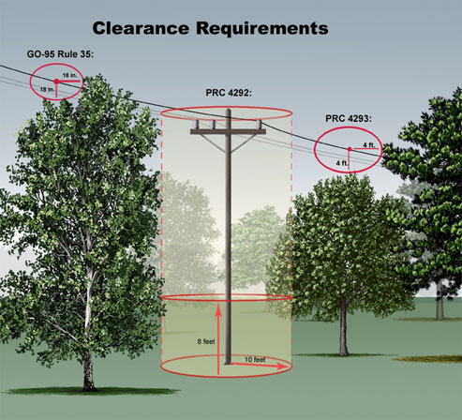

Ground Level Vegetation Clearance and Removal
SVEC maintains firebreaks around bases of certain power poles throughout the OH distribution system. The projected work product consists of providing a firebreak by removing all vegetation at ground level around and adjacent to specific poles or structures as identified by location and pole number.

ROW Trimming Specifications
SVEC has an operational and management responsibility and is required by State and Federal Agencies to maintain the right of way, under or around its power lines. To lessen our liability of fire and safety hazard due to live, dead or leaning trees and vegetation, SVEC crews work on an ongoing effort to clear any such hazard by removing any tree or brush that are directly under the power line and considered a problem. Trees or vegetation that is outside of the power line but is encroaching inside the ROW shall be trimmed or removed as needed.
Removal of tree limbs as necessary to provide the proper line clearance as described and illustrated in the SVEC Tree Trimming Guide M22 (Appendix E):
M22-1 Spec — When it is not possible to remove a tree from the right-of-way corridor, said tree should be “topped” or top trimmed by the Pollard method to provide the necessary clearance below the line and produce a symmetrical appearance when completed. A “flat-topped” trim is acceptable in many cases when pollarding will remove too much canopy. The standard “L” cut, and “V” trim will not pass inspection and are not the type of tree trimming which SVEC will sponsor or approve. If a tree which requires trimming is standing in the right-of-way corridor it must be topped to SVEC specs.
M22-2 Spec — When side trimming is required to produce a clear and open right-of-way, all limbs extending into the right-of-way “zone” or corridor from trees standing outside the right-of-way shall be removed on both sides of the pole line or under-ground route as necessary for spec clearances from ground level to the sky, as the rule of thumb. The exception to this rule is underground clearances where it is not necessary in most cases to gain more than approximately 15 feet of overhead clearance above ground level. Limbs of all deciduous trees should be cut on the lateral or flush with the tree trunk so, as to prevent, or lessen as much as possible, “suckering” regrowth from the cuts and to extend the effectiveness of trimming. The substandard “L” cut will not pass inspection and is not the type of tree trimming which SVEC will sponsor or approve. If a tree which requires trimming is standing outside the right-of-way corridor it must be side trimmed to SVEC specs.

Clear Cut ROW Specifications
All stumps shall be cut as close to the ground level as possible and parallel to the ground so as not to leave a “spike” or angle cut stump in the ROW which can damage tires or equipment. All cut stumps of deciduous trees should be treated with herbicide wherever practicable to prevent re-sprouting.
All firewood-sized lumber should be cut to a usable length of not more than four feet long. All lumber and/or brush should be stacked to that side of the ROW which may suit the landowner but shall always be stacked away from poles, roadways and water routes, i.e.:
- 10’ minimum width for overhead secondary routes
- 15’ minimum width for underground routes of all types
- 20’ minimum width for overhead single-phase routes
- 30’ minimum width for overhead multi-phase and single-phase routes constructed on cross arms

Chipping Brush and Removal of Lumber or Firewood
In areas where brush chipping is required but chips cannot be blown into the cleared right-of-way, all reasonably accessible brush should be chipped and blown into a truck equipped with a chip dump box or other similar conveyance and hauled away from the work location to be disposed of properly. In areas where brush which is inaccessible for chipping but cannot be stacked as it normally would, chainsaws shall be used to “beaver chop” or reduce the size of limbs and the area occupied by the inaccessible brush so as to present the smallest brush pile reasonably possible.

Slash Treatment
The protocol for the treatment of the slash and debris generated by the removal of these trees shall be as follows:
- If the area is accessible by chip truck, chip all wood less than 6 inches (including limbs and tops from larger material) into truck. If the area is not accessible by chip truck, drag brush to chipper location when chipper is in reasonable proximity (within 150 feet) of line clearance tree work. When slash is not in reasonable proximity of a chipper, crews shall lop and scatter the slash out of the Right of Way.
- When slash is in public view or within designated recreation areas, all wood greater than 6 inches in diameter will be cut into manageable lengths and stacked in 4’ x 4; piles for public consumption. All wood is to be cut into 4’ - 8’ lengths.
Access for Maintenance
Crews shall clear the surrounding area where vehicles and chippers are in operation to bare mineral soil for at least 10 feet from location of equipment being operated.

Herbicide Applications
SVEC approved, environmentally safe herbicides shall be applied wherever feasible using the cut stump, basal bark and/or broadcast foliage methods of application as outlined in the SVEC Herbicide Applications Guide (Appendix E). Great care shall be taken to use herbicides and related products to provide the most cost efficient and effective maintenance of rights-of-way possible.

T&D System Vegetation Management Standards
SVEC VM crews perform ground-based inspections of tree and conductor clearances and hazard tree identification. Patrols are scheduled to ensure all lines are inspected for vegetation hazards on a three-year timeline. The results of the patrols are targeted areas for vegetation pruning or removal. Annual ground-based field patrols ensure compliance with state and federal regulatory requirements (Public Resource Code 4293) and alignment with standards in CPUC GO 95 Rule 35 and FAC 003-4. During tree work, contractors aim to achieve up to 12 feet of clearance, unless otherwise directed by SVEC VM staff. The contractor also clears vegetation from SVEC’s secondary voltage, service drops and pole climbing space on an as needed basis. SVEC’s contractors follow American National Standards Institute (ANSI) A300 concepts and utility directional pruning, which supports proper pruning/tree health while achieving and maximizing the pruning cycle.

SVEC/Contractor Tools and equipment
Fire Tools and Equipment: SVEC or its contractors shall meet the minimum requirements of Section 4428 (Appendix D) of the California Public Resource Code (C.P.R.C.). Fire tools are kept at each operating landing shall be enough to equip all employees in the fell, yarding, loading, chipping and material processing operations associated with each landing.
All required fire tools shall be suitable, maintained and in serviceable condition for firefighting purposes. Trucks, tractors, pickups and other similar mobile equipment shall always be equipped with and carry a size 0 (zero) or larger shovel with an overall length of not less than 46 inches.
Each 3-man crew will have the following tools with them while working with an internal combustion engine:
- 1 shovel (size “0” or larger with an overall length of 46 inches).
- 1-10 lb. ABC portable fire extinguisher.
- 1- backpack pump located within 50-feet or working area.
Fire Extinguishers: SVEC or its contractor shall equip each internal combustion truck, tractor, pickup, and other similar mobile equipment with a fire extinguisher for oil and grease fires.
All fire extinguishers shall be mounted, readily accessible, properly maintained and fully charged.
Spark Arrestors and Mufflers: Except for motor vehicles equipped with a maintained muffler as defined in C.P.R.C. Section 4442 (Appendix D) or tractors with exhaust-operated turbochargers, SVEC or its contractor shall equip each operating tractor and any other internal combustion engine with a spark arrestor. Every registered motor vehicle shall always be equipped with an adequate exhaust system meeting the requirements of the California Vehicle Code.
Power Saws: Each power saw shall be equipped with a spark arrestor approved in accordance with C.P.R.C. Section 4442 or 4443 (Appendix D) and shall be maintained in effective working order. An approved fire extinguisher containing a minimum 14 ounces of fire retardant shall be kept with each operating power saw.
Tank Truck or Trailer: During the Fire Precautionary Period, SVEC or their contractor will have access to a water tank truck/trailer or similar.

Fire Mitigation Construction

Non-Expulsion Current Limiting Fuses
SVEC has undertaken a project to replace traditional expulsion fuses on portions of its overhead distribution system with CAL-Fire exempt, non-expulsion type fuses. Typical utility industry practice is to install expulsion fuses on transformer and tap-lines as a means of protecting and isolating parts of the system that have experienced a faulted condition. Expulsion fuses utilize a tin or silver-link element in an arc-tube that vents gas and potentially molten metal to atmosphere as a means of extinguishing an arc created by a faulted condition. The molten metal, however, can be a source of ignition for fire. In contrast, non-expulsion current-limiting fuses are a non-venting fuse encapsulated within a tube to contain the arc and gases, which minimizes the potential for molten metals to be expelled. It is SVEC’s goal to install non-expulsion fuses throughout the system, where benefits from this design can be achieved. A significant reduction in vegetation management costs can be achieved, since the use of CAL-Fire exempt fuses eliminates the need to maintain the required radius of mowed grasses beneath every distribution pole. Currently, only 5-10% of SVEC system uses non-expulsion fuses on its system.

Defensible Space Requirements
In January 2005, a new state law became effective that extended the defensible space clearance around homes and structures from 30 feet to 100 feet. Proper clearance to 100 feet dramatically increases the chance of a structure surviving a wildfire. Public Resources Code 4291 covers requirements for property owners in mountainous, forest, brush and grass covered lands to maintain a defensible space around structures. In February 2006, the State Board of Forestry (BOF) adopted additional guidelines which can be found in the document titled “General guidelines for Creating Defensible Space”. As part of SVEC’s overall approach to wildfire mitigation, SVEC supports and promotes the public awareness and adherence of these safety requirements. A PRC 4291 code compliance checklist with diagrams can be found in Appendix E.

Pilot Projects
Pilot projects are initiated to explore technologies and practices that are new to SVEC. These projects are intended for SVEC staff to evaluate the effectiveness and benefits of the technologies or practices. Based on the results of the pilots, SVEC may elect to integrate the technologies or practices into its various ongoing maintenance programs. -

Drone Inspection Program
SVEC is looking into utilizing drone technology to enhance its asset inspection program. The drone would be equipped with a high-resolution camera allowing for detailed inspections of crossarms, hardware and equipment not visible from the ground. The drone may also be fitted with infrared imaging technology, which is used to identify problem areas with spans and equipment. Failing splices are also easily identified with this technology.

GIS Mapping
An electric distribution utility uses a network of physical facilities to provide electric power and energy to customers connected to those facilities throughout a geographical area. Each component of the distribution system (i.e., asset) has a physical location and associated data. So does each customer. In order to plan, construct, maintain, operate and manage the electric distribution network it is necessary to create, manage and utilize this geospatial data. SVEC is looking at options to integrate GIS technology.

Workforce Training
SVEC has developed rules and complementary training programs for its workforce to reduce the likelihood of an ignition. All field staff will be:
- Trained on the content of the WMP
- Trained in proper use and storage of fire extinguishers
- Required, during pre-job briefings, to discuss the potential(s) for ignition, environmental conditions (current and forecasted weather that coincides with the duration of work for the day)
- Required to identify the closest fire extinguisher and other fire abatement tools
- Required to report all ignition events to management for follow-up
- Encouraged to identify deficiencies in the WMP and bring such information to management

THIS PAGE INTENTIONALLY LEFT BLANK

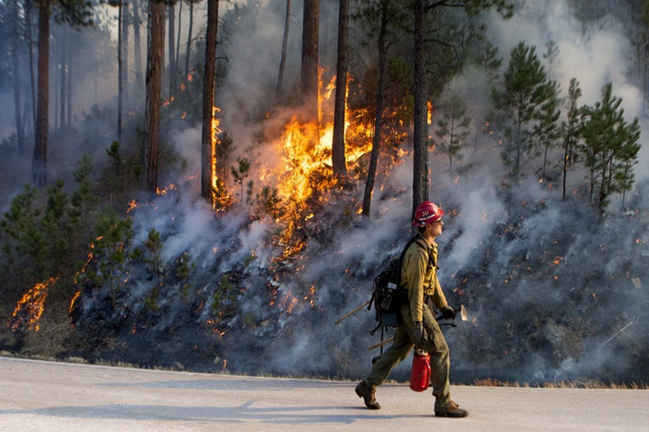

Emergency Response

Preparedness and Response Planning
SVEC strives to minimize the impacts of any disruptive event regardless of the size or scope, while consistently focusing attention on the community’s most critical systems and infrastructure.
SVEC’s emergency preparedness and response planning has resulted in an Emergency Response Plan (Appendix C) that facilitates effective utility-wide response to incidents of varying sizes and emergency disruptions, including wildfire response operations. Emergency preparedness and response plans are periodically reviewed, evaluated and updated to maintain continued effectiveness in protecting public and employee health and safety and minimizing damage to public and private property as well as SVEC infrastructure.
SVEC’s emergency preparedness and response plans consider hazards that have been identified as potentially impacting SVEC’s service territory. This plan was developed to streamline SVEC response efforts, inform critical actions and decision-making, determine roles and responsibilities of SVEC first responders and maximize SVEC’s ability to respond and recover following any type of disruptive incident. By undertaking comprehensive planning efforts, SVEC aims to minimize the impacts of wildfire incidents on customers and communities. SVEC’s emergency preparedness and response plans make available critical information for incident response and recovery team members to implement an efficient, effective and safe response to any type of incident, disruption or disaster.

Community Outreach
Community involvement can play an important role in wildfire mitigation. As part of the SVEC’s holistic approach, SVEC encourages its members to take proactive measures to safeguard their homes from wildfires. To help create an awareness of fire danger and the steps members can take to mitigate wildfire risk, SVEC provides helpful information on its web site. Members will find links to information regarding Defensible Space Requirements, National Weather Service RFW alerts and fire season preparation. Links to Modoc and Lassen County Fire Safe Council websites, which contain excellent information on how residents can mitigate fire hazards, are also provided.

Standardized Emergency Management System (SEMS)
SVEC is designated a Special District and is considered a local government agency. As such, SVEC has planning, communication and coordination obligations pursuant to the California Office of Emergency Services’ (OES) and Standardized Emergency Management System (SEMS) Regulations. The standard organizational model is based on an approach called the Incident Command System (ICS) which was developed by fire departments to give them a common language when requesting personnel and equipment from other agencies and to give them common tactics when responding to emergencies. CCR, Title §2403 specifies five levels of the SEMS organization, which are activated as necessary. The five levels are outlined briefly below:
- Field Response: Local Emergency response personnel and resources, under the command of an appropriate authority, carry out tactical decisions and activities in direct response to an incident or threat.
- Local Government: Local governments manage and coordinate the overall emergency response and recovery activities within their jurisdiction. CCR, Title 19, §2407 states that SEMS shall be utilized when the local government Emergency Operation Center (EOC) is activated and when a local emergency is declared or proclaimed.
- Operational Area: OA means an intermediate level of the state’s emergency services organization which encompasses the county and all political subdivisions within the county including special districts.
- Regional: The state has been divided into six mutual aid regions to provide for more effective application and coordination of mutual aid and other emergency related activities.
- State: This level manages state resources in response to the emergency needs of the other levels and coordinates mutual aid among the mutual aid regions and between the regional level and state level. It serves as the coordination and communication link between the state and the federal disaster response system.

SVEC coordinates with its local emergency response agencies as well as other relevant local and state agencies, as a peer partner. In response to all emergency events, SVEC collaborates with the local OES and provide an agency representative to the county and/or city Emergency Operations Centers (EOC) to ensure effective communication and coordination. SVEC’s two primary coordination points are Modoc County OES and Lassen County Sheriff’s Office OES. SVEC has direct radio communication with Modoc County Sheriff’s Department.
During emergency events, SVEC Emergency Response staff contact the local OES and establish themselves as the duty officer for coordination. The LS acts as the communications officer during an emergency.

Emergency Precautions
Reporting Fires: As soon as feasible but no later than fifteen minutes after initial discovery, SVEC or their contractors shall notify proper Fire Department Entities or Forest Service of any fires in the operating area or along roads being used by operators. Operators shall report all fires as soon as possible to any of the Forest Service facilities and/or personnel listed in Table 8 Dispatch Center and Table 9 Forest Service Facilities/Personnel Emergency Notification List.
Fire Patrolman: SVEC or its contractors shall furnish a qualified Fire Patrolman each operating day. When on duty, sole responsibility of Patrolman shall be to patrol the operation for prevention and detection of fires, take suppression action where necessary and notify the Fire Department Entities and/or Forest Service as required. One Patrolman may provide patrol on this and adjacent projects. No Patrolman shall be required on specified road construction jobs except during clearing operations unless otherwise specified.
SVEC/Contractors or their contractor’s employees shall report all fires to any of the following Forest Service facilities and/or personnel listed below depending on the area of fire.
Table 8 Sheriff’s Office / Dispatch Center
NAME | EMERGENCY AREA | TELEPHONE
Dispatch Center | Modoc County | 530-233-4416
Dispatch Center | Lassen County | 530-257-6121

When reporting a fire, SVEC staff/Contractors are to provide the following information:
- Name
- Call back telephone number
- Project Name
- Location: Legal description (Township, Range, Section); and Descriptive location (Reference Point)
- Fire information: Including Acres, Rate of Spread and Wind Conditions.

Table 9 Forest Service Facilities / Personnel Emergency Notification List
AREA OF WORK | PHONE NUMBER | RANGER DISTRICT | DISTRICT RANGER | ADDRESS
Lassen | 530-257-2151 | Deb Bumpus | Dave Hays | 2550 Riverside Dr. Susanville, CA 96130
Modoc | 530-233-5811 |  | Amanda McAdams | 225 W. 8th St. Alturas, Ca 96101
Cedarville | 530-279-6116 | Warner Mountain | Lisa Spahr | 710 Townsend St.  PO Box 220 Cedarville, CA 96104
Adin | 530-299-3215 | Big Valley | Chris Christofferson | PO Box 159 Adin, CA 96006
Alturas | 530-233-5811 | Devil’s Garden | Lisa Spahr | 225 W. 8th St. Alturas, CA 96101
Madeline | 530-257-4188 |  | Matt Boisseau | 477-050 Eagle Lake Rd. Susanville, CA 96130

Coordination with Stakeholders
SVEC understands the importance of proactive planning and coordinating closely with local governments, agencies and customers. There are several stakeholders that are involved in emergency preparedness and response. The key stakeholders include local governmental agencies as well as location-specific organizations, including critical facilities, resorts, customers and business groups.

Stakeholder Assets
Below are specific locations of some of the stakeholder assets in Modoc County.
- Local radio repeaters and cell towers – The are 65 FCC registered antenna towers in the Alturas area alone and several hundred throughout all service areas.

- Hospitals – SVEC does not directly serve hospitals, police or sheriff departments. However, loss of our Cedar Pass transmission line would result in loss of power to the Surprise Valley Hospital, which is served by Pacific Power. The Surprise Valley Hospital has a backup generator.

- Federal and State Fire Stations – Cal Fire Lassen-Modoc Unit located in Susanville (LMU/2200). Stations in Deer Springs (Alturas), Adin, Canby, Cedarville, Ravendale, Likely, Paisley, Westwood and Bieber.

- Water Districts - Located in Cedarville.

- Local Volunteer Fire Departments – Numerous rural volunteer fire stations are served throughout the service area.

Table 10 SVEC Emergency Preparedness and Response Stakeholder List
STAKEHOLDER GROUP | DESCRIPTION
Critical Agencies | - Primary Care Hospitals  - Schools  - Water SVECs  - Public Safety Dispatch Centers  - Local Emergency Planning Committees  - California Department of Transportation  - CPUC Safety and Enforcement Division
Communications | - Telecommunications companies  - Local news stations  - Local radio station
STAKEHOLDER GROUP (cont.) | DESCRIPTION
First Responders | - Law enforcement/holding facilities  - Fire operations facilities  - CAL Fire stations  - USFS (U.S Forest Service-Pacific Northwest)
Local Government | - Cities/Towns (Modoc and Lassen county (CA), Washoe county (NV), and Lake county (OR)
Safety Councils | - Modoc County Fire Safety Council  - Lassen County Fire Safe Council
Customers | - Any person, organization, or critical facility receiving electricity from SVEC

Emergency Level Definitions
In 2018, Cal OES, the State Sheriff’s Association and statewide fire agencies adopted new terminology regarding wildfire evacuation incidents.
The following is a list of evacuation terminology that Modoc county’s OES currently uses:
- Evacuation Warning: Potential threat to life and/or property. Those who require additional time to evacuate and those with pets and livestock shall evacuate immediately.
- Evacuation Order: Immediate threat to life. This is a lawful order to leave immediately. The area is lawfully closed to public access.
- Shelter in Place: Stay indoors. Shut and lock doors and windows. Prepare to self-sustain until further notice and/or until being contacted by emergency personnel with additional direction.

Work Crew Communications
SVEC or its contractor shall have and maintain reliable communications (e.g., cell phone, satellite phone or radio) present and available on the job site. If cellular coverage is not available, the location of the nearest public phone will be identified to all crewmembers. In addition, the phone numbers for the designated Forest Service Dispatch Center and Cal-Fire will be made available to all crewmembers. All communications equipment shall be operable during all operations during the Fire Precautionary Period.

CodeRED and IPAWS Alerts
The Modoc County Office of Emergency Services, in conjunction with the Modoc County Sheriff’s office, strongly encourage all Modoc County residents to sign up for a CodeRED account and to load CodeRED phone numbers into their phones to receive Modoc County Emergency Notifications. IPAWS notifications will be sent to alert all cell phones in the county with cell service in the event of a catastrophic wildfire. While this system can quickly alert a substantial number of residents, poor cell phone coverage in many areas will prevent complete notification with this system. A link to the CodeRED sign-up can be found on the Modoc County Sheriff’s Office website by clicking the “Emergency Notification” button.

Public Agency and Customer Communications
SVEC has a comprehensive plan for communicating with its customers during emergencies, especially during outages. SVEC’s current process includes sharing information with the local newspaper for posting on their Facebook page for unplanned outages. For planned maintenance outages there are several methods, depending on the number of customers affected and the amount of time there is prior to the outage happening. Customers who will be affected either receive a bill stuffer, a postcard in the mail, telephone call advising of the outage or a hang tag at their residence. Information is also posted on the SVEC Facebook web site.
For scheduled maintenance outages, SVEC provides as much notice as possible. Depending on how many customers will be affected by the outage, 500 or more affected customers is a 30-day advance notification. SVEC also shares some power poles with Pacific Power. This organization may sometimes require SVEC to de-energize shared power poles for planned-maintenance work. This work is schedule at least 1 or 2 weeks in advance.
SVEC calls the local communications companies (phone and internet providers), county government officials and Office of Emergency Services (EOS) prior to planned outages. Businesses are called in all cases. Table 10 SVEC Emergency Preparedness and Response Stakeholder list displays all the critical local government/ agencies that are contacted in case of a catastrophic wildfire event.
Examples of SVEC’s communication and engagement with elected officials, government agencies and commercial customers include:
- Regular in-person briefings with federal, state and local elected officials and key staff on wildfire risk mitigation and other utility-related issues with comprehensive “leave-behind” materials
- Meetings with regional and local government staff and elected officials focused on individual SVECs, communities and neighborhoods and mitigation opportunities
- Regular in-person and/or digital communication with critical facilities and key customers through SVEC Strategic Account Advisors
- Interagency projects, collaborative staff training efforts and regular communication with first responders and essential service providers
- Ongoing communication, collaboration and support for local Fire Safe Councils and other fire prevention agencies and nonprofits

Actions Taken to Support Customers During and After A Wildfire
SVEC takes specific actions to support customers during and after wildfires, including:
- Facilitating billing adjustments
- Extending payment plans
- Suspending disconnection and non-payment fees
- Waiving of extension fees
These activities are described in further detail the following sections.

Facilitating Billing Adjustments
For customers who have experienced catastrophic losses to homes or businesses due to natural disaster, SVEC will discontinue billing and close the service account from the date of a disaster event included in a Governor’s State of Emergency Proclamation. In support of the rebuilding efforts, customer account information and history will be maintained and transferred to the new residence or business, along with a re-establishing their credit.
SVEC suspends bill estimation for customers impacted by disasters, including those customers who were away from their residences or businesses when evacuations were ordered. SVEC works with the appropriate city and county agencies to identify and verify homes and small businesses in SVEC’s service territory that were destroyed or damaged by wildfires and follows up with field verifications. Upon contact from customers who receive bills based on estimated usage for the times they were evacuated, SVEC conducts an account review and makes appropriate billing adjustments. If a customer is billed during the evacuation period based on actual electricity usage, SVEC considers adjusting customer bills under specific circumstances, even if the customer’s residence or business was not destroyed in the disaster. In addition, SVEC adjusts minimum charges for evacuated customers, as appropriate.

Extending Payment Plans
SVEC relies on its customers to contact SVEC and self-certify their disaster-related financial situation. SVEC works with impacted customers who contact SVEC to establish reasonable payment arrangements based on individual customer need. SVEC customers are eligible to pay off their arrearages at any time (sooner), if they prefer.

Suspending Disconnection and Nonrepayment Fees
As part of its regular business practice, SVEC does not assess or charge disconnection fees for destroyed homes or small businesses. Upon identification of impacted customers, SVEC immediately confirms that customer accounts are flagged, suspends disconnection for non-payment, waives late fees and deposit requirements and delays late payment reports to credit reporting agencies. SVEC assists customers whose homes or small businesses were damaged by disaster in their re-building efforts within reason.

Waiving of Extension Fees
SVEC will only waive all line extension fees if the customer requests the electric service be built exactly as it was prior to the disaster. If a customer chooses to change the service in any way (i.e., overhead to underground, different panel size, different path) the customer must pay the entire cost for the new line extension.

Restoration of Service
Although SVEC does not have a PSPS operational practice, if an outside emergency management/emergency response agency requests a power shutdown, or if SVEC elects to de-energize segments of its system due to extreme weather, SVEC staff will patrol the affected portions of the system before the system can be re-energized. Suspect equipment or distribution lines that cannot immediately be patrolled will remain de-energized. Poles and structures damaged in a wildfire must be assessed and rebuilt as needed prior to re-energization. Periodic customer and media updates of restoration status prior to full restoration will be made.

Service Restoration Process
SVEC work crews will take the following steps prior to restoring electrical service after a de-energization event. These measures are intended to protect the worker, general public and the reliability of the system.
- Patrol: If the de-energization was a PSPS, lines are patrolled to ensure no hazards have affected the system during the outage. If an outage is due to wildfire or other natural disaster, as soon as it is deemed safe by fire officials, lines and equipment are inspected for obvious damage or foreign objects and to estimate equipment needed for repair and restoration. Lines located in remote and rugged terrain with limited access may require additional time for inspection. VM crews are called on to assist in clearing downed trees and limbs as needed.
- Isolate: Isolate the outage and restore power to areas not affected.
- Repair: After the initial assessment, SVEC supervisors, managers and engineers meet to plan the needed work. Re-building will commence as soon as affected areas become safe. Repair plans prioritize substations and transmission facilities, then distribution circuits that serve the most critical infrastructure needs. While the goal is to reenergize all areas as soon as possible, emergency services, medical facilities and utilities are given first consideration when resources are limited. Additional crew and equipment will be dispatched as necessary. Sheriff’s department is notified if an outage will be longer than 4 hours, as they may desire to check on citizens with medical needs. Sheriff’s Department will be kept informed of outage and restoration timeframes.
- Test: After repairs are completed and the equipment is safe to operate, line segments are energized and tested.
- Restore: After successful line testing, power is restored to homes and businesses as quickly as possible. Customers, local news and other agencies are then notified of the restoration of electric service. Periodic customer and media updates of restoration status prior to full restoration will be made. After initial power restoration, further demolition and rebuilding will likely take place.

Performance Metrics and Monitoring
In addition to a robust mitigation strategy, SVEC developed performance metrics to monitor their efforts over time. The goal of these metrics is to provide a data-driven evaluation of performance to help SVEC determine the effectiveness of the Plan and to identify areas for improvement.
This section identifies SVEC’s management responsibilities for overseeing this WMP and includes the operating departments and teams responsible for carrying out the various activities described in the previous chapters. This section also identifies the controllable metrics which are used to demonstrate compliance with this WMP.

Plan Accountability
The Board of Directors makes policy decisions relative to the Cooperative – they will be responsible for approving and adopting the Wildfire Mitigation Plan. The GM directs management staff responsible for operations, customer service and finance. The LS supervises the Supervising Foreman and foremen, Trouble man, Linemen, Vegetation Program Manager and Groundman. The office administrator supervises the Clerks, the meter department and provides human resources support and administrative assistance to the LS, GM, Board of Directors and Chief Financial Officer (CFO). The CFO is responsible for SVEC finances. The Administrative Secretary provides support and administrative assistance to the GM and other staff as needed.
The GM is responsible for executing the WMP. Staff will be directed as to their roles and responsibilities. The LS is responsible for communicating with public safety, media outlets, public agencies, first responders, local Office of Emergency Services and health agencies during an emergency or planned maintenance outages. The LS determines when and how to notify outside agencies in cases of wildfire emergency events.

Operating Unit Responsibility
Table 11, on the following page, identifies the Departments responsible for tracking and implementing the various components of the WMP.

Table 11 Accountability of Plan Implementation
MITIGATION ACTIVITIES | RESPONSIBLE DEPARTMENT AND WORKGROUP
Risk Analysis | General Manager
Fire threat assessment in service territory | Distribution System Operations & Maintenance Planning
Wildfire Prevention Strategy Programs
- Disable reclosers  - Planned de-energization | Grid Strategy & Operation: Grid Operations T&D System Operations, Distribution System Operations
- T&D line patrols  - 69 kV & transmission line inspections  - Wood pole intrusive inspection  - Detailed line inspections | Grid Assets: Line Assets,  Distribution System Operations
- Substation visual and detailed inspections | Grid Assets: T&D Substation Maintenance
- Vegetation management  - Pole clearing program  - Line Patrols | Grid Assets: Vegetation Management
Fire Mitigation Construction
- Non-expulsion equipment | Distribution System Operations  Maintenance: Design & Standards
System Enhancement Capital Projects
- Install non-expulsion equipment in high risk areas | Distribution System Operations & Maintenance: T&D Maintenance Planning, Grid Assets: Line Assets
Pilot Projects
- Drone enabled inspections  - GIS mapping | Grid Strategy & Operation: Grid Operations
Emergency Preparedness
- SVEC Emergency Operations Center | Workforce and Enterprise Services: Facilities Operations
- Public and agency communications for wildfires | Customer & Community Services: Revenue Operations, Communications Marketing & Community Relations

Performance Metrics
Metrics to gauge the success or shortcomings of the WMP and outlined programs are covered in this section. As with other aspects of the Plan, these metrics will likely evolve in the future iterations of the WMP.

Metrics and Assumptions for Measuring WMP Performance
SVEC will use the follow metrics to measure the performance and efficacy of the Plan.

Table 12 Metrics
METRIC | RATIONAL | INDICATOR | MEASURE OF EFFECTIVENESS
Number of Utility Caused Fires | Demonstrates effectiveness of overall plan | Count of events | No material increase
Ignitions on Circuits in HFTD | Demonstrates effectiveness of overall plan | Sum of acres affected | No Material Increase
Events Recorded with Fire Reference | Demonstrates effectiveness of overall plan | Count of events | Reduction in general trend of events
Service Interruption Events with Fire Reference | Assess system hardening efforts | Count of events | Reduction in general trend of events
Non-Expulsion Type Fuse Trip Event with Fire Reference | Measure success of fuse replacement program | Count of events | Reduction in general trend of events
Traditional Fuse Trip Event with Fire Reference | Measure success of fuse replacement program | Count of events | Reduction in general trend of events
Bare Line Contact with Vegetation | Assess Vegetation Management Program | Number of contacts recorded | Reduction of vegetation contacts
Number of Customer Service Calls Re: At Risk Vegetation | Assess if VM Program has reduced customer concerns and risk events | Number of calls received | Reduction in general trend of events
Power Line Down Event in HFRA | Assigns risk to root cause | Count of events | Reduction in general trend of events

As this Plan is in the initial stage of implementation, relatively limited data is on hand. However, as results of the programs become evident and additional data is collected, SVEC will identify areas of its operations that will require a different approach, as well as methods that are working towards the goal of eliminating SVEC asset sourced ignitions. As the metrics are analyzed in the following years, refinements will be made to the WMP annually.
PUC section 8387 subsection b(2)(E) requires a discussion of how the application of previously identified metrics to previous Mitigation Plan performance has informed this WMP. SVEC will include this discussion in the next annual revision.

Programmatic Metrics
SVEC outlines and schedules required work on an annual basis. Any work that is incomplete or behind schedule is flagged for review or field verification. SVEC’s goal is to complete 100% of the work within the initially scheduled time frame, however, emergencies or other unforeseen contingencies can occur that may require material and labor resources to be otherwise assigned. In this instance, delayed work will be prioritized in following time periods. All work is completed within time periods to allow for the safe and reliable operation of the electric system in accordance with applicable requirements and industry standards.

Table 13 Programmatic Metrics
PROGRAM | TARGET | METRIC DESCRIPTION
Distribution Line Inspections | 95-100% | Perform all detailed line inspections within the compliance period set in General Order (GO) 95/165 by the end of the year. The inspections must be completed within the specified time intervals set for each inspection type. (Chapter 6)
Distribution Wood Pole Intrusive Tests | 95-100% | Perform all wood pole intrusive tests scheduled for the year. SVEC’s goal is to perform wood pole tests within 15 years of installation and 10 years thereafter. (Chapter 6)
Distribution Annual Line Patrol | 95-100% | Perform all annual distribution line patrols within the compliance period set in GO 95/165. See Chapter 6 for a detailed description of the program.
Annual Pole Clearing Program | 95-100% | Complete all vegetation clearing activities) prior to the beginning of fire season of each year. (Chapter 6)
Transmission Structure Patrols | 95-100% | There are three inspection regions for transmission structure patrols. The goal is to perform all scheduled patrols prior to the end of the year.
Distribution Vegetation Pruning/Clearing | 95-100% | Complete scheduled respective tree work to ensure compliance with PRC 4293 to prevent ignition and propagation of fire caused by SVEC electric overhead assets.
Transmission Vegetation Pruning/Clearing | 95-100% | Complete scheduled respective tree work to ensure compliance with PRC 4293 and NERC FAC-003-4 to prevent ignition and propagation of fire caused by SVEC electric overhead assets.

Monitoring and Auditing of the WMP
The WMP will be included as a discussion item on the agenda of regularly scheduled management meetings. SVEC will monitor efforts of the WMP quarterly and report on its effectiveness to the Board of Directors on an annual basis. Quarterly reports of the Plan’s current progress and risk reduction impact will be developed and circulated to appropriate utility staff to engender collaborative discussion to make changes to approved strategies. The GM, or their designee, will update leadership with recommendations or proposed action in enhancing the Plan’s objectives overtime.
The WMP annual review will align with SVEC’s existing business planning process. This review will include an assessment of the WMP programs and performance.
Annually, SVEC will engage a CPUC approved evaluator to review and assess SVEC’s compliance with WMP regulation requirements for the state of California.
SVEC’s business planning process includes budgeting and strategic planning for a 3-5-year planning horizon.

Accountability
SVEC’s GM and LS will be responsible for monitoring and auditing the targets specified in the WMP to confirm that the objectives of the WMP are met. They have the responsibility of monitoring and auditing the implementation of the plan in general.
SVEC’s management structure is shown in Figure 12 on the following page.

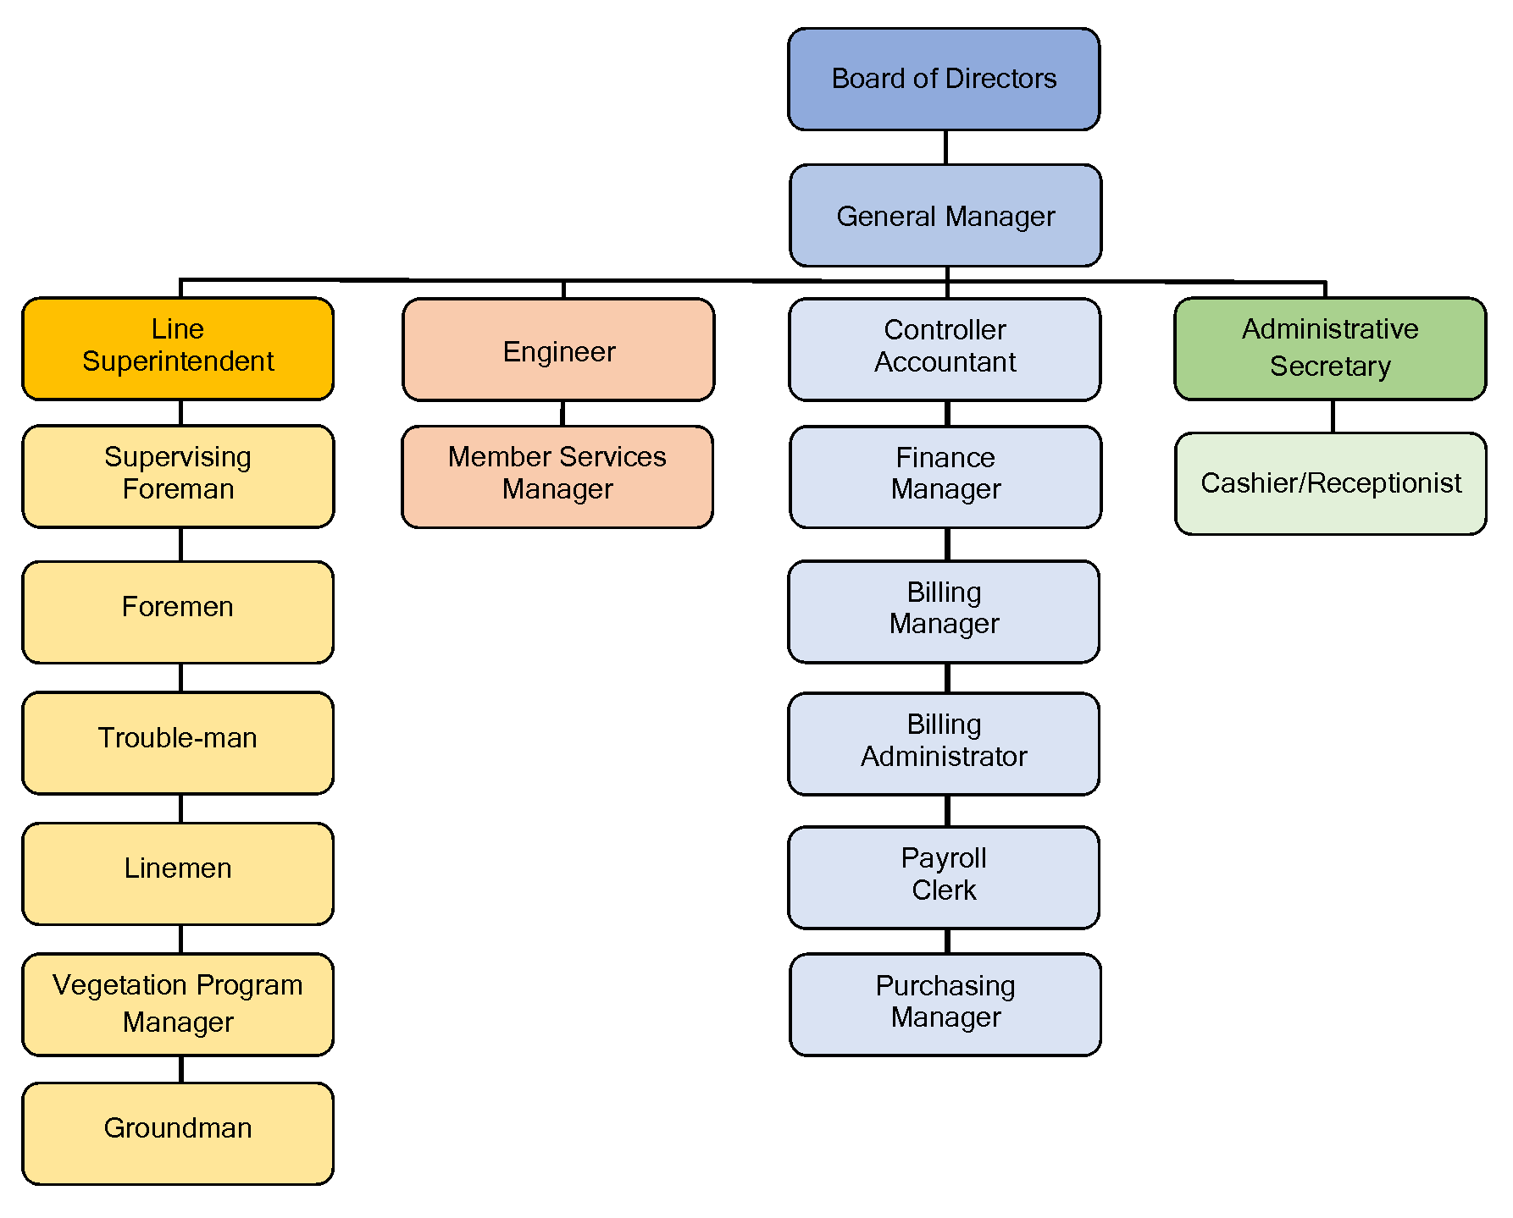
Figure 12. SVEC Management Structure

Identify Deficiencies in the WMP
The GM will be responsible for ensuring that this WMP meets all the State of California guidelines to mitigate the risk of its assets becoming the source or contributing factor of a wildfire. Staff responsible for assigned mitigation areas have the role of vetting current procedures and recommending changes or enhancements to build upon the strategies in the WMP. Either due to unforeseen circumstances, regulatory changes, emerging technologies or other rationales, deficiencies within the WMP will be sought out and reported to the Board of Directors in the form of an updated WMP on an annual basis. The GM, or their designee, will be responsible for spearheading discussions on addressing deficiencies, and collaborating on solutions when updating the WMP for its annual filing. At any point in time when deficiencies are identified, the Supervisors or their delegates are responsible for correcting the deficiencies. SVEC staff and qualified stakeholders are encouraged to bring any potential deficiencies to the attention of the GM. The GM, along with the appropriate staff, will evaluate each reported deficiency, and if determined to be valid, shall record the deficiency for further action.

Monitor and Audit the Effectiveness of Inspections
SVEC’s compliance with Commission regulations ensures that facilities are inspected and repaired in accordance with GO 165 program standards. Any issues found impacting safety and reliability are addressed as outlined in that program. In addition to this maintenance program, SVEC is constantly evaluating its facilities while performing other activities such as outage patrols, new business planning, replacements and related field work.
Monitoring the effectiveness of inspection practices will occur through ongoing tracking and annual review of findings resulting from internal processes. The LS or their designee supervises the Vegetation Manager and will review concerns found during routine field work and equipment and line inspections. SVEC will use this information as a method to assess the effectiveness of inspection procedures. The review process will take place annually where inspection records will be reviewed, deficiencies identified, and corrective actions determined. An internal report will be provided to the utility’s leadership in deliberation of future strategies. Related strategies that mitigate wildfire risk will then be identified and proposed within the next iteration of the Plan. Aggregating this data will guide future decision-making on the direction of wildfire mitigation strategy with the intention that incidents will become less frequent or hazardous system wide.
SVEC has quality control processes embedded in its existing general practices. However, for certain programs, there is a formal quality control process. The following depicts a few of these programs.

Written Processes and Procedures
SVEC documents its operational procedures and processes to maintain consistent and thorough implementation at all levels. Processes are reviewed and updated as needed to maintain the most efficient, effective, beneficial and safety driven methods and protocols.

Programmatic QA/QC processes

Distribution System Inspections
The LS manages T&D line and substation assets and develops the comprehensive inspection and maintenance programs. These programs are driven by the need to ensure the safe operation of T&D line and substation facilities.
Key imperatives are to:
- Reduce the risk of power-related wildfire.
- Meet federal and state regulatory requirements.
- Achieve reliability performance within mandated limits and to optimize capital and O&M investments.
In addition, the LS or designated managers regularly monitor inspection and corrective maintenance records, as well as diagnostic test results to adjust maintenance plans and develop new programs. Best industry practices are used in development of the maintenance programs.
SVEC’s Grid Assets group is responsible for performing the inspections and corrective maintenance. When deficiencies are found, work orders are created by LS. The priority for corrective maintenance is to remove safety hazards immediately and repair minor deficiencies according to the type of defect, severity and HFTD tier. Work orders are monitored throughout the year to ensure timely completion via regular internal reports.

Vegetation Management (VM)
SVEC’s vegetation management work is performed by contractors. This VM work is Quality Control (QC) audited by SVEC’s LS. Approximately 10% of the distribution system related clearing and pruning is field audited. Quality Assurance (QA) efforts are tracked to monitor program effectiveness and overall tree work performance. For both T&D QA efforts, all deficiencies are recorded and work reissued to the contractor for corrective action. Distribution QC is only on SVEC contractors and consists of approximately a 10% sample of tree work.

THIS PAGE INTENTIONALLY LEFT BLANK

Independent Evaluation, Public Comment and Board Presentation

Plan Approval Process
SVEC made all efforts to consider stakeholder input in the preparation of its Wildfire Mitigation Plan. Local fire safe councils, OES and healthcare organizations as well as federal, state and local agencies were consulted. The initial draft of the WMP will be posted on SVEC’s website and made available for public comment for thirty days (30 days). Interested parties are invited to comment on the plan at the time it is presented to SVEC’s Board of Directors in a properly noticed public meeting. Annually reviewed and revised WMPs will follow these same protocols.

Independent Evaluation
PUC section 8387(c) requires SVEC to contract with a qualified independent evaluator with experience in assessing the safe operation of electrical infrastructure to review and assess the comprehensiveness of this WMP. SVEC will issue a public request for qualification, consistent with SVEC’s current procurement practice, to select an independent evaluator. The independent evaluator will provide a report that will be posted to SVEC’s website and made available for review at the SVEC office. The Independent Assessment and WMP will be available for public review and comment prior to plan adoption at a properly noticed SVEC Board of Directors meeting.
The independent evaluator’s report will be posted to SVEC’s website and presented to SVEC’s Board of Directors at a properly noticed public meeting. The Independent Evaluation Report will be included in Appendix H when concluded.

Public Comment
A draft copy of the WMP is being made available to the public for comment for a minimum period of 30 days.
- The draft WMP is available on SVEC’s website (www.surprisevalleyelectric.org). Public comments will be addressed in the final WMP.
- SVEC will also provide an opportunity for public comments on the draft WMP at a regularly scheduled Board Meeting.
- SVEC Board Committee meetings are open and accessible to the public. Meeting notices and agendas are posted, at a minimum, 72 hours in advance at the SVEC office and on SVEC’s website.
The public comments received prior to adoption will be included in Appendix I.

Board Presentation
Information and meeting minutes will be added as an addendum to this section after SVEC’s board presentation in the Spring 2020.

Appendix A: Definitions
Cal Fire: California Department of Forestry and Fire Protection serves and safeguards the people and protects the property and resources of California.
Fire Hazard: “Hazard” is based on the physical conditions that give a likelihood that an area will burn over a 30 to 50-year period without considering modifications such as fuel reduction efforts.
Fire Risk: “Risk” is the potential damage a fire can do, to the area under existing conditions, including any modifications such as defensible space, irrigation and sprinklers and ignition resistant building construction which can reduce fire risk. Risk considers the susceptibility of what is being protected.
Hardening: Modifications to electric infrastructure to reduce the likelihood of ignition and improve the survivability of electrical assets.
High Fire Threat SVEC (HFTD): The HFTD identifies areas of elevated and extreme fire risk related to electric utility facilities. These areas are reflected in a map adopted by the CPUC after an extensive public process. It is a composite of two maps:
- Tier 1 High Hazard Zones (HHZs) on the U.S. Forest Service - CAL FIRE joint map of Tree Mortality HHZs (“Tree Mortality HHZ Map”). Tier 1 HHZs are zones in direct proximity to communities, roads and utility lines and are a direct threat to public safety.
- Tier 2 and Tier 3 fire-threat areas on the CPUC Fire-Threat Map. Tier 2 fire-threat areas depict areas where there is an “elevated risk” (including likelihood and potential impacts on people and property) from utility associated wildfires. Tier 3 fire-threat areas depict areas where there is an “extreme risk” (including likelihood and potential impacts on people and property) from utility associated wildfires.
Red Flag Warning (RFW): A term used by fire- weather forecasters to call attention to limited weather conditions of importance that may result in extreme burning conditions. It is issued when it is an on-going event, or the fire weather forecaster has a high degree of confidence that Red Flag criteria will occur within 24 hours of issuance. Red Flag criteria occurs whenever a geographical area has been in a dry spell for a week or two, or for a shorter period, if before spring green-up or after fall color, and the National Fire Danger Rating System (NFDRS) is high to extreme and the following forecast weather parameters are forecasted to be met:
- A sustained wind average 15 mph or greater
- Relative humidity less than or equal to 25 percent and
- A temperature of greater than 75 degrees F
In some states, dry lightning and unstable air are criteria. A Fire Weather Watch may be issued prior to the RFW.
Pole Clearing: The process of establishing a firebreak clearance as required by PRC 4292 are applicable within an imaginary cylindrical space surrounding each pole or tower on which a switch, fuse, transformer or lightning arrester is attached and surrounding each dead end or corner pole unless such pole or tower is exempt from minimum clearance requirements by provisions of 14 CCR 1255 or PRC 4296.
State Responsibility Area (SRA)1: “The California Board of Forestry and Fire Protection classify areas in which the primary financial responsibility for preventing and suppressing fires is that of the state. California Department of Forestry (CDF) has SRA responsibility for the protection of over 31 million acres of California’s privately-owned wildlands.”
Substation: Part of the electrical generation, transmission and distribution system, substations transform voltage from high to low, or the reverse, or perform any of several other important functions. Between the generating station and consumer, electric power may flow through several substations at different voltage levels. A substation may include transformers to change voltage levels between high transmission voltages and lower distribution voltages, or at the interconnection of two different transmission voltages.
Transmission and Distribution (T&D): At SVEC, for line maintenance purposes, the transmission system includes 60 kV lines tied to generation facilities. The distribution system includes 21 kV, 12.47 kV, 12 kV and 7.2 kV lines not tied to generation facilities.
Utility Cooperative: A type of cooperative that is tasked with the delivery of a public utility such as electricity, water or telecommunications to its members. Profits are either reinvested for infrastructure or distributed to members in the form of "patronage" or "capital credits", which are dividends paid on a member's investment in the cooperative.
Each customer is a member and owner of the business. This means that all members have equal individual authority, unlike investor-owned utilities where the extent of individual authority is governed by the number of shares held.
Vegetation Management: A broad term that includes tree pruning; brush removal through the use of power saws and mowers; the judicious use of herbicides and tree growth regulators; hazard tree identification and removal; the implementation of strategies to minimize the establishment of incompatible species under and near power lines; and the control of weeds.
Wildfire: “Also called wildland fire, uncontrolled fire in a forest, grassland, brushland or land sown to crops.” “Fire danger in a wildland setting varies with weather conditions: drought, heat and wind participate in drying out the timber or other fuel, making it easier to ignite. Once a fire is burning, drought, heat and wind all increase its intensity. Topography also affects wildfire, which spreads quickly uphill and slowly downhill. Dried grass, leaves and light branches are considered flash fuels; they ignite readily, and fire spreads quickly in them, often generating enough heat to ignite heavier fuels such as tree stumps, heavy limbs and the organic matter of the forest floor. Such fuels, ordinarily slow to kindle, are difficult to extinguish. Green fuels—growing vegetation—are not considered flammable, but an intense fire can dry out leaves and needles quickly enough to allow ready ignition. Green fuels sometimes carry a special danger: evergreens, such as pine, cedar, fir and spruce, contain flammable oils that burst into flames when heated sufficiently by the searing drafts of a forest fire.”
Wildfire Mitigation Plan (WMP): As amended by SB 901, section 8387 of the Public Utilities Code (PUC) more specifically requires every publicly owned utility to prepare and present a wildfire mitigation plan to its governing body by January 1, 2020, and annually thereafter.
Wildfire Safety Advisory Board: Under section 326.2 “The California Wildfire Safety Advisory Board shall do all of the following:
(a) Develop and make recommendations to the Wildfire Safety Division related to wildfire safety and mitigation performance metrics.
(b) Develop and make recommendations related to the contents of wildfire mitigation plans pursuant to Chapter 6 (commencing with Section 8385) of Division 4.1.
(c) Review and provide comments and advisory opinions to each local publicly owned electric utility and electrical cooperative regarding the content and sufficiency of its wildfire mitigation plan and recommendations on how to mitigate wildfire risk.
(d) Provide other advice and recommendations related to wildfire safety as requested by the Wildfire Safety Division.”
(Added by Stats. 2019, Ch. 79, Sec. 5. (AB 1054) Effective July 12, 2019.)

Appendix B: Reference for Definitions
- CPUC Fire Threat Map, https://ia.cpuc.ca.gov/firemap/
- Public Utilities Code, Chapter 6. Wildfire Mitigation [8387], http://leginfo.legislature.ca.gov/faces/codes_displaySection.xhtml?lawCode=PUC&sectionNum=8387
- General Order 95 contains rules for the design, construction, maintenance, inspection, repair and replacement of overhead utility lines. http://docs.cpuc.ca.gov/PublishedDocs/Published/ G000/M209/K464/209464026.pdf
- General Order 165, Inspection Requirements for Electric Distribution and Transmission Facilities. http://docs.cpuc.ca.gov/PublishedDocs/Published/ G000/M209/K552/209552704.pdf
- General Order 166, Standards for Operation, Reliability and Safety During Emergencies and Disasters http://docs.cpuc.ca.gov/PublishedDocs/Published/ G000/M209/K451/209451792.pdf
- General Order 174, Rules for Electric Utility Substations http://docs.cpuc.ca.gov/PublishedDocs/Published/ G000/M031/K879/31879476.PDF
- Power Line Fire Prevention Field Guide, http://cdfdata.fire.ca.gov/pub/fireplan/fpupload/ fppguidepdf126.pdf

THIS PAGE INTENTIONALLY LEFT BLANK

Appendix C: Emergency Plan Response Plan
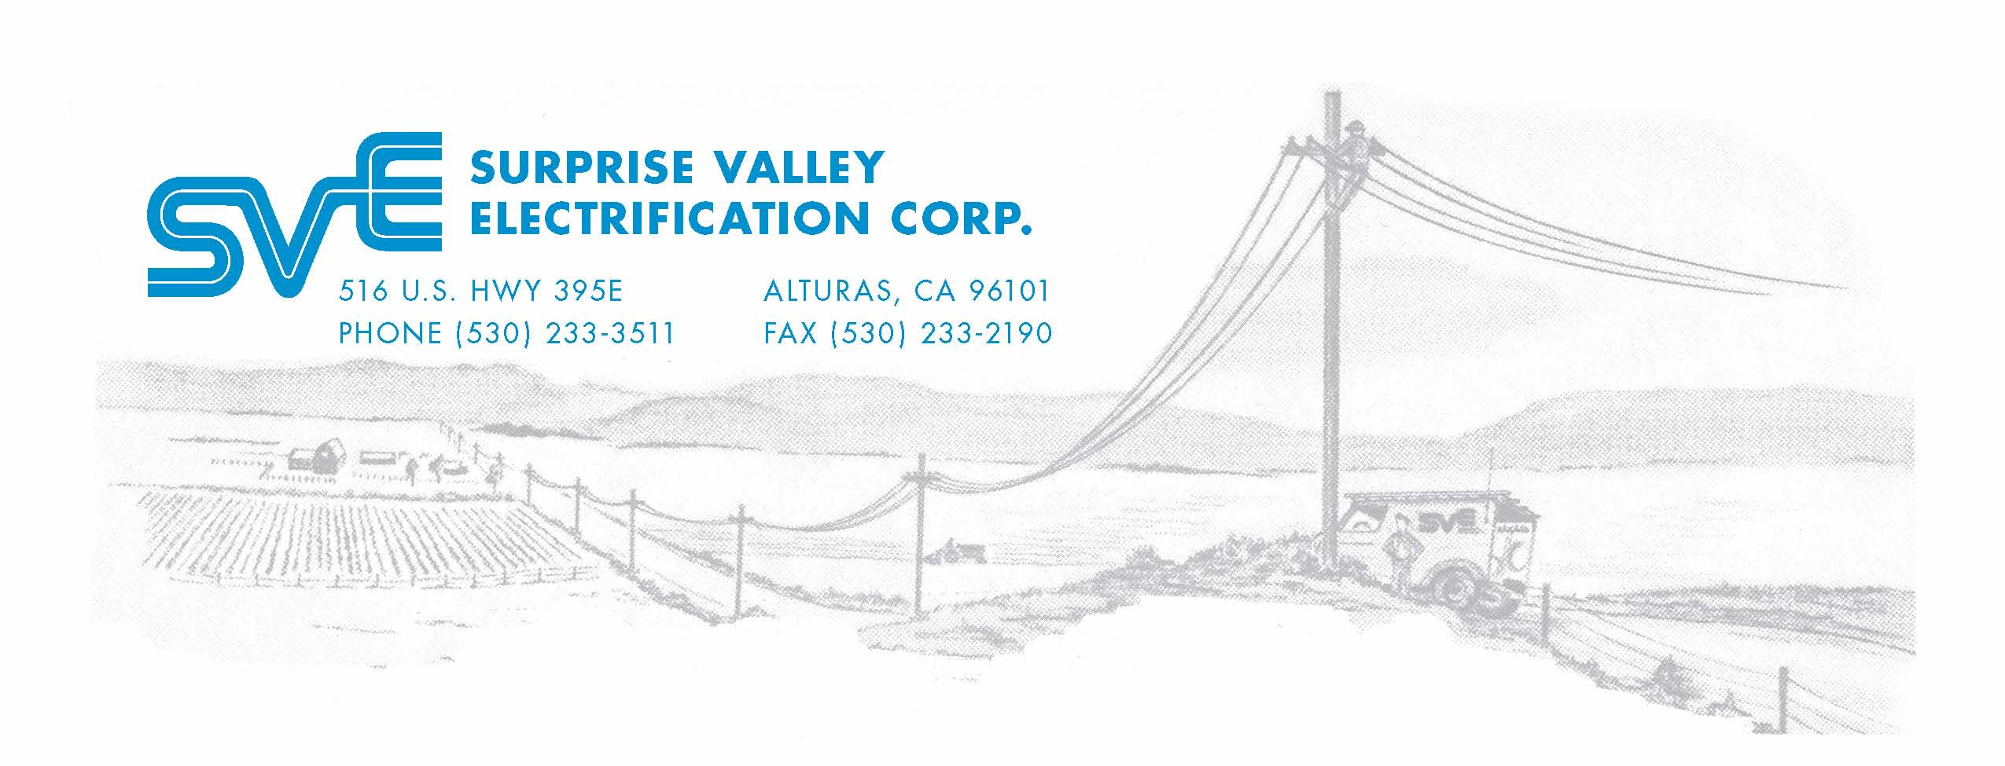

SURPRISE VALLEY ELECTRIFICATION CORP.
EMERGENCY RESPONSE PLAN

Surprise Valley Electrification Corp.

Surprise Valley Electrification Corp. (SVEC) is a private, non-profit electric cooperative owned by the members it serves. SVEC’s service area extends North to Summer Lake, Oregon, South to Ravendale, California, West to Day, California, and East to Vya, Nevada. The total area served is 7,650 square miles. Within this service area the cities of Alturas, California and Lakeview, Oregon and the smaller towns of Cedarville, California and New Pine Creek, Oregon are served by Pacific Power.

The Cooperative serves 6,550 electric meters. Of those accounts 4,002 are residential, 1,048 are irrigation, 1,370 are small commercial, and 37 large power meters.

Surprise Valley Electrification Corp. has 222 miles of transmission line, 1,840 miles of distribution line, and 300 miles of underground line.

This booklet contains the Emergency Restoration Plan for Surprise Valley Electrification Corp.

Surprise Valley Electric Service Territory

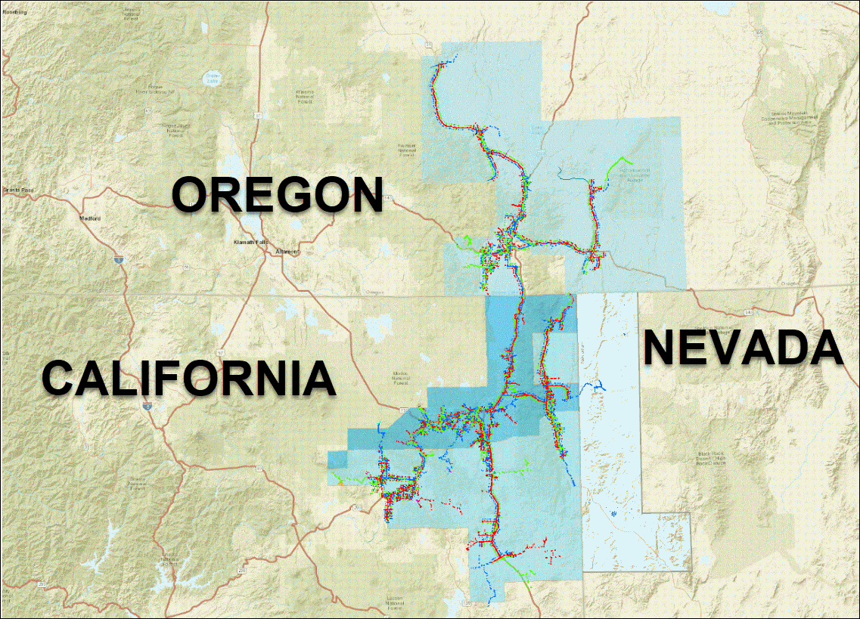

Surprise Valley Electrification Corp. used an actual event that occurred in past years to exercise our Emergency Response Plan.

On January 4th, we were notified by a member/consumer who reported arcing and flashing in out Lookout Substation. Our office staff took the information and notified our Line Superintendent of the situation. The Line Superintendent immediately sent our Serviceman to the Lookout Substation. The Serviceman found a 69kVa switch was not closing and was arcing badly causing fluctuating voltages. The Serviceman advised the Line Superintendent that the switch needed to be bypassed. A line crew was immediately sent to assist the Serviceman with this procedure. The task of bypassing the switch was completed and a catastrophic substation failure was averted. This temporary fix avoided an extended outage and protected the substation equipment from permanent damage. Loss of this substation would have almost certainly caused the Canby switch to open, which would have resulted in nearly 1,100 customers out of power. This represents approximately 20 percent of the SVE accounts. The Lookout substation was temporarily isolated, and the load was picked up by the Adin and Bieber substations. The Lookout substation was repaired and is now back online. All of this was done without any member/consumer being out of power or inconvenienced. As our Line Superintendent said, “No one even knew we were working on it”. In order to perform the isolation of this substation, specific switching orders were developed and followed. A copy of this order is attached. We are making an ongoing effort to develop specific switching orders for each of our substations and a switch order standard operating procedure. As these are developed, they will be added to our ERP. We Learned from this event that our new tie line at the Lookout substation will carry our full winter load. This was not a “normal” outage event, but our procedures worked well. We followed our guidelines and the situation was corrected and a disastrous event averted without any loss of power.

Lookout Substation Switching Orders

- Change fuse size at Co. Rd. 87 Pole # 020 to loots.
- Zero & turn off regulator’s at Gouger Neck Rd. and Co. Rd. 87.
- Tie East & West Circuit at Lookout Sub with new underground shoe fly.
- Open West Circuit at Lookout Sub.
- Close dead blades to make parallel at upside down arms on Co. Rd. 87
Pole # 095.
- Open East switch at Lookout Sub.
- Close dead blades at bridge Co. Rd. 91, making parallel from Bieber Sub to
Lookout Sub.
- Open South switch at Lookout Sub.
- Open disconnects on North, South, & East Circuits in Lookout Sub.
- Remove Mac on 69 kV air switch Lookout Sub.
- Open 69 kV air switch in Lookout Sub.
- Remove Jumpers on 69 kV high side feed.
- Test and ground high and load side in Lookout Sub.
- Check amps at Adin Sub West Circuit & Regulators.
- Check Regulators at dump in Lookout.
Another actual event that occurred in past years was used to exercise
our ERP.

After receiving outage calls from our members over a large portion of our service
territory our Line Superintendent was notified of the situation. By the number of
calls and the area affected we believed we had a catastrophic failure at a
substation. Our Line Superintendent directed line crews to isolate the affected
sections so that power could be back fed from three separate substations until
the system could be repaired. In the process of back feeding our system a downed wire was located that had caused the outage. This line was repaired by our crews and power was restored to all members within three hours of the initial calls.
During the event we lost power to our main office for three hours. This outage
allowed us to test our main frame computer backup and our phone system
backup. Both backup systems worked as designed. The main frame computer went
through a normal shutdown securing all data. The backup for the phone system
kept all phone lines operating normally and allowed the office staff to take
inquiries and assist members. When power was restored the main frame computer system was restarted with no corruption of data. Modoc County Sheriff Emergency Services Officer was kept aware of the restoration progress as information became available. This exercise demonstrated our normal procedures as outlined in our ERP for restoring power to our system. It also demonstrated that our phone system back up will operate our phone system for several hours and that our new mainframe backup system operates as designed.
We also use two more events to exercise our ERP.
A transmission pole fire caused a switch to open at our Canby substation
resulting in loss of power to about 20 percent of our consumers. We began receiving member calls reporting an outage at 10:00 AM. We identified from the calls that all Big Valley and Canby areas were out of power. The Line Superintendent was notified of the outage and a serviceman was dispatched to assess the damages. The serviceman located the outage and confirmed that the pole top had burned out. The Line Superintendent dispatched a line crew to replace and rebuild the pole structure. The serviceman isolated the outage to the Big Valley transmission line and restored power to Canby consumers around 11:00 AM. The line crew completed repairs and energized Big Valley transmission line at 12:30 PM. restoring power to all Big Valley consumers. Restoration of power for this outage demonstrates our normal procedures as outlined in the ERP.
Another incident occurred where a car/pole accident in Alturas knocked
out power to our Alturas business office for 1.5 hours. Our computer main frame immediately switched to battery backup and allowed for proper system shutdown.
When power was restored the main frame system, was restarted with no corruption of data. This exercise demonstrated proper use of battery backup system. We identified that the batteries were worn and have replaced them. We also identified through this exercise that our phone system does not operate when power is out. We have installed a battery back up to the phone system, so the phone program is not lost. We are considering other options for communication with members when phone systems are not operating.

Emergency Restoration Plan
Vulnerability and Risk Assessment

The Vulnerability Risk Assessment (VRA), consisted of identifying vulnerable areas and the risks associated with them. We reviewed the protection these vulnerable areas have at present and discussed ways to provide additional protection if they are critical to the operation of Surprise Valley Electrification Corp.

The following items were reviewed:

- Office Facilities and Cyber Data.

We determined the greatest threats to the office facility were from an inside fire and vandalism.

  - Fire could destroy office equipment and data; this would cause a major disruption to our business function.
- We identified the number of extinguishers in the facility and discussed the need for training in proper use of these.
    - Our community is well equipped with volunteer and agency fire personnel which are located less than one mile from Surprise Valley Electrification Corp’s facilities.
    - Our building is mostly made of concrete and brick construction and is not susceptible to fire.
    - Properly stored data files in our fireproof safe will protect data and allow quick restoration of business functions.
  - Vandalism could cause random and severe destruction of property and data.
    - Facilities are locked during off hours and gate is locked.
    - Saved data files are locked in the safe at night.

    - Identified that sometimes facilities are no locked properly. A check list has been developed to remind employees of proper closing of office facilities
- Considered the effects of floods, snow/ice storms, and earthquakes, we rated the impact of these events as low to the office facility.

- Substations.

We determined the greatest threats to our substations were vandalism and equipment failure.

  - Vandalism at a substation could disable specific equipment or the whole substation resulting in power loss to a portion of the system.
    - Identified that all substations are fenced with chain and barbed wire, locked, and warning signs.
    - All substations are susceptible to projectiles.
  - Equipment failure is always a possibility and becomes greater as the system ages. Equipment failure would be isolated to one substation, resulting in power loss to limited portions of our system.
    - We can operate with alternate feed to pick up most of our system is a substation is down.
    - We have a dual voltage 7,200/14,400 mobile transformer that can be used at all our substations.
    - We perform monthly inspection and maintenances at each substation.

- Our substations are cleared of all vegetation and graveled, making them well protected from wildland fires. Snow and ice storms could cause outages at individual substations but did not rate as a high probability.

- Transmission and Distribution Lines.

We determined that snow and ice storms had the highest probability of occurring, but that a wildland fire would cause the most damage and would put the greatest strain on our resources.

Both events could result in power loss to a significant portion of the system. We do not envision either of these events taking out our whole system because Surprise Valley Electrification Corp’s system is spread over a large area and is served by two separate supply transmission line.

  - Wildland fire could destroy a significant portion of transmission and distribution facilities, which would tax the resources we have on hand and our ability to restore power quickly.
    - Local wildland fire suppression crews are abundant. The USFS, BLM, Bureau of Indian Affairs, Cal-Fire and numerous rural fire departments are all trained for rapid responses to wildland fires.

  - Snow, ice, and windstorms could result in destruction and damage in a specific area to transmission and distribution lines and structures. Adequate resources are on hand to manage these events.

- A Chain of Command was established in the following order: General Manager, Operations Manager, Line Superintendent, Member Service Manager.
- We determined that Surprise Valley Electrification Corp does not have any critical assets or infrastructure that is significant to national security.
- Discussed communication, several means available including; radio, cell phones, and land lines. We have direct radio communication with the Modoc County Sheriff’s Department.
- Contact lists of employees, emergency agencies, and suppliers were developed and put into the ERP.
- Surprise Valley Electrification Corp. does not directly serve hospitals, police, or sheriff departments. However, loss of our Cedar Pass transmission line would result in loss of power to the Surprise Valley Hospital, which is served by Pacific Power. The Surprise Valley Hospital has a backup generator.

- Surprise Valley Electric does serve the Big Valley Medical Center, but no patients are housed at this facility.
- Surprise Valley Electric does serve Federal and State fire stations in Alturas, Adin, Canby, Cedarville, Ravendale, Likely, and Paisley. Numerous rural volunteer fire stations are also served.

Chain of Command Under
Emergency Restoration Plan

General Manager – Responsible for all aspects of restoration plan unless delegated.

Line Superintendent – Acts as General Manager in his absence.

Responsible for the coordination of Surprise Valley Electrifications Corp’s system with outside utilities, coordination of protective devices, metering, and substation restoration plans.

Engineer – In the absence of the Line Superintendent and General Manager, acts as General Manager.

Responsible for coordination of crews, securing additional crews from other utilities if necessary, providing adequate equipment and materials for restoration activities, and determining rest periods.

Member Service Manager – In the absence of the Line Superintendent, Engineer, and General Manager, acts as General Manager.

Responsible for headquarters office and for communication with local agencies and media.

Procedures for Loss of Office Power
Do the following in the event of loss of power to the office:

- UPS battery backup will allow the AS 400 main frames to operate for several minutes.
- System Operator will shut down AS 400 system.
- UPS battery backup will allow phone system to operate for a short time.
- Connect powerless phone so that one line available for extended outage.

Procedures for Restoring Power

- Receive calls from affected members.
- Dispatch line crews or qualified employee to determine extent of damage.
- Assess damage or problem causing the outage, estimate equipment needed for repair and restoration.
- Isolate outage and restore power to areas not affected.
- The line crew on site will repair and restore power if possible.
- Notify Line Superintendent if additional crew and equipment needed.
- Dispatch additional crew and equipment as necessary.
- Repair and restore as quickly and safely as possible.
  - Begin restoration to substations and transmission facilities that serve largest concentration of consumers.
  - Restore power to distribution lines
- Notify Sheriff if outage will be longer than 4 hours. They may desire to check on citizens with medical needs. Keep Sheriff informed of situation.

Procedures for Closing Office
- Store daily system save in safe.
- Store financial files in safe.
- Shut down desk computers and copy machine.
- Run detail report and settlement on card machine.
- Store cash drawer in safe.
- Forward phone to Modoc county Sheriff’s Department.
- Lock front door.
- Turn off radio.
- Turn off lights. One light in payroll office always on.
- Lock garage doors.
- Lock inside back doors.
- Lock outside back doors.
- Lock front gate.

- Note: All doors and gates to be locked even if lineman is on an outage.
Procedures in Case of Emergency
Person in charge will:

- Call 911
- Determine extent of injuries & report to office by radio or cell phone the following:
  - Exact location of scene of accident, landmarks, etc.
  - Extent of injuries – (NO NAMES, IDENTIFYING NUMBER OK).
  - Need for Doctor and/or an ambulance.
- Office personnel will arrange for ambulance, call Doctor and hospital.
- Upon arrival at hospital or Doctor’s office report by phone to office details of accident and extent of injuries. Further arrangements can be made, as Doctor recommends, by office.

Alturas Area: Call 911
Modoc Medical Center, McDowell Street, Alturas, CA 530-233-5131
Modoc Medical Center, Clinic 530-233-7052
Alturas Health Clinic 530-233-2288
Canby Family Practice Clinic, 670 Co. Rd. 83, Canby, CA 530-233-4641

Lookout / Day Area: Call 911
Mayer’s Memorial Hospital SVEC, Fall River Mills, CA 530-336-5511
Big Valley Health Center, 554-850 A2 Rd. Bieber, CA 530-294-5241

Redding Area: Call 911
Cascade Health Center, 37394 Cascade Ave, Burney, CA 530-335-2954
Pit River Health Service Inc. 36977 Park Ave, Burney, CA 530-335-3651
Mercy Medical Center, 2175 Rosaline Ave, Redding, CA 530-225-6000

Surprise Valley Area: Call 911
Surprise Valley Health Care SVEC, Main St. Cedarville, CA 530-279-6111
Surprise Valley Medical Clinic, Main St. Cedarville, CA 530-279-6115
Warner Mountain Indian Health Clinic, Ft. Bidwell, CA 530-279-6194

Lakeview, Paisley, Plush, & Adel Areas: Call 911
Lake SVEC Hospital, 700 South J St. Lakeview, OR 541-947-2114
Emergency Medical Procedures
In the event of major injury or illness requiring emergency medical assistance, do the following:

- Call 911
- Give the Dispatcher the following information
  - Your name.
  - Location and nature of emergency.
  - Age, sex, and nature of injury or illness for each person.
  - Your recommendation for type of transport.
  - Directions to the scene or location where transport will be met.
  - Weather at the scene.
- Stand by to give additional information or relay instructions

If you are in the field and do not have phone access, contact via radio and provide above information.

The General Manager, Operations Manager, and Line Superintendent will be notified any time there is a situation involving major injury or illness to any employee.

The following phone numbers may prove useful in contacting office, management, emergency personnel, and law enforcement.

Office
Surprise Valley Coop | 530-233-3511
General Manager – Brad Kresge | 530-640-3490
Line Superintendent – Dennis Reed | 530-640-1025
Sheriff’s Department
Modoc County Sheriff’s Department | 530-233-4416
Lassen County Sheriff’s Department | 530-251-8013
Lake County Sheriff’s Department | 541-947-6027
Washoe County Sheriff’s Department | 775-328-3001
State Police
California Highway Patrol | 530-233-2919
Oregon State Police | 541-947-2267

SURPRISE VALLEY ELECTRIC CONTACT LIST
MAIN OFFICE
 | Home Phone | Cell Phone |  | Work Phone | Radio
GENERAL MANAGER  Brad Kresge | (530) 233-3490 | (530) 640-3490 |  |  | 13
LINE SUPERINTENDANT  Dennis Reed | (530) 233-2050 |  |  | (530)640-1025 | 30
ENGINEER  John Minto | (530) 233-4785 |  | (530) 640-1636 |  | 33
MEMBER SVC MANAGER  DJ Northrup |  |  | (530) 640-1421 | (530) 640-2668 | 19
PURCHASING AGENT  Cameron Wheeler |  |  |  | (530) 640-2672 | 22
CALIFORNIA
 | Home Phone | Cell Phone | Work Phone | Radio
Bo Davis | (530) 233-9223 | (530) 640-0468 | (530) 640-0518 | 18
Ken Lewis | (530) 233-5769 | (530) 640-2911 | (530) 640-0580 | 31
Wayne Hawes | (530) 233-3387 |  | (530) 640-2671 | 26
Anthony Silva |  | (530) 640-3535 | (530) 640-1579 | 24
Jesse Harer |  | (530) 640-2807 |  | 28
Clay Mauer |  | (530) 708-2546 |  | 25
Neil Mohr |  | (530) 640-3421 |  | 17
Kelly Roberts |  | (530) 708-0686 |  | 27
OREGON
 | Home Phone | Cell Phone | Work Phone | Radio
Matt Eversole | (541) 274-9555 |  | (530) 640-2849 | 58
Jack Anderson | (541) 947-2546 | (530) 640-2956 | (530) 708-2072 | 59
Matt Sutfin | (541) 219-2699 |  |  | 52
Sean Hickey | (541) 591-4656 |  |  | 57
Tristan Ward |  | (530) 640-3421 |  | 51
Mike Norris | (503) 991-3593
Paisley Geothermal Plant | (541) 219-0066

THIS PAGE INTENTIONALLY LEFT BLANK

Appendix D: PRC 4428, 4442, 4443, 4292
Public Resources Code (PRC): Section 4428. (Repealed and added by Stats. 1971, Ch. 445.)
Cite as: Cal. Pub. Res. Code §4428
No person, except any member of an emergency crew or except the driver or owner of any service vehicle owned or operated by or for, or operated under contract with, a publicly or privately owned utility, which is used in the construction, operation, removal, or repair of the property or facilities of such utility when engaged in emergency operations, shall use or operate any vehicle, machine, tool or equipment powered by an internal combustion engine operated on hydrocarbon fuels, in any industrial operation located on or near any forest, brush, or grass-covered land between April 1 and December 1 of any year, or at any other time when ground litter and vegetation will sustain combustion permitting the spread of fire, without providing and maintaining, for firefighting purposes only, suitable and serviceable tools in the amounts, manner and location prescribed in this section.
(a) On any such operation a sealed box of tools shall be located, within the operating area, at a point accessible in the event of fire. This fire toolbox shall contain: one backpack pump-type fire extinguisher filled with water, two axes, two McLeod fire tools, and a enough shovels so that each employee at the operation can be equipped to fight fire.
(b) One or more serviceable chainsaws of three and one-half or more horsepower with a cutting bar 20 inches in length or longer shall be immediately available within the operating area, or, in the alternative, a full set of timber-felling tools shall be located in the fire toolbox, including one crosscut falling saw six feet in length, one double-bit ax with a 36-inch handle, one sledge hammer or maul with a head weight of six, or more, pounds and handle length of 32 inches, or more, and not less than two falling wedges.
(c) Each rail speeder and passenger vehicle, used on such operation shall be equipped with one shovel and one ax, and any other vehicle used on the operation shall be equipped with one shovel. Each tractor used in such operation shall be equipped with one shovel.
(d) As used in this section:
(1) “Vehicle” means a device by which any person or property may be propelled, moved, or drawn over any land surface, excepting a device moved by human power or used exclusively upon stationary rails or tracks.
(2) “Passenger vehicle” means a vehicle which is self-propelled, and which is designed for carrying not more than 10 persons including the driver, and which is used or maintained for the transportation of persons, but does not include any motortruck or truck tractor.

Public Resources Code (PRC): Section 4442. (Amended by Stats. 1982, Ch. 1333, Sec. 18.)
Cite as: Cal. Pub. Res. Code §4442.
(a) Except as otherwise provided in this section, no person shall use, operate, or allow to be used or operated, any internal combustion engine which uses hydrocarbon fuels on any forest-covered land, brush-covered land, or grass-covered land unless the engine is equipped with a spark arrester, as defined in subdivision (c), maintained in effective working order or the engine is constructed, equipped, and maintained for the prevention of fire pursuant to Section 4443.
(b) Spark arresters affixed to the exhaust system of engines or vehicles subject to this section shall not be placed or mounted in such a manner as to allow flames or heat from the exhaust system to ignite any flammable material.
(c) A spark arrester is a device constructed of nonflammable materials specifically for the purpose of removing and retaining carbon and other flammable particles over 0.0232 of an inch in size from the exhaust flow of an internal combustion engine that uses hydrocarbon fuels or which is qualified and rated by the United States Forest Service.
(d) Engines used to provide motive power for trucks, truck tractors, buses, and passenger vehicles, except motorcycles, are not subject to this section if the exhaust system is equipped with a muffler as defined in the Vehicle Code.
(e) Turbocharged engines are not subject to this section if all exhausted gases pass through the rotating turbine wheel, there is no exhaust bypass to the atmosphere, and the turbocharger is in effective mechanical condition.
(f) Motor vehicles when being operated in an organized racing or competitive event upon a closed course are not subject to this section if the event is conducted under the auspices of a recognized sanctioning body and by permit issued by the fire protection authority having jurisdiction.

Public Resources Code (PRC): Section 4443. (Added by Stats. 1977, Ch. 949.)
Cite as: Cal. Pub. Res. Code §4443.
No person shall use, operate, or cause to be operated on any forest-covered land, brush-covered land, or grass-covered land any handheld portable, multi-position, internal-combustion engine manufactured after June 30, 1978, which is operated on hydrocarbon fuels, unless it is constructed and equipped and maintained for the prevention of fire.
The board shall, by regulation, specify standards for construction, equipment, and maintenance of such engines for the prevention of fire and shall specify a uniform method of testing to be used by engine and equipment manufacturers, governmental agencies, and equipment users. The regulations shall include specification of exhaust system standards for carbon particle retention or destruction, exposed surface temperature, gas temperature, flammable debris accumulation, durability, and serviceability.
Portable power saw and other portable equipment described in this section which were manufactured prior to July 1, 1978, shall be subject to fire safety design specifications as prescribed by the board.
14 CA ADC § 1254BARCLAYS OFFICIAL CALIFORNIA CODE OF REGULATIONS
Barclays Official California Code of Regulation Currentness
Title 14. Natural Resources
Division 1.5 Department of Forestry and Fire Protection
Chapter 7. Fire Protections [FNA2]
Article 4. Fire Prevention Standards for Electric Utilities

14 CCR § 1254
§ 1254. Minimum Clearance Provisions - PRC 4292.
The firebreak clearances required by PRC 4292 are applicable within an imaginary cylindrical space surrounding each pole or tower on which a switch, fuse, transformer or lightning arrester is attached and surrounding each dead end or corner pole unless such pole or tower is exempt from minimum clearance requirements by provisions of 14 CCR 1255 or PRC 4296. The radius of the cylindroid is 3.1 m (10 feet) measured horizontally from the outer circumference of the specified pole or tower with height equal to the distance from the intersection of the imaginary vertical exterior surface of the cylindroid with the ground to an intersection with a horizontal plane passing through the highest point at which a conductor is attached to such pole or tower. Flammable vegetation and materials located wholly or partially within the firebreak space shall be treated as follows:
(a) At ground level -remove flammable materials, including but not limited to, ground litter, duff and dead or desiccated vegetation that will allow fire to spread.
(b) From 0-2.4 m (0-8 feet) above ground level -remove flammable trash, debris or other materials, grass, herbaceous and brush vegetation. All limbs and foliage of living trees shall be removed up to a height of 2.4 m (8 feet).
(c) From 2.4 m (8 feet) to horizontal plane of highest point of conductor attachment -remove dead, diseased or dying limbs and foliage from living sound trees and any dead, diseased or dying trees in their entirety.
Note: Authority cited: Section 4292, Public Resources Code. Reference: Section 4292, Public Resources Code

Appendix E: R.O.W Clearing Guide, Tree Trimming Guide & Herbicide Applications Guide
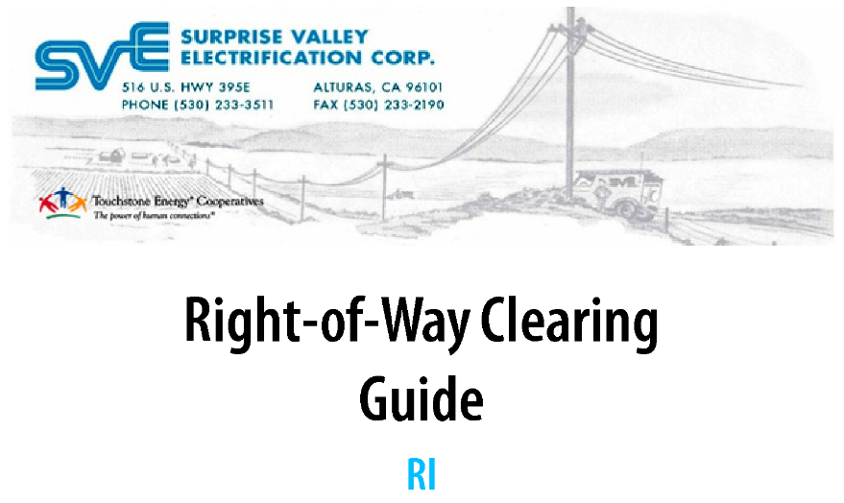

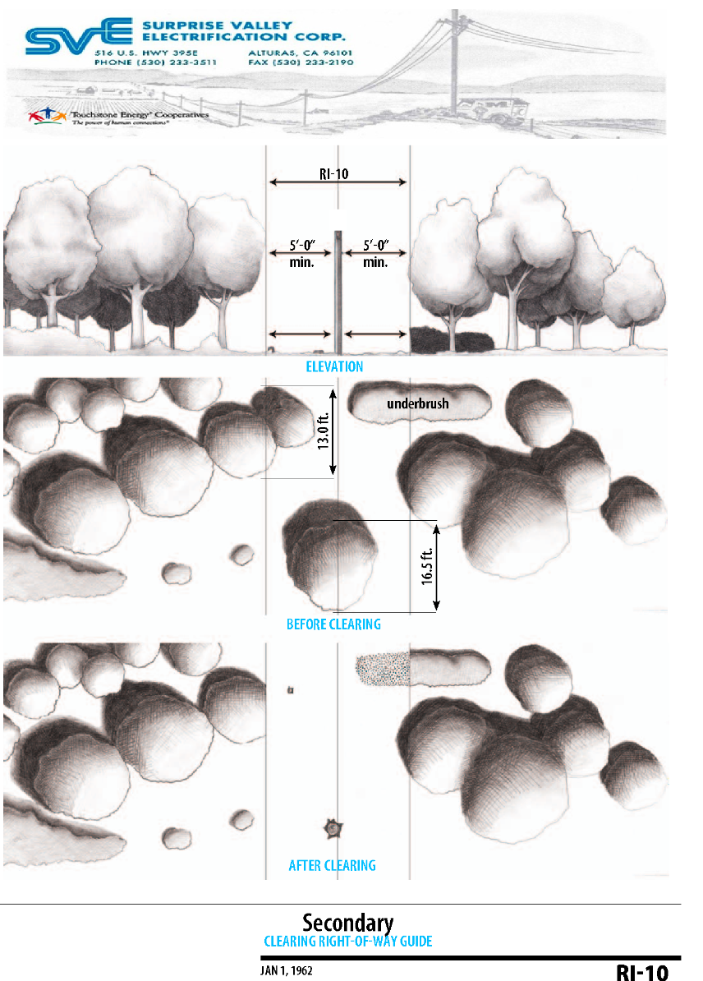
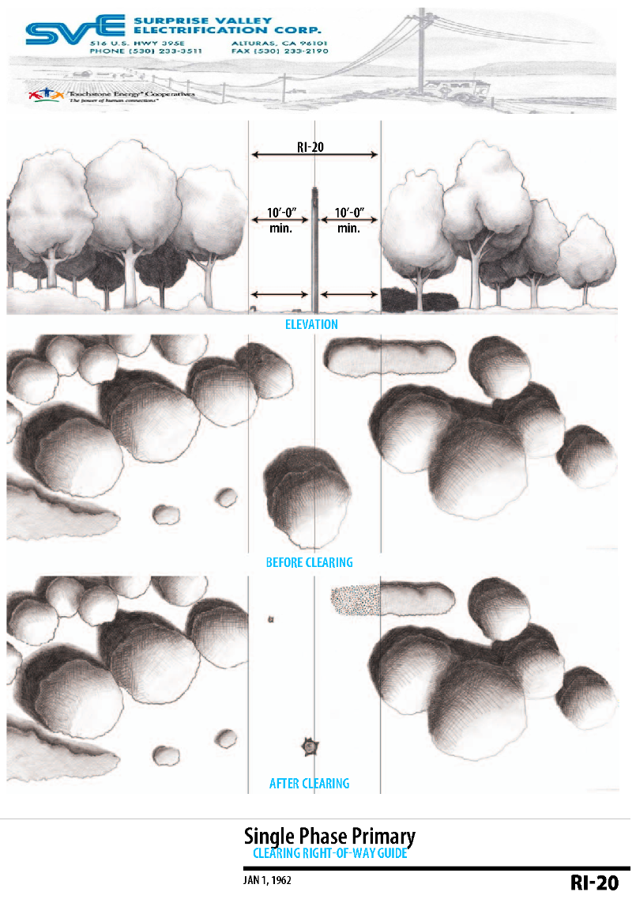
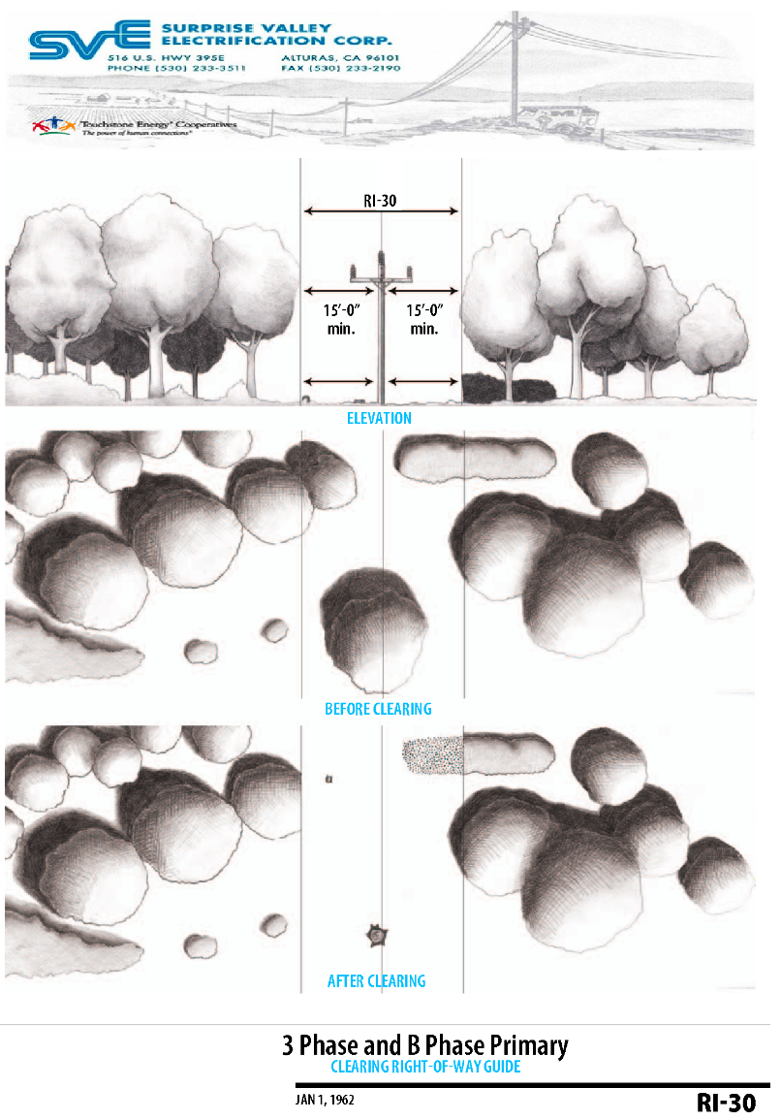
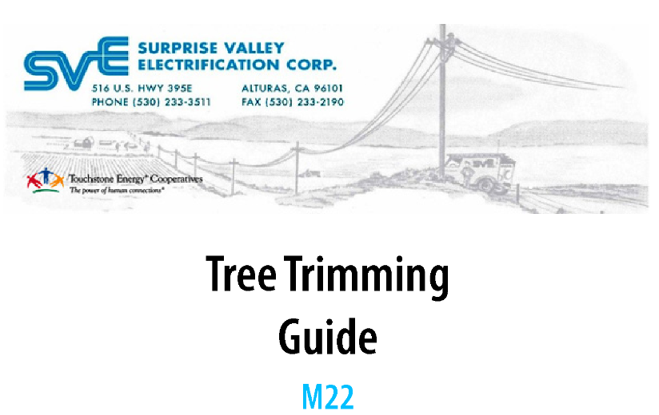

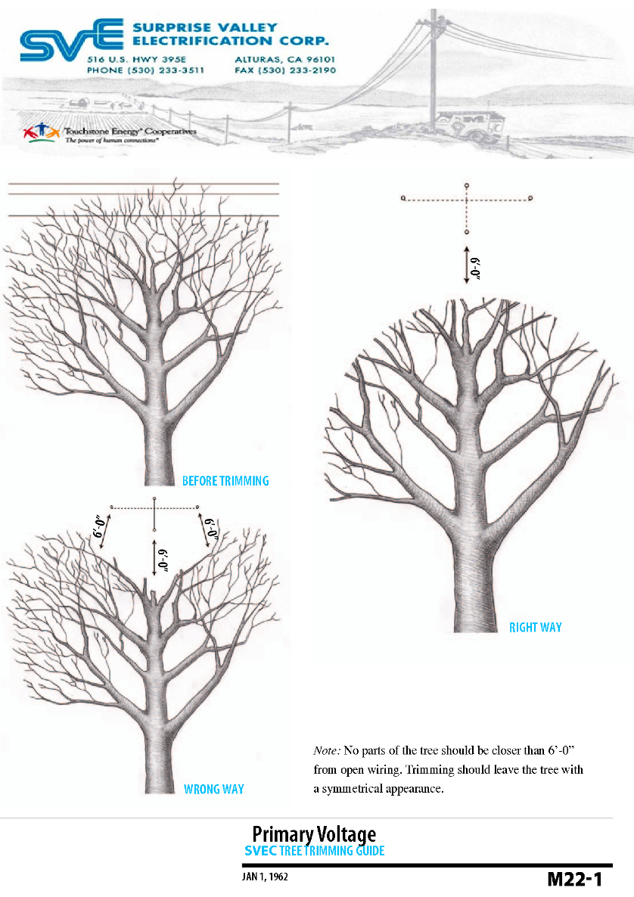
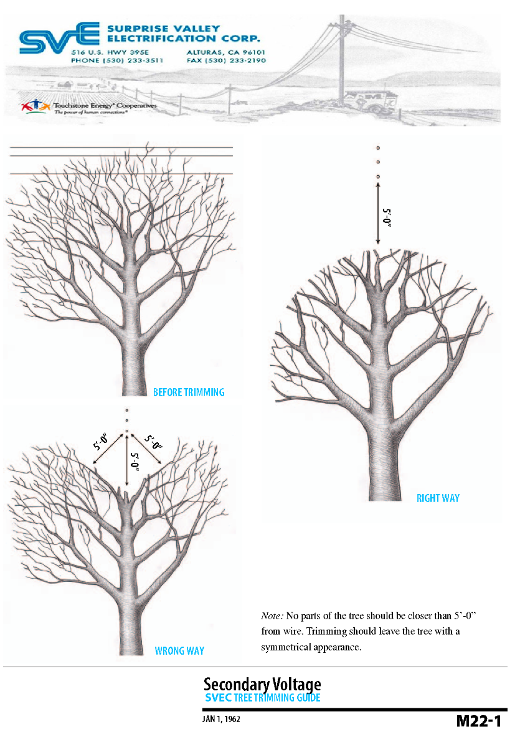
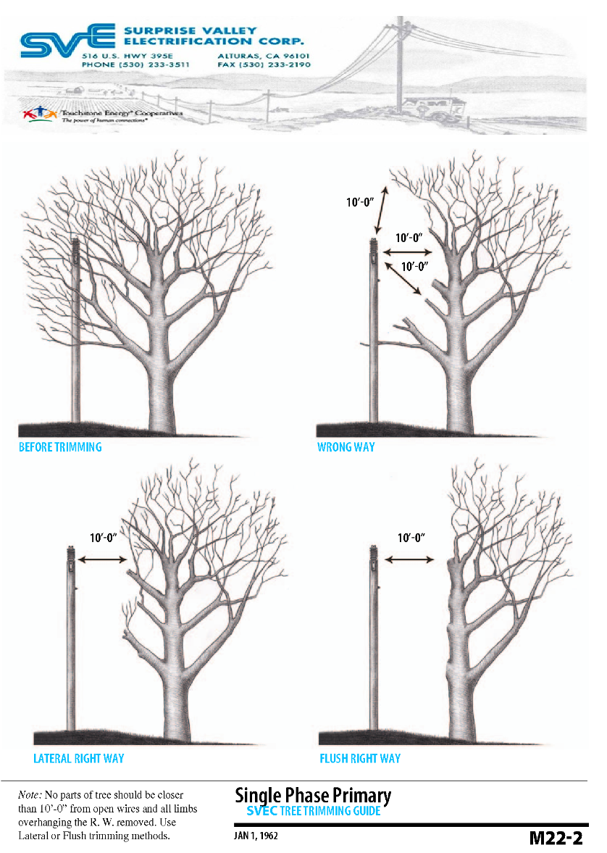
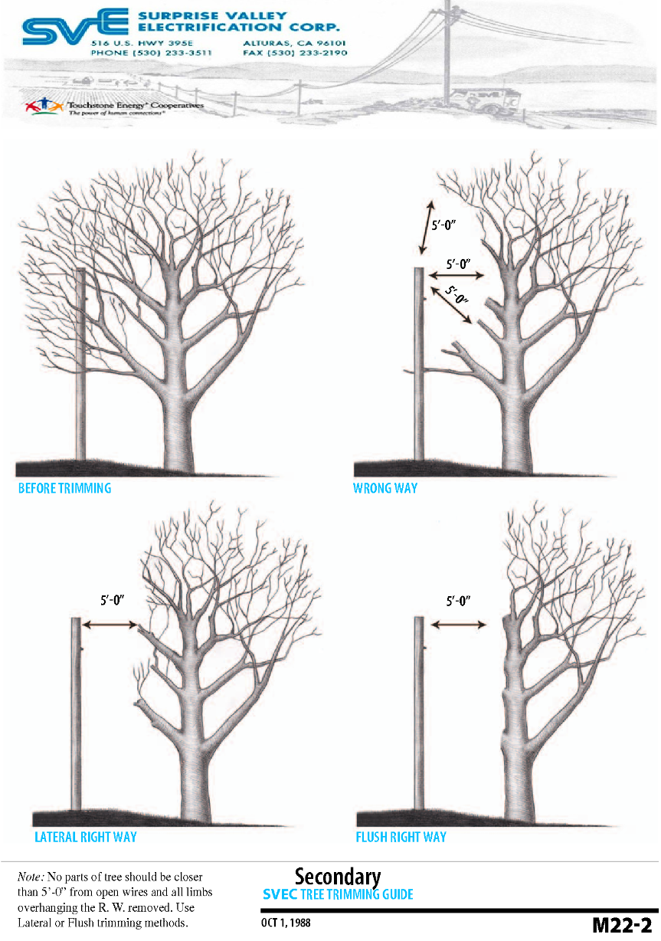

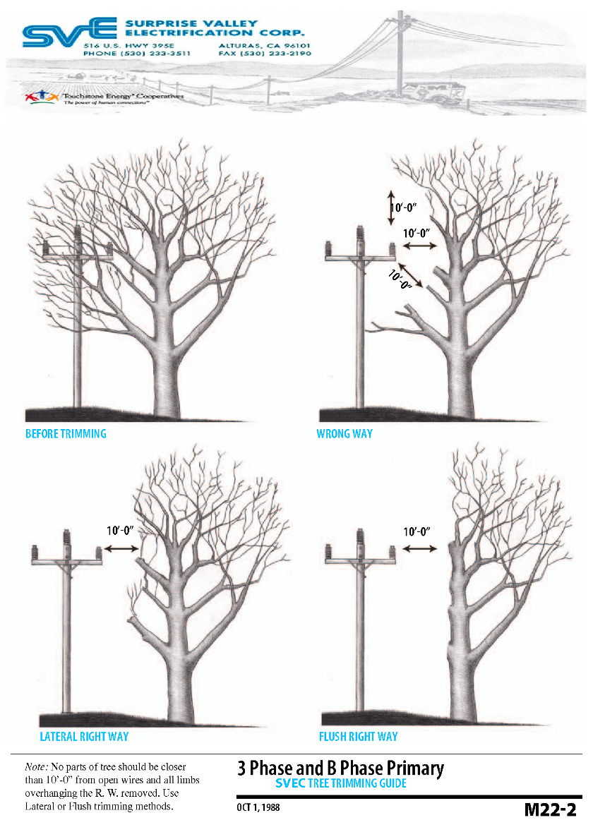

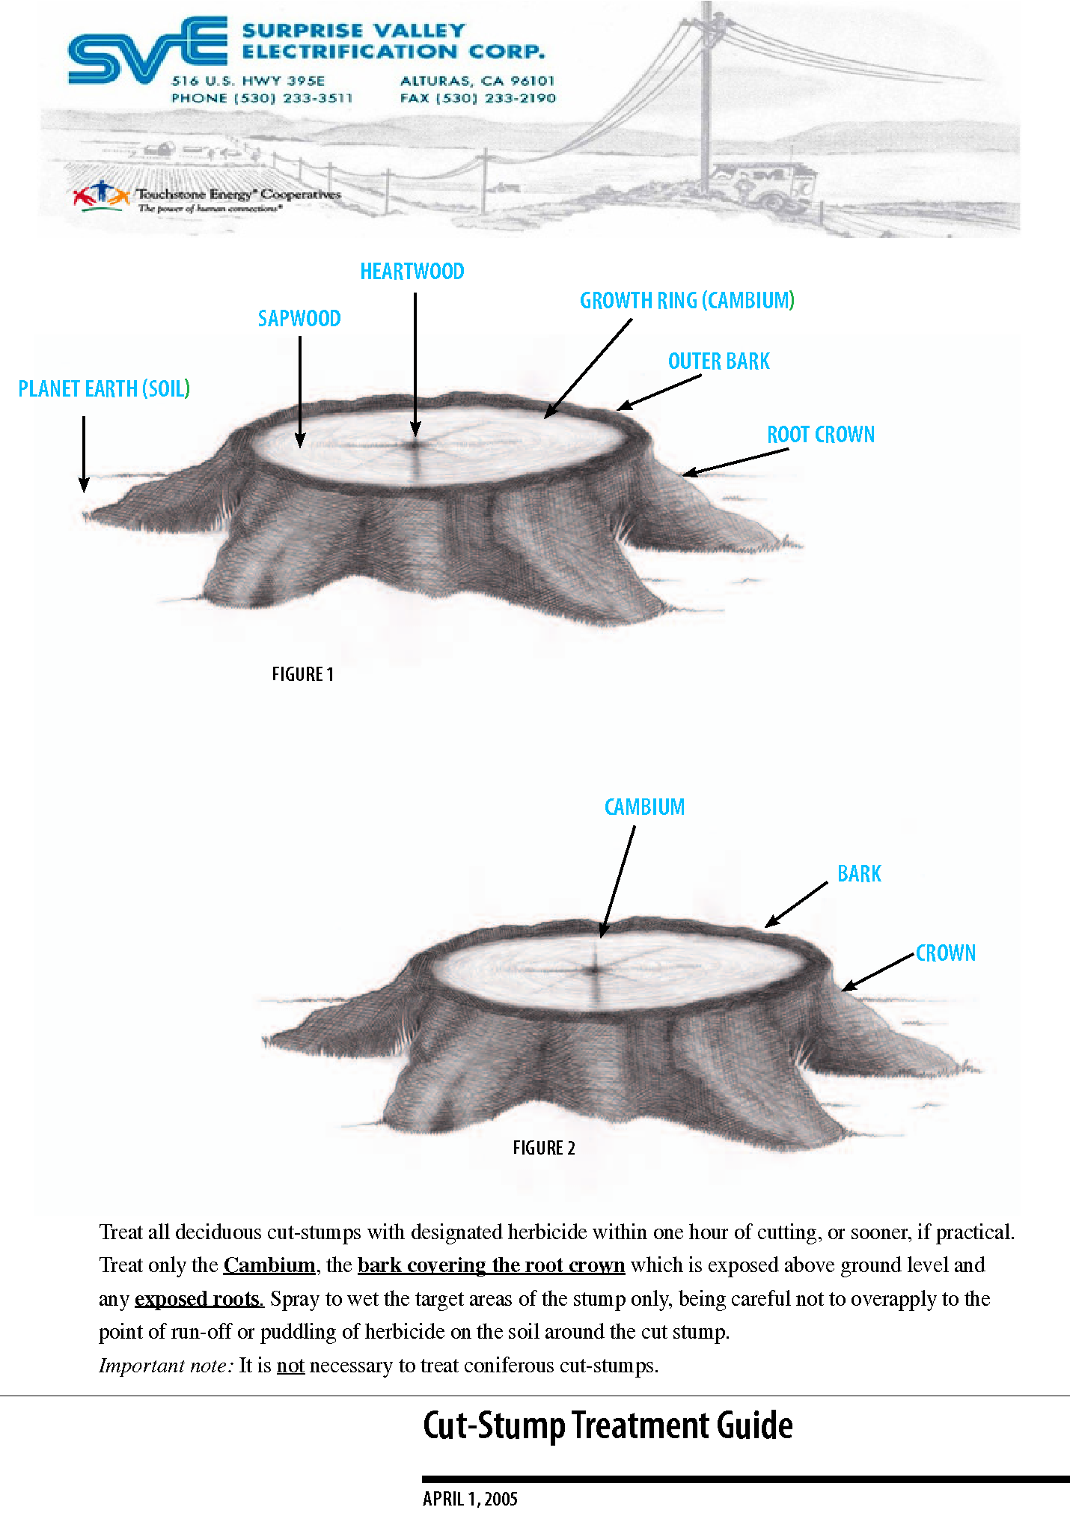


THIS PAGE INTENTIONALLY LEFT BLANK

Appendix F: Defensible Space Requirements - PRC 4291
Zone 1: Within 30 feet of all structures or to the property line
- Remove all branches within 10 feet of any chimney or stovepipe outlet, pursuant to PRC § 4291(a)(4) and 14 CCR § 1299.03(a)(2).
- Remove leaves, needles or other vegetation on roofs, gutters, decks, porches, stairways, etc. pursuant to PRC § 4291 (a)(6) and 14 CCR § 1299.03(a)(1).
- Remove all dead and dying trees, branches and shrubs or other plants adjacent to or overhanging buildings, pursuant to PRC § 4291 (a)(5) and 14 CCR § 1299.03(a)(2).
- Remove all dead and dying grass, plants, shrubs, trees, branches, leaves, weeds and needles, pursuant to 14 CCR § 1299.03(a)(1).
- Remove or separate live flammable ground cover and shrubs, pursuant to PRC § 4291(a)(1) and BOF General Guidelines item1.
- Remove flammable vegetation and items that could catch fire which are adjacent to or below combustible decks, balconies, and stairs, pursuant to 14 CCR § 1299.03(a)(4).
- Relocate exposed wood piles outside of Zone1 unless completely covered in a fire resistive material, pursuant to 14 CCR § 1299.03(a)(3).

Zone 2: Within 30-100 feet of all structures or to the property line
- Cut annual grasses and forbs to a maximum of 4 inches in height, pursuant to 14 CCR § 1299.03(b)(2)(B).
- Remove fuels in accordance with the Fuel Separation or Continuous Tree Canopy guidelines (see back), pursuant to BOF General Guidelines item 4.
- All exposed woodpiles must have a minimum of ten feet (10 feet) clearance, down to bare mineral soil, in all directions, pursuant to 14 CCR § 1299.03(b)(2)(C).
- Dead and dying woody surface fuels and aerial fuels shall be removed. Loose surface litter, normally consisting of fallen leaves or needles, twigs, bark, cones, and small branches, shall be permitted to a maximum depth of three inches (3 in.), pursuant to 14 CCR § 1299.03(b)(2)(A).
Defensible and reduced fuel zone/within 100 feet of all structures or toe the property line
- Logs or stumps embedded in the soil must be removed or isolated from other vegetation, pursuant to BOF General Guidelines item 3

Other requirements:
- Outbuildings and Liquid Propane Gas (LPG) storage tanks shall have ten feet (10 ft.) of clearance to bare mineral soil and no flammable vegetation for an additional ten feet (10 ft.) around their exterior, pursuant to 14 CCR § 1299.03(c)(1).
- Address numbers shall be displayed in contrasting colors (4” min. size) and readable from the street or access road, pursuant to 2013 CFC § 505.1.
- Equip chimney or stovepipe openings with a metal screen having openings between 3/8” and ½”, pursuant to 2013 CBC § 2113.9.2.

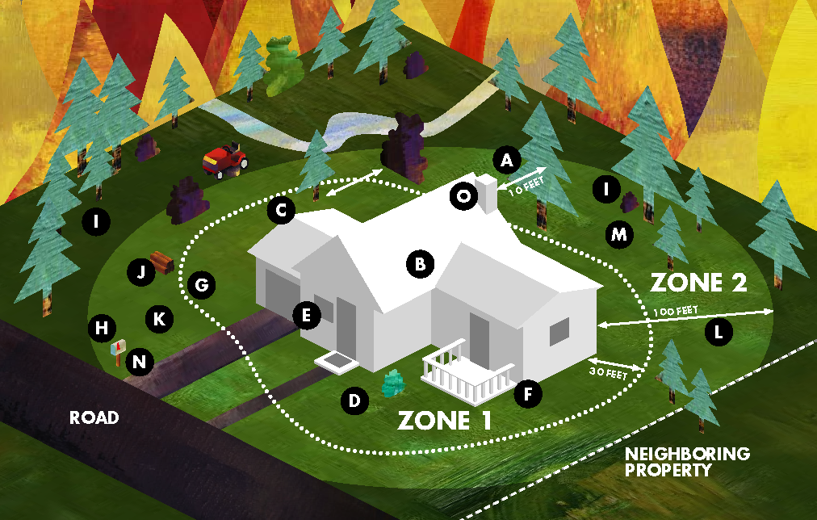
CAL FIRE Defensible Space Requirements Illustration

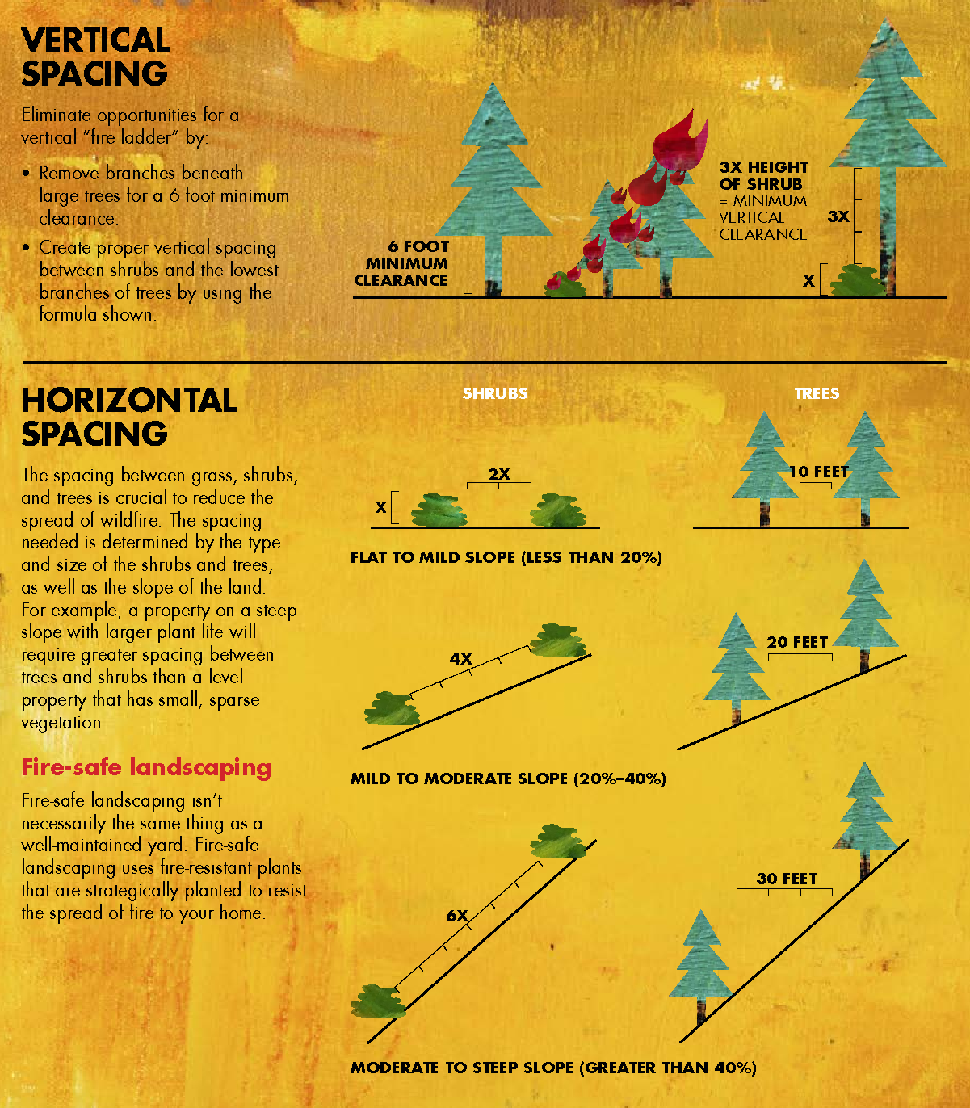
CAL FIRE Vegetation Spacing Guidelines

THIS PAGE INTENTIONALLY LEFT BLANK

Appendix G: Acronym Glossary
ANSI American National Standards Institute
AQS Audit and Quality Services .
BLA Bureau of Indian affairs
BMP Best management practices
BOF Board of Forestry
BPA Bonneville Power Administration
CA California
CCR California Code of Regulation
CDF California Department of Forestry
CFO Chief Financial Officer
CPUC California Public Utilities Commission
DBH Diameter at Breast Height
DLI Detailed Line Inspections
EAM Enterprise Asset Management
EOC Emergency Operation Center
ERM Enterprise Risk Management
LMU Lassen-Modoc Unit
LS Line Superintendent
FAC Facilities Design, Connections and Maintenance
GM General Manager
GO General Order
HFTD High Fire Threat District
ICS Incident Command System
KV Kilovolt
KWH Kilowatt Hours
MW Mega Watts
NFDRS National Fire Danger Rating System
NV Nevada
OH Overhead
OES Office of Emergency Services’
OR Oregon
PRC Public Resources Code
PSPS Public Safety Power Shutoff
PUC Public Utilities Code
QA Quality Assurance
QC Quality Control
RFW Red Flag Warning
ROW Right of Way
SB Senate Bill
SEMS Standardized Emergency Management System
SRA State Responsibility Areas
T&D Transmission and Distribution
SVEC Surprise Valley Electrification Corporation
UG Underground
USFS U.S Forest Service-Pacific Southwest
VM Vegetation Management
VRA Vulnerability Risk Assessment
WMP Wildfire Mitigation Plan

Appendix H: Independent Evaluation

THIS PAGE INTENTIONALLY LEFT BLANK

Appendix I: Public Comments

THIS PAGE INTENTIONALLY LEFT BLANK

Amended by Stats. 2018, Ch. 626, Sec 42. (SB 901) Effective January 1, 2019
PUC DIVISION 1, part 1, Ch. 2, Section326.2 (Added by Stats. 2019, Ch. 79, Sec. 5. (AB 1054) Effective July 12, 2019.)
PUC DIVISION 4.1. Ch 6, 8387, (b)(1) (Amended by Stats. 2019, Ch. 79, Sec. 20. (AB 1054) Effective July 12, 2019.)
Public Resources Code 4292 is administered by the California Dept. of Forestry and Fire Protections (CAL FIRE)
California’s 4th Climate Change Assessment
https://www.drought.gov/drought/states/california
2017 Modoc County Community Wildfire Protection Plan
National Lightning Detection Network (NLDN)
https://www.fire.ca.gov/programs/communications/red-flag-warnings-fire-weather-watches/
Adopted by CPUC Decision 1-24-024
https://bofdata.fire.ca.gov/projects-and-programs/state-responsibility-area-viewer/
Data from CPUC Fire Threat Map adopted 1/19/2018
Data acquired from Oregon Dept. of Forestry / Forest Service Dept. of Agriculture
Data acquired from Nevada Division of Forestry
Author: CDF, PG&E, SCEC & SDG&E
As defined by ANSI 300 Part 7 standards
§ 1255. Exemptions to Minimum Clearance Provisions -PRC 4292.
http://leginfo.legislature.ca.gov/faces/codes_displaySection.xhtml?lawCode=PRC&sectionNum=4291.
Ch 7 of Div. 2 of §8607
SEMS Guidance for Special SVECs
https://rivcoready.org/Have-a-Plan/Evacuations
Source: http://www.fire.ca.gov/fire_protection/downloads/siege/2007/Overview_Glossary.pdf
Source: http://www.cpuc.ca.gov/FireThreatMaps/
Source: https://w1.weather.gov/glossary/index.php?word=Red%20Flag%20Warning
Source: https://www.britannica.com/science/wildfire
State Board of Forestry and Fire Protection (BOF) General Guidelines for Creating Defensible Space 1 February 8, 2006

