

Wildfire
Mitigation
Plan
2026

Version 7.0
(Seventh annual update)
June 8, 2026

Table of Contents
Acronyms and Abbreviations v
Executive Summary vii
Wildfire Mitigation Program Highlights vii
Layered Wildfire Mitigation Strategy viii
Prevention viii
Detection viii
Looking Ahead ix
I. Utility Overview and Context 1
A. Utility Description and Context Setting Table 1
B. Statutory Cross-Reference Table 8
C. Process for Utility Adoption and Submittal of Annual WMP and Opportunities for Public Comment 12
D. Description of Where WMP Information Can Be Found on Utility Website 13
E. Purpose of the WMP 13
F. Organization of the WMP 13
II. Objectives of the WMP 14
A. Minimizing Sources of Ignition 14
B. Resiliency of the Electric Grid 14
C. Minimizing Unnecessary or Ineffective Actions 14
III. Roles and Responsibilities 15
A. TDPUD Roles and Responsibilities 15
B. Coordination with Water Utilities/Department 16
C. Coordination with Communication Infrastructure Providers 17
D. Standardized Emergency Management System 17
IV. Wildfire Risks and Drivers 19
A. Particular Risks and Drivers Associated with Design, Construction, Operation, and Maintenance 19
B. Particular Risks and Risk Drivers Associated with Topographical and Climatological Risk Factors 20
Climate Change 20
C. Enterprise-Wide Safety Risks 21
D. Changes to the CPUC Fire Threat Map 21
V. Wildfire Preventative Strategies 22
A. High Fire Threat Map for TDPUD 22
B. Weather Monitoring 22
C. Design and Construction Standards 23
System Hardening Program 24
Non-Expulsion Current-Limiting Fuses 24
Fr3 Insulating Fluid 24
Covered Primary Jumper Wire And Conductors 25
Proposed Service Requirements 25
Tree Attachments (Legacy Attachments) 25
Advanced Metering Infrastructure 26
Outage Management System (OMS) 26
Supervisory Control and Data Acquisition 27
D. Vegetation Management 27
E. Inspections 28
F. Workforce Training 29
G. Recloser Policy 29
H. De-Energization 29
Impacts to Public Safety 31
Customer Notification Protocols 31
VI. Community Outreach and Public Awareness 32
VII. Restoration of Service 33
VIII. Evaluating the Plan 34
A. Wildfire Mitigation Implementation Plan (2026–2028) 34
Annual Review and Continuous Improvement 40
B. Metrics and Assumptions for Measuring Plan Performance 41
Metric 1 – Fire Ignitions 41
Metric 2 – Outage Causes 41
Metric 3 – Vegetation Management 43
Metric 4 – Red Flag Warnings 43
Metric 5 – Reliability Metrics 44
C. Impacts of Metrics on the Plan 44
D. Monitoring and Auditing the Plan 45
E. Identifying and Correcting Deficiencies in the Plan 45
F. Monitoring the Effectiveness of Inspections 45
G. Independent Auditor 46
IX. WMP Adoption Process 46
X. References 47

Tables
Utility Description and Context Setting Table 3
Statutory Cross Reference Table 8
SMART Goal Summary Table 35
2026–2028 Wildfire Mitigation SMART Goals Table 35
2025 Wildfire Season Outage Report 42
Figure
1 TDPUD Electric Service Territory 12
Appendixces
A CPUC High Fire Threat District Map for the Truckee Donner Public Utility
B Prevailing Wind Map
C Vegetation Management Program
D Preemptive Power Shutoff - Standard Operating Procedure
E Weather and Risk Intelligence (Cloudfire) Dashboard

Acronyms and Abbreviations
Acronym/Abbreviation | Definition
AGM | Assistant General Manager
AMI | advanced metering infrastructure
CAL FIRE | California Department of Forestry and Fire Protection
CPUC | California Public Utilities Commission
ELF | Energy Limiting Fuse
GIS | geographic information system
GO | General Order
HFTD | High Fire Threat District
kV | kilovolt
NCJPA | Northern California Joint Pole Association
NISC | National Information Solutions Cooperative
OMS | Outage Management System
PIO | Public Information Officer
PPS | Preemptive Power Shutoff
PSOM | Public Safety Outage Management
PSPS | Public Safety Power Shutoff
RFW | Red Flag Warning
SCADA | Supervisory Control and Data Acquisition
SEMS | Standardized Emergency Management System
TDPUD | Truckee Donner Public Utility District
VMP | Vegetation Management Plan
WMP (or Plan) | Wildfire Mitigation Plan

Executive Summary
The Truckee Donner Public Utility District (TDPUD or District) is committed to providing safe, reliable, and resilient electric service while reducing the risk of utility-related wildfire ignitions. The District's Wildfire Mitigation Plan (WMP or Plan) establishes a comprehensive, risk-based approach to wildfire prevention through strategic investments in infrastructure, advanced technologies, vegetation management, operational readiness, and continuous improvement.
Prepared in accordance with California Public Utilities Code Section 8387, as amended by Senate Bill 254, this Wildfire Mitigation Plan documents the District's wildfire mitigation strategies, operational practices, and long-term investment priorities. The Plan reflects TDPUD's commitment to protecting public safety, enhancing system reliability, reducing wildfire risk, and adapting to evolving environmental conditions and regulatory requirements.

Wildfire Mitigation Program Highlights
Since 2025, TDPUD has significantly expanded its wildfire mitigation program through targeted investments in infrastructure, advanced protection technologies, situational awareness, and operational preparedness. These investments have strengthened the District's ability to reduce wildfire ignition risk, improve system reliability, and enhance operational readiness during elevated fire weather conditions. Major initiatives include:
- Established an annual overhead system hardening program targeting approximately six miles of distribution line improvements utilizing ductile iron poles, covered conductor, and composite crossarms.
- Deployed approximately 378 Gridware line sensors and three weather stations to enhance system monitoring and situational awareness.
- Integrated CloudFire weather forecasting, Composite Risk Index (CRI), and AlertWest camera systems to support operational decision-making.
- Implemented a comprehensive vegetation management program supported by LiDAR analysis, annual inspections, enhanced patrols, and risk-based asset inspections.
- Developed Public Safety Power Shutoff (PSPS) procedures supported by Incident Command System (ICS) training, tabletop exercises, and emergency response planning.
- Implemented FAST Trip (Adaptive Protection Settings Scheme – APSS) to reduce fault clearing times during elevated wildfire risk conditions.
- Initiated a phased Fault Tamer Fuse program to improve protection coordination and wildfire resilience on the Glenshire 14.4-kilovolt (kV) distribution system.
- Continued strategic investments in asset inspection, maintenance, and infrastructure replacement to improve system resilience and reduce wildfire ignition risk.

Layered Wildfire Mitigation Strategy
TDPUD's wildfire mitigation program is built upon a layered defense strategy that integrates prevention, detection, and protection to reduce the likelihood of utility-related wildfire ignitions while enhancing system reliability and operational resiliency. Rather than relying on a single mitigation measure, the District employs multiple complementary strategies that work together to reduce wildfire risk.

Prevention
The prevention layer focuses on reducing the likelihood of a wildfire ignition through proactive infrastructure investments, vegetation management, inspections, and engineering practices.
System Hardening
- Covered conductor
- Ductile iron poles
- Composite crossarms
- CAL FIRE–approved non-expulsion fuse technology, where appropriate
Vegetation Management
- Routine vegetation inspections and clearances
- LiDAR-supported vegetation analysis
- Targeted hazard tree mitigation
Inspections and Patrols
- GO 165 inspections
- Enhanced patrols before and after Red Flag Warning events
- Risk-based asset inspections
Industry Expert Support
- Engineering support
- Wildfire mitigation planning
- Continuous improvement and incorporation of industry best practices

Detection
The detection layer enhances situational awareness by providing real-time information about system conditions and wildfire risk.
Line Sensor Technology
- Approximately 378 Gridware line sensors
- Real-time fault detection
- Conductor monitoring
- Predictive operational awareness
Situational Awareness
- Weather station network
- CloudFire weather forecasting
- Composite Risk Index (CRI)
- AlertWest camera network
- SCADA and Outage Management System (OMS)
- Protection
The protection layer minimizes wildfire ignition potential through advanced protection settings and operational response strategies.
Fast Trip Settings (APSS)
- Adaptive Protection Settings
- Reduced fault clearing times during elevated fire weather conditions
Non-Reclose Settings
- Temporary operational settings during elevated wildfire risk
- Reduces the potential for restrike events following a fault
Preemptive Power Shutoff (PPS)
- Risk-based de-energization during extreme wildfire conditions
- Last-resort protective measure to protect life and property
Together, these three layers provide a comprehensive wildfire mitigation strategy that reduces wildfire risk through prevention, early detection, and rapid protective actions.

Looking Ahead
TDPUD is committed to continuously strengthening its wildfire mitigation program through measurable performance objectives and long-term capital investment. Key priorities for 2026 through 2028 include:
- Continue the District's annual overhead system hardening program targeting approximately six miles of distribution improvements each year.
- Complete implementation of FAST Trip (APSS) on applicable distribution circuits by the end of 2026.
- Complete engineering of the Fault Tamer Fuse program in 2026, followed by phased installation on the Glenshire 14.4 kV distribution system beginning in 2027.
- Continue annual investments in Gridware line sensors and advanced situational awareness technologies.
- Expand LiDAR-supported vegetation management and risk-based asset inspection programs.
- Continue enhancing Public Safety Power Shutoff procedures and emergency preparedness capabilities.
- Update the Wildfire Mitigation Plan, as required, to incorporate lessons learned, technological advancements, and evolving regulatory requirements.
TDPUD recognizes that wildfire mitigation is an ongoing responsibility requiring continuous investment, evaluation, and improvement. Through implementation of this Wildfire Mitigation Plan, the District will continue strengthening the safety, reliability, and resilience of its electric system while protecting the communities, customers, and natural resources it serves.

I. Utility Overview and Context

A. Utility Description and Context Setting Table
The Truckee Donner Public Utility District (TDPUD) is a special district of the State of California engaged in the distribution, sale, and delivery of electric power and water. TDPUD provides retail electric service to 14,838 customer accounts as of December 31, 2024; the region also has a large transient population driven by second homeowners and destination tourism, which can increase population by two to three times. TDPUD’s local primary transmission system is connected to the NV Energy transmission system and is located high on the eastern slope of the Sierra Nevada. TDPUD’s electric service territory comprises approximately 44 square miles in eastern Nevada County and approximately 1.5 square miles in adjacent Placer County. The electric system includes approximately 225 miles total. with 135 miles of 12.47 kV and 14.4 kV overhead distribution lines, as well as about 0.5 miles of 60 kV overhead transmission lines. In total, TDPUD has about 5,500 poles in its service territory (Figure 1).
Summary of Changes to the TDPUD 2026 WMP:
This Plan has been updated as part of the regular annual review process to include current data and information. Key changes to the 2026 WMP include:
- This Summary of Changes to the TDPUD 2026 Wildfire Mitigation Plan (WMP) highlights key updates, program advancements, and new technologies implemented since the 2025 WMP
- TDPUD has expanded its grid monitoring and situational awareness capabilities through deployment of approximately 378 Gridware (Gridscope) devices, including three weather stations installed across two complete circuits and a portion of a third circuit. These devices provide:
  - Real-time detection of faults and line disturbances
  - High-resolution operational data and visual monitoring
  - Hyper-local weather conditions (wind, temperature, humidity)
  - Enhanced ability to rapidly detect, locate, and respond to potential ignition events, reducing outage duration and wildfire risk
- TDPUD has significantly enhanced its weather monitoring capabilities by integrating Gridware weather station functionality with existing NOAA data sources, improving localized forecasting and supporting more informed operational decision-making during elevated fire risk conditions.
- TDPUD continues implementation of its System Hardening Program, maintaining a target of six miles per year, utilizing:
  - Ductile iron (metal) poles
  - Covered conductor (tree wire)
  - Fiberglass/composite crossarms
These improvements are designed to reduce ignition risk, improve system resilience, and minimize outage frequency in high fire threat areas.
- TDPUD has updated its Design and Construction Standards to reflect ongoing system hardening efforts, including expanded use of covered conductor, continued intrusive pole inspections to prioritize replacements, and completion of the Non-Expulsion Current-Limiting Fuse program across nearly the entire system.
- TDPUD has enhanced its performance tracking and reporting by continuing to refine key reliability metrics, including:
  - SAIFI (System Average Interruption Frequency Index) – measuring outage frequency across all customers
  - SAIDI (System Average Interruption Duration Index) – measuring total outage duration
  - CAIDI (Customer Average Interruption Duration Index) – measuring restoration time for affected customers
  - These metrics are increasingly used to quantify the effectiveness of wildfire mitigation and system hardening investments.
- TDPUD has developed and implemented a formal Preemptive Power Shutoff (PPS) Standard Operating Procedure, consistent with District Code authority, to proactively de-energize portions of the system during extreme fire weather conditions. This program includes:
  - Defined operational triggers based on weather and system conditions
  - Integration with emergency response protocols (ICS structure)
  - Coordination with regional partners and public communication strategies
TDPUD has transitioned from planning to full implementation of its preemptive de-energization program, strengthening its ability to reduce wildfire ignition risk during Red Flag and high wind events.
- TDPUD is in the process of implementing Advanced Power Safety Settings (APSS) on select circuits to further reduce wildfire ignition risk during elevated fire weather conditions:
  - Adjusts protective device settings to trip faster under fault conditions
  - Reduces fault energy and duration, lowering the likelihood of ignition
  - Will be utilized during high-risk periods such as Red Flag Warnings and high wind events
  - May increase momentary or sustained outages as a tradeoff to enhance public safety and wildfire risk mitigation
- TDPUD continues to invest in Supervisory Control and Data Acquisition (SCADA), Graphic Information Systems (GIS), and Outage Management Systems (OMS) to enhance situational awareness, operational responses, and communications.
- California’s strict liability standards (Inverse Condemnation), civil liability exposure, and the lack of affordable wildfire insurance remain a major threat to electric utilities.
Utility Description and Context Setting Table
Utility Name | Truckee Donner Public Utility District (TDPUD)
Service Territory Size | 45.5 square miles
Owned Assets | ☒ Transmission ☒ Distribution ☐ Generation
Number of Customers Served | 14,838 customer accounts
Population Within Service Territory | 16,778 people (full-time population as reported by Town of Truckee using data from Census)  34,825 people (actual population using people per dwelling unit data from Census)
Customer Class Makeup | Number of Accounts | Share of Total Load (MWh)
Customer Class Makeup | 89% Residential  2% Government  0% Agricultural  8.9% Small/Medium Business  0.1% Commercial/Industrial | 56% Residential  18% Government  0% Agricultural  21% Small/Medium Business  5% Commercial/Industrial
Service Territory | <1% Agriculture  <3% Barren/Other  ~55% Conifer Forest  0% Conifer Woodland
Location/Topography¹ | 0% Desert  <.75% Hardwood Forest  0% Hardwood Woodland ~3% Herbaceous  <30% Shrub  ~8% Urban  <5% Water
Service Territory Wildland Urban Interface (based on total area) | 30% Wildland Urban Interface 20% Wildland Urban Intermix
Percent of Service Territory in CPUC High Fire Threat Districts (based on total area) | ☒ Includes maps (Appendix A)  Tier 2: 55%  Tier 3: 27%
Prevailing Wind Directions and Speeds by Season | ☒ Includes maps (Appendix B)  Prevailing winds were taken from both the Global Winds Atlas and Wind Rose data from archived records and assembled by Iowa State University. Gradient winds are generally out of the south/southwest shifting to the west/southwest in the spring and summer months. The average wind speed is 4.4 mph, with frequent gusts in excess of 20 mph throughout the year. TDPUD’s extreme weather and wind events occur in the winter months, when wildfire threat is typically low. These events are caused by atmospheric rivers and can bring winds in excess of 100 mph. These atmospheric river events and heavy snowfalls are the reason TDPUD builds to a heavy loading standard and is able to withstand extreme weather events.  Source: https://globalwindatlas.info; https://mesonet.agron.iastate.edu/  sites/windrose.phtml?network=CA_ASOS&station=TRK
Miles of Owned Lines Underground and/or Overhead | Overhead Dist.: ~135 miles  Overhead Trans.: <0.5 miles  Underground Dist.: ~100 miles  Underground Trans.: 0 miles
Miles of Owned Lines Underground and/or Overhead | Explanatory Note 1 - Methodology for Measuring “Miles”: [e.g., circuit miles, line miles.] Data from GIS system
Miles of Owned Lines Underground and/or Overhead | Explanatory Note 2 – Description of Unique Ownership Circumstances: N/A
Miles of Owned Lines Underground and/or Overhead | Explanatory Note 3 – Additional Relevant Context: [e.g., percentage of lines located outside service territory] N/A
Percent of Owned Lines  in CPUC High Fire  Threat Districts | Overhead Distribution Lines as % of Total Distribution System  (Inside and Outside Service Territory)
Percent of Owned Lines  in CPUC High Fire  Threat Districts | Tier 2: 23%  Tier 3: 64%
Percent of Owned Lines  in CPUC High Fire  Threat Districts | Overhead Transmission Lines as % of Total Transmission System  (Inside and Outside Service Territory)
Percent of Owned Lines  in CPUC High Fire  Threat Districts | Tier 2: 100%  Tier 3: 0%
Percent of Owned Lines  in CPUC High Fire  Threat Districts | Explanatory Note 4 – Additional Relevant Context: [e.g., explain any difference from data reported in WMP due to different numerator used for this form]
Customers have ever lost service due to an IOU PSPS event? | Yes ☒ No
Customers have ever been notified of a potential loss of service to due to a forecasted IOU PSPS event? | ☒Yes ☐ No
Has developed protocols to pre-emptively shut off electricity in response to elevated wildfire risks? | ☒Yes ☐ No  In 2025, the TDPUD developed protocols to preemptively shut off electricity in response to elevated wildfire risk.
Has previously preemptively shut off electricity in response to elevated wildfire risk? | Yes ☒ No  If yes, then provide the following data for calendar year 2024:Number of shut-off events: N/A  Customer Accounts that lost service for >10 minutes: N/A  For prior response, average duration before service restored: N/A
Notes: TDPUD = Truckee Donner Public Utility District; CPUC = California Public Utilities Commission; GIS = geographic information system; N/A = not applicable; IOU = Investor-Owned Utilities; PSPS = Public Safety Power Shutoff.

B. Statutory Cross-Reference Table
The table below explains where TDPUD’s WMP addresses regulatory requirements.
Statutory Cross Reference Table
Requirement | Statutory Language | Location in TDPUD’s WMP
Persons  Responsible | PUC Section 8387(b)(2)(A): An accounting of the responsibilities of persons responsible for executing the plan. | Section: 3  Pages: 14–15
Objectives of  the Plan | PUC Section 8387(b)(2)(B): The objectives of the wildfire mitigation plan. | Section: 2  Pages: 13–14
Preventive  Strategies | PUC Section 8387(b)(2)(C): A description of the preventive strategies and programs to be adopted by the local publicly owned electric utility or electrical cooperative to minimize the risk of its electrical lines and equipment causing catastrophic wildfires, including consideration of dynamic climate change risks. | Section: 5  Pages: 20–30
Evaluation  Metrics | PUC Section 8387(b)(2)(D): A description of the metrics the local publicly owned electric utility or electrical cooperative plans to use to evaluate the wildfire mitigation plan’s performance and the assumptions that underlie the use of those metrics. | Section: 8  Pages: 32–35
Impact of Metrics | PUC Section 8387(b)(2)(E): A discussion of how the application of previously identified metrics to previous wildfire mitigation plan performances has informed the wildfire mitigation plan. | Section: 8  Page: 35
De-energization  Protocols | PUC Section 8387(b)(2)(F): Protocols for disabling reclosers and de-energizing portions of the electrical distribution system that consider the associated impacts on public safety and protocols related to mitigating the public safety impacts of those protocols, including impacts on critical first responders and on health and communication infrastructure. | Section: 5  Pages: 28–29
Customer  Notification  Procedures | PUC Section 8387(b)(2)(G): Appropriate and feasible procedures for notifying a customer who may be impacted by the de-energizing of electrical lines. The procedures shall consider the need to notify, as a priority, critical first responders, health care facilities, and operators of telecommunications infrastructure. | Section: 5  Pages: 29–30
Vegetation  Management | PUC Section 8387(b)(2)(H): Plans for vegetation management. | Section: 5  Pages: 26
Inspections | PUC Section 8387(b)(2)(I): Plans for inspections of the local publicly owned electric utility’s or electrical cooperative’s electrical infrastructure. | Section: 5  Page: 27
Prioritization of  Wildfire Risks | PUC Section 8387(b)(2)(J): A list that identifies, describes, and prioritizes all wildfire risks, and drivers for those risks, throughout the local publicly owned electric utility’s or electrical cooperative’s service territory. The list shall include, but not be limited to, both of the following:  (i) Risks and risk drivers associated with design, construction, operation, and maintenance of the local publicly owned electric utility’s or electrical cooperative’s equipment and facilities.  (ii) Particular risks and risk drivers associated with topographical and climatological risk factors throughout the different parts of the local publicly owned electric utility’s or electrical cooperative’s service territory. | Section: 4  Pages: 18–20
CPUC Fire Threat  Map Adjustments | PUC Section 8387(b)(2)(K): Identification of any geographic area in the local publicly owned electric utility’s or electrical cooperative’s service territory that is a higher wildfire threat than is identified in a commission fire threat map, and identification of where the commission should expand a high fire threat for TDPUD based on new information or changes to the environment. | Section: Appendix A  Page: Attached
Enterprise-wide  Risks | PUC Section 8387(b)(2)(L): A methodology for identifying and presenting enterprise-wide safety risk and wildfire-related risk. | Section: 4  Page: 20
Restoration of  Service | PUC Section 8387(b)(2)(M): A statement of how the local publicly owned electric utility or electrical cooperative will restore service after a wildfire. | Section: 7  Pages: 31
Monitor and  Audit | PUC Section 8387(b)(2)(N): A description of the processes and procedures the local publicly owned electric utility or electrical cooperative shall use to do all of the following:  (i) Monitor and audit the implementation of the wildfire mitigation plan.  (ii) Identify any deficiencies in the wildfire mitigation plan or its implementation and correct those deficiencies.  (iii) Monitor and audit the effectiveness of electrical line and equipment inspections, including inspections performed by contractors, that are carried out under the plan, other applicable statutes, or commission rules. | Section: 8  Pages: 35–36
Qualified  Independent  Evaluator | PUC Section 8387(c): The local publicly owned electric utility or electrical cooperative shall contract with a qualified independent evaluator with experience in assessing the safe operation of electrical infrastructure to review and assess the comprehensiveness of its wildfire mitigation plan. The independent evaluator shall issue a report that shall be made available on the internet website of the local publicly owned electric utility or electrical cooperative and shall present the report at a public meeting of the local publicly owned electric utility’s or electrical cooperative’s governing board. | Section: 9  Pages: 36–37
Notes: TDPUD = Truckee Donner Public Utility District; WMP = Wildfire Mitigation Plan; PUC = Public Utilities Code.
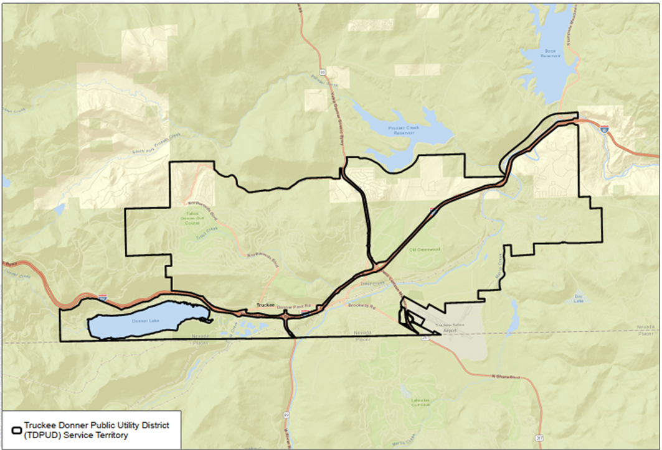
Figure 1. TDPUD Electric Service Territory

C. Process for Utility Adoption and Submittal of Annual WMP and Opportunities for Public Comment
The TDPUD Wildfire Mitigation Plan (WMP or Plan) is adopted by the TDPUD Board of Directors (Board) during a public meeting. TDPUD staff present the final version of the annual WMP to the Board for review. Included with the Plan is an agenda packet with a summary of the background and the contents of the current WMP. The agenda packet also includes a description of major changes from the previous year’s WMP.
During the Board meeting, consideration for the adoption of the current WMP is presented as an action item. TDPUD staff present an overview of the WMP, accomplishments, and changes to the Board members and the general public. After the conclusion of the presentation, Board members allow a period for public comment. After the public comment period has ended, Board members consider adoption of the WMP as presented by TDPUD staff.
Board meeting documents, including meeting minutes, agendas, and presentations, as well as the meeting minutes and the agenda for the adoption of the 2026 WMP, are available online at the TDPUD website: https://web.tdpud.org/WebLink/Browse.aspx?id=289229&dbid=
0&repo=TDPUD.

D. Description of Where WMP Information Can Be Found on Utility Website
The current version of TDPUD’s WMP is published on the utility website on the page dedicated to wildfire mitigation, safety, and emergency preparedness. The webpage contains information about TDPUD’s wildfire prevention mitigation efforts, links to sign up for emergency notification by the utility, and links to the WMP from 2026 and previous WMPs and independent evaluator reports.
This page is easily accessible from the menu on TDPUD’s home page and can be found by using the search tool on every page on the utility’s website. The link to the website is: https://www.tdpud.org/departments/wildfire-emergency-preparedness.

E. Purpose of the WMP
This WMP describes the range of activities and strategies TDPUD is using to mitigate the threat of overhead power line- and equipment-ignited wildfires, including its various programs, policies, and procedures. It addresses the unique features of TDPUD’s service area such as topography, weather, infrastructure, grid configuration, and potential wildfire risks.
This Plan is subject to direct approval by TDPUD’s Board of Directors and is implemented by the General Manager. This Plan meets or exceeds the requirements of Public Utilities Code Section 8387 for publicly owned electric utilities to prepare a WMP by January 1, 2020, and to evaluate and update annually thereafter.

F. Organization of the WMP
This WMP includes the following elements:
- Utility overview and context
- Objectives of the Plan
- Roles and responsibilities for executing the Plan
- Identification of key wildfire risks and risk drivers
- Description of wildfire prevention strategies
- Metrics for measuring performance of the Plan and identifying areas for improvement
- Annual and historical results for metrics
- Description of community outreach and education, covering communication about wildfire prevention, utility mitigation efforts and strategies, and potential de-energization and re-energization practices
- List of references cited
- Appendices

II. Objectives of the WMP

A. Minimizing Sources of Ignition
The primary objective of this Plan is to establish and implement actionable measures that enhance the reliability and safety of TDPUD’s electric distribution system while reducing the likelihood that TDPUD’s infrastructure may serve as an origin or contributing factor in the ignition of wildfire. TDPUD has conducted a thorough evaluation of prudent and cost-effective enhancements to its physical assets, operational procedures, and workforce training to support this objective. In addition, TDPUD is updating its operational practices to reflect a continued commitment to responsible system management and will actively pursue additional opportunities to improve the effectiveness of this Plan. The Plan encompasses programs focused on safety, prevention, mitigation, and recovery, in alignment with applicable California State laws.

B. Resiliency of the Electric Grid
The secondary objective of this Plan is to ensure and improve, where practicable, system resiliency. System resiliency is defined by the National Infrastructure Advisory Council as the ability to reduce the magnitude and/or duration of disruptive events. As part of the development of this Plan, TDPUD assesses new industry practices and technologies that will reduce the likelihood of a disruption in service and improve the timeline for restoration of service.

C. Minimizing Unnecessary or Ineffective Actions
The final objective of this Plan is to evaluate the effectiveness of specific mitigation strategies as they pertain to TDPUD’s operations. In instances where an action, program component, or protocol is determined to be unnecessary or ineffective, TDPUD will assess the appropriateness of modifying or replacing the measure in question. This evaluative approach will also support the identification of more cost-effective alternatives that may yield equal or superior outcomes. This is especially relevant in the adoption of new technologies and operational practices, where a phased approach—from prototype development to pilot deployment to full-scale implementation—is often warranted to optimize performance and minimize the risk of unintended consequences.

III. Roles and Responsibilities

TDPUD Roles and Responsibilities

TDPUD utilizes a Public-Owned Utility Board/General Manager reporting hierarchy.
Board members are elected at large by registered voters to staggered 4-year terms, representing constituents across TDPUD’s service territory. The Board President and Vice President positions are nominated and appointed by the Board annually. The Board is responsible for adoption and oversight of all policies and delegates the operational implementation of policies to the General Manager.
The General Manager has full operational authority of TDPUD and operates as the Chief Executive, reporting directly to the Board. The General Manager provides direction and management to all TDPUD staff while implementing Board-adopted policy.
The Public Information Officer (PIO)/Strategic Affairs Director serves as TDPUD’s public liaison to customers and outside agencies, responds to requests for information, and promulgates public awareness outreach or emergency information.
The Director of Electric Engineering and Operations has overall functional management of the electric utility and provides day-to-day oversight of the electric utility. The Director of Electric Engineering and Operations utilizes the Electric Operations Manager and Electric Engineering Manager for division oversight.
The Electric Operations Manager oversees the electric utility operations, including construction, maintenance, and other ancillary daily duties. The Electric Operations Manager maintains functional management of assigned divisions within the electric utility and reports to the Electric Utility Director.
The Electric Engineering Manager oversees the design/engineering tasks associated with distribution system modification and development/maintenance of material specifications. The Electric Engineering Manager maintains functional management of the electric engineering, vegetation management, and related tasks within the electric utility and reports directly to the Electric Utility Director.
The Chief Financial Officer oversees the customer service, call center, and dispatch duties.
The Director of Human Resources and Risk Management provides oversight for the development of the TDPUD’s Emergency Operations Plan (EOP). TDPUD staff have the following responsibilities regarding fire prevention, response, and investigation:
- Conduct work in a manner that will minimize potential fire dangers
- Take all reasonable and practicable actions to prevent and suppress fires resulting from TDPUD electric facilities
- Coordinate with federal, state, and local fire management personnel to ensure that appropriate preventative measures are in place
- Immediately report fires pursuant to specified procedures
- Take corrective action when observing or having been notified that fire protection measures have not been properly installed or maintained
- Ensure compliance with relevant federal, state, and industry-standard requirements
- Ensure that wildfire data are appropriately collected
- Practice adaptive management by reviewing past performance and data to inform and improve future plans
- Maintain adequate training programs for all relevant employees

Coordination with Water Utilities/Department
TDPUD owns and operates a water utility within its service territory, providing retail service to approximately 13,500 customers. When electric operations could or are known to impact the water utility, TDPUD electric and water staff will coordinate to mitigate or, where practicable, eliminate impact to electric and/or water service continuity. TDPUD electric and water operations maintain direct coordination to ensure timely communication related to planned and unplanned power outages that may impact one or both enterprises. This emergency notification will be extended to the local public safety partners as needed.

Coordination with Communication Infrastructure Providers
TDPUD has been a member of the Northern California Joint Pole Association (NCJPA) since 2014. Members of NCJPA participate voluntarily to share expenses for the installation and maintenance of new and existing utility pole structures, as well as relinquishment or removal of those structures based on interest. TDPUD typically acts as the coordinating agency within its service territory because many of the structures were installed as solely owned TDPUD poles prior to joining NCJPA. The exception would be existing, solely owned communication poles within the service territory that TDPUD does not currently attach to. AT&T is the only other NCJPA member within TDPUD’s service territory and is responsible for the reserved communication space on utility poles. AT&T manages the attachment of other communication providers within the communication space on joint poles.
TDPUD has also created a list of local agencies and key safety partners that does include key operational and management contacts from the communication providers, Truckee Fire Protection District, and the Town of Truckee. TDPUD also has regular communication protocols through our customer account notification, Outage Management System, and our website.

Standardized Emergency Management System
TDPUD has planning, communication, and coordination obligations pursuant to the California Governor’s Office of Emergency Services’ Standardized Emergency Management System (SEMS) Regulations, adopted in accordance with Government Code Section 8607. The SEMS Regulations specify roles, responsibilities, and structures of communications at five different levels: field response, local government, operational area, regional, and state. Pursuant to this structure, TDPUD regularly coordinates and communicates with the relevant safety agencies and other relevant local and state agencies.
TDPUD understands the role of SEMS in emergency communications and follows the Town of Truckee, Nevada County, and Placer County, which are the local leads for emergency operations and disaster response. Due to emerging needs, the TDPUD added a risk and compliance position. More formally implementing SEMS was a priority for 2024 through the development, adoption, and implementation of TDPUD’s Emergency Operations Plan (EOP).
Under the SEMS structure, a significant amount of preparation is done through advanced planning at the county level, including the coordination of effort of public, private, and nonprofit organizations. Generally, the majority of TDPUD’s service territory resides in Nevada County. Nevada County serves as the operational area, which is guided by the Operational Area Emergency Service Council (Nevada County) and is headed by the Chairman of the Board of Supervisors (or designee). The operational area includes local and regional organizations that bring relevant expertise to the wildfire prevention and recovery planning process. These participants include:
- Office of Emergency Services Program Manager, Nevada County, Paul Cummings (paul.cummings@co.nevada.ca.us, 530.265.1515)
- City of Nevada City (or designee)
- City of Grass Valley (or designee)
- Town of Truckee (or designee)
- Nevada Irrigation District (or designee)
- Nevada County Fire Chief’s Association (or designee)
- Nevada County Sheriff (or designee)
- American Red Cross (or designee)
- Tahoe National Forest (or designee)
- California Department of Forestry and Fire Protection (CAL FIRE; or designee)
- Tahoe Forest Hospital District (or designee)
- Pacific Gas and Electric Company (or designee)
- Nevada County Public Health Administrator (or designee)
- Placer County Public Health Administrator (or designee)
- Others that the Operational Area Emergency Service Council requests be in attendance
Additionally, a small portion of TDPUD’s service territory resides in Placer County, overseen by the Placer County Office of Emergency Services Council. The Placer County Office of Emergency Services’ operational area includes local and regional organizations that bring relevant expertise to the wildfire prevention and recovery planning process. TDPUD staff play a formal role in emergency response through the local lead agency (either Town of Truckee, Nevada County, or Placer County). Dependent upon the severity and scope of the incident, TDPUD may activate its own Emergency Operations Center (EOC) and/or participate in an operational area EOC upon request, representing the Utilities Unit of the EOC (note: the Truckee area is serviced by multiple electric utilities). TDPUD also works directly with its public safety partners daily in responding to outages, fire, accidents, and a wide variety of emergencies. The Town of Truckee has an adopted Emergency Operations Plan that is periodically updated and can be found at this link: https://bof.fire.ca.gov/media/420iskxo/rpc-2-b-iv-town-of-truckee-emergency-operations-plan-supplemental.pdf.
TDPUD is a member of the California Utilities Emergency Association (CUEA), which plays a key role as a statewide Incident Management Team (IMT), ensuring critical communications between utilities and county or state OES. TDPUD also participates in the Western Energy Institute’s Western Region Mutual Assistance Agreement, which is a mutual assistance agreement covering utilities across a number of western states. In addition to those agreements, TDPUD is also signatory to the American Public Power Association mutual aid agreement, providing nationwide access to resources for system restoration and support after a major event that exhausts TDPUD resources.
It should be noted that TDPUD’s service territory is largely within the Town of Truckee boundaries but does include unincorporated areas of Placer and Nevada Counties. The Town of Truckee did not formally incorporate until the 1990s, leaving more than a dozen local governmental agencies covering utilities, fire, and other critical local functions. Each local agency, when it comes to emergency response, is aware of their role and responsibility, with overall management and communication strictly controlled by the appropriate town/county/state/federal emergency response agency through the Emergency Operations Center.

IV. Wildfire Risks and Drivers

Particular Risks and Drivers Associated with Design, Construction, Operation, and Maintenance
TDPUD designs and constructs its electric facilities to meet the relevant federal, state, or industry standards. TDPUD treats California Public Utilities Commission (CPUC) General Order (GO) 95 as a key industry standard for design and construction standards for overhead electrical facilities and, as such, meets all applicable standards in GO 95. Additionally, TDPUD monitors and follows, as appropriate, the National Electric Safety Code to support the safety and reliability of its electric system.
Risk drivers associated with design, construction, operations, and maintenance within TDPUD’s 45-square-mile service territory include:
- TDPUD has replaced the expulsion fuses on the entire 12 kV system. However, TDPUD currently continues to utilize expulsion fuses in portions of its 14.4 kV distribution system due to the lack of a suitable replacement. While these devices remain in use within certain areas of the service territory, TDPUD continues to evaluate alternatives that align with safety and operational objectives.
- Combustible poles in the High Fire Threat District (HFTD)
- Limited staff and equipment
- 132.5 miles of bare overhead distribution wires; 64% of overhead wires are in an HFTD (~2.5 miles of overhead conductor)
- Overhead circuits in areas with poor road access

Particular Risks and Risk Drivers Associated with Topographical and Climatological Risk Factors
The TDPUD service territory is located at elevations between 6,000 and 8,000 feet on the eastern slope of the Sierra Nevada mountain chain near Lake Tahoe. The TDPUD service territory experiences the most severe weather during the winter, when severe storms can bring damaging levels of snow and/or rain and extreme winds (80++ mph). During the fire season, the Truckee area experiences fast-moving low-pressure systems that bring high winds and dry lightning to the TDPUD service territory.
Within the TDPUD service territory and the surrounding areas, the primary topographical and climatological risk drivers for wildfires include:
- Overhead circuits traverse mountainous areas of mixed conifer forests with continuous surface fuels, including annual grasses, herbaceous vegetation, and patches of woody shrubs.
- Overhead circuits traverse areas of steep slopes. Several circuits are on slopes or in canyons aligned with the prevailing winds (Interstate 80 corridor).
- Summertime precipitation in the area occurs in the form of afternoon thunderstorms; along with these storms may come dry lightning with very little precipitation.
- Prevailing winds align with the Interstate 80 corridor, resulting in strong winds through the center of the TDPUD service territory.

Climate Change
Truckee has warmed an average of 2.0°F over the last 80 years, when comparing the historical 30-year period (1937–1966) and the recent 30-year period (1987–2016). There are now eight fewer days per year below freezing, and the number of days above 90°F has increased by 10 days per year. Average snowfall has declined by 15%. All these changes have occurred from a 2.0°F temperature increase. If greenhouse gas emissions continue at current levels globally, then Truckee’s average temperatures are expected to warm by 5–7°F by the 2050s and 8–11°F by the 2080s. By the 2080s, April snowpack could be reduced by 84% to 96%. However, if emissions are significantly reduced in the near term, then warming could level off in the 2050s (Town of Truckee Planning Division 2020).
It is expected that by mid-century the TDPUD service territory will experience:
- A 55%–68% reduction of days below freezing per year
- A 68%–71% reduction of April snowpack
- A 31%–51% increase in drought stress
- Up to 31 more days above 90°F per year
- Up to 61% more acres burned by wildfire per year

Enterprise-Wide Safety Risks
TDPUD employs a methodical approach to identify, assess, and mitigate enterprise safety risks. This approach integrates formal risk assessment methodologies with comprehensive knowledge of the District’s operational practices. Risk assessment serves as a critical tool in identifying potential threats that may disrupt core business functions, compromise business continuity, or hinder recovery efforts. It is used to evaluate a range of safety-related risks, including but not limited to:
- Wildfire risk and threat to TDPUD’s electric infrastructure and service territory
- Unavailability of NV Energy transmission due to outages or planned Public Safety Outage
- Management (PSOM) de-energization events related to wildfire risk
- Interconnection and distribution system vulnerabilities, particularly in the Glenshire area
- Unavailability of the California Pacific Electric Company/Liberty Utilities alternate distribution feed (Glenshire)
- Loss of internet connectivity
- Loss of radio communications
- Loss of cellular communications
- Impacts associated with system de-energization
- Roadway disruptions that could restrict the movement of personnel and equipment
To support this effort, TDPUD has retained the services of an experienced electric utility consultant to assist in evaluating system risks, identifying infrastructure vulnerabilities, and informing the development of effective risk mitigation strategies.

Changes to the CPUC Fire Threat Map
In preparation for the development of the 2026 Wildfire Mitigation Plan (WMP), TDPUD conducted a review of conditions within its service territory, including the current boundaries of the High Fire Threat Districts (HFTDs) as defined by the California Public Utilities Commission (CPUC). Based on this review, TDPUD does not propose any modifications to the CPUC statewide Fire Threat Map at this time. Additionally, TDPUD has conducted a preliminary assessment of the updated CAL FIRE Fire Hazard Severity Zone maps, released in early 2025, and is continuing to evaluate their potential implications for this Plan.

V. Wildfire Preventative Strategies

A. High Fire Threat Map for TDPUD
TDPUD participated in the development of the CPUC Fire Threat Map, which designates the HFTDs across California. In the map development process, TDPUD served as a territory lead and worked with CAL FIRE, CPUC staff, and local fire officials to identify areas of the TDPUD service territory that are at an elevated or extreme risk of power-line-ignited wildfire.
TDPUD incorporated the HFTD mapping into its construction, inspection, operation, maintenance, repair, and vegetation management practices. The fire threat areas, as designated by both CAL FIRE and CPUC, have been incorporated into the TDPUD geographic information system (GIS) to overlay with TDPUD water and electric facilities and identify any infrastructure within areas of high fire threat.
For the purpose of the WMP and to retain consistency, TDPDU has treated its entire service territory as tier 3 high fire threat.

B. Weather Monitoring
The TDPUD service territory covers a relatively small section (~4 miles by ~10 miles) of the Truckee watershed. Local, state, and national sources provide accurate and comprehensive weather information for the TDPUD service territory. Variations in weather due to terrain or microclimates are often well known by TDPUD staff. TDPUD monitors current and forecasted weather data from a variety of sources including:
- U.S. National Weather Service–Truckee Donner Remote Automatic Weather Station (TADC1) and the Truckee Airport in addition to other online weather stations and resources
- U.S. Forest Service Wildland Fire Assessment System
- Northern California Geographic Area Coordination Center–Predictive Services Fire Weather/Fire Danger Outlooks for Region NC07 (Northern Sierras)
- Internal knowledge of local conditions; local weather data from NV Energy and Liberty Utilities–owned automated weather stations
- Gridware weather stations provide near real-time, location-specific monitoring of wind, temperature, and humidity conditions, supporting more precise operational decision-making and enhancing situational awareness during elevated wildfire risk events
- TDPUD has engaged CloudFire as its weather and risk intelligence consultant to enhance wildfire risk forecasting and operational decision-making.
  - Provides advanced weather modeling and fire risk analytics
  - Supports development of operational thresholds and triggers for PPS and APSS
  - Delivers a Composite Risk Index (CRI) to inform system operations during elevated fire risk conditions
- In addition to the Gridware weather stations, TDPUD added one weather station in 2024, located centrally in our service territory, and continues to explore additional fire modeling/risk tools, including California’s Wildfire Forecast and Threat Intelligence Integration Center (WFTIIC).
Each day, TDPUD will assign one of four operating conditions based on the relevant weather data and knowledge of local conditions:
- Normal: During normal conditions, no changes are made to operations or work procedures.
- Elevated: During elevated fire-risk conditions, TDPUD staff will perform normal work with an elevated level of observation for environmental factors that could lead to an ignition.
- Extreme: During extreme fire-risk conditions, TDPUD may delay routine work on energized primary lines (12.47 kV and 14.4 kV). TDPUD may perform necessary work to preserve facilities or property. Extreme weather is defined as weather phenomena that are at the extremes of the historical distribution and are rare for a particular place and/or time, especially severe or unseasonal weather. Such extremes include severe thunderstorms, severe snowstorms, ice storms, blizzards, flooding, high winds, or heat waves.
- Red Flag: The National Weather Service issues Red Flag Warnings (RFWs) and Fire Weather Watches to alert fire departments of the onset, or possible onset, of critical weather and dry conditions that could lead to rapid or dramatic increases in wildfire activity.

C. Design and Construction Standards
TDPUD electric facilities are designed and constructed to meet relevant federal, state, and industry standards. TDPUD treats GO 95 as a guiding standard for design and construction of overhead electrical facilities. TDPUD complies with design standards in GO 95 and constructs its facilities consistent with a “heavy-loading” district as defined by the CPUC. TDPUD’s overhead electric system is designed to withstand winter storms, including high wind and snow events. Winds during severe winter storms generally exceed the wind speeds that the TDPUD service territory experiences during RFWs. As a result of this approach, TDPUD’s system has remained resilient to extreme weather events such as high winds and heavy snow loads.
As stated above, TDPUD’s electric facilities are designed to meet GO 95 for design, construction, and maintenance. While TDPUD may choose to exceed the standard based on local conditions and/or knowledge, the minimum requirement is to meet the standard over the duration of the action. Where review/inspection shows that the minimum standard is not sufficient to maintain compliance, TDPUD adapts accordingly.
In addition to meeting the GO 95 standards, TDPUD is making the following upgrades to its facilities and equipment to reduce the risk that its equipment will start a wildfire.

System Hardening Program
TDPUD has updated its Design and Construction Standards to reflect a focused system hardening approach, including expanded use of covered conductor on primary overhead systems and increased deployment of ductile iron (metal) poles and fiberglass/composite crossarms. These system hardening measures are designed to improve structural integrity, enhance system resilience, reduce wildfire ignition risk, and meet GO 95 heavy loading requirements in high fire threat areas.

Non-Expulsion Current-Limiting Fuses
TDPUD has been replacing expulsion fuses with non-expulsion current-limiting fuses over the past several years and has completed this work on the 12 kV system.
Glenshire 14.4 kV Protection Coordination
The District has not implemented Expulsion Limiting Fuses (ELFs) on the Glenshire 14.4 kV distribution circuit due to protection coordination limitations associated with the available ELF fuse size ratings. Engineering evaluations determined that the available ELF fuse sizes do not provide acceptable coordination with upstream protective devices while maintaining reliable service to customers.
To improve both wildfire mitigation and system protection, the District is implementing a phased Fault Tamer Fuse program for the Glenshire 14.4 kV system. Fault Tamer fuses provide additional fuse rating options that improve protection coordination while maintaining current-limiting performance. Engineering of the program will be completed in 2026, with phased installation beginning in 2027 at a target rate of approximately 25% of the identified locations annually.

Fr3 Insulating Fluid
This project has been completed.

Covered Primary Jumper Wire And Conductors
TDPUD has incorporated the use of covered (tree wire) primary jumper wire into its Design and Construction Standards as part of its system hardening efforts. Primary jumpers, which connect transformers, underground risers, and fuse cutouts to main overhead circuit conductors, are now installed using covered conductor in place of traditional bare wire to reduce the risk of contact with wildlife and windblown debris. This approach supports wildfire mitigation and improves system reliability. In addition, TDPUD has incorporated the broader use of covered conductor on primary distribution systems as a standard practice to further enhance system resilience and reduce ignition risk as part of its system hardening efforts.

Proposed Service Requirements
Since 1995, TDPUD code has required all new or reconstructed developments to take service from TDPUD via an underground system; however, limited exceptions exist in current TDPUD code for some single-family residences. TDPUD seeks to minimize the installation of overhead power lines, where practicable; TDPUD will, therefore, recommend an underground requirement for all electric services and will consider the following:
- All new installations will be required to take service from an underground source.
- Like-for-like panel replacements will be required to convert to underground service.
- Upgraded panel replacements will be required to convert to underground service.
- TDPUD will not attach to trees for any reason.
- Customer(s) receiving service via legacy tree attachment(s) will be required to comply with Section 5.36, Tree Attachments.

Tree Attachments (Legacy Attachments)
Existing tree attachment service drops are tracked within the GIS to identify locations where trees and branches may be a potential hazard to electric infrastructure and to provide TDPUD crews with location information for inspecting tree attachments. Legacy tree attachments are no longer allowed. When an existing tree attachment fails or is damaged, a new utility pole is installed and used for securing all secondary attachments.
Pursuant to Title 14 of the California Code of Regulations Section 1257, and annually starting in 2020, contract tree crews trim the area of the attachments and perform an inspection. Any hazard found is immediately reported to TDPUD staff for mitigation.
TDPUD monitors trends in materials, technology, and work methods to evaluate prudent operational changes to enhance the efficacy of wildfire mitigation. These evaluations include:
- Engineering pole-ranking tools
- Intrusive pole inspections
- New construction methods/materials
- Undergrounding new construction and tree wire (covered wire) use, where applicable

Advanced Metering Infrastructure
TDPUD has invested in and deployed advanced metering infrastructure (AMI) across the entire service territory. AMI is an integrated system of smart meters, communications networks, and data management systems that enable two-way communication between utilities and customers. The system provides several important functions that were not previously possible or had to be performed manually, such as the ability to automatically send an outage notification to TDPUD’s OMS, automatically and remotely measure electricity use, connect and disconnect services, detect tampering, identify and isolate outages, and monitor voltages.
In 2021, TDPUD implemented the National Information Solutions Cooperative (NISC) Operational Analytics module for the electric utility. The Operational Analytics module is an enhancement to the existing Meter Data Management System used by TDPUD to gather interval data across all AMI meters. The Operational Analytics module has improved TDPUD’s operational efficiencies and grid reliability through advanced data analysis. The implementation included integrations with TDPUD’s AMI, Esri GIS, and Supervisory Control and Data Acquisition (SCADA) systems, which are now used to proactively locate and replace critically overloaded or underloaded transformers and reduce feeder losses.

Outage Management System (OMS)
Since 2007, TDPUD has utilized an OMS for tracking and responding to electric outages and system hazards. The OMS captures outage information in real time from the electric meters and captures incoming phone calls from the public and TDPUD customers. In 2019, TDPUD extended categorizing incidents to include fires, hazard trees, or branches in proximity to electric lines.
In addition to tracking active hazards in the system, all calls entered into the OMS can later be used for reporting based on outage cause, duration, system device, and number of customers affected. This information is used by TDPUD engineers to plan electric system upgrades and device replacements. Events recorded and stored in the OMS archives are available for engineering and operations staff upon request and made available to public agencies as part of yearly CPUC reporting requirements on reliability indices.
In 2021, TDPUD’s Board of Directors authorized a contract for a new OMS available through NISC. TDPUD utilizes NISC software as the base enterprise planning resource software that manages TDPUD’s accounting, payroll, and customer information systems. TDPUD has standardized this software for the past 18 years due to in-house expertise with the product, the advanced leadership of NISC with other public power utilities, and its compatibility with other TDPUD products, including the AMI, Esri GIS, and SCADA systems.
The NISC OMS informs TDPUD on how to best resolve an outage while automatically communicating with customers that they are experiencing an outage and providing information on how the outage is being resolved. The OMS also includes an interactive map with active locations of crews in the field responding to an incident and allows TDPUD customers to customize outage alerts through the MyAccount/SmartHub customer engagement tool.

Supervisory Control and Data Acquisition
TDPUD has invested in a fiber-based Supervisory Control and Data Acquisition (SCADA) system that provides staff with real-time visibility into the distribution network, supporting system monitoring, issue diagnosis, and forecasting under all operating conditions.
TDPUD is in the process of upgrading its SCADA system to enable supervisory control of all critical field reclosers, a capability that is not presently available. This enhancement will allow TDPUD personnel to remotely modify recloser settings, including placing reclosers in non-reclose (i.e., one-shot) mode on an annual basis or as needed, to reduce the risk of fire ignition resulting from arcing or fault conditions. In addition, the upgraded SCADA system will provide the ability to remotely apply fast curve settings to reclosers, further enhancing wildfire mitigation efforts by reducing fault energy during high-risk periods.

D. Vegetation Management
TDPUD has developed a comprehensive vegetation management program for maintaining vegetation near its facilities and circuits. TDPUD’s vegetation management program is described in detail in its Vegetation Management Plan (VMP), which is attached to this WMP in Appendix C.
In addition to maintaining the statutory requirements for clearance around high-voltage wires, TDPUD’s VMP prescribes a treatment for a 20-foot right-of-way on all sides of its utility poles.
Within this easement, all dead vegetation, including dead trees and shrubs, is removed and surface vegetation is maintained to minimize the accumulation of surface fuels. TDPUD vegetation management staff identify standing dead trees within 200 feet of high-voltage wires regardless of ownership and will seek permission to remove any dead tree within this area that has the potential to strike TDPUD infrastructure.
In the current version of the VMP, TDPUD’s tree-trimming program is on a 5-year tree-trimming cycle because the majority of the trees near TDPUD lines are mature conifers with compact crowns as compared to hardwood trees. These trees have relatively low growth rates and do not respond with rapid shoot growth. Dead vegetation in the right-of-way and dead trees that threaten the wires are treated on an as-needed basis.
As part of TDPUD’s VMP, contractors and internal TDPUD staff are equipped with TDPUD-provided mobile devices to record the location and dates of vegetation-management-related activities. Vegetation management generally consists of removing, cutting, trimming, and clearing away trees, tops, limbs, branches, bushes, vines, and foliage, as well as the removal of hazard trees and inspection of legacy tree attachments in proximity to TDPUD electrical lines, stations, and property within public utility easements. All tree-trimming inspection records are stored in TDPUD’s GIS and are used for recording yearly tree-trimming progress, planning future tree- trimming routes and locations, and prioritizing the most critical areas.
In addition to planned tree trimming, the TDPUD customer information system also records customer calls regarding concern for potential tree hazards in proximity to electric lines. Service orders are created for crews to respond to and correct hazard tree reports, as well as record the outcome of the hazard. This information can also be used for reporting the number of customer calls regarding hazard trees, number of hazard tree removals, and number of occurrences by location. This program began in 2005 and, continuing for 2025, TDPUD will be on a 5-year cycle cut and will adjust as needed.
It should be noted that TDPUD removes dead or dying vegetation within the vegetation management area. Given the high-mountain environment and relatively short growing season, TDPUD has not had problems with treatment areas being replaced with fast-growing grasses or invasive species. TDPUD uses minimal or no herbicides while conducting vegetation management.

Inspections
TDPUD exceeds the minimum inspection requirements outlined in CPUC GO 165, Table 1; and GO 95, Rule 18. In lieu of performing separate patrols, the District conducts a comprehensive, detailed inspection of its overhead electric system on an annual basis. This approach allows TDPUD to identify potential safety hazards, assess asset condition, and evaluate overall system integrity while meeting and surpassing the inspection frequency standards established in GO 165.
During periods of elevated or extreme wildfire risk, TDPUD may perform targeted patrols based on intelligence and forecasting provided by its weather and risk consultant. These supplemental patrols provide an additional layer of situational awareness and support the District’s efforts to identify emerging risks and mitigate potential wildfire hazards.
TDPUD maintains comprehensive records of all inspections conducted under this framework. Field personnel are equipped with mobile devices that provide real-time access to the District’s centralized asset and inspection data systems, enabling efficient documentation of findings and immediate reporting of observed deficiencies or hazards. Inspection results are reviewed by engineering staff and used to prioritize corrective maintenance, capital improvements, and other system enhancements necessary to maintain safe, reliable, and resilient electric service. TDPUD is committed to ensuring that all inspections are completed in a timely and effective manner. The District continuously monitors drought conditions and other relevant environmental risk factors throughout the year and may adjust patrol or inspection schedules accordingly to maintain system safety and operational reliability.
If TDPUD personnel identify infrastructure in need of repair that is owned by another utility or agency, the District will promptly notify the responsible entity or jurisdiction to ensure that appropriate corrective actions are taken.

Workforce Training
TDPUD has developed rules and complementary training programs for its workforce to reduce the likelihood of an ignition. All field staff are trained annually in the following areas: in the content of the WMP, in proper use and storage of fire extinguishers, in required pre-job briefings to discuss the potential(s) for ignition and environmental conditions (current and forecasted weather that coincides with the duration of work for the day), and in identifying the closest fire extinguisher.
TDPUD staff are also active in electric utility joint-action groups, such as the California Municipal Utilities Association, Northern California Power Agency, Utah Associated Municipal Power Systems, and the American Public Power Association, to leverage the industries’ collective experience and to take advantage of training and other workforce development activities.

Recloser Policy
TDPUD places automatic circuit reclosers (ACRs) into non-reclose (one-shot) operation based on conditions and guidance provided by its weather and risk intelligence consultant. This operational approach reduces the potential for repeated fault events that could result in wildfire ignition during periods of elevated fire risk. The timing and duration of these settings are determined based on real-time weather conditions, fire danger, and system risk.
TDPUD is in the process of implementing Advanced Power Safety Settings (APSS), anticipated in 2026, which will further enhance wildfire mitigation capabilities. APSS will enable more dynamic control of protective device settings, including faster trip response and operational flexibility during high-risk conditions. In addition, TDPUD continues to evaluate and implement fast curve settings on ACRs to reduce fault duration and associated risk, further lowering ignition potential in fire-prone areas.
Operational settings may be adjusted in response to changing conditions within TDPUD’s service territory. During periods of lower fire risk or favorable conditions, ACRs may be returned to standard automatic operation to support system reliability. Conversely, during periods of elevated or extreme fire risk, non-reclose settings and enhanced protective measures may be implemented or maintained based on real-time weather intelligence and system conditions.

De-Energization
In 2025, the Truckee Donner Public Utility District (TDPUD) implemented a formal preemptive de-energization program aimed at mitigating wildfire risks. In developing this program, TDPUD reviewed Investor-Owned Utility (IOU) Public Safety Power Shutoff (PSPS) plans, which are required by the CPUC, and adapted applicable elements to fit the District’s system and operational needs. TDPUD has taken a proactive approach to implementation and has since engaged in discussions with peer utilities to share lessons learned and operational insights. The program establishes defined criteria and protocols for proactively de-energizing portions of the system during periods of elevated wildfire threat, with the objective of enhancing public safety while minimizing disruptions to essential services.
The development of this program involved a comprehensive evaluation of several critical factors:
- TDPUD's infrastructure is built to heavy-loading construction standards, designed to
- withstand high winds, snow loads, and ice formation.
- Seasonal offset between severe winter storms and Red Flag wildfire conditions, typically
- occurring in late summer and fall
- Potential adverse impacts on fire response, water supply, public safety, and emergency
- communications during a de-energization event
- Risk of losing firefighting water supply due to de-energization of wells and pumping facilities
- Disruption to emergency response and public safety due to internet and cellular service
- loss during prolonged outages
- Operational and community impacts of extended outages
- Weather conditions conducive to wildfire ignition or spread
- Threats to TDPUD infrastructure from active wildfires
- Insurance and liability considerations related to preemptive de-energization
Historically, TDPUD has considered de-energizing portions of its system on a case-by-case basis in response to public safety threats or at the request of emergency management agencies. These actions have been, and will continue to be, coordinated with TDPUD’s water utility and local partners. In 2025, the District’s formal Preemptive De-Energization Plan was approved by the Board of Directors and implemented, establishing a structured and consistent approach to proactive de-energization during periods of elevated wildfire risk.
As a transmission-dependent utility, TDPUD receives power from NV Energy, which operates a Public Safety Outage Management (PSOM) program approved by the Public Utilities Commission of Nevada. This program includes provisions for de-energizing transmission lines that serve the Truckee-North Tahoe region. Consequently, there is a higher likelihood of a preemptive outage initiated by NV Energy than by TDPUD itself. To address this, TDPUD holds annual coordination meetings with NV Energy and key stakeholders to understand the conditions under which NV Energy may de-energize transmission infrastructure and to establish communication protocols to ensure timely notifications to local agencies and customers. These efforts will continue in 2026 and have expanded to include scenarios where NV Energy proactively de-energizes due to encroaching wildfire activity near transmission lines.

Impacts to Public Safety
The TDPUD service territory includes seven Truckee Fire Protection District stations, a CAL FIRE facility at the Truckee Tahoe Airport, one hospital, and three police stations. TDPUD does not generate electricity locally, and its sole source of power comes from NV Energy transmission. In the event of a power outage or an NV Energy–initiated wildfire de-energization (PSOM), first responders would be reliant on backup generators for power. The seven fire stations, CAL FIRE facility, three police stations, and the hospital all have backup generators that can supply electricity to their facilities in the event of power shutdown. Truckee residents in general are accustomed to adverse conditions, including extreme weather that shuts down public transportation and services. Many of TDPUD’s customers have backup generators installed at their properties, and TDPUD encourages customers to be prepared for preemptive shutoff events with several informational postings on its website, including generator safety and the installation of permanently installed backup generators.

Customer Notification Protocols
TDPUD has developed a list of critical agencies/emergency responders with a commitment to make direct contact should the surrounding utilities announce a potential preemptive shutoff event. If TDPUD gets notified of a pending event, then TDPUD staff will contact local emergency responders and the hospital by phone, text, and/or email, using all channels until contact and message receipt are confirmed.
Customers are notified of wildfire alerts, related outages, potential preemptive shutoff outages, relay setting outages, and re-energizations using contact information in their customer accounts and by signing up for individual alerts through the customer engagement tool (MyAccount/
SmartHub). Customer notification is achieved through several channels, including text alerts and email alerts. The methods for customer notification are based on the extent of the outage, with customer alerts occurring through the OMS and the website outage map in real time. During limited outages, TDPUD may only use its website and automated customer notifications through the OMS. For more significant outages, TDPUD will use social media and the website emergency banner to notify customers of an outage and provide updates when available. Major transmission and system-wide outages would also include Nixle alerts and coordination with Code Red posts.
Non-customers can sign up for Nixle alerts for major outages, including preemptive shutoff outages, by texting “TDPUD” to 333111. TDPUD also posts information regarding emergencies on its website and on several social media outlets. An online outage map is available for more information about emergencies and outages in TDPUD. The website also includes information and links to sign up for email and text alerts.
To help TDPUD’s customers and community be aware and prepared for wildfire safety power outages, TDPUD has spent significant time and resources to communicate both the timing of an outage and the expected start of restoration. Should TDPUD implement a wildfire preemptive de-energization program, the communication efforts and customer notifications and protocols would be similar.

VI. Community Outreach and Public Awareness
TDPUD has extensive relationships across all organizations in the community. These relationships include direct interactions with the agencies directly responsible for fighting fires (Truckee Fire Protection District and CAL FIRE), agencies leading emergency response efforts (Town of Truckee, Nevada County, and Placer County), and key public and private landowners (U.S. Forest Service, Tahoe National Forest, California State Parks, Tahoe Donner Association, Tahoe-Truckee Airport District, etc.). TDPUD staff regularly provide information to these agencies, including updates on fire, vegetation management requirements, and TDPUD programs.
TDPUD also works closely with our partners and considers key planning and other documents in implementing this WMP. This includes the Truckee Fire Protection District's Community Wildfire Protection Plan and the Town of Truckee's right-of-way clearing program and other emergency response activities.
As the local electric and water utility, TDPUD has robust community outreach and marketing programs to effectively communicate with its customers and community. The agendas for all TDPUD Board meetings are publicly available, and the meetings are open for the public to attend. The regularly scheduled Board meetings are also broadcast locally from TDPUD’s website (www.tdpud.org) and archived on TDPUD’s website for access after the meeting.
TDPUD is active in the community, typically attending dozens of community events each year, including Truckee Day, Truckee Thursdays, Tahoe Truckee Earth Day, Tahoe Donner Expo, Town of Truckee annual fire meeting, and Big Truck Day. TDPUD staffs booths, has staff available to interact with the community, and delivers energy, water, and customer programs directly to its customers. TDPUD provides information on its vegetation management program, performs free de-energizing of customers’ overhead service connections to allow them to clear defensible space while working safely, and educates the community on TDPUD’s overall efforts to respond to catastrophic wildfires. TDPUD intends to continue this effective engagement in the future.
TDPUD also has robust marketing and communication efforts leveraging its website (www.tdpud.org), social media (Facebook/Twitter/Instagram), print ads, and digital marketing. TDPUD is a regular advertiser in the Sierra Sun, Moonshine Ink, Truckee Chamber of Commerce, Tahoe Donner News, and The Shire, as well as on KTKE 101.5 local radio. In addition, TDPUD has an informative customer lobby with ready access to customer service representatives, extensive digital media to educate customers, and engaging displays.
Specific to wildfire-related community outreach, TDPUD has been very active in promoting the wildfire mitigation plan and vegetation management program, including past regulatory changes increasing the vegetation clearances and vegetation management practices. TDPUD also engages in direct communication with property owners for quick resolution of any concerns or disputes. TDPUD has information on its website, social media, digital media, print advertising, and radio. TDPUD has worked with Tahoe Donner Association, which is in a tier 3 area and has almost half of TDPUD’s residential connections, to include an extensive article in the monthly Tahoe Donner News with information regarding fire, vegetation management, and everyone doing their part.

VII. Restoration of Service
TDPUD implemented a formal Preemptive Shutoff Policy in 2025 as part of its broader wildfire mitigation strategy. TDPUD has historically retained the operational discretion to de-energize portions or the entirety of its overhead electric system under specific conditions, including:
- At the request of an external emergency management or emergency response agency
- When TDPUD determines that extreme weather or other safety considerations necessitate de-energization
- In response to a preemptive shut-off event or transmission outage initiated by NV Energy
- or another upstream provider
In the event of an outage during wildfire season, TDPUD will conduct patrols of affected portions of the system prior to re-energization. Any equipment or distribution lines that cannot be safely inspected will remain de-energized until a full assessment can be completed. In parallel, system performance and field conditions will be actively monitored using TDPUD’s Supervisory Control and Data Acquisition (SCADA) system, Advanced Metering Infrastructure (AMI), Outage Management System (OMS), and Gridware/Gridscope devices to support outage assessment, event validation, operational awareness, and restoration activities.
TDPUD actively participates in statewide emergency coordination efforts through its engagement with the California Governor’s Office of Emergency Services (Cal OES) and the California Utilities Emergency Association (CUEA). Cal OES is responsible for overseeing and coordinating emergency preparedness, response, recovery, and homeland security activities across the state. CUEA serves as a critical liaison between utility operators and Cal OES, facilitating timely communication and coordination during emergency events and supporting planning, mitigation, training, and response activities.
As a transmission-dependent utility, TDPUD receives power from NV Energy, which operates a Public Safety Outage Management (PSOM) program approved by the Public Utilities Commission of Nevada. NV Energy has committed to providing TDPUD with advance notifications of PSOM events, including estimated times of restoration, to support proactive communication with local agencies and the public.
In preparation for potential wildfire-related outages, TDPUD has developed and continues to refine re-energization protocols aligned with NV Energy’s PSOM transmission de-energization framework. Following implementation of TDPUD’s Preemptive Power Shutoff (PPS) program in 2025, restoration of service following District-initiated de-energization events will follow established re-energization procedures intended to support safe, systematic, and coordinated restoration practices.

VIII. Evaluating the Plan

Wildfire Mitigation Implementation Plan (2026–2028)

The Truckee Donner Public Utility District's Wildfire Mitigation Program is implemented through a multi-year planning process that integrates capital improvement projects, operations and maintenance activities, vegetation management, system inspections, operational technology, and emergency preparedness.
The District has established the following Specific, Measurable, Achievable, Relevant, and Time-Bound (SMART) goals for 2026. SMART Goals will be reviewed and established annually based on wildfire risk, system needs, available resources, approved budgets, and progress achieved during the preceding year.
These goals support the District's ongoing commitment to reducing wildfire risk, improving electric system resiliency, enhancing situational awareness, and protecting public safety. Progress toward each goal will be reviewed annually and reported as part of the District's annual Wildfire Mitigation Plan review.

SMART Goal | 2026 Commitment | Performance Measure
System Hardening Program | Complete approximately 6 circuit miles. | Annual circuit miles completed compared to the approved Capital Improvement Program.
Line Sensors | Continue deployment of Gridware line sensors and supporting weather stations consistent with the Board-approved budget. | Number of Gridware devices and weather stations installed and percentage of planned deployment completed.
Vegetation Management |  | Percentage of planned inspections completed and corrective actions tracked.
  Complete 100% of planned annual vegetation inspections and associated mitigation activities.
System Inspections | Complete 100% of annual GO 165 overhead line and wildfire inspections and associated corrective maintenance. | Inspection completion rate and corrective maintenance completed.
FAST Trip (APSS) | Develop, test, and implement FAST Trip (APSS) settings on applicable distribution circuits by year-end 2026. | FAST Trip (APSS) implemented on applicable distribution circuits by December 31, 2026.
Non-Explosive Fuse Program | Complete engineering and design for the Non-Explosive Fuse Program on the Glenshire 14.4 kV distribution system. | Engineering and design completed in 2026.
Emergency Preparedness  continuously improve District procedures. |  | Exercise and training completed and documented.
  Conduct at least one wildfire preparedness exercise and complete annual wildfire mitigation training for applicable personnel.
WMP Program Review | Complete the annual review of WMP implementation and establish SMART Goals for the following year. | Annual review completed and next-year SMART Goals established.

Annual Review and Continuous Improvement
The District will evaluate progress toward the SMART Goals annually as part of its Wildfire Mitigation Plan review process. The annual review will consider wildfire risk, completed mitigation work, operational performance, system needs, available resources, workforce and supply-chain capacity, and Board-approved funding. Based on this review, the District will establish SMART Goals for the following year.
The effectiveness of these implementation goals will be evaluated using the performance metrics identified in the following section, including system hardening accomplishments, Gridware deployment, vegetation management completion, wildfire-related ignition events, wire-down incidents, reliability indices (SAIFI, SAIDI, and CAIDI), inspection completion rates, and other wildfire mitigation performance measures.

Metrics and Assumptions for Measuring Plan Performance
TDPUD uses a series of outcome-based and operational metrics to evaluate the effectiveness of its Wildfire Mitigation Plan (WMP). These metrics measure wildfire risk reduction activities, system performance, and external conditions that influence wildfire risk within the District’s service territory.

Metric 1 – Fire Ignitions
Fire ignitions are the primary outcome metric used to evaluate the effectiveness of the Wildfire Mitigation Plan. For purposes of this metric, a fire ignition is defined as a fire associated with TDPUD electrical infrastructure that ignites vegetation or other combustible material, travels greater than one linear meter from the point of ignition, and is known to TDPUD. Fire ignitions are tracked separately for the distribution and transmission systems and categorized by cause when known. The objective of this metric is to minimize utility-caused ignitions and reduce wildfire risk associated with District facilities. During the 2025 wildfire season, TDPUD recorded one fire ignition associated with the distribution system and zero fire ignitions associated with the transmission system.

Metric 2 – Outage Causes
Outage causes are tracked to identify conditions, equipment issues, and external events that may increase wildfire risk or indicate emerging system vulnerabilities. For purposes of this metric, an outage is defined as an unplanned event recorded in the Outage Management System (OMS) that results in a sustained interruption of electric service to one or more customers. Outages are categorized by system type and cause, including vegetation, equipment failure, animal contact, weather, third-party damage, and unknown causes. Analysis of outage causes helps TDPUD identify trends, prioritize mitigation activities, and evaluate the effectiveness of system hardening, maintenance, operational response, and vegetation management programs. During 2025, TDPUD continued to collect and analyze outage data through its OMS to support wildfire risk reduction and reliability improvement efforts. The 2025 outage cause data is presented below.
2025 Wildfire Season Outage Report
Outage Description | Quantity
Animal | 10
Cause Unknown | 20
Conductor Sag/Inadequate Clearance | 0
Third Party | 17
Equipment Failure | 28
Lightning | 0
Weather | 27
Motor Vehicle | 3
No Selection Made | 5
Other | 8
Planned | 118
Public Tree | 3
Public Other | 9
Wire Down | 7
Tree Failure | 1
Tree Grow into Line | 0
Unknown | 1
Vandalism | 0
Wind (Not Tree) | 0
Total | 257

Metric 3 – Vegetation Management
Vegetation management activities are tracked to measure implementation of TDPUD’s vegetation management program and to reduce the risk of vegetation-related outages and fire ignitions. This metric measures the number of distribution line miles trimmed and the number of distribution and transmission poles cleared in accordance with California Public Resources Code Section 4292 requirements. During 2025, TDPUD trimmed 10.65 distribution line miles, cleared vegetation around 57 distribution poles, and cleared vegetation around 2 transmission poles as part of its ongoing wildfire risk reduction efforts.

Metric 4 – Red Flag Warnings
Red Flag Warnings are tracked as an external risk metric to measure the frequency of weather conditions that increase wildfire potential within or near TDPUD’s service territory. This metric is based on Red Flag Warnings issued by the National Weather Service Reno Forecast Office and is reported as the number of days during which a warning was in effect for all or a portion of the District’s service territory. Monitoring Red Flag Warning activity helps TDPUD assess seasonal wildfire risk and evaluate operational readiness. During 2025, There were no Red Flag Warning events that affected all or portions of the District’s service territory.

Metric 5 – Reliability Metrics
Reliability metrics are used to evaluate overall electric system performance and identify trends that may indicate increased wildfire or operational risk. TDPUD tracks industry-standard reliability indices, including the System Average Interruption Frequency Index (SAIFI), System Average Interruption Duration Index (SAIDI), and Customer Average Interruption Duration Index (CAIDI). These metrics provide insight into the frequency and duration of customer outages and help measure the effectiveness of vegetation management, maintenance practices, operational response, and infrastructure investments. TDPUD reviews these metrics annually and uses the results to identify opportunities for continuous improvement in system reliability and wildfire risk reduction.
2025 Reliability Metrics:
- SAIFI: 2.36 Interruptions/Customer
- SAIDI: 311 Minutes/Customer
- CAIDI: 132 Minutes/Interruption

Impacts of Metrics on the Plan
As part of the annual Wildfire Mitigation Plan (WMP) review process, TDPUD evaluates the effectiveness and usefulness of each performance metric and makes adjustments, as necessary, to ensure the metrics provide meaningful insight into wildfire risk and mitigation efforts. Over time, TDPUD has refined several metrics and introduced new measures in an effort to identify those that provide the greatest value in evaluating program performance, operational effectiveness, and wildfire risk reduction. TDPUD will continue to review and refine its metrics as data collection capabilities improve and industry best practices evolve.
The data obtained through these metrics, combined with information from outage investigations, fire ignition reviews, vegetation management activities, weather monitoring, and reliability performance, is used to identify trends, prioritize mitigation efforts, and support risk-informed decision-making. This information helps TDPUD target areas where additional wildfire prevention measures may be warranted, including enhanced vegetation management, system hardening investments, equipment replacement, animal protection measures, and other wildfire risk reduction initiatives.

Monitoring and Auditing the Plan
Internally, the wildfire prevention strategies and programs described in the WMP are evaluated on an ongoing basis. TDPUD staff track the utility’s progress in completing wildfire prevention program goals. The progress data, data regarding the metrics, and outage information are reviewed by the Electric Engineering and Operations Director. The Electric Engineering and Operations Director, or designee, will, at least on a semi-annual basis, update the General Manager regarding the Plan’s implementation, identified deficiencies, or recommendations for updating. Any critical or immediate concerns will be brought to TDPUD’s Board of Directors.
In addition to the ongoing internal review, TDPUD presents the current WMP to its Board of Directors for review on an annual basis in a public setting with agendized materials. Development of the Plan, along with the updates, is done collaboratively with the local emergency response and fire agency.

Identifying and Correcting Deficiencies in the Plan
TDPUD staff have the role of vetting current procedures and recommending changes or enhancements to build upon non-optimized strategies in the Plan. TDPUD staff utilize the data (e.g., progress in completing prevention tasks) obtained during the ongoing review of its wildfire prevention programs to identify areas where additional work is needed, such as increasing clearance between wires and adjacent vegetation or removing dead trees, or areas where system upgrades need to be prioritized, such as pole replacement or the installation of animal deterrents.
The Electric Engineering and Operations Director, or their designee, will be responsible for spearheading discussions on correcting deficiencies when updating the Plan for its annual presentation to the Board. This is done in collaboration with sister utilities and joint-action groups such as the California Municipal Utilities Association, Northern California Power Agency, and Southern California Public Power Authority. All stakeholders are empowered to suggest improvement opportunities, including, but not limited to, field crews, management, auditors, fire safety professionals, and members of the public.

Monitoring the Effectiveness of Inspections
TDPUD currently utilizes GO 95 and GO 165, respectively, as its guide to inspect its system. Field staff routinely patrol the service territory and correct deficiencies as they are encountered. TDPUD tracks deficiencies that are repaired upon discovery within its GIS and consistent with the guidelines of GO 95 and GO 165, respectively. Further, deficiencies that cannot be repaired upon discovery are assigned a priority level based upon Electric Operation Manager review. TDPUD continues to investigate a more formally documented process where deficiencies are assigned a priority level upon field review. The repairs will be redefined as Level 1 (highest), Level 2 (moderate), or Level 3 (lowest) as defined by GO 95, Rule 18, with the discovery, remedy, and supporting documentation tracked within TDPUD’s GIS. Once this improvement is in place, deficiencies and repairs can be tracked according to priority level.
Monitoring the effectiveness of inspection practices will occur through ongoing tracking and annual review of TDPUD’s findings, including deficiencies found and corrective actions taken. The Electric Operations Manager or their designee supervises the VMP, all routine fieldwork, and equipment and line inspections. Related strategies that mitigate wildfire risk will be identified and proposed within the next iteration of the Plan. Aggregating these data will guide future decision-making in the direction of the wildfire mitigation strategy, with the intention that incidents will become less frequent or less hazardous system-wide.

Independent Auditor
TDPUD utilizes a two-step review process for comprehensive updates to its Wildfire Mitigation Plan. The process includes a Comprehensive Review followed by an Independent Evaluation.
As the first step, TDPUD contracted with Dudek to conduct a Comprehensive Review of the 2026 WMP. The Comprehensive Review evaluated the Plan for alignment with applicable statutory requirements, industry practices, and opportunities for continued improvement. TDPUD considered the findings and recommendations from the Comprehensive Review in developing the 2026 WMP.
As the second step, Public Utilities Code Section 8387(c) requires TDPUD to contract with a qualified independent evaluator with experience in assessing the safe operation of electrical infrastructure to review and assess the comprehensiveness of the WMP. For the 2026 WMP, TDPUD contracted with L J Manz Consulting Inc. to perform the Independent Evaluation. The Independent Evaluator’s report is made available on TDPUD’s website and presented to TDPUD’s Board at a public meeting as required by law.
Navigant Consulting conducted the Independent Evaluation of TDPUD’s WMP in 2019, and Guidehouse conducted the Independent Evaluation in 2023. Both evaluations concluded that TDPUD’s WMP appropriately addressed the applicable requirements of Public Utilities Code Section 8387 and was comprehensive.
TDPUD considered the findings and recommendations from the Comprehensive Review and Independent Evaluation, along with recommendations from prior evaluations, in finalizing the 2026 WMP. TDPUD will continue to utilize this two-step review process for future comprehensive updates to its WMP.

IX. WMP Adoption Process
Annually, TDPUD presents WMP revisions to the Board for approval before the end of July of each year prior to submitting the WMP to the Wildfire Safety Advisory Board by September 1st of the same year. Board meetings are typically held on the first Wednesday of the month, and the meetings are open to the public except for closed sessions. Members of the public can attend the Board meeting in person. Board meeting agendas include an attached agenda report, such as the one that presents the WMP to the Board, and are available online on the TDPUD website (www.tdpud.org).
Board members receive the WMP prior to the meeting date as part of the public Board packet. During the meeting, TDPUD staff present the WMP to the Board as an action item, and Board members provide comments when the presentation ends. Board member comments are followed by a period of public comment where the Board opens the meeting for public comment on the WMP. The WMP is either adopted by vote by the Board or returned to TDPUD for revision if there are comments that cannot be resolved during the meeting.
The final adoption of the 2025 WMP by the Board was done on June 4, 2025. A similar schedule is anticipated for 2026 adoption.

X. References
Carlson, A.R., D.P. Helmers, T.J. Hawbaker, M.H. Mockrin, and V.C. Radeloff. 2022. “Wildland-urban interface maps for the conterminous U.S. based on 125 million building locations.” Retrieved from USGS ScienceBase Catalog: https://www.sciencebase.gov/
catalog/item/617bfb43d34ea58c3c70038f.
Town of Truckee Planning Division. 2020. Climate Ready Truckee: A Climate Change Adaptation Plan. Truckee, California: Town of Truckee Planning Division. July 2020.

Appendix A
CPUC High Fire Threat District Map for the Truckee Donner Public Utility

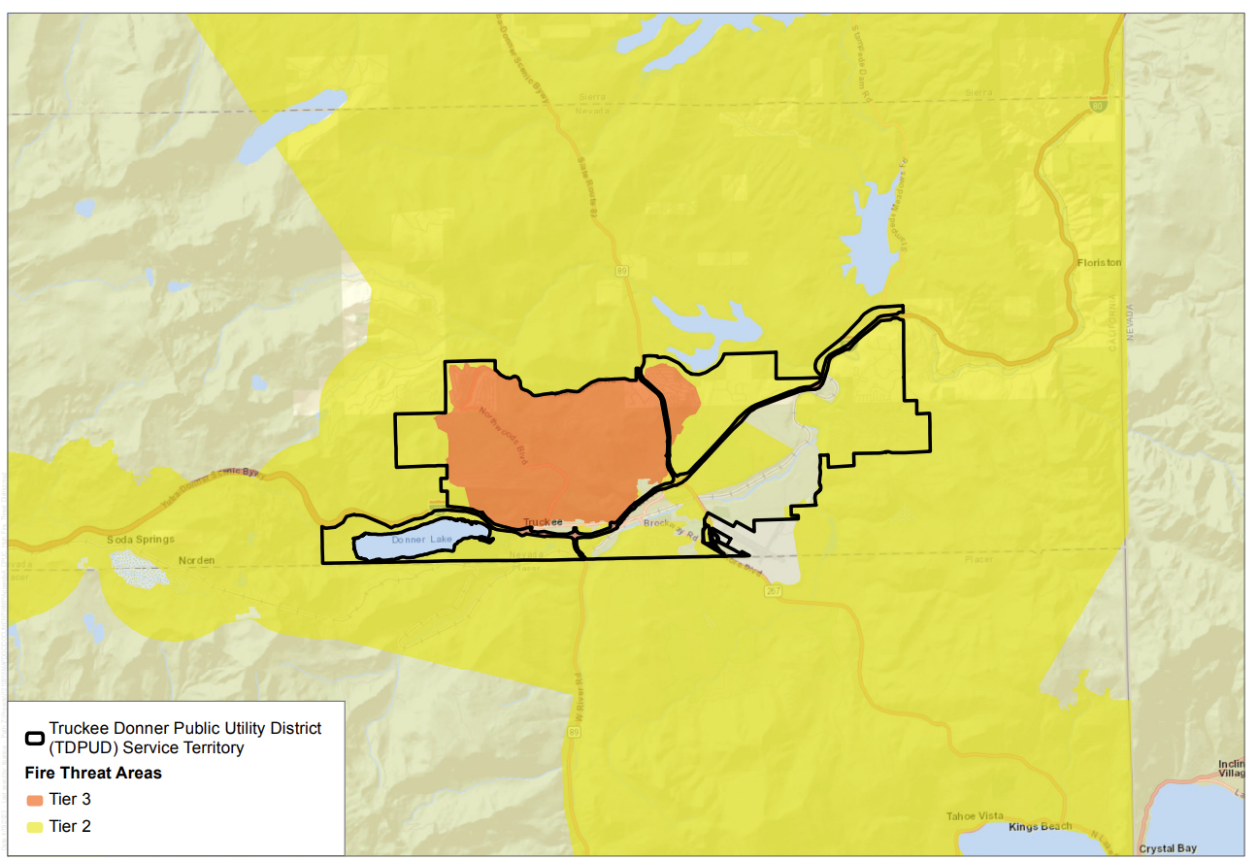

Appendix B
Prevailing Wind Map

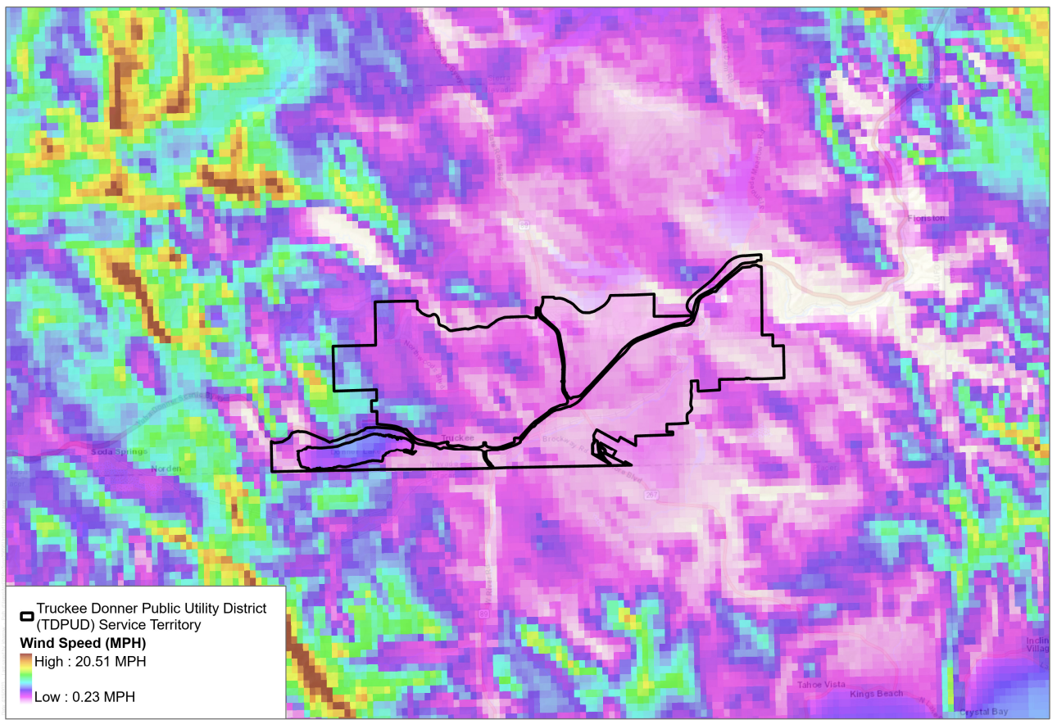
Appendix c
Vegetation Management Program

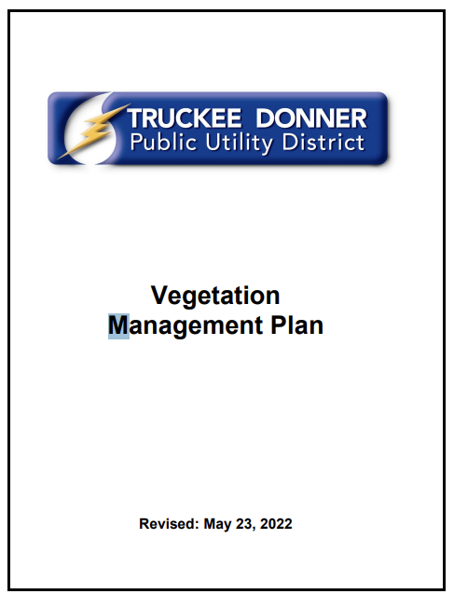
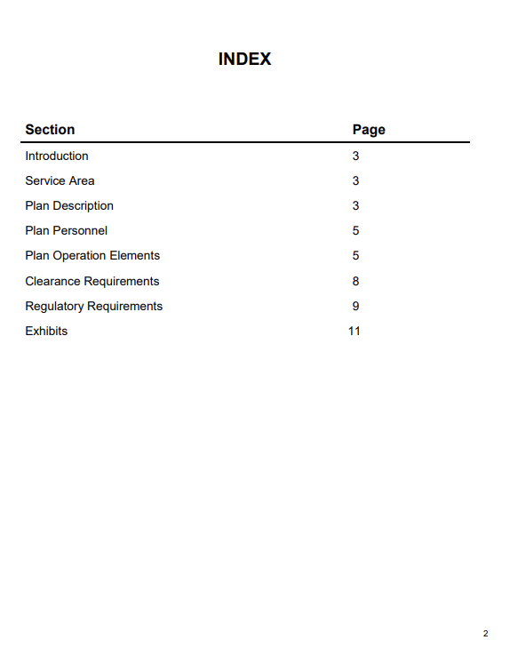
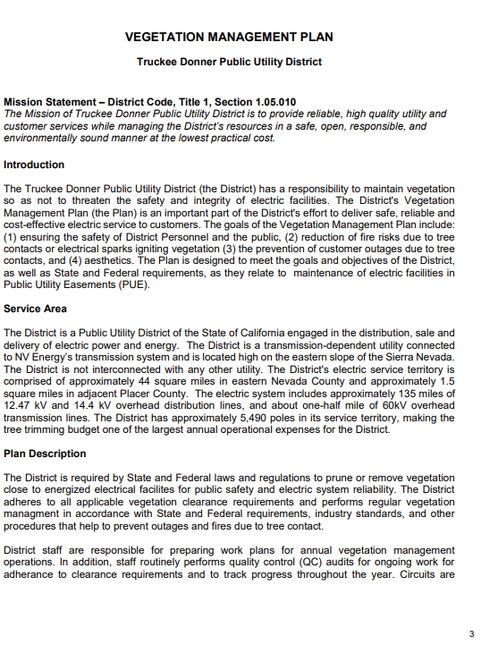
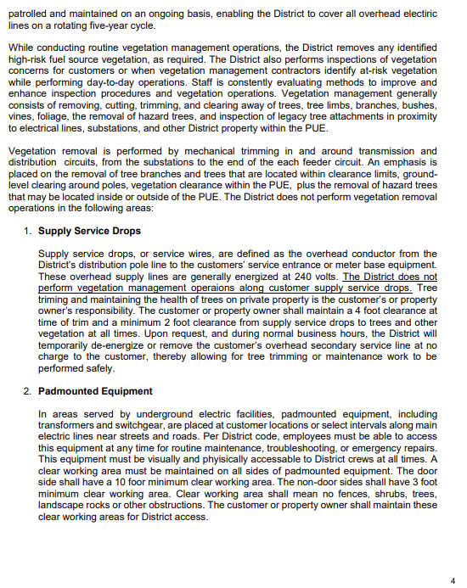
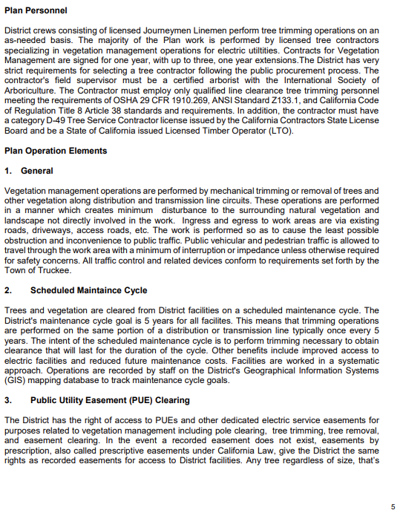
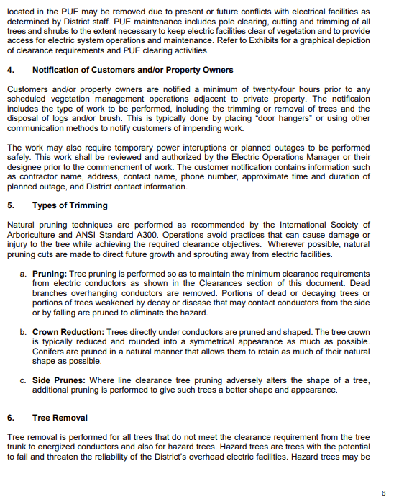
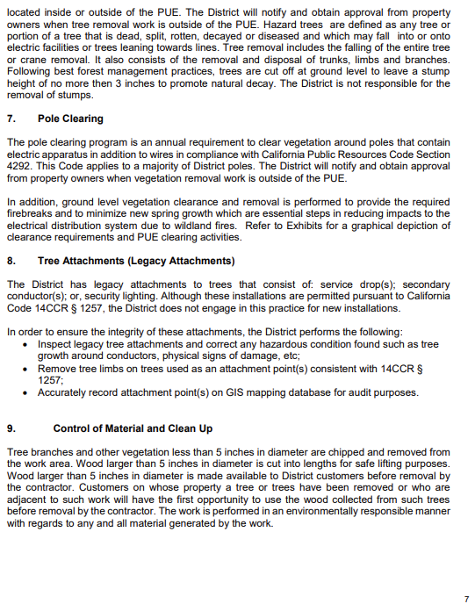
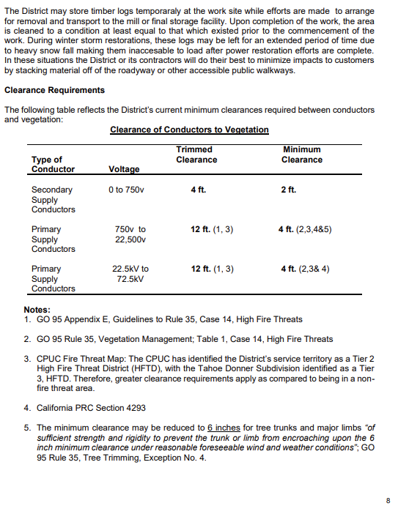
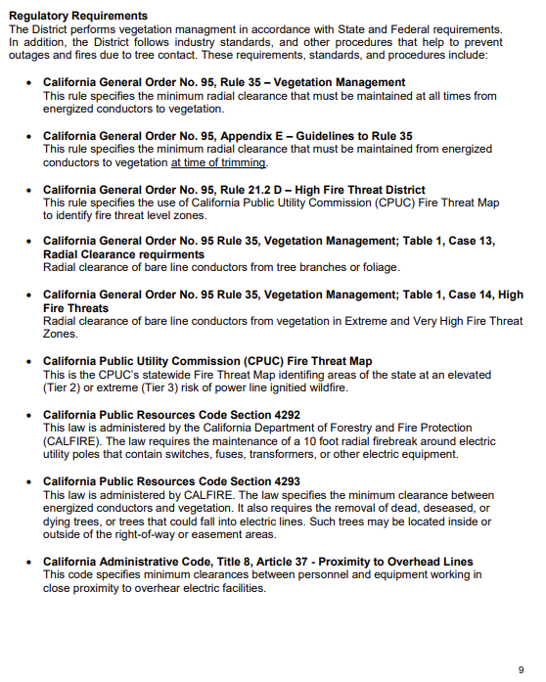
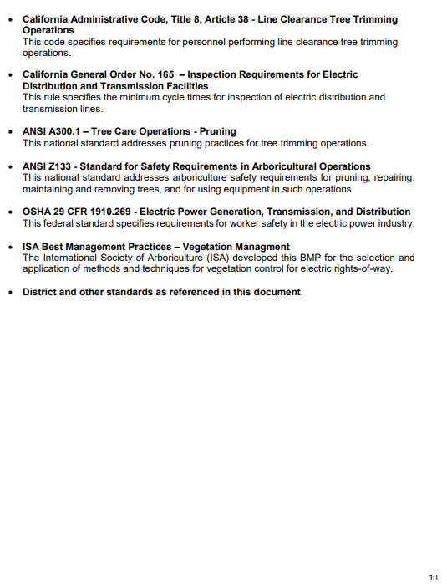
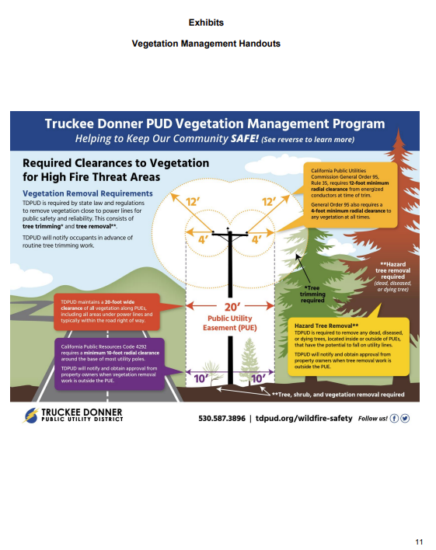
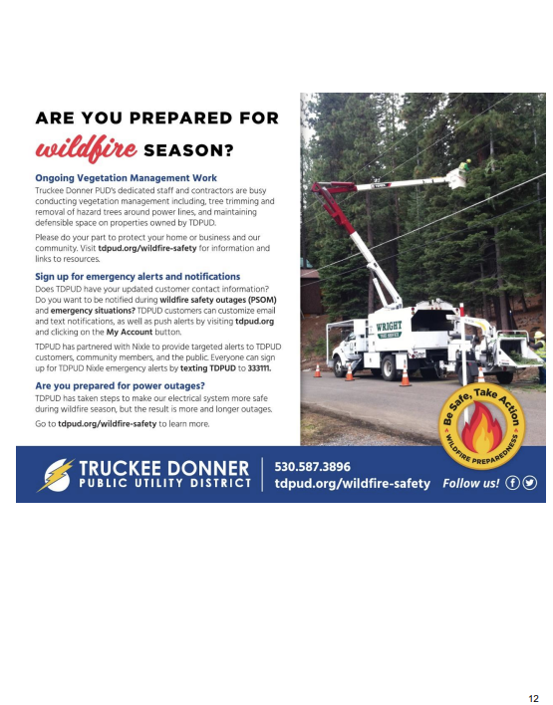
Appendix D
Preemptive Power Shutoff
Standard Operating Procedure



Preemptive Power Shutoff (PPS)
_________________________________________________________________

A. Purpose and Overview
This Standard Operating Procedure, effective 07/02/2025, outlines the Truckee Donner Public Utility District (TDPUD) operational framework for implementing Preemptive Power Shutoffs (PPS). PPS will be employed only as a last resort, when all other mitigation measures are deemed insufficient to protect the public from significant risks posed by TDPUD facilities if not de-energized. These risks may include, but are not limited to, wildfire ignition, public safety hazards, or threats to critical infrastructure.
By temporarily de-energizing specific portions of the electric distribution system under defined environmental and operational conditions, TDPUD aims to protect public safety, preserve critical infrastructure, and support emergency response efforts. This procedure establishes the criteria, roles, responsibilities, and communication protocols necessary to execute a controlled and coordinated de-energization and restoration process.
PPS events are initiated based on real-time weather data, field observations, system conditions, and risk assessments, in conjunction with input from internal operations staff, fire agencies, and emergency management partners. Restoration of power will be conducted as safely and swiftly as conditions allow, following thorough inspections to verify system integrity and safety.
During a Preemptive Power Shutoff (PPS) event, the Water Department plays a critical role in maintaining essential services by ensuring continuous access to safe and reliable water. Emergency generators are already installed at key pumping and treatment facilities and are tested regularly to ensure operational readiness. In advance of anticipated shutoffs, water storage tanks will be verified and filled to maximum capacity to ensure an adequate supply is available throughout the duration of the event. These preparedness measures help safeguard public health, support firefighting efforts, and strengthen the community’s resilience during power outages.
This SOP is intended to ensure a consistent and transparent approach to PPS decision-making, with a focus on public safety, interagency coordination, and customer awareness.

B. Roles and Responsibilities
During a Preemptive Power Shutoff (PPS) event, TDPUD will utilize the Incident Command System (ICS) structure to manage and coordinate response efforts. An Incident Commander (IC) will be designated to lead the overall event response. Supporting ICS roles will include an Operations Section Chief to oversee field activities and a Planning Section Chief to manage situational awareness, coordinate the de-energization process, and establish restoration priorities. A Logistics Section Chief will coordinate resources and operational support, while a Finance/Administration Section Chief will be responsible for cost tracking, timekeeping, and documentation. A Public Information Officer (PIO), Safety Officer, and Liaison Officer will also be assigned to ensure effective communication, regulatory compliance, and coordination with external stakeholders. Additional personnel may be assigned to ICS roles, as necessary, to support a scalable and efficient response.

Incident Commander
The Incident Commander (IC) provides strategic oversight and leads TDPUD’s response during a PPS event, ensuring coordination across all ICS functions and alignment with District objectives. Responsibilities include:
- Maintaining situational awareness of weather and fire risk conditions that may necessitate a PPS
- Initiating PPS protocols when defined triggers are met, and informing Command and General Staff to support decision-making
- Approving and overseeing system de-energization and restoration activities based on input from the Operations and Planning Section Chiefs, and in consultation with the Weather and Risk Intelligence Consultant
- Ensuring alignment with District-wide safety, regulatory, and customer service objectives
- Supporting high-level internal and external communications in coordination with the Public Information Officer (PIO)
- Coordinating with Section Chiefs and Command Staff to ensure an effective and unified response
- Reviewing and endorsing post-event reports, corrective actions, and continuous improvement efforts
- Serving as the primary point of contact for all system-level decisions during a PPS event

Public Information Officer (PIO)
Reporting to the Incident Commander (IC), the Public Information Officer (PIO) oversees external communications and strategic coordination with stakeholders throughout the PPS event. Responsibilities include:
- Coordinating logistics and support for Community Resource Centers (CRCs) and related community outreach efforts in collaboration with the Logistics Section Chief
- Organizing and delivering community briefings and public updates
- Ensuring local leaders, organizations, and stakeholders are kept informed with timely and accurate information
- Working directly with community leaders to provide situational updates and ensure alignment of messaging
- Leading the public and media communications strategy, including content development and dissemination
- Coordinating closely with the Incident Commander, Operations and Planning Section Chiefs, and Liaison Officer to ensure message consistency
- Managing official communications with local, regional, and regulatory stakeholders, as appropriate
- Ensuring that communication records, updates, and reports are documented and archived for internal review and external compliance

Communications Unit Leader
Reporting to the Public Information Officer (PIO), the Communications Unit Leader is responsible for supporting the development and dissemination of information to the public, customers, and media during all phases of a PPS event. Responsibilities include:
- Drafting public messages, alerts, and updates for review and approval by the PIO
- Coordinating with ICS sections to ensure consistent and accurate messaging
- Assisting with customer notifications and community outreach efforts
- Serving as a designated spokesperson for media or public communications when assigned by the PIO
- Managing digital communication platforms, including social media channels and the TDPUD website
- Posting real-time updates and monitoring community feedback and inquiries across digital platforms
- Escalating significant public questions or concerns from online sources to the PIO for response and follow-up

Safety/Liaison Officer
Reporting to the Incident Commander (IC), the Safety/Liaison Officer plays a key role in safeguarding public and employee safety, supporting wildfire risk mitigation, and ensuring effective coordination with external stakeholders. Responsibilities include:
- Ensuring timely notifications to public safety partners, critical infrastructure contacts, and external agencies
- Monitoring compliance with internal safety protocols, regulatory requirements, and documentation standards
- Identifying and communicating operational risks, safety concerns, or stakeholder issues to the Incident Commander and Public Information Officer (PIO)
- Supporting initiatives that protect the health and safety of employees, the public, and response personnel during PPS events
- Maintaining and updating risk and compliance contact lists, distribution records, and coordination protocols.

Operations Section Chief
Reporting to the Incident Commander (IC), the Operations Section Chief is responsible for managing and directing all tactical field operations during a PPS event, including electric and water system operations. This role ensures real-time coordination between field crews, system operators, and support personnel to safely execute de-energization, maintain essential services, and carry out restoration activities. Responsibilities include:
- Monitoring weather and fire risk conditions to support informed operational decisions
- Overseeing system-wide de-energization and restoration efforts across electric and water infrastructure
- Updating and maintaining the Outage Management System (OMS) with accurate system status and restoration information
- Initiating patrols and step restoration protocols following an “all clear” determination
- Ensuring accurate and timely updates to the Outage Management System (OMS)
- Directing electric and water field crews to support system stability, hazard mitigation, and restoration priorities
- Identifying impacted circuits, service areas, and customer groups for both electric and water systems
- Coordinating with the Planning Section Chief to align field operations with restoration strategies and resource planning
- Communicating operational status, field conditions, and system needs to the Incident Commander and Command Staff
- Ensuring water system continuity by maintaining pressure and supply, supported by emergency generation
- Deploying water personnel and resources to assist with field logistics, hazard identification, and cross-functional restoration activities
- Working with the Logistics Section to provide vehicles, equipment, and other material support, and to ensure continued access to and functionality of critical infrastructure throughout all phases of the PPS event

Planning Section Chief
Reporting to the Incident Commander (IC), the Planning Section Chief is responsible for situational analysis, strategic planning, and coordination of restoration priorities for both electric and water systems during a PPS event. This role ensures that engineering data, system assessments, and operational intelligence are used to guide safe and effective decision-making. Responsibilities include:
- Monitoring weather and fire risk conditions and supporting PPS initiation when defined triggers are met
- Analyzing and defining impacted areas using system data, weather intelligence, and fire risk indicators
- Coordinating with the Operations Section Chief to align field activities with engineering and restoration priorities
- Supporting the initiation of patrol and step restoration activities following the issuance of an “all clear”
- Assist Operations Section with updating and maintaining the Outage Management System (OMS) with accurate system status and restoration information
- Prioritizing restoration efforts based on critical infrastructure, system integrity, and community needs
- Conducting and documenting engineering assessments for both electric and water infrastructure
- Developing restoration strategies that maintain system balance and ensure reliability post-event
- Planning for water system continuity, including verification of tank levels, pump station functionality, and emergency water supply strategies
- Coordinating with the Logistics Section to ensure that restoration plans account for accessibility, resource allocation, and personnel deployment
- Providing timely updates and forward-looking projections to the Incident Commander and Command Staff to support informed decision-making
- Preparing and maintaining necessary ICS reports, including status updates, incident action plans, and post-event documentation

Logistics Section Chief
Reporting to the Incident Commander (IC), the Logistics Section Chief is responsible for providing all necessary support services during a PPS event, including personnel accommodations, equipment supply, and resource coordination. This role ensures field crews and command staff have the tools, transportation, and facilities needed to sustain safe and effective operations. Responsibilities include:
- Coordinating procurement and distribution of equipment, fuel, and materials
- Securing lodging and meals for deployed personnel
- Managing staging areas, rest locations, and Incident Command Post facilities
- Overseeing transportation logistics and field support vehicles
- Supporting crew health and safety through medical readiness and basic care

Customer Outreach Unit Leader
Reporting to the Public Information Officer (PIO), the Customer Outreach Unit Leader is responsible for coordinating frontline customer communications and ensuring consistent, targeted outreach to all customer segments during a PPS event. This role includes responsibilities typically handled by a Key Accounts Liaison, providing focused communication to critical and high-impact customers. Responsibilities include:
- Coordinating closely with the Communications Unit Leader to ensure alignment between public messaging and direct customer outreach
- Managing proactive outreach to Medical Baseline customers and other vulnerable populations, ensuring timely notifications, resource information, and support
- Serving as the primary point of contact for high-impact accounts such as hospitals, emergency services, schools, and essential infrastructure providers
- Tracking and documenting all customer interactions, inquiries, and support efforts for post-event review and regulatory reporting
- Monitoring incoming customer feedback from all communication channels (phone, email, social media, web) and escalating critical issues or trends to the PIO
- Supporting the development and distribution of FAQs, service bulletins, and direct customer notifications based on current conditions and customer concerns
- Assisting in the deployment, monitoring, and troubleshooting of customer notification tools and systems to ensure reliable and timely outreach.

Finance/Administration Section
Reporting to the Incident Commander (IC), the Finance/Administration Section Chief oversees all financial and administrative functions to ensure accurate cost tracking, timekeeping, and documentation throughout the PPS event. Responsibilities include:
- Tracking labor hours, equipment usage, and materials costs associated with PPS response and recovery
- Coordinating with the Logistics and Operations Sections to gather cost data and resource usage in real time
- Developing and maintaining cost reports, expenditure summaries, and resource allocation records
- Supporting procurement and reimbursement efforts by ensuring documentation aligns with applicable funding or regulatory requirements
- Managing timekeeping processes and personnel tracking for all ICS participants
- Preparing financial documentation needed for post-event reporting, audits, and agency reviews
- Completing and submitting all required ICS financial and administrative forms (e.g., ICS 214, ICS 213RR, ICS 219 as applicable)
- Coordinating with the Administrative Support Unit to maintain accurate, complete, and accessible event records

Administrative Support Unit
Reporting to the Finance/Administration Section Chief, the Administrative Support Unit provides critical support services to ensure documentation is accurate, meetings are well-coordinated, and event records are maintained throughout the PPS life cycle. Responsibilities include:
- Scheduling and facilitating internal coordination meetings and external stakeholder briefings
- Supporting the planning and execution of community briefings and public-facing updates in coordination with the Public Information Officer (PIO)
- Assisting with the preparation, organization, and completion of all event-related documentation and post-event reports
- Coordinating data collection efforts, tracking issues, and compiling notes for inclusion in after-action reviews and debriefs
- Maintaining document control to ensure consistency, accessibility, and compliance with internal procedures and ICS standards
- Completing and filing required ICS administrative forms (e.g., ICS 214 Unit Log, ICS 221 Demobilization Check-Out) in coordination with section staff

C. Preemptive Power Shutoff Phases

Phase 1 - Potential PPS
72 HOURS UNTIL DE-ENERGIZATION
This phase is initiated when weather forecasts indicate potential to meet de-energization thresholds. Although activation is not yet confirmed, conditions warrant increased readiness and interdepartmental coordination.
Phase 1 Assumptions
- Weather conditions may exceed thresholds within 72 hours of a potential PPS event.
- Forecast models show possible weakening or redirection of the weather system.
- Risk level is moderate; potential exists but is not guaranteed.
Objectives
- Begin operational and communication readiness.
- Establish coordination between internal departments and external stakeholders.
- Prepare situational awareness tools, resource alignment, and notification templates.

Key Actions by Role
Incident Commander (IC)
- Lead Phase 1 planning and coordination
- Confirm weather and fire risk data; initiate Phase 1 procedures
- Notify General Manager and Command and General Staff of projected or met thresholds
- Provide go/no-go criteria for transition to Phase 2
Operations Section Chief
- Coordinate with Planning Section Chief to identify at-risk electric circuits and critical water infrastructure
- Begin tactical restoration planning based on potential impact zones for both electric and water systems
- Monitor Outage Management System (OMS) and weather inputs for trigger alignment
- Direct field crews to assess and support water system continuity, including generator checks, tank levels, and pump station status
- Coordinate with Logistics to ensure availability of vehicles, equipment, and emergency fuel for both electric and water operations
- Deploy personnel to assist with pre-energization patrols and post-event restoration across utility functions
Planning Section Chief
- Generate initial impact maps and circuit exposure models for electric and water systems
- Establish de-energization and restoration prioritization criteria for electric and water infrastructure based on system integrity and customer needs
- Update OMS and SCADA data as the forecast evolves
- Verify SCADA setpoints for water storage tanks to maintain capacity during the event
- Develop and maintain water system continuity strategies, including staffing plans, equipment readiness, and emergency response coordination
- Coordinate with Operations and Logistics Sections to ensure resource alignment for water and electric restoration
Logistics Section Chief
- Coordinate with Operations and Planning Sections to anticipate support needs for field deployment
- Arrange lodging and meals for field and support personnel during multi-day PPS events
- Procure and distribute necessary materials, tools, and emergency fuel to support electric and water operations
- Manage staging areas, rest locations, and the Incident Command Post (ICP) to ensure readiness
- Provide transportation logistics, including vehicle coordination and support for field mobility
- Ensure availability of basic medical supplies and support for crew health and safety in the field
Public Information Officer (PIO)
- Coordinate with the Communications Unit Leader on external awareness and media content
- Maintain alignment with Safety/Liaison Officer to ensure message accuracy and regulatory consistency
- Prepare for Community Resource Center (CRC) activation, including initiating notifications, coordinating site readiness, and ensuring support resources are in place
Communications Unit Leader
- Draft and review internal and external messaging templates
- Prepare and schedule updates for the website and social media platforms
- Monitor digital platforms for public concerns, questions, or misinformation
- Support the PIO with message rollout, real-time tracking, and public feedback escalation
Safety/Liaison Officer
- Verify initial regulatory requirements for PPS response
- Begin documentation of early-stage response actions for compliance tracking
- Ensure public and employee safety are reflected in all operational and communication recommendations
Customer Outreach Unit Leader
- Segment and assess customer types in projected impact zones
- Coordinate draft outreach content with the Communications Unit Leader
- Validate contact information for key accounts, vulnerable customers, and Medical Baseline participants
Finance/Administration Section Chief
- Track labor hours, equipment usage, and material costs associated with PPS operations
- Coordinate with Operations and Logistics Sections for real-time cost and resource data
- Prepare cost reports, timekeeping logs, and financial summaries
- Complete and submit required ICS forms (e.g., ICS 214, ICS 213RR, ICS 219)
- Support post-event financial reporting, audits, and funding documentation
Administrative Support Unit (Finance/Admin Section)
- Schedule recurring ICS coordination meetings (e.g., morning and evening briefings)
- Track and log all communications, decisions, and key planning milestones
- Assist with preparation of post-event reports and after-action reviews
- Complete and file required ICS administrative forms (e.g., ICS 214 Unit Log, ICS 221 Demobilization Check-Out)
This phase is concluded when conditions either worsen (triggering Phase 2: Imminent PPS) or improve sufficiently to cancel pre-activation procedures.

Phase 2 - Imminent PPS
48 HOURS UNTIL DE-ENERGIZATION
This phase is activated when weather forecasts confirm a high probability that de-energization thresholds will be met. All operational units transition from preparation to full readiness and begin execution of Phase 2 protocols.
Phase 2 Assumptions
- Weather/fire conditions will exceed thresholds within 48 hours.
- Forecasts confirm sustained threat with no likely alternate path.
Objectives
- Confirm operational readiness across departments
- Communicate imminent risk to customers and stakeholders
- Stage resources and staff for system impact and CRC deployment

Key Actions by Role
Incident Commander (IC)
- Confirm readiness and initiate transition to Phase 2
- Notify General Manager and Command and General Staff of the transition
- Lead cross-functional readiness briefings and decision-making
Operations Section Chief
- Confirm at-risk electric circuits and critical water infrastructure with Planning Section Chief
- Ensure readiness of electric patrol teams, field crews, and Community Resource Center (CRC) field support
- Verify pre-positioning of materials, tools, and staffing resources for electric and water operations
- Coordinate generator deployment to water system facilities and confirm start-up at key sites (in coordination with electricians)
- Confirm communications readiness across operations teams, including radio and SCADA systems
Planning Section Chief
- Finalize de-energization zone maps for electric and water systems
- Provide updated OMS and GIS data for use in field operations and situational awareness
- Deliver technical system data to support tactical field decisions and public communications
- Coordinate with Operations Section Chief and Logistics to ensure water system continuity, including generator placement, equipment readiness, and site accessibility
- Confirm communications equipment and system monitoring functionality (SCADA, radios, alarms)
Logistics Section Chief
- Coordinate with Operations and Planning Sections to anticipate support needs for field deployment
- Arrange lodging and meals for field and support personnel during multi-day PPS events
- Procure and distribute necessary materials, tools, and emergency fuel to support electric and water operations
- Manage staging areas, rest locations, and the Incident Command Post (ICP) to ensure readiness
- Provide transportation logistics, including vehicle coordination and support for field mobility
- Ensure availability of basic medical supplies and support for crew health and safety in the field
Public Information Officer (PIO)
- Distribute updated internal communications and email messaging to staff
- Finalize and issue talking points and situational updates to internal teams
- Coordinate public-facing messaging in alignment with Communications Unit Leader
- Support CRC activation planning, including notification procedures, readiness confirmation, and coordination of on-site support
Communications Unit Leader
- Finalize and publish messaging for the website, email, and social media platforms
- Coordinate partner messaging efforts, including press releases, PSAs, and CMS notifications
- Support all digital and external communication channels in coordination with the PIO
Safety/Liaison Officer
- Initiate notifications to public safety agencies, emergency management, and regulatory stakeholders regarding elevated PPS risk
- Log critical decisions, coordination actions, and regulatory steps
- Monitor and ensure continued alignment with safety standards and public health protocols
Customer Outreach Unit Leader
- Execute targeted outreach to vulnerable populations and high-impact customers
- Confirm readiness of Customer Service Representatives (CSRs) and initiate outbound contact plans
- Lead coordination and response for key customer updates and status inquiries
Finance/Administration Section Chief
- Update cost tracking logs and verify accuracy of pre-event resource expenditures
- Review and approve resource requests for generator support, fuel supply, and staffing
- Maintain updated ICS financial documentation (ICS 213RR, 214, etc.)
- Ensure readiness for real-time documentation during de-energization
Administrative Support Unit (Finance/Admin Section)
- Issue updated Incident Action Plan (IAP) for Phase 2
- Support daily situational meetings, track section deliverables, and maintain document control
Document CRC readiness, internal staffing assignments, and communications milestones
This phase concludes upon the start of the de-energization event or cancellation due to improved conditions.

Phase 3 - Imminent PPS
24 HOURS UNTIL DE-ENERGIZATION
This phase is activated when weather and fire risk forecasts confirm that de-energization is highly probable within 24 hours. All coordination efforts must shift to near-term execution and resource mobilization.
Phase 3 Assumptions
- Weather/fire conditions will exceed thresholds within 24 hours.
- Forecast models confirm direct impact with no deviation expected.
Objectives
- Finalize communications to customers and partners.
- Confirm CRC logistics and team readiness.
- Mobilize critical resources and finalize internal staffing.

Key Actions by Role
Incident Commander (IC)
- Conduct final review of environmental conditions and operational readiness
- Confirm de-energization timeline in coordination with the General Manager and Executive Leadership
- Lead 24-hour coordination meetings and approve trigger execution based on Planning and Operations input
Operations Section Chief
- Validate readiness of patrol and restoration crews for both electric and water systems
- Confirm staging of field equipment, mobile generators, and resource allocations
- Place water crews on standby for rapid deployment
- Ensure all assigned vehicles, equipment, and auxiliary fuel tanks (including those supporting water facilities) are fueled and ready for extended operations
- Coordinate with Logistics to ensure materials and personnel can support extended outage response
Planning Section Chief
- Deliver final outage footprint and customer segmentation using OMS and GIS data
- Validate restoration models and confirm system readiness inputs
- Provide technical prioritization guidance for re-energization of electric circuits and water system infrastructure
- Verify all water storage tanks are filled and SCADA setpoints are adjusted to maintain optimal levels throughout the event
- Coordinate final system readiness data for inclusion in the IAP and situational reports
Logistics Section Chief
- Coordinate with Operations and Planning Sections to anticipate support needs for field deployment
- Arrange lodging and meals for field and support personnel during multi-day PPS events
- Procure and distribute necessary materials, tools, and emergency fuel to support electric and water operations
- Manage staging areas, rest locations, and the Incident Command Post (ICP) to ensure readiness
- Provide transportation logistics, including vehicle coordination and support for field mobility
- Ensure availability of basic medical supplies and support for crew health and safety in the field
Public Information Officer (PIO)
- Distribute finalized internal briefings and talking points to ICS staff and frontline employees
- Coordinate final CRC readiness and staffing confirmation
- Issue updated employee communications reflecting Phase 3 status and community expectations
- Finalize external messaging strategy with the Communications Unit Leader
Communications Unit Leader
- Launch final pre-event messaging on web, email, and social media platforms
- Distribute CMS and PSA materials to media outlets and local partners
- Ensure digital messaging is synchronized with CRC activation and electric/water service expectations
- Support the PIO with consistent content delivery across all communication platforms
Safety/Liaison Officer
- Notify public safety and emergency management agencies that PPS activation is imminent (within 24 hours)
- Submit required regulatory notifications in compliance with local and state mandates
- Maintain detailed logs of key actions and decisions for post-event reporting
Customer Outreach Unit Leader
- Contact all Medical Baseline and key account customers to confirm receipt of final notifications
- Ensure staff readiness for inbound customer inquiries during the de-energization period
- Coordinate distribution of door hangers or physical notices to at-risk or hard-to-reach customers
Finance/Administration Section Chief
- Confirm readiness of cost tracking, timekeeping, and resource documentation systems
- Ensure ICS financial forms (ICS 214, ICS 213RR, ICS 219) are updated for Phase 3 operations
- Support resource accountability as generator and staffing expenses increase during outage conditions
Administrative Support Unit (Finance/Admin Section)
- Distribute the finalized Incident Action Plan (IAP) and updated meeting calendar
- Schedule and facilitate recurring briefings and coordination calls with external partners
- Track key milestones, including CRC activation, public notifications, and interagency coordination
This phase ends when de-energization is initiated or canceled due to changed conditions.

Phase 4 - Final Preparation for PPS Activation
4 HOURS UNTIL DE-ENERGIZATION
This phase is activated when de-energization is projected to begin within four hours. All systems and teams should be fully mobilized, and communications finalized. This is the final phase before execution of the PPS event.
Phase 4 Assumptions
- De-energization will begin imminently.
- All planning and customer outreach should be complete or in final execution.
Objectives
- Confirm team readiness across all departments.
- Ensure customer and stakeholder notifications are complete.
- Activate CRCs and finalize field execution plans.

Key Actions by Role
Incident Commander (IC)
- Validate final environmental and operational conditions and approve PPS activation
- Lead final pre-activation coordination meeting
- Inform the General Manager, Executive Leadership, and key external stakeholders of activation decision
Operations Section Chief
- Confirm staging of electric field crews and final circuit patrol sequencing
- Validate equipment pre-checks, fuel levels, and vehicle readiness for sustained field deployment
- Coordinate transfer of critical water sites to emergency generator power one hour prior to de-energization
- Ensure successful generator start-up and verify transfer to backup power at designated water facilities
- Oversee the transition of well sites and critical water pumps to manual “off” mode in SCADA to prevent equipment damage during power loss
- Assess and prepare for shutdown of vulnerable water infrastructure during initial de energization
Planning Section Chief
- Support final circuit validation and system readiness assessments
- Confirm de-energization sequencing in coordination with field operations and electric engineering
- Validate SCADA configurations for both electric and water systems, ensuring tank levels, pump logic, and manual control settings are correctly implemented
- Ensure documentation and technical plans are updated in the IAP for real-time use by operations staff
Public Information Officer (PIO)
- Deliver the final round of internal briefings and staff messaging
- Coordinate with CRC site leads to confirm opening plans, logistics, and public communications
- Issue final press releases, media statements, and talking points
- Work with Communications Unit Leader to initiate real-time public updates during the activation window
Logistics Section Chief
- Coordinate with Operations and Planning Sections to anticipate support needs for field deployment
- Arrange lodging and meals for field and support personnel during multi-day PPS events
- Procure and distribute necessary materials, tools, and emergency fuel to support electric and water operations
- Manage staging areas, rest locations, and the Incident Command Post (ICP) to ensure readiness
- Provide transportation logistics, including vehicle coordination and support for field mobility
- Ensure availability of basic medical supplies and support for crew health and safety in the field
Communications Unit Leader
- Post final alerts to social media channels and the TDPUD website
- Finalize and distribute press releases, PSAs, and public notifications
- Monitor public feedback through digital channels and coordinate timely responses with the PIO
Safety/Liaison Officer
- Notify public safety and emergency management agencies when PPS activation is within 4 hours
- Ensure all required notifications and briefings are documented with timestamps
- Verify all legal, regulatory, and safety compliance criteria are met before de energization
Customer Outreach Unit Leader
- Confirm Customer Service Representative (CSR) availability and readiness of communication tools
- Log final outreach actions to vulnerable populations and Medical Baseline customers
- Coordinate last-mile notification efforts, including door hanger distribution and direct outreach in impacted areas
Finance/Administration Section Chief
- Confirm financial tracking systems are ready to capture costs during activation and response
- Review final resource commitments and ensure documentation is in place
- Maintain continuity of ICS form tracking and update expenditure estimates
Administrative Support Unit (Finance/Admin Section)
- Document final meeting notes, stakeholder call logs, and CRC activation status
- Support the launch and distribution of the updated Incident Action Plan (IAP)
- Prepare ICS documentation systems for transition into active de-energization monitoring and real-time support
This phase concludes as the PPS event is initiated and circuits are de-energized.

Phase 5 - Implement PPS
DE-ENERGIZATION INITIATED UNTIL CONDITIONS IMPROVE
This phase is activated when the PPS event is officially underway. All systems shift from preparation to active management, customer support, safety coordination, and status monitoring.
Phase 5 Assumptions
- Power has been turned off for fire risk mitigation
- Weather/fire conditions remain above re-energization thresholds
Objectives
- Maintain real-time communication with customers and stakeholders
- Provide safe and timely support through CRCs
- Prepare for eventual restoration planning

Key Actions by Role
Incident Commander (IC)
- Oversee implementation of the PPS response and maintain strategic situational awareness
- Communicate ongoing event status and developments to the General Manager and Executive Leadership
- Support cross-functional coordination and resource prioritization in response to evolving conditions
Operations Section Chief
- Confirm grid status and full extent of de-energization with field and control center inputs
- Monitor field safety conditions and coordinate directly with crews for status updates and hazard reporting
- Evaluate critical water sites and determine if pump shutdown is necessary; oversee placement of applicable pumps in manual “off” mode in SCADA to prevent equipment damage
- Deploy Water Department staff to assist with electric system logistics, field observations, or infrastructure support as needed
- Initiate 12-hour shifts for Water Crew members to maintain continuous operational coverage throughout the PPS event
Planning Section Chief
- Maintain real-time situational updates in OMS and GIS systems
- Confirm and update impacted customer lists, electric circuit visuals, and water system performance data
- Support restoration prioritization strategy by incorporating field intelligence, SCADA data, and system conditions
- Monitor water SCADA in real time to track tank levels, performance indicators, and operational anomalies
Logistics Section Chief
- Coordinate with Operations and Planning Sections to anticipate support needs for field deployment
- Arrange lodging and meals for field and support personnel during multi-day PPS events
- Procure and distribute necessary materials, tools, and emergency fuel to support electric and water operations
- Manage staging areas, rest locations, and the Incident Command Post (ICP) to ensure readiness
- Provide transportation logistics, including vehicle coordination and support for field mobility
- Ensure availability of basic medical supplies and support for crew health and safety in the field
Public Information Officer (PIO)
- Issue internal de-energization communications and staff updates
- Coordinate CRC status and ensure accurate, real-time operational updates are shared with stakeholders
- Respond to media inquiries and provide updated talking points to internal and external audiences
- Coordinate with Communications Unit Leader to ensure consistency and accuracy in public messaging
Communications Unit Leader
- Distribute alerts and updates across digital platforms, including the TDPUD website and social media
- Publish media updates including PSAs, CMS messages, and social media posts
- Monitor customer sentiment, CRC feedback, and digital engagement to inform message refinement
- Provide real-time support to the PIO for content distribution and public engagement
Safety/Liaison Officer
- Log all significant response actions, updates, and interagency coordination activities
- Submit and update required regulatory notifications to CPUC, Cal OES, and other authorities
- Confirm CRC sites remain accessible and compliant with legal, safety, and communication requirements
Customer Outreach Unit Leader
- Manage call center messaging and ensure Customer Service Representatives (CSRs) have current status updates
- Support inquiries from Medical Baseline and vulnerable customers, coordinating with CRC staff as needed
- Ensure continuous coordination between customer-facing staff, CRCs, and field personnel
Finance/Administration Section Chief
- Track resource utilization and real-time expenses associated with PPS operations
- Maintain accurate ICS documentation (ICS 214, 219, 213RR) for current event activities
- Support planning for financial reporting and reimbursement after the event concludes
Administrative Support Unit (Finance/Admin Section)
- Maintain the most recent version of the Incident Action Plan (IAP) as operational needs evolve
- Log key actions, decisions, and timeline milestones for post-event review and improvement planning
- Provide documentation support for webinars, stakeholder meetings, and daily ICS coordination
This phase continues until weather conditions improve and safe re-energization can begin.

Phase 6 - Re-Energization Initiated
POWER RESTORATION BEGINS
This phase begins once weather conditions improve and grid inspections confirm circuits can safely be re-energized. Teams shift to prioritizing safe, efficient power restoration.
Phase 6 Assumptions
- Fire risk conditions have subsided for at least one hour.
- Field inspections validate circuits as safe for re-energization.
Objectives
- Safely restore power in prioritized stages.
- Maintain customer communication and regulatory transparency.
- Begin post-event documentation and support.

Key Actions by Role
Incident Commander (IC)
- Approve initiation of system restoration and re-energization
- Coordinate with Section Chiefs on staging, sequencing, and restoration status
- Provide Executive Leadership Team with timely updates and event transition progress
Operations Section Chief
- Direct patrol and step restoration teams in coordination with field supervisors
- Confirm circuit clearance and safety validation before energization
- Communicate restoration milestones to support units and ICS staff
- Maintain coordination with water operations during re-energization period
- Keep all generators supporting water infrastructure online during the initial two hours of re-energization to help manage demand and system stability
- Coordinate demobilization of generators once use is complete, and return equipment to ready state
- Continue to assign Water Department staff to assist with logistics, field operations, or system assessments as needed
- Resume standard shift schedules for Water Department personnel once the system stabilizes
Planning Section Chief
- Update OMS and GIS systems in real time as circuits are restored
- Assist in identifying system performance issues or anomalies during re-energization
- Support prioritization of remaining circuits based on customer needs, system topology, and critical services
- Restore SCADA settings for water operations to normal configurations
- Verify functionality of remote-control systems and document return to standard operations
Logistics Section Chief
- Coordinate with Operations and Planning Sections to anticipate support needs for field deployment
- Arrange lodging and meals for field and support personnel during multi-day PPS events
- Procure and distribute necessary materials, tools, and emergency fuel to support electric and water operations
- Manage staging areas, rest locations, and the Incident Command Post (ICP) to ensure readiness
- Provide transportation logistics, including vehicle coordination and support for field mobility
- Ensure availability of basic medical supplies and support for crew health and safety in the field
Public Information Officer (PIO)
- Issue employee communications regarding restoration progress and operational status
- Coordinate re-energization messaging for key stakeholders and partners
- Work with the Communications Unit Leader to deliver timely updates through public and media channels
Communications Unit Leader
- Update social media platforms and the TDPUD website with live restoration updates
- Support press and media communications with accurate restoration milestones
- Provide safety messaging and coordinate CRC demobilization notifications for the public
Safety/Liaison Officer
- Notify public safety and emergency management agencies when the PPS event concludes and restoration begins
- Document key safety and compliance actions during restoration
- Coordinate follow-up notifications if restoration delays or hazards arise
Customer Outreach Unit Leader
- Notify customers as service is restored, and respond to ongoing inquiries
- Coordinate real-time status updates between Customer Service Representatives (CSRs) and field operations
- Maintain ongoing direct communication with Medical Baseline and other sensitive accounts until full restoration is confirmed
Finance/Administration Section Chief
- Continue tracking restoration-related resource usage and expenditures
- Begin preparing financial summaries and cost reporting for post-event review
- Maintain up-to-date ICS financial documentation and cost logs
Administrative Support Unit (Finance/Admin Section)
- Log each restoration milestone and corresponding timestamp
- Support preparation of post-restoration documentation, including incident logs, meeting notes, and reports
- Maintain and finalize internal reporting tools and event timelines
This phase ends once all circuits are restored and the event transitions into post-incident review.

Phase 7 - Post-Incident Review
AFTER RESTORATION IS COMPLETE
This phase focuses on evaluating the PPS event, documenting all actions taken, and conducting a comprehensive review to identify successes, gaps, and opportunities for improvement.
Phase 7 Assumptions
- All circuits have been re-energized and service restored.
- CRCs have been deactivated and demobilized.
- Regulatory reporting requirements are in effect.
Objectives
- Conduct full internal and external review of the PPS event.
- Fulfill regulatory and stakeholder reporting requirements.
- Integrate lessons learned into future PPS planning.

Key Actions by Role
Incident Commander (IC)
- Lead the executive-level post-event debrief
- Participate in lessons learned sessions and approve follow-up action planning
- Oversee the completion of final reports and ensure accountability for improvement planning
Operations Section Chief
- Submit a full report on electric and water field operations, including restoration timelines and challenges encountered
- Document any field safety incidents, delays, or issues related to access and coordination
- Provide operational feedback on CRC setup, logistics, and demobilization effectiveness
Planning Section Chief
- Archive GIS and OMS data, including de-energization and restoration maps
- Submit a system performance and condition review, highlighting restoration outcomes and SCADA system observations
- Identify gaps and opportunities in outage modeling and system forecasting used during the event
Logistics Section Chief – Post Event
- Recover and return equipment, vehicles, and unused materials to appropriate storage or vendors
- Coordinate demobilization of staging areas, ICP, and any temporary facilities
- Finalize lodging and meal arrangements, including reconciliation of expenses
- Conduct inventory of all logistical assets and restock emergency supplies as needed
- Provide documentation of logistical support activities for the After-Action Report (AAR)
- Participate in post-event debrief to identify lessons learned and improvements for future PPS events
Public Information Officer (PIO)
- Compile and analyze public, media, and stakeholder feedback
- Assess the effectiveness of internal and external messaging—reach, clarity, and timeliness
- Draft the communications section of the after-action report, including key takeaways and areas for improvement
Communications Unit Leader
- Archive all digital messages, social posts, media updates, and analytics
- Summarize trends in community sentiment, misinformation, and communication gaps
- Support the PIO with findings, digital performance data, and public engagement outcomes
Safety/Liaison Officer
- Notify public safety partners and emergency management agencies that the PPS event is officially closed
- Verify regulatory compliance and ensure documentation meets audit standards
- Coordinate or support a root cause analysis process if required by internal policy or external mandate
Customer Outreach Unit Leader
- Compile and analyze customer call volume, service metrics, and inquiry trends
- Document CSR team feedback and operational challenges in customer communication
- Engage key accounts and Community-Based Organizations (CBOs) for input during the debrief process
Finance/Administration Section Chief
- Review and reconcile all cost documentation and time tracking records
- Finalize ICS financial forms and prepare materials for post-event financial review or reimbursement processes
- Ensure cost recovery efforts are supported by clean and complete documentation
Administrative Support Unit (Finance/Admin Section)
- Coordinate scheduling and facilitation of lessons-learned workshops across ICS sections
- Assemble the final documentation package, including IAPs, ICS forms, action logs, and meeting notes
- Archive all planning, response, and recovery documents in accordance with District protocols and retention policies
This phase concludes once all reporting is submitted and lessons learned are integrated into future procedures.

D. General Education
ONGOING PUBLIC OUTREACH AND PREPARATION
This section outlines proactive educational efforts that TDPUD shall undertake throughout the year to inform customers and stakeholders about wildfire mitigation practices, what occurs during a PPS event, and how to be prepared.

Communications Overview
General Communication Tactics
TDPUD shall distribute PPS and wildfire mitigation educational materials through multiple channels, including:
- Website
- Emails
- Community events
- Social media
- Printed materials (e.g., flyers, brochures)
- Videos
- Bill inserts
- Radio ads
Communication Schedule
TDPUD will communicate wildfire preparedness and PPS-related information through a mix of recurring and event-specific outreach using the following schedule:
Communication Schedule Table
Frequency | Channels
Daily | Call-hold scripts
Weekly | Social media
Bi-monthly | Advertisements, bill inserts
Quarterly | Email, HOA articles/op-eds, direct mail, public meetings, stakeholder outreach, Public Safety Partner outreach
As Needed | First responder, critical facilities outreach

Responsibility: Communications Specialist (in coordination with PIO and Risk and Compliance Specialist)
General education continues year-round and supports overall community readiness for potential PPS activations.

Appendix E
Weather and Risk Intelligence
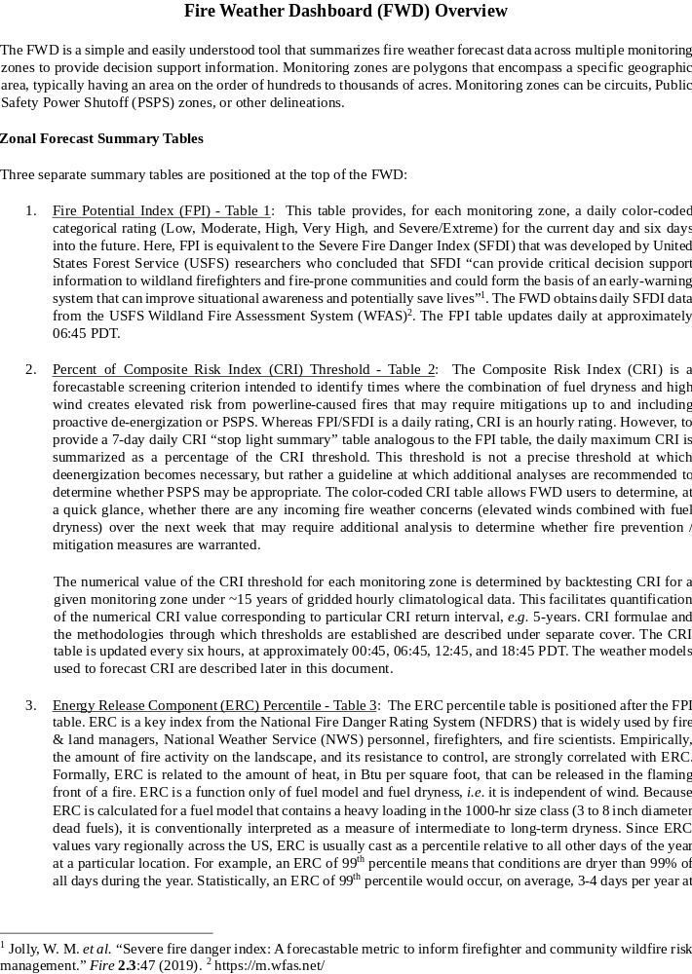
a particular location. In the FWD, ERC is obtained from USFS WFAS¹. The ERC table is updated once per day at the same cadence as the FPI table.

Table 1. Sample FPI Table.
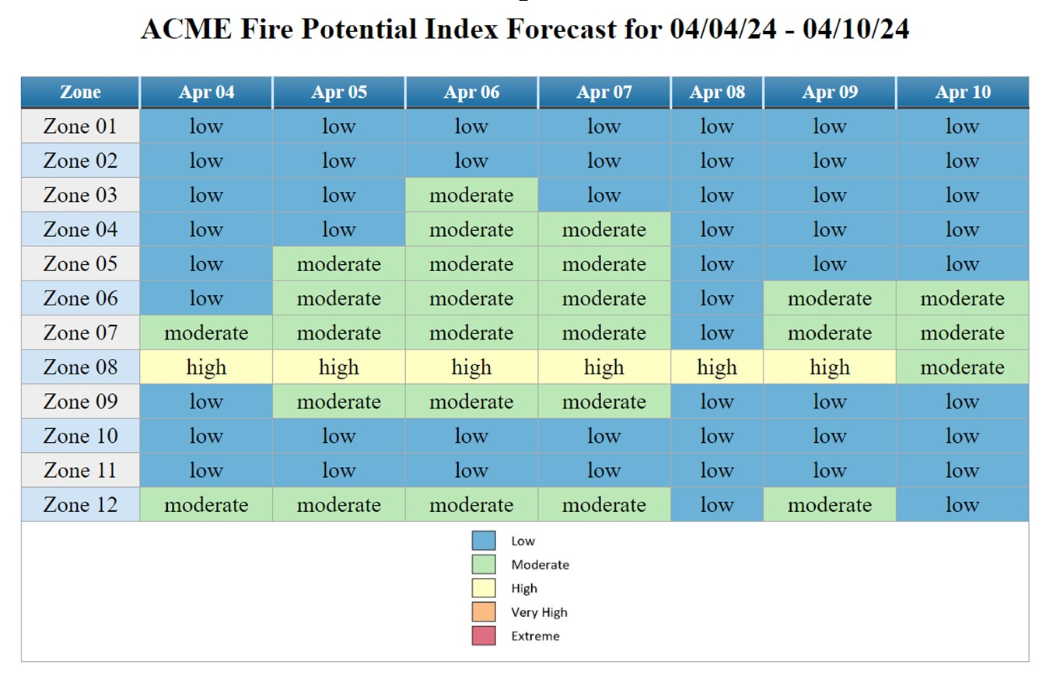

Table 2. Sample Percent of CRI Threshold Table.
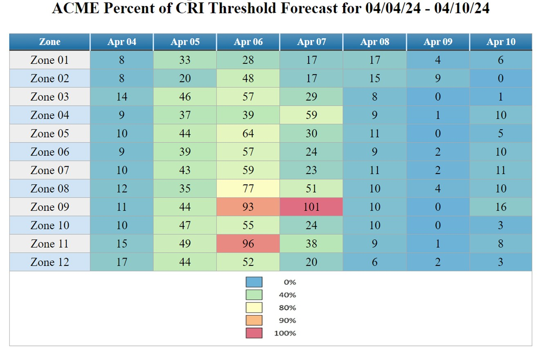

Table 3. Sample ERC Percentile table

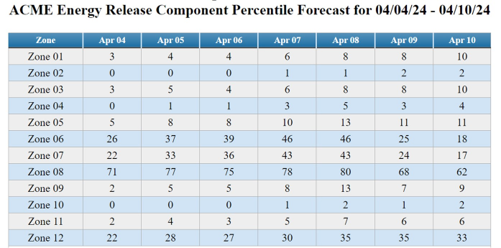

Fire Weather Summary Plots

After the summary tables, the FWD provides a series of fire weather forecast summary plots, grouped by monitoring zone - see Figure 1 for an example. These plots are intended to provide temporally granular fire weather forecast information for use in decision making. Six panels, arranged in a matrix of 3 columns by two rows, are provided for each monitoring zone. From the upper left, moving clockwise to lower left, these panels are:

- Fosberg Fire Weather Index. FFWI is a fuel-independent meteorological index calculated from relative humidity, temperature, and sustained wind speed. As a general rule of thumb, areas that have a FFWI value above 50 for 3 or more hours are of concern from a fire weather standpoint.

- Wind gust. This panel plots the 3-second average wind gust (mph) at 20 ft above the average height of predominant vegetative cover. Powerline-caused ignitions are a strong function of wind gust, increasing by approximately a factor of 10 for every 15 mph increase above 20 mph.

- Wind speed. This is the sustained, nominally 10-minute average, wind speed at 20 ft above the average height of predominant vegetative cover. Sustained wind speed is the primary driver of continuous fire front propagation.

- Firebrand ignition probability. This is the NFDRS Ignition Component (IC), an estimate of the probability that a firebrand making contact with a receptive fuel bed would result in a fire requiring suppression. It is useful for estimating the likelihood that small metallic or woody particles generated by powerline interactions could ignite a fire.

- CRI. This is the CRI described above in the Forecast Summary Tables section. In this panel, the CRI is not normalized by its threshold and the 80%, 90%, and 100% threshold lines are indicated on the plot.

- Head fire flame length. This is the modeled average head fire flame length. It is calculated from the Rothermel fire behavior model as implemented in the fire model ELMFIRE³. Flame length is directly related to resistance to control and is also viewed as a proxy for fire consequence.

The fire weather summary plots are updated four times per day, at approximately 00:45, 06:45, 12:45, and 18:45 PDT. Four panels (FFWI, wind gust, sustained wind speed, and firebrand ignition probability) include data from 7 different weather models. Flame length is calculated from a “hybrid” forecast (described below), and CRI is calculated from the hybrid forecast as well as the hybrid forecast plus the wind gust forecast from the ECMWF weather model, described in greater detail below.

Weather Forecast Models used in FWD

Data in the fire weather summary plots are obtained from 7 operational weather forecast models. These industry standard weather models are widely-used and understood in the meteorological, atmospheric sciences, and fire science communities. Background information on these models is beyond the scope of this document and can be obtained from the organizations that maintain and operate them. The seven models used in the FWD, along with their spatial resolution and forecast duration as used in the FWD, are:

- ECMWF: European Center for Medium-Range Weather Forecasts HIRES forecast (0.1°, 8 days).
- HRRR: High Resolution Rapid Refresh (3 km, 48 hours)
- NAM 3 km: North American Mesoscale Model nest (3 km, 60 hrs)
- NAM 12 km: North American Mesoscale Model (12 km, 84 hrs)
- GFS 0.125°: Global Forecast System (0.125°, 8 days)
- GFS 0.125°: Global Forecast System (0.25°, 8 days)
- NBM: National Blend of Models (2.5 km, 8 days)

3 https://elmfire.io
Particularly for wind gust forecasting, the high-resolution HRRR and NAM 3 km models are preferred for forecast durations less than 48 hours (HRRR) and 60 hours (NAM). After 60 hours, the NBM and ECMWF models are preferred for wind gust forecasting. For a geospatial view of these models, the PyreCast tool (https://pyrecast.org) is recommended. CloudFire has developed and maintains the weather pipeline that powers FWD and PyreCast, so the same forecast data in the FWD can also be viewed geospatially in PyreCast.

Modeled flame length is calculated with ELMFIRE using a hybrid forecast constructed as follows:
- 0-48 hr: Average of HRRR and NAM 3 km
- 49-60 hr: NAM 3 km
- > 61 hr: GFS 0.125°

Due to the ECMWF model’s superior wind gust forecast skill relative to the GFS, the CRI is calculated using both the hybrid gust forecast (labeled “HRRR/NAM/GFS gust” in the CRI panel) and the ECMWF gust forecast (labeled “ECMWF gust” in the CRI panel). Note that 1.0 degree of latitude is approximately 111 km, so the resolution of the 0.1° ECMWF forecast is 11.1 km.

Composite Risk Index (CRI) Overview

The Composite Risk Index (CRI) is a screening criterion that combines a function of wind gust (as a proxy for utility fire ignition likelihood) and flame length (as a proxy for fire consequence) into a single forecastable composite index. CRI is intended for use in implementation of incremental utility fire mitigation measures up to and including proactive de-energization / public safety power shutoff when weather and fuel conditions create elevated risk from powerline caused fires. CRI is defined as wind gust force (in units of lb/ft²) multiplied by 10 × head fire flame length, which is expressed mathematically in Equation 1 as:
Composite risk index 𝐹 10 𝐿 0.00256 𝑉 10 𝐿 (1)
Here, F_{wind} is wind gust force (lb/ft), L_{f} is head fire flame length (ft), and V_{g} is 3-second wind gust speed (mph). In this formulation, wind force represents probability of powerline-caused ignitions and L_{f} represents the consequence of those ignitions as flame length directly affects resistance to control. The decision to use wind force, which scales with the square of wind speed, to represent the ignition axis in this composite risk index is based in part on work completed during the California Public Utilities Commission (CPUC) high fire threat district mapping². In that work, an Independent Expert Team (IET) led by CAL FIRE deliberated over several powerline-fire ignition models and after analyzing ten years of fault records from utilities selected the following formula for the ignition axis:
IET ignition axis 0.00256 𝑉 𝑃 (2)
where P_{ign} is ignition probability which is similar to the NFDRS Ignition Component (IC). The same formula is used here but without the P_{ign} factor. The choice to omit P_{ign} is conservative because in a line down situation, ignition is probable and P_{ign} can only decrease the ignition axis as defined in Equation 2.

The CRI in Equation 1 is calculated for each zone using weather model forecast data and fire modeling (see for example https://nvfireweather.com). Forecasts are provided 8 days into the future and are automatically refreshed every 6 hours (00:45, 06:45, 12:45, and 18:45 PDT). The weather models used in calculation of the CRI include High Resolution Rapid Refresh (HRRR, 3 km, 48 hours), North American Mesoscale Model nest (NAM, 3 km, 60 hrs), Global Forecast System (GFS, 0.125°, 8 days), and the European Center for Medium-Range Weather Forecasts (ECMWF) HIRES forecast (ECMWF HIRES, 0.1°, 8 days).
The operational fire spread model ELMFIRE (Eulerian Level set Model of FIRE spread), is used to calculate head fire flame length at every 30 m pixel within each zone for each discrete timestep in the forecast period. Although flame length and wind gust vary spatially within a given zone, Equation 1 requires a single value of wind gust and flame length. Therefore, spatial mean values of flame length and wind gust are calculated using zonal statistics for each time in the forecast period. The flame length calculation directly or indirectly includes the following factors: • Surface fuel characteristics (fuel type, fuel load, etc.)
- Dead fuel moisture by size / time lag class (1-hr, 10-hr, and 100-hr)
- Live herbaceous and live woody fuel moisture
- Sustained mid-flame wind speed and direction
- Topographical slope and aspect
- Relative humidity, temperature, precipitation, and solar heating

A CRI threshold exceedance analysis is conducted for each zone using ~15 years of historical gridded (2.5 km resolution) hourly mesoscale weather analysis data to calculate CRI via Equation 1 for each hour in the period of record. This analysis provides zone-specific estimates of the probability that a specific numerical CRI value is exceeded in a given year, allowing CRI threshold guidelines to be established for each zone based on an annual exceedance probability (or inversely, a recurrence interval).

Based on the Wildland Urban Interface Maps available from the U.S. Geological Survey website titled “Wildland-urban interface maps for the conterminous U.S. based on 125 million building locations” (Carlson et al. 2022).
19 California Code of Regulations Section 2407.
Cal. Gov. Code Section 2403(b): (1) “Field response level” commands emergency response personnel and resources to carry out tactical decisions and activities in direct response to an incident or threat. (2) “Local government level” manages and coordinates the overall emergency response and recovery activities within their jurisdiction. (3) “Operational area level” manages and/or coordinates information, resources, and priorities among local governments within the operational area and serves as the coordination and communication link between the local government level and the regional level. (4) “Regional level” manages and coordinates information and resources among operational areas within the mutual aid region designated pursuant to Government Code §8600 and between the operational areas and the state level. This level along with the state level coordinates overall state agency support for emergency response activities. (5) “State level” manages state resources in response to the emergency needs of the other levels, manages and coordinates mutual aid among the mutual aid regions and between the regional level and state level, and serves as the coordination and communication link with the federal disaster response system.
Adopted by CPUC Decision 17-12-024.
An RFW is issued for weather events that may result in extreme fire behavior that will occur within 24 hours. RFW is the highest alert. While an RFW is in effect, TDPUD’s crews limit hot work, such as welding, grinding, and cutting, and TDPUD will delay all routine work on energized primary lines (12 kV and 14.4 kV). TDPUD may perform necessary work to preserve facilities or property. Vegetation management and line crews have on-site fire suppression equipment and conduct tailboard meetings to confirm the location and readiness of the fire suppression equipment.
The factor of 10 stems from the definition of Burning Index (BI) in the National Fire Danger Rating System (NFDRS) as ten times flame length in ft.
Sapsis, D. et al., “Mapping Environmental Influences on Utility Fire Threat,” A Report to the California Public Utilities Commission Pursuant to R.08 – 11-005 and R.15-05-006, Final Report, February 2, 2016.
Lautenberger, C., “Wildland Fire Modeling with an Eulerian Level Set Method and Automated Calibration,” Fire Safety Journal 62: 289-298 (2013).
https://elmfire.io 1

