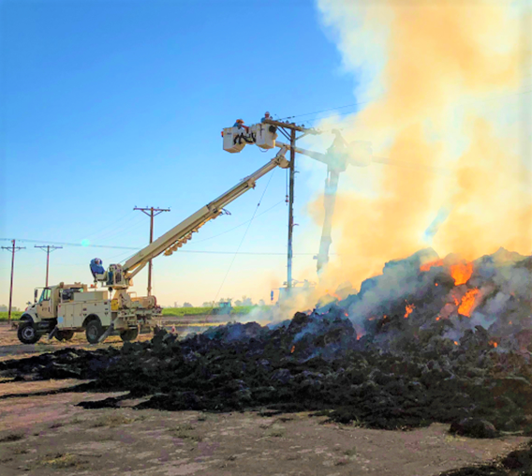

Imperial Irrigation District

SB 901 Wildfire Mitigation Plan

2023-2025
September 5, 2023

Table of Contents

- Executive Summary
- Imperial Irrigation District SB 901 Wildfire Mitigation Plan Objective
- Authority to Implement the Plan
- SB 901 Public Owned Utility Statutory Requirements Cross Reference Table
- Wildfire Safety Advisory Board Recommendations for Publicly Owned Utilities Cross Reference Table
- Wildfire Safety Advisory Board Recommendations Specific to Imperial Irrigation District Cross Reference Table
- Imperial Irrigation District Service Territory Overview
- IID Service Territory Climate Change Projections
- IID Service Territory Fire Threat Information
- IID Utility Practices
- IID SB 901 Practice
- IID Wildfire Mitigation Plan Roles and Responsibilities
- Projects Expected to Reduce Fire Ignitions Caused by IID Infrastructure
- Revision History
- Approval
- Appendix A Independent Evaluator Review

- Executive Summary
  - The IID Wildfire Mitigation Plan meets applicable California SB 901 requirements.
  - Inside the IID service territory, there are no IID owned and operated transmission, distribution, or generation facilities, inside CAL FIRE designated High or Very High Fire Hazard Severity Zones.
  - Long-term wildfire risk caused by Climate Change will remain very low through end of this century.
  - Although there is no IID owned and operated infrastructure located inside CAL FIRE designated High or Very High Fire Hazard Severity Zones, IID is submitting this plan that identifies efforts expected to help reduce the risk of fire ignitions caused by IID service territory power infrastructure.
  - The IID plan addresses additional requests from The Wildfire Safety Advisory Board regarding plan organization and contents.
  - The IID plan identifies four performance metrics;
(1) encroachments,
(2) imminent treats,
(3) lines and poles down incidents, and
(4) fire incidents caused by IID infrastructure.
IID is actively working on procedures and software applications to begin to capture, and report metric information.
  - The IID SB 901 Wildfire Mitigation Plan 2023-2025 will activate on January 1, 2023, or soon thereafter, upon IID Board approval. A comprehensive update of the plan is required every (3) years thereafter.
  - Annual status reports will be posted on the IID.com website for public comment, submitted to the Imperial Irrigation District Board of Directors, and provided to the California Wildfire Safety Advisory Board.

- Imperial Irrigation District SB 901 Wildfire Mitigation Plan Objectives
The primary objectives of the Imperial Irrigation District SB 901 Wildfire Mitigation Plan are as follows:
- Meet requirements identified in sections applicable to publicly owned electric utilities, of the State of California Senate Bill 901 Wildfires.
- Reduce the number of fire ignitions caused by Imperial Irrigation District power infrastructure.
- Authority to Implement the Plan
This plan is implemented under the authority of the Imperial Irrigation District Board of Directors.
- SB 901 Public Owned Utility Statutory Requirements Cross Reference Table
 | SB 901 – Public Owned Utility  Wildfire Plan Requirements | IID SB 901 WF Mitigation Plan Sections
4.1 | Staff Responsibilities  SB 901 Section 42 (b) (2) (A) An accounting of the responsibilities of persons responsible for executing the plan. | Sec 12 IID Wildfire Mitigation Plan Roles and Responsibilities
4.2 | General Objectives  SB 901 Section 42(b) (2) (B) The objectives of the wildfire mitigation plan. | Sec 2 Imperial Irrigation District SB 901 Wildfire Mitigation Plan Objectives
4.3 | Program Descriptions  SB 901 Section 42(b)(2)(C) A description of the preventive strategies and programs to be adopted by the local publicly owned electric utility or electrical cooperative to minimize the risk of its electrical lines and equipment causing catastrophic wildfires, including consideration of dynamic climate change risks. | Sec 10 IID Utility Practices  Sec 11 IID SB901 Practice  Sec 13 Projects Expected to Reduce Fire Ignitions Caused by IID Infrastructure
4.4 | Evaluation Metrics  SB 901 Section 42(b)(2)(D) A description of the metrics the local publicly owned electric utility or electrical cooperative plans to use to evaluate the wildfire mitigation plan’s performance and the assumptions that underlie the use of those metrics. | Sec 11.8 Performance Metrics
4.5 | Lessons Learned, Metrics Application  SB 901 Section 42(b) (2) (E) A discussion of how the application of previously identified metrics to previous wild fire mitigation plan performances has informed the wildfire mitigation plan. | Sec 11.7 Monitoring the Plan and Performance Metrics
4.6 | Protocols for Reclosers, De-energization, and PSPS Mitigation  SB 901 Section 42(b)(2)(F) Protocols for disabling re-closers and de-energizing portions of the electrical distribution system that consider the associated impacts on public safety, as well as protocols related to mitigating the public safety impacts of those protocols, including impacts on critical first responders and on health and communication infrastructure. | Sec 10.15 Disabling Re-Closer Procedure – System Operations Center  Sec 10.16 Public Safety Power Shutoff – Emergency Management Unit
4.7 | Community Notification – De-energization  SB 901 Section 42(b) (2) (G) Appropriate and feasible procedures for notifying a customer who may be impacted by the de-energizing of electrical lines. The procedures shall consider the need to notify, as a priority, critical first responders, health care facilities, and operators of telecommunications infrastructure. | Sec 10.16 Public Safety Power Shutoff – Emergency Management Unit  Sec 10.5 Community Outreach and Public Awareness – Line Clearance Unit, Customer Service Unit
4.8 | Vegetation Management  SB 901 Section 42(b) (2) (H) Plans for vegetation management. | Sec 10.1 FAC-003 Transmission System Vegetation Management Program  Sec 10.2 Vegetation Management Power Lines 200 kV and Below Not Subject to FERC Jurisdiction - Line Clearance Unit
4.9 | Infrastructure Inspections  SB 901 Section 42(b) (2) (I) Plans for inspections of the local publicly owned electric utility’s or electrical-cooperative’s electrical infrastructure. | Sec 10.6 Monitor and Audit the Effectiveness of Substation Inspections – Substation Construction and Maintenance  Sec 10.7 Monitor and Audit the Effectiveness of Powerline and Powerline Equipment Inspections – Power Restoration and Troubleshooting Unit  Sec 10.8 Transmission Power Line Inspections - Power Restoration and Troubleshooting Unit  Sec 10.9 Distribution Power Line Inspections - Power Restoration and Troubleshooting Unit
4.10 | - Grid Design, Construction and Operation Risks  SB 901 Section 42(b)(2)(J) A list that identifies, describes, and prioritizes all wildfire risks, and drivers for those risks, throughout the local publicly owned electric utility’s, or electrical cooperative’s Service Territory. The list shall include, but not be limited to, both of the following:  SB 901 Section 42(b)(2)(J)(i) Risks and risk drivers associated with design, construction, operation, and maintenance of the local publicly owned electric utility’s or electrical cooperative’s equipment and facilities. | Sec 9 IID Service Territory Fire Threat Information
4.11 | - Vegetation, Topographic, and Climate Risks  - SB 901 Section 42(b)(2)(J)(ii) Particular risks and risk drivers associated with topographic and climatological risk factors throughout the different parts of the local publicly owned electric utility’s or electrical cooperative’s Service Territory. | Sec 7 Imperial Irrigation District Service Territory Overview  Sec 8 IID Service Territory Climate Change Projections
4.12 | Identification and Expansion of Higher Wildfire Threat Areas  SB 901 Section 42(b) (2) (K) Identification of any geographic area in the local publicly owned electric utility’s or electrical cooperative’s Service Territory that is a higher wildfire threat than is identified in a commission fire threat map, and identification of where the commission should expand a high fire threat district based on new information or changes to the environment. | Sec 11.1 Service Territory Survey by Independent Evaluator
4.13 | Identify Enterprise-wide Risk  SB 901 Section 42(b) (2) (L) A methodology for identifying and presenting enterprise wide safety risk and wildfire-related risk. | Sec 9 IID Service Territory Fire Threat Information
4.14 | Restoration of Service  SB 901 Section 42(b) (2) (M) A statement of how the local publicly owned electric utility or electrical cooperative will restore service after a wildfire. | Sec 10.10 Emergency Event Procedures– Emergency Management Unit  Sec 10.11 Emergency Event Procedures – System Operations Center  Sec 10.12 Service Restoration After Major Events – System Operations Center  Sec 10.13 Standardized Emergency Management System – Emergency Management Unit
4.15 | - Monitoring and Auditing of WMPs  - A description of the processes and procedures to;  - SB 901 Section 42(b) (2) (N) (i) Monitor and audit the implementation of the wildfire mitigation plan. | Sec 11.7 Monitoring the Plan and Performance Metrics
4.16 | - Identifying and Correcting Deficiencies  - A description of the processes and procedures to;  - SB 901 Section 42(b) (2) (N) (ii) Identify any deficiencies in the wildfire mitigation plan or its implementation, and correct those deficiencies. | Sec 11.7 Monitoring the Plan and Performance Metrics
4.17 | - Monitoring Asset Inspections  - SB 901 Section 42(b)(2)(N)(iii) Monitor and audit the effectiveness of electrical line and equipment inspections, including inspections performed by contractors, that are carried out under the plan, other applicable statutes, or commission rules. | Sec 10.4 Monitor and Audit the Effectiveness of Powerline Clearance Inspections - Line Clearance Unit  Sec 10.6 Monitor and Audit the Effectiveness of Substation Inspections – Substation Construction and Maintenance  Sec 10.7 Monitor and Audit the Effectiveness of Powerline and Powerline Equipment Inspections – Power Restoration and Troubleshooting Unit  Sec 11.1 Service Territory Survey by Independent Evaluator
4.18 | Wildfire Plan Public Comments  SB 901 Section 42(b) (3) The local publicly owned electric utility or electrical cooperative shall present each wildfire mitigation plan in an appropriately noticed public meeting. The local publicly owned electric utility or electrical cooperative shall accept comments on its wildfire mitigation plan from the public, other local and state agencies, and interested parties, and shall verify that the wildfire mitigation plan complies with all applicable rules, regulations, and standards, as appropriate. | Sec 11.3 Annual WSAB Submittal
4.19 | Independent Evaluator Wildfire Plan Assessment  SB 901 Section 42(c) The local publicly owned electric utility or electrical cooperative shall contract with a qualified independent evaluator with experience in assessing the safe operation of electrical infrastructure to review and assess the comprehensiveness of its wildfire mitigation plan. The independent evaluator shall issue a report that shall be made available on the Internet Web site of the local publicly owned electric utility or electrical cooperative, and shall present the report at a public meeting of the local publicly owned electric utility’s or electrical cooperative’s governing board. | Sec 11.1 Service Territory Survey by Independent Evaluator  Sec 11.5 Comprehensive Wildfire Plan Update - every three (3) years
4.20 | Biomass Energy Contract  SB 901 Section 43 An electrical corporation, local publicly owned electric utility, or community choice aggregator with a contract to procure electricity generated from biomass pursuant to subdivision (b) of Section 399.20.3, commission Resolution E-4770 (March 17, 2016), or commission Resolution E-4805 (October 13, 2016), or with a contract that is operative at any time in 2018, and expires or expired on or before December 31, 2023, shall seek to amend the contract to include, or seek approval for a new contract that includes, an expiration date five years later than the expiration date in the contract that was operative in 2018, so long as the contract extension follows the feedstock requirement of subdivision (b) of Section 399.20.3. This section shall not apply to facilities located in federal severe or extreme nonattainment areas for particulate matter or ozone. | Sec 10.20 Addressing SB 901 Section 43 Biomass Power Purchase Requirement - Energy Business and Regulatory Compliance Programs Unit
- Wildfire Safety Advisory Board Recommendations for Publicly Owned Utilities Cross Reference Table
Recommendations included in the WSAB Guidance Advisory Opinion for the 2022 Wildfire Mitigation Plans of Electric Publicly Owned Utilities and Rural Electric Cooperatives, Adopted February 23, 2022.
 | WSAB Recommendations for Publicly Owned Utilities  Guidance Advisory Opinion for the 2022 Wildfire Mitigation Plans of Electric Publicly Owned Utilities and Rural Electric Cooperatives, February 23, 2022 | IID SB901 WF Mitigation Plan Sections
5.1 | Context Setting Information  Include template containing key information about the service area, near the front of the WMP | Sec 7 Imperial Irrigation District Service Territory Overview  Sec 8 IID Service Territory Climate Change Projections  Sec 9 IID Service Territory Fire Threat Information
5.2 | Prominent WMP Information Location  Locate current and past wildfire mitigation information, including Independent Evaluator reports at a prominent and easily locatable web-based publication location. | https://www.iid.com/energy/vegetation-management/wildfire-mitigation-plan
5.3 | Statutory Cross Reference  Include statutory cross reference table near the front of the WMP. Include live links from table to plan section. | Sec 4 SB 901 Public Owned Utility Statutory Requirements Cross Reference Table
5.4 | Reducing the Risk of Catastrophic Wildfires  Add as one of the objectives of the WF plan, to reduce the risk of catastrophic wildfires  Question whether broader thought and strategies may be appropriate going forward. | Due to the low wildfire threat in the Imperial Irrigation District Service territory, Imperial Irrigation District does not have a formal catastrophic wildfire risk reducing plan objective.
5.5 | Public Input and Approval  Provide context-setting detail regarding how utilities approach WMP approval, consideration of public comment and budgetary protocols for mitigation and WMP tasks. Include in the statutory staff responsibilities section. | Sec 11.4 Annual Funding of Projects  Sec 12 IID Wildfire Mitigation Plan Roles and Responsibilities
5.6 | Metric Tracking  Provide more comprehensive and consistent metric tracking. Assure metrics are appropriate for the POU | Sec 11.8 Performance Metrics
5.7 | Independent Evaluations  Independent Evaluators shall perform a robust evaluation of the contents and substance of the POU’s WMP, in comparison to relevant industry standards, and provides useful recommendations for wildfire mitigation improvements where applicable. | Sec 11.1 Service Territory Survey by Independent Evaluator  Sec 11.5 Comprehensive Wildfire Plan Update - every three (3) years
5.8 | Grid Design  Are there design or construction issues related to the utility’s specific topography or geographic location that the Board should be aware of? | There are no reportable design or construction issues related to specific topography or geographic location.
5.9 | Grid Design  How will the utility address risks associated with facilities requiring power that abut a Tier 2 or Tier 3 HFTD? | Note: IID follows CAL FIRE, Fire Hazard Severity Zone designations; CAL FIRE High and Very High Fire Hazard Severity Zones.  Due to the low wildfire threat in the Imperial Irrigation District service territory, Imperial Irrigation District does not have a formal procedure to address risks with facilities requiring power that are adjacent to CAL FIRE High and Very High Fire Hazard Severity Zones.  Portable generators may be provided to customers on a case-by-case basis.
5.10 | Grid Design  How does the utility assess its risks associated with system design and construction? | IID construction practices meet industry construction practices such as G.O. 95.  IID inspection practices meet industry inspection practices such as G.O. 165, GO 174.  The Independent Evaluator service territory survey scope of work, includes a G.O. 95 detailed inspection spot check, noting G.O. 95 construction practice infractions, infrastructure condition issues.
5.11 | Grid Design  In what areas does the utility consider going above and beyond G.O. 95 and other General Order standards related to design and construction? | Due to the low wildfire threat in the Imperial Irrigation District service territory, Imperial Irrigation District construction practices do not go above and beyond G.O. 95 construction practices.
5.12 | Grid Design  Provide information about facilities not directly subject to G.O. 95 due to their construction prior to G.O. 95 first being adopted. How are these included in the WMP and safety protocols equivalently or in a different fashion to newer lines that would be subject to G.O. 95 protocols. | IID construction practices meet industry construction practices such as G.O. 95.
5.13 | Grid Design  Provide information how the utility goes beyond the G.O. 95 minimum standards if wildfire circumstances merit exceeding the standard. Explain how and why any specific POU goes beyond the G.O. 95 minimum standards. | Due to the low wildfire threat in the Imperial Irrigation District service territory, Imperial Irrigation District construction practices do not go above and beyond G.O. 95 construction practices.
5.14 | Grid Design  Provide information regarding what new ideas or enhanced protocols for design, build, and maintain, POUs are considering to further mitigate wildfire risk, due to changing wildfire conditions in the State due to climate change, land use change, or other change in vegetation conditions. | Sec 13 Projects Expected to Reduce Fire Ignitions Caused by IID Infrastructure  Although the Imperial Irrigation District does not have infrastructure located inside a CAL FIRE designated High Fire Hazard, or Very High Fire Hazard Severity Zone, the Imperial Irrigation District is submitting this plan that identifies projects expected to reduce the risk of fire ignitions caused by Imperial Irrigation District power infrastructure.  Relay Modernization Program – Relay Protection Unit  Sec 13.1 Relay Modernization Program – Relay Protection Unit  Sec 13.2 Distribution Power Line Bird Deterrents – Electrical Engineering Section
5.15 | Risk Assessment and Mapping  Provide information about the installation of situational awareness technologies, to better understand wildfire risk drivers, particularly through collaborative activities and shared data with neighboring utilities. Wind speed and direction, temperatures and moister contents, active monitoring for ignitions. Weather stations, cameras, drones, satellites, and other monitoring technologies. | Due to the low wildfire threat in the Imperial Irrigation District service territory, Imperial Irrigation District does not perform this activity.
5.16 | Risk Assessment and Mapping  Further development of consideration of the risks and benefits of mitigation measures, such as PSPS | Due to the low wildfire threat in the Imperial Irrigation District service territory, Imperial Irrigation District does not perform this activity.
5.17 | Risk Assessment and Mapping  Develop information on any potential negative impacts of new technologies and how those impacts may be mitigated. | Due to the low wildfire threat in the Imperial Irrigation District service territory, Imperial Irrigation District does not perform this activity.
5.18 | Vegetation Management and Inspections  Provide clarity about meeting, exceeding, or substituting for G.O. 95 standards, going beyond minimum standards due to specific wildfire conditions | Sec 10.1 FAC-003 Transmission System Vegetation Management Program  Sec 10.2 Vegetation Management Power Lines 200 kV and Below Not Subject to FERC Jurisdiction - Line Clearance Unit  Due to the low wildfire threat in the Imperial Irrigation District service territory, Imperial Irrigation District construction practices do not go above and beyond G.O. 95 construction practices.
5.19 | Vegetation Management and Inspections  Include descriptions of the variety of treatment methods each POU uses, such as tree or branch removal, trimming, pruning, mowing, goats to remove grass, use of mechanical tools to clear brush, surface fuel clearing during dry season and herbicide use. | Sec 10.1 FAC-003 Transmission System Vegetation Management Program  Sec 10.2 Vegetation Management Power Lines 200 kV and Below Not Subject to FERC Jurisdiction - Line Clearance Unit
5.20 | Vegetation Management and Inspections  When all vegetation is cleared from beneath or around an asset, or for access purposes, describe how POU deals with flammable new growth. How is new growth tracked, and managed to prevent increased fire risk. | Due to the low wildfire threat in the Imperial Irrigation District service territory, Imperial Irrigation District does not perform this activity.
5.21 | Vegetation Management and Inspections  How does the POU identify native and other vegetation by species, considering the ignition risk of these species, and describing how treatment methods vary depending upon the type of species? | Due to the low wildfire threat in the Imperial Irrigation District service territory, Imperial Irrigation District does not perform this activity.
5.22 | Vegetation Management and Inspections  Provide information of POU consideration, where appropriate of alternate management methods, such as replacing vegetation with less flammable native options and reducing the ignition chances of vegetation by strategically increasing moister content. | Due to the low wildfire threat in the Imperial Irrigation District service territory, Imperial Irrigation District does not perform this activity.
5.23 | Vegetation Management and Inspections  How is expertise from scientists or experts that understand the relative growing and regeneration patterns, species traits, flammability, and ecological role that vegetation plays relative to fire ignition and behavior and from ongoing fire research is integrated into vegetation management planning. | Due to the low wildfire threat in the Imperial Irrigation District service territory, Imperial Irrigation District does not perform this activity.
5.24 | Community Communication, Outreach, Emergency Preparedness and Recovery  How does POU provide information and assistance to their customers during wildfire starts | Sec 10.5 Community Outreach and Public Awareness – Line Clearance Unit, Customer Service Unit
5.25 | Community Communication, Outreach, Emergency Preparedness and Recovery  Provide information regarding resource availability and alternatives sole in the wildfire context, such as backup supplies to vital services and businesses | Sec 10.5 Community Outreach and Public Awareness – Line Clearance Unit, Customer Service Unit  Portable generators may be provided on a case-by-case basis.
- Wildfire Safety Advisory Board Recommendations Specific to Imperial Irrigation District Cross Reference Table
Recommendations included in the WSAB Guidance Advisory Opinion for the 2022 Wildfire Mitigation Plans of Electric Publicly Owned Utilities and Rural Electric Cooperatives, Adopted February 23, 2022.
 | WASB Recommendations Specific to Imperial Irrigation District  Guidance Advisory Opinion for the 2022 Wildfire Mitigation Plans of Electric Publicly Owned Utilities and Rural Electric Cooperatives, February 23, 2022 | IID SB901 WF Mitigation Plan Sections
6.1 | Utility Information and Cross Reference Table  Provide utility information template and cross reference table up front in the wildfire mitigation plan. | Sec 4 SB 901 Public Owned Utility Statutory Requirements Cross Reference Table  Sec 5 Wildfire Safety Advisory Board Recommendations for Publicly Owned Utilities Cross Reference Table  Sec 6 Wildfire Safety Advisory Board Recommendations Specific to Imperial Irrigation District Cross Reference Table
6.2 | Location of Wildfire Mitigation Reports in IID Website  Provide WMP reports and information in a clear and prominent place on IID website | https://www.iid.com/energy/vegetation-management/wildfire-mitigation-plan
6.3 | Next Comprehensive Wildfire Mitigation Report  Incorporate appropriate informational response information as recommended. | Sec 5 Wildfire Safety Advisory Board Recommendations for Publicly Owned Utilities Cross Reference Table  Sec 6 Wildfire Safety Advisory Board Recommendations Specific to Imperial Irrigation District Cross Reference Table
6.4 | Metrics  Provide future metric results for fire ignitions, wires down, imminent treat violations, encroachment violations, and infrastructure developments in HFTD areas | Sec 11.8 Performance Metrics  Metric results are included in IID SB901 Wildfire Mitigation Annual Status Report 2021 and are expected to be included in future annual status reports.  https://www.iid.com/energy/vegetation-management/wildfire-mitigation-plan
6.5 | Independent Evaluator Reports  Provide updates on the issues identified by the independent evaluator and their impact on reducing wildfire risk in future wildfire mitigation plans. | Expect to include updates on approved projects resulting from issues identified by Independent Evaluator in the annual IID SB901 Wildfire Mitigation Annual Status Reports

- Imperial Irrigation District Service Territory Overview
Irrigation District (IID) is an irrigation special district established under Division 11 of the California Water Code, Sections 20500, which provides non-potable water, farm drainage, and power services to the lower southeastern portion of California's desert.
Imperial Irrigation District is a transmission, distribution, and generation, energy utility. The utility operates over 1,800 miles of overhead energy transmission lines, and over 4,400 miles of power distribution lines throughout its service territory.
The Imperial Irrigation District Service Territory is located in the southeastern corner of California. The Service Territory covers over 6,600 square miles, including all of Imperial County, the Coachella Valley in Riverside County, and a part of eastern San Diego county. The service territory is outlined with a dashed black and yellow line on the map included in the table below.
The following table provides an overview of the IID service territory.
 | Imperial Irrigation District
7.1  Service Territory Size | 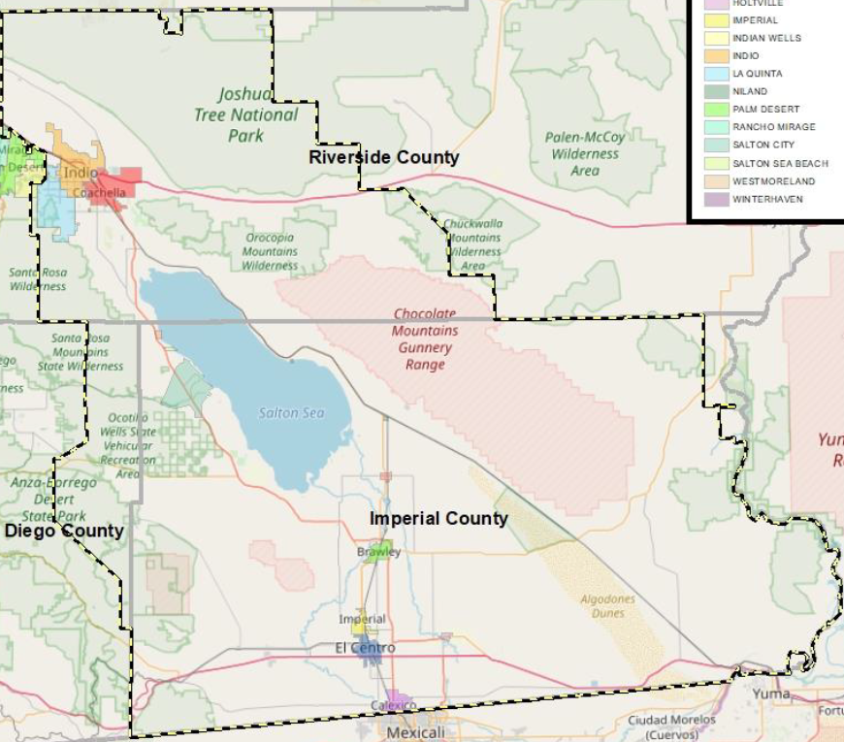  The IID Service Territory is approximately 6,600 square miles.
7.2  Owned Assets | IID is a vertically integrated load balancing electric utility with transmission, distribution, and generation assets.
7.3  Number of Customers Served | IID serves approximately 158,000 power contract accounts.
7.4  Population Within Service Territory  (source, IID internal report)
  Year | Imperial County Projected Population | Coachella Valley Projected Population | Total Service Area Projected Population
  2020 | 214,590 | 252,388 | 468,998
  2025 | 232,998 | 288,867 | 523,890
  2030 | 251,611 | 330,619 | 584,260
  2035 | 263,309 | 378,405 | 643,749
  2040 | 293,889 | 433,099 | 729,028
7.5 Customer Class Makeup | Number of Accounts  86 % Residential,  3.4 % Commercial,  0.6 % Industrial  Share of Total Load (MWh)  47% Residential  50% Commercial  3% Industrial
7.6  Service Territory  Location | 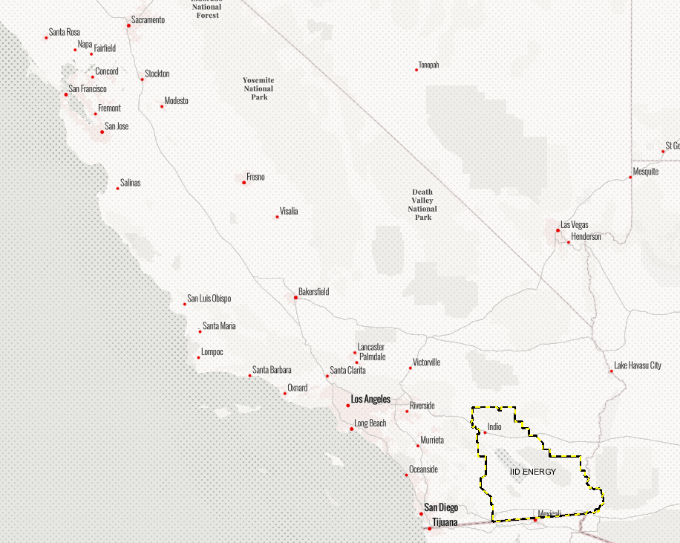  Service Territory is located in the southeastern corner of California.
7.7  Service Territory  Wildland Urban Interface | 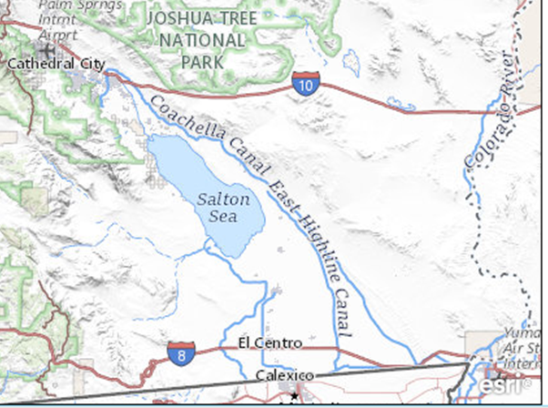  https://www.sciencebase.gov/catalog/item/imap/617bfb43d34ea58c3c70038f  Wildland urban interface is located to the north and northwest corner of the IID service territory.  Source USGS 09/07/2022
7.8  Percent of Service Territory in CAL FIRE High or Very High Fire Hazard Severity Zones (based on total area, IID GIS 2019) | High Fire Hazard Severity Zone: approx. 0.5%  Very High Fire Hazard Severity Zone: approx. 0.6 %  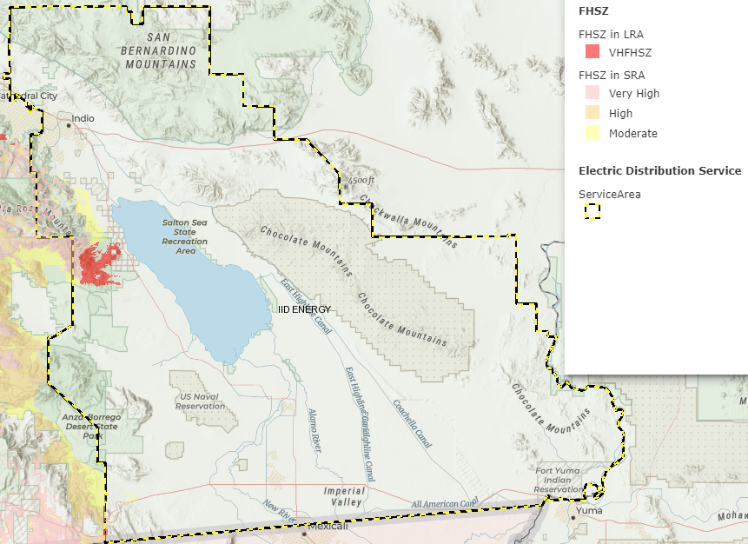  CAL FIRE Fire Hazard Map with IID service territory layer 01-25-2022  FHSZ – fire hazard severity zone  LRA – Local Responsibility Area  SRA – State Responsibility Area
7.9  Prevailing Wind Directions & Speeds by Season | Source: Western Regional Climate Center  https://wrcc.dri.edu/Climate/wind.php
  Prevailing Wind Direction 1992-2002
  Prevailing wind direction is based on the hourly data from 1992-2002 and is defined as the direction with the highest percent of frequency.
  Station | JAN | FEB | MAR | APR | MAY | JUN | JUL | AUG | SEP | OCT | NOV | DEC |  | ANN
  El Centro Naval Air Facility | W | W | W | W | W | W | W | SE | W | W | W |  | W |  | W
  Imperial Airport | W | W | W | W | W | W | W | ESE | W | W | W |  | W |  | W
  Thermal Airport | N | N | NNW | NNW | NW | NW | NW | NW | NNW | NNW | NW |  | NW |  | NW
  Average Wind Speed 1996-2006
  Average wind speeds are based on the hourly data from 1996-2006 from automated stations at reporting airports (ASOS) unless otherwise noted.
  Station | JAN | FEB | MAR | APR | MAY | JUN | JUL | AUG | SEP | OCT | NOV |  | DEC |  | ANN
  El Centro Naval Air Facility | 5.7 | 6.7 | 8.2 | 10.7 | 8.7 | 8.9 | 7.5 | 6.7 | 7.1 | 6.9 | 5.4 |  | 5.4 |  | 7.3
  Imperial Airport | 5.8 | 7.0 | 8.4 | 10.5 | 9.3 | 9.4 | 8.3 | 7.6 | 7.0 | 6.6 | 5.8 |  | 5.5 |  | 7.5
  Thermal Airport | 5.1 | 5.7 | 7.6 | 9.2 | 9.3 | 9.0 | 7.4 | 6.6 | 6.8 | 6.2 | 5.2 |  | 4.9 |  | 6.8
7.10  Miles of Owned Lines Underground and/or Overhead | - 3971 miles of distribution overhead and underground circuits,  - 974 miles of distribution overhead  - 2997 miles of distribution underground  - 563 miles of transmission circuits,  - 129 substations, generation stations, switching stations, and mini-substations,  - 10,703 distribution pad mount transformers,  - 4,520 vaults,  - 21,080 underground pull boxes,  - 1,048 switch cabinets,  - 38,102 steel poles and towers,  - 98,299 wood poles,  - 15,669 overhead service drops,  - 18 miles of All Dielectric Self-Supporting (ADSS) overhead communication cable,  - 2,603 IID owned streetlights,  - 5,316 customer owned streetlights.  Notes  - Miles are measured as conductor length in miles  - Customer Owned facilities are facilities owned by others  - Sections of F line to Blythe and A line to Yucca Generation Station are outside service territory maintained by IID, other lines outside service territory are operated by others
7.11  Percent of Owned Lines in CAL FIRE High or Very High Fire Hazard Severity Zones | Overhead Distribution Lines as % of Total Distribution System  (Inside IID Service Territory)  HIGH: 0%  VERY HIGH: 0%
Overhead Transmission Lines as % of Total Transmission System
(Inside IID Service Territory)
HIGH: 0%
VERY HIGH: 0%
7.12  Customers have ever lost service due to an IOU PSPS event? | ☐ Yes X No  IID is at a low risk of being impacted by IOUs responding to PSPS events. IID customer load is contained within the IID BA and external customer load being interrupted by neighboring BAs or TOPs has little overall impacts to IID customers.
7.13  Customers have ever been notified of a potential loss of service to due to a forecasted IOU PSPS event? | ☐ Yes X No  Customers have not been notified of a potential loss of service to due to a forecasted IOU PSPS event since IID’s customers are located within the IID BA.
7.14  Utility has developed protocols to pre-emptively shut off electricity in response to elevated wildfire risks? | ☐ Yes X No  IID has not previously pre-emptively shut off electricity in response to elevated wildfire risk as it is not in the high-risk area.
7.15  Has previously pre-emptively shut off electricity in response to elevated wildfire risk? | ☐ Yes X No  IID has not previously pre-emptively shut off electricity in response to elevated wildfire risk as it is not in the high-risk area.

- IID Service Territory Climate Change Projections
  - Projections of ecological system change within the Imperial Irrigation District Service Territory with a horizon of 60 years.
The following text is from the Climate Change and Health Profile Report – Imperial County, Climate Change and Health Report – Riverside County California Department of Public Health UC Davis 2017
https://scag.ca.gov/sites/main/files/file-attachments/chpr025imperial_county2-23-17.pdf?1604524054
https://www.shaperivco.org/content/sites/riverside/reports/Climate_Change/Climate_Change_and_Health.pdf
Climate change impacts vary widely across California. The impact of climate change in California varies across the state due to diversity in biophysical setting, climate, and jurisdictional characteristics.
The California Adaptation Planning Guide organized the state into climate impact regions based on county boundaries in combination with projected climate impacts, existing environmental settings, socioeconomic factors, and regional designations and organizations (see map below depicting California Climate Impact Regions designated in the “California Climate Adaptation Planning Guide,” with the IID service territory identified with the red outline).
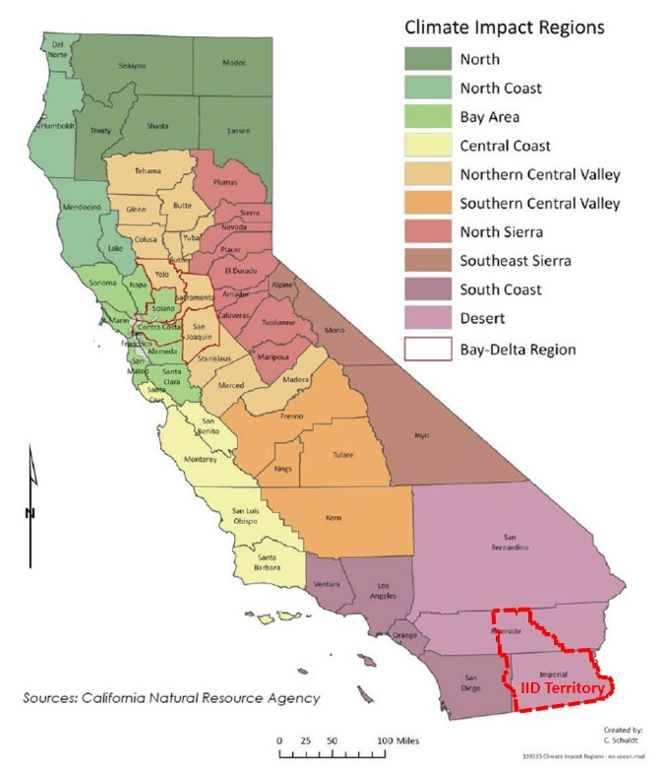
The IID Service Territory is located almost entirely in the “Desert Region”, and the California Climate Adaptation Planning Guide provides the following ecological climate change impact projections for that region:
  - Summary of Cal-Adapt Climate Projections for the Desert Region (2011 model)
Temperature Change, 1990-2100 | Projected temperatures, based on the high carbon emissions scenario;  January increase in average temperatures: 2°F to 4°F by 2050 and 5°F to 8°F by 2100  July increase in average temperatures: 3°F to 5°F by 2050 and 6°F to 9°F by 2100
Precipitation | Projected rainfall, based on high carbon emissions scenario;  Generally, annual rainfall will decrease in the most populous areas. Wetter areas like the western part of Riverside and southwestern San Bernardino counties will experience a 2 to 4-inch decline by 2050 and 3.5 to 6-inch decline by the end of the century. Big Bear is expected to lose around 8 inches per year by 2090.  Southern Imperial County will have a small decline of about 0.5 inches. The eastern, desert portion of the region will see little to no change in annual rainfall.
Heat Wave | Heat waves are defined by five consecutive days over temperatures in the 100s over most of the region.  Three to five more heat waves will be experienced by 2050, increasing to 12 to 16 in the western parts of the region to more than 18 to 20 in the eastern parts of the region.
Snowpack | Projected snowpack based on CCSM3 climate model; high emissions scenario  March snowpack in the Big Bear area will diminish from the 2.5-inch level of 2010 to 1.4 inches in 2030 and almost zero by 2090.  Note the Big Bear area is outside the IID service territory.
Wildfire Risk | Wildfire risk projections based on GFDL model, high carbon emissions scenario.  Most areas are projected to have the same or slightly increased likelihood of wildfire risk.
Source: Public Interest Energy Research, 2011. Cal-Adapt6 http://cal-adapt.org
The following two charts show a closer view of projected temperature increases for Imperial and Riverside counties through 2099.
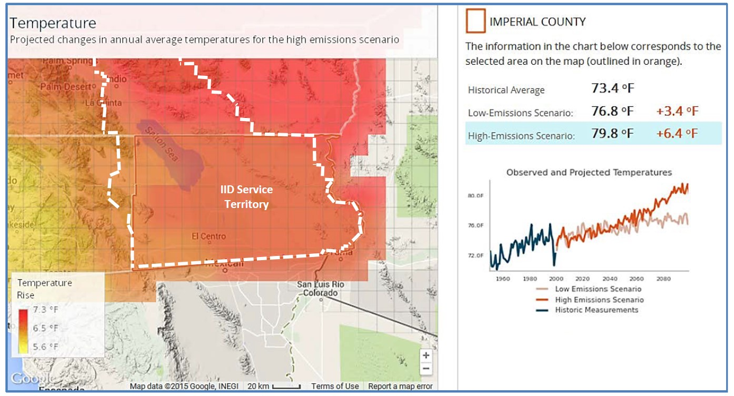

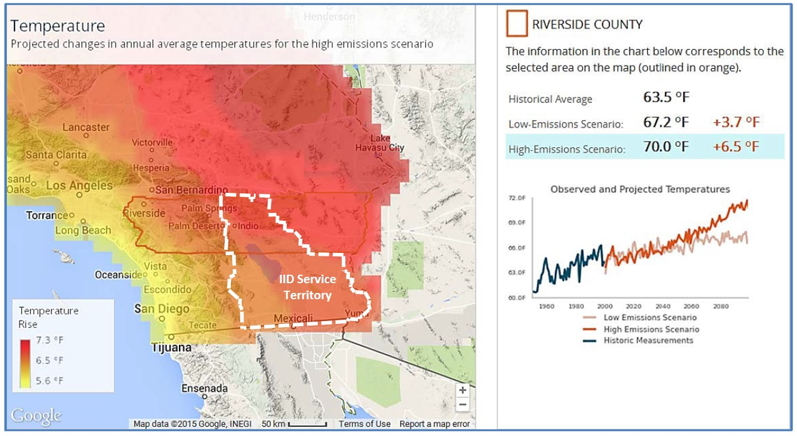
The Section 8.3 includes two charts that show the measured 12-month temperature averages for Imperial and Riverside Counties.
By comparing the 2010 model projections in Section 8.2, to the actual measured temperature charts below, one can see the actual measured high water-mark temperatures for year 2020 are slightly higher than the model projections.
  - Actual Measured 12 Month Temperature Averages Imperial County and Riverside County 1900-2020
Source USA Facts
https://usafacts.org/issues/climate/state/california/county/imperial-county
https://usafacts.org/issues/climate/state/california/county/riverside-county#climate
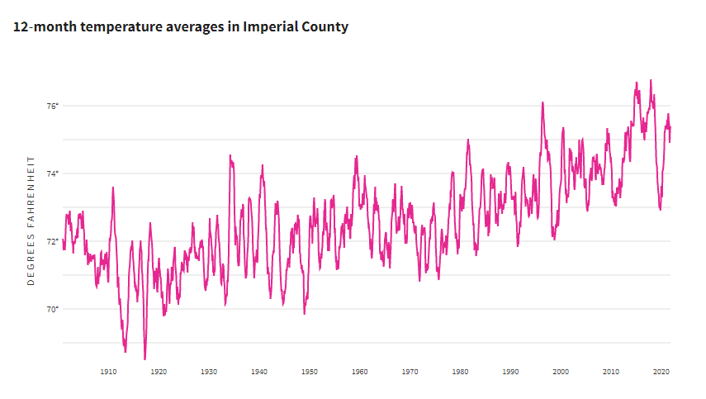
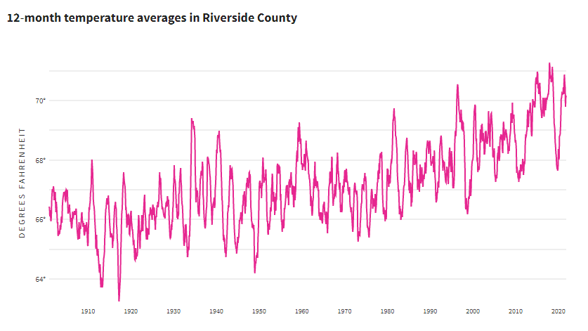

  - Imperial and Riverside Counties Projected Increase or Decrease in Area Burned
While all of California is subject to some degree of fire hazard, there are specific features that make some areas more hazardous.
CAL FIRE, Fire Hazard Severity Zones (FHSZ) were developed using a computer model. They predict the physical damage a fire is likely to cause based on the factors that influence fire likelihood and behavior. Many factors are considered such as fire history, existing and potential fuel (natural vegetation), flame length, blowing embers, terrain, and typical weather for the area. Fire Hazard Severity Zones are categorized into three categories:
Moderate: Wildland areas supporting areas of typically low fire frequency and relatively modest fire behavior, or developed/urbanized areas with a very high density of non-burnable surfaces (including roadways, irrigated lawn/parks, and low total vegetation cover (<30%) that is highly fragmented and low in flammability).
High: Wildland areas supporting medium-to high-hazard fire behavior and roughly average burn probabilities, or developed/urbanized areas with moderate vegetation cover and more limited non-burnable cover. Vegetation cover typically ranges from 30-50% and is only partially fragmented.
Very High: Wildland areas supporting high to extreme fire behavior resulting from climax fuels typified by well-developed surface-fuel profiles (e.g., mature chaparral) or forested systems where crown fire is likely, or developed/urban areas typically with high vegetation density (>70% cover) and associated high fuel continuity. This allows flames to spread over much of the area impeded only by isolated non-burnable areas.
The FHSZ rating system is more completely described on the following CAL FIRE website.
https://osfm.fire.ca.gov/divisions/community-wildfire-preparedness-and-mitigation/wildfire-preparedness/fire-hazard-severity-zones/#:~:text=California%20law%20requires%20CAL%20FIRE,How%20are%20FHSZ%20determined%3F
Periodic natural fire is an important ecosystem disturbance. Fire can promote vegetation and wildlife diversity, release nutrients into the soil, and eliminate heavy accumulation of underbrush that can fuel catastrophic fires. However, uncontrolled wildfires can be extremely damaging to communities and ecosystems.
The maps below for Imperial and Riverside Counties display the projected increase or decrease in potential area burned based on projections of the Coupled Global Climate Model (version 3) for the high carbon emissions scenario in 2085.
The bar graphs to the right of the maps on the following page, illustrate the projected time trend over the 21st century for both the high and low emissions scenarios.
Note: data are modeled solely on climate projections and do not take landscape and fuel sources into account. The projections of acreage burned are expressed in terms of the relative increase or decrease (greater or less than 1) from a 2010 baseline for fires that consume at least 490 acres. The 2010 baseline reflects historic data from 1980-1989 and trends through 2010.
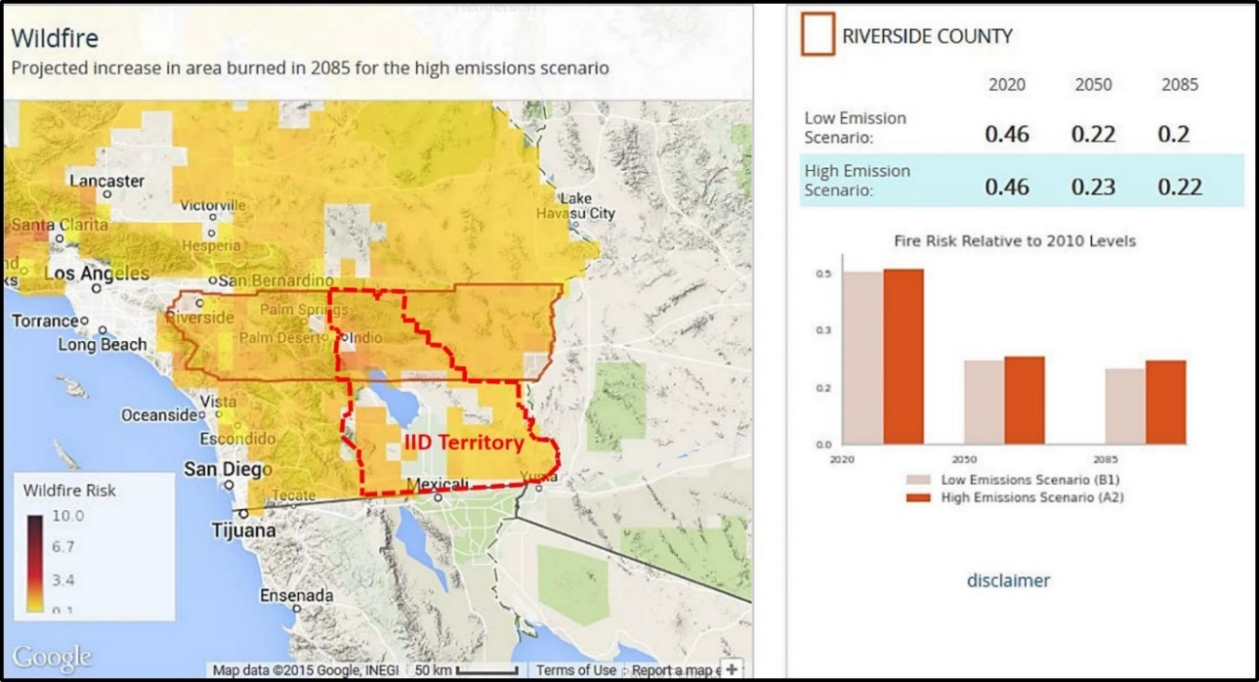
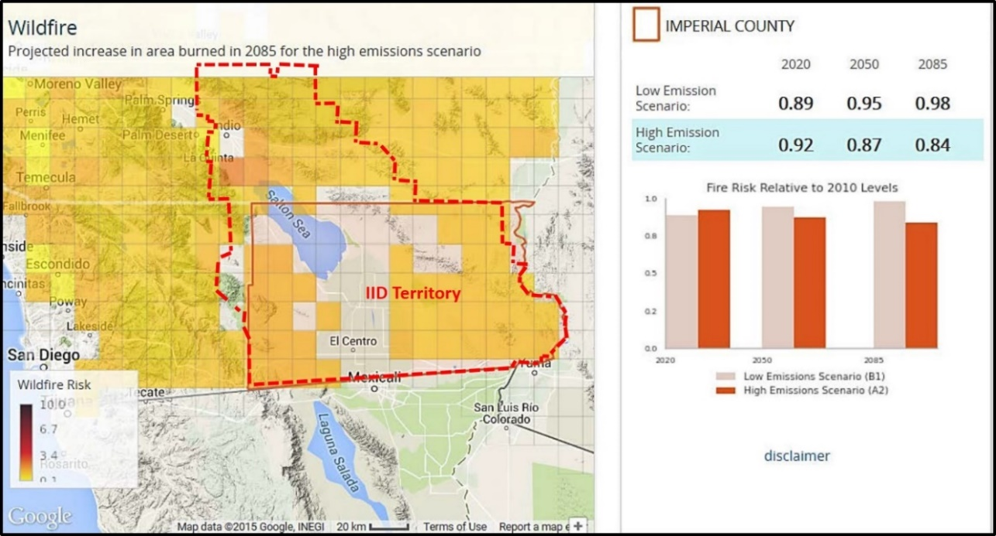
  - Projections Summary
IID service territory projections of fire risk relative 2010 levels show a relative decrease through 2085, with the high emissions scenario. High emissions are projected to increase average temperatures, increase the number of heat waves, decrease the amount of rainfall, resulting in less wildland vegetation.
Climate Change is not likely to cause an increase of wildfires in the IID service territory.

- IID Service Territory Fire Threat Information
  - CAL Fire High and Very High Fire Hazard Severity Zones
The Current Fire Hazard Severity Zones (FHSZ) for Imperial and Riverside Counties are shown below, with an IID Service Territory overlay - Note: Map includes only state and local responsibility areas. Also, note the small fringe hazard areas in northwest Imperial County and southwest Riverside County. The interactive CAL FIRE map (without the IID service territory layer) can be found at the following website https://egis.fire.ca.gov/FHSZ/
CAL Fire Map with IID Service Territory layer 01-24-2022, source IID GIS
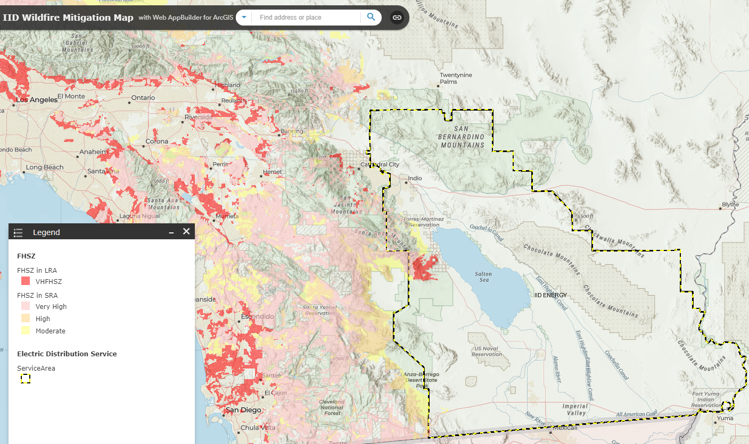
There is one CAL FIRE designated Very High Fire Hazard Severity Zone of approximately 43 square miles, or 0.66% of the service territory, located on the West side of the Imperial Irrigation District Service Territory, near the Imperial-Riverside County line.
The area is noted with a red circle on the map on the next page. Part of this High Fire Threat zone is located in the northern section of the Anza Borrego Desert State Park continuing north, through a desert mountainous area.
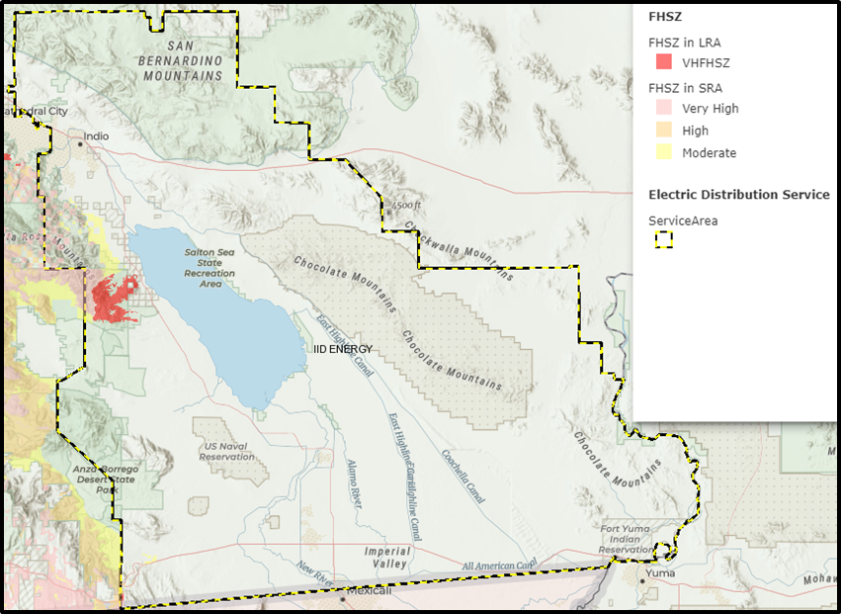
CAL FIRE Fire Hazard Map with IID service territory layer 01-25-2022, source IID GIS
FHSZ – fire hazard severity zone, LRA – Local Responsibility Area, SRA – State Responsibility Area

  - California Forest Observatory Surface Fuels
The California Forest Observatory map below shows surface fuels.
California Forest Observatory map of California with Surface Fuels layer displayed, 01-27-2022. https://forestobservatory.com/
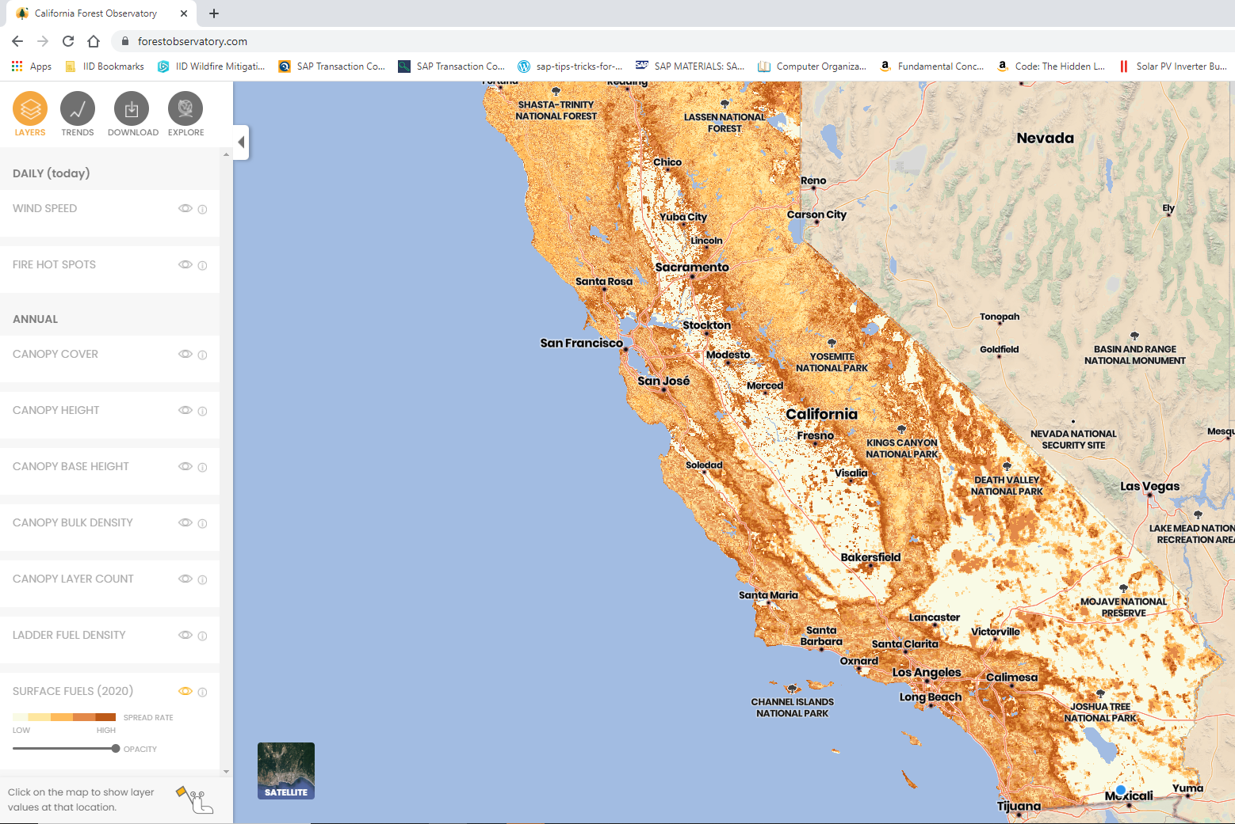
California Forest Observatory map containing Imperial Irrigation District Service Territory, Coachella Division with Surface Fuels layer displayed, 01-27-2022 https://forestobservatory.com/
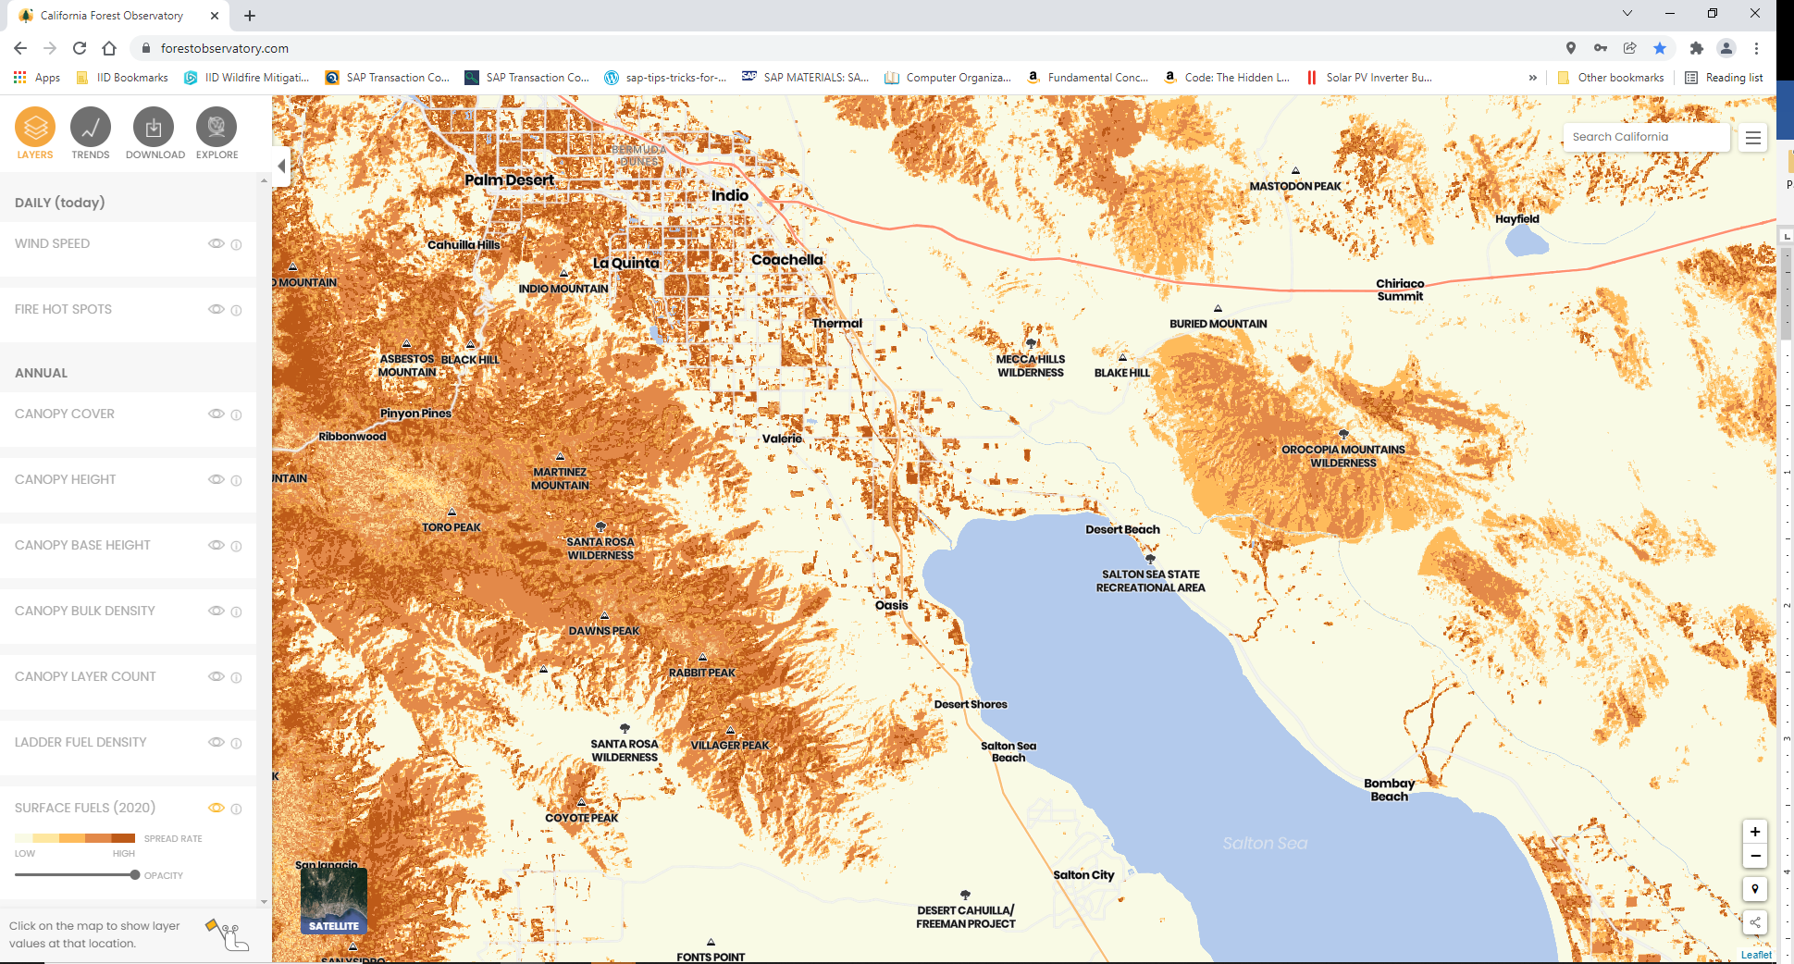
California Forest Observatory map containing Imperial Irrigation District Service Territory, Imperial Division with Surface Fuels layer displayed, 01-27-2022
https://forestobservatory.com/
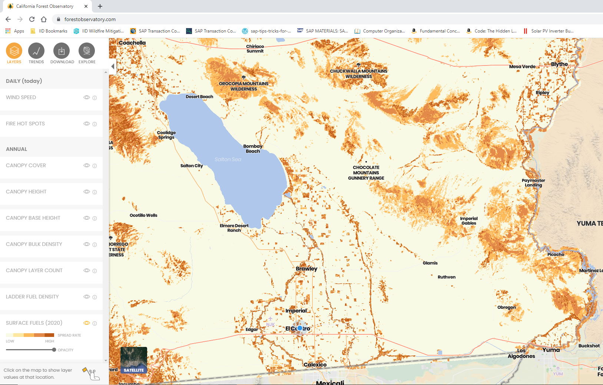
  - CAL FIRE Communities at Risk from Wildfire - IID Service Territory
CAL FIRE also provides a list of “Communities at Risk from Wildfire” in California.
https://osfm.fire.ca.gov/divisions/community-wildfire-preparedness-and-mitigation/fire-plan/communities-at-risk/
The CAL FIRE Communities at Risk list (01/05/2022) includes the communities at risk within the IID Service Territory.
Note that there are 6 communities identified that are inside the IID Service Territory.
Riverside County: Coachella, Indian Wells, Indio, La Quinta, Torrez Martinez Indian Reservation.
Imperial County: Winterhaven (Fort Yuma Indian Reservation).

  - National Interagency Fire Center – WFIGS – Wildland Fire Locations Full History, 2008- 9/14/2022; view of Southern California.
https://data-nifc.opendata.arcgis.com/datasets/nifc::wfigs-wildland-fire-locations-full-history/explore?location=33.326839%2C-115.461644%2C9.33
Locations for reported wildland fires caused by power generation/transmission are displayed as blue dots on the map below of the very southern section of California.
Note: no wildland fires caused by power generation/transmission were reported by the National Interagency Fire Center inside the IID service territory for period 2008-9/14/2022.
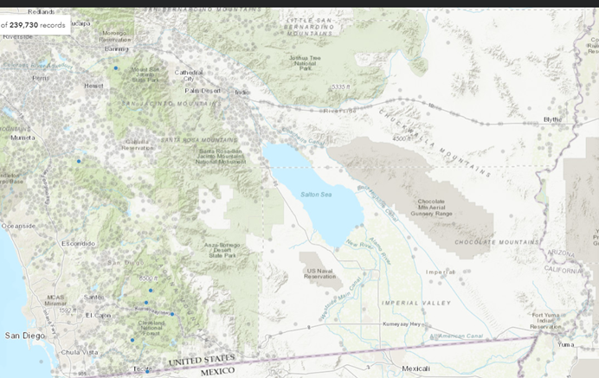
  - CAL FIRE Incidents inside the Imperial Irrigation District Service Territory 2013 – 2021 The tables below show the number of reported CAL FIRE incidents and acreage burned for each county inside the IID Service Territory, for calendar years 2013-2021.
https://www.fire.ca.gov/incidents/

  - IID 2014-2019 Distribution Power Outages by Cause
The graph below shows IID distribution system power outages categorized by cause, occurring between 2014 and 2019, including causes linked to infrastructure-related risks. (IID Power Outages GIS 03-14-2022)
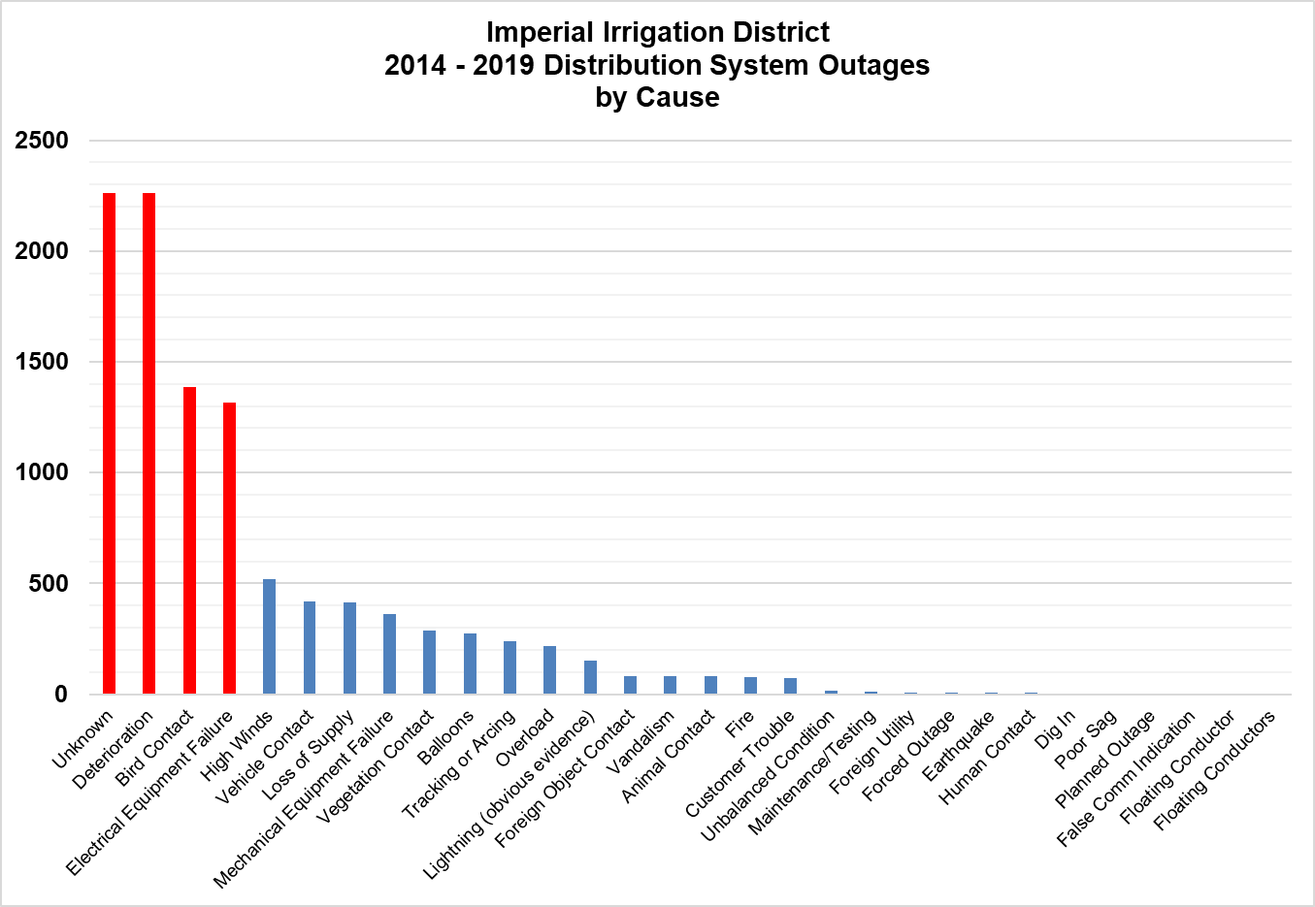

In the table below, distribution system outages are categorized by outage cause. Similar causes are further grouped to form larger cause groups.
The percentage of the total number of customer minutes out for each cause, and cause group, is shown in the table below.
Top three cause groups with the greatest percentage of customer-minutes-out include:
- INFRASTRUCTURE (45%) – customer-minutes-out caused by old defective infrastructure, equipment failure, overloaded equipment, and unbalanced conditions.
- UTILITY ACTIVITY (19%) – customer-minutes-out caused by IID or other power providers.
- HUMAN FACTOR (15%) – customer-minutes-out caused by human activity such as vehicle accidents, mylar balloon contact, vandalism, etc.
Note from the table above, that approximately 1% of customer-minutes-out involve incidents where fire is also reported.
The cause of fires is not easily reportable with the IID incident tracking system at this time. Correction of this issue is one of the SB901 projects identified later in this plan document.
Summary
For period 2010-2021, inside the IID service terriory:
- No wildland fires caused by power generation or transmission infrastructure were reported by the National Interagency Fire Center.
- No fires caused by IID infrastructure were reported by CAL FIRE.
- The IID work management system shows IID responded to 1380 incidents where fires involving or adjacent to IID infrastructure were reported. A work management system improvement is planned, to provide the ability to report if a fire is caused by IID infrastructure or is caused by others.
IID Distribution Outage System information for period 2014-2019:
- Approximately 1% out of the total number of IID customer-minutes-out, involve incidents where a fire is also reported.
- The top three customer minutes-out cause groups are:
  - Infrastructure
  - Utility Activity
  - Human Factor
The key risks and drivers related to IID design, construction, operation and maintenance, per the table above in the infrastructure section will continue to be addressed. Work will include:
- Aging infrastructure repairs and replacement
- Insulator washing
- Avian deterrents
- Relay replacements
- IID Utility Practices
  - FAC-003 Transmission System Vegetation Management Program
IID Objective – Line Clearance Unit
Ensure the Transmission System Vegetation Management program adheres to Western Electricity Coordinating Council (WECC) requirements and latest NERC FAC-003 standard, where applicable.
IID Practice
The Imperial Irrigation District Transmission System Vegetation Management program is a comprehensive vegetation management program applicable to the Imperial Irrigation District Bulk Electric System located in the IID Service Territory, which adheres to Western Electricity Coordinating Council (WECC) requirements. For transmission-level facilities, Imperial Irrigation District complies with the latest NERC FAC-003 standard, where applicable.
  - Vegetation Management Power Lines 200 kV and Below Not Subject to FERC Jurisdiction - Line Clearance Unit
IID Objective
Ensure the Distribution System Vegetation Management practice contains and effectively implements the following components:
- Inspection Patrols,
- Regulatory Requirements and Standards,
- Pruning Best Practices,
- Safety,
- Vegetation Control, and
- Customer Service
IID Practice
The work procedures identify responsible parties, inspection cycles, clearance distance for overhead, ground mounted and underground infrastructure, details procedures to address inspection findings.
Imperial Irrigation District Distribution System Vegetation Management practice contains the following components:
Inspection Patrols – The Imperial Irrigation District vegetation management practice performs periodic and on-demand patrols to identify vegetation in and adjacent to, energy infrastructure. These inspections are a trigger for pruning jobs, vegetation removals, and the application of herbicides.
Regulatory Requirements and Standards – The vegetation management practice complies with applicable regulatory requirements and standards such as, California Public Resources Code, National Electrical Safety Code, and Imperial Irrigation District regulations.
Pruning Best Practices – Imperial Irrigation District requires Vegetation Management Contractors to prune trees following the American National Standards Institute A300 pruning best practices.
Safety – The Imperial Irrigation District requires Vegetation Management Contractors to adhere to regulations and best practices such as, American National Standards Institute Z133, Safety Requirements for Arboricultural Operations, Occupational Safety, and Health Administration, California Department of Industrial Relations, and Imperial Irrigation District, safety work practices. Vegetation Management Contractors working for the Imperial Irrigation District are required to maintain certifications to work in electric utility environments and pruning best practices.
Vegetation Control - The goal is to maintain a vegetation control buffer of at least six (6) feet in addition to the required clearance distances, to allow at least one (1) year of vegetation growth, before vegetation growth encroaches into the Danger Zone. The Danger Zone clearance distances follow California Public Resources Code requirements: California Public Resources Code, Division 4, Part 2, Chapter 3 Mountainous, Forest-, Brush- and Grass-Covered Lands, Section 4293.
Imperial Irrigation District will use specific knowledge of growing conditions to determine the appropriate amount of clearance required for each site.

Clearance in All Directions Between All Vegetation and All Energized Conductors Which Are Carrying Electric Current
Operating Voltage | Clearance Distance
2,400 or more Volts, but less than 72,000 Volts | 4 FT
72,000 or more Volts, but less than 110,000 Volts | 6 FT
110,000 or more Volts | 10 FT
Customer Service – Customers may contact the Imperial Irrigation District Call Center for vegetation related service requests and information. Customers may review Vegetation Management practice information on the Imperial Irrigation District website. As an added service, the Imperial Irrigation District offers safety inspections of customer meter panels, as part of commissioning a new service panel. In addition, Imperial Irrigation District will de-energize customer service drops to allow customers to perform work adjacent to meter panels and Imperial Irrigation District electric infrastructure.
  - Power Line Corridor Clearance Regulation 23 – Line Clearance Unit, Power Line Inspection Unit, Real Estate Unit, Security Claims and Investigation Unit.
IID Objective
Enforce the Power Line Corridor Clearance Regulation 23, and the corresponding standard work procedure to manage power line clearance incidents.
IID Practice
In 2019, the Imperial Irrigation District, enacted Power Line Corridor Clearance Regulation 23, and a corresponding standard work procedure to manage power line clearance incidents. The regulation provides the Imperial Irrigation District the authority to clear power line encroachments within, or adjacent to, District transmission and distribution infrastructure that may threaten the reliability of the power system and pose a safety threat to persons and property. Such encroachments can take the form of vegetation, structures, haystacks, equipment, or even persons performing tasks in close proximity to Imperial Irrigation District facilities.
The regulation addresses, line to ground clearances within the District’s rights-of-way; safety clearances for personnel working in proximity to the lines; potential hazards that could fall onto overhead lines; prohibits fires under or adjacent to power lines and other power infrastructure; and provides the Imperial Irrigation District an enforcement mechanism.
  - Monitor and Audit the Effectiveness of Powerline Clearance Inspections - Line Clearance Unit
IID Objective
Assure power line clearance inspections are meeting applicable requirements.
IID Practice
Imperial Irrigation District currently uses a geographic information system and an SAP system to plan and manage field inspections of powerline clearances. Imperial Irrigation District follows industry practice CPUC General Order 165 to schedule powerline clearance inspections.
Imperial Irrigation District Powerline Clearance Inspectors use the IID Vegetation Management Guide to standardize vegetation management practices.
To assure the effectiveness of powerline clearance inspections, IID performs the following:
As part of the SB 901 annual service territory inspection, IID identifies service territory zones for inspection. These may include CAL FIRE areas of interest, areas with a history of power disturbances, areas with a history of fire ignitions, and areas in or adjacent to high or very high fire hazard zones. The independent inspector performs an inspection of the areas identified. Inspection findings are shared with the IID management team and responsible staff. The IID management team reviews the information and makes operational adjustments as required.
  - Community Outreach and Public Awareness – Line Clearance Unit, Customer Service Unit
IID Objective
Perform outreach activities targeting the general public, public agencies, commercial developers, housing developers, local tree trimming contractors and landscape contractors as outlined in the wildfire mitigation plan.
IID Practice
The new Vegetation Management Program identifies outreach activities targeting the general public, public agencies, commercial developers, housing developers, local tree trimming contractors and landscape contractors.
Communication includes safety information, information regarding vegetation management danger zones, recommended trees for the wire zone and border zone, program information, process information, self-help resources, and program contact information.
Communications are performed via: customer billing inserts, Imperial Irrigation District website, outreach events, and internal IID information events
The program also contains a community outreach component where Imperial Irrigation District personnel hold annual events for land developers, local government, and the public, providing information regarding power line clearance requirements, ground mounted equipment clearance requirements, best practices for planning trees adjacent to power line corridors.
The Imperial Irrigation District provides internal communications that notify employees and the public of events as required.
Email alerts are issued to employees as required for heat advisories, energy conservation Flex Alerts, major road closures, cell telephone service outages, flash flood warnings, Red Flag Warnings, and other major weather events.
The IID Customer Service Unit issues social media notifications for energy conservation Flex Alerts and notification of major power outages.
In addition, IID management may request notifications for emergency events on a case by case basis.
  - Monitor and Audit the Effectiveness of Substation Inspections – Substation Construction and Maintenance
IID Objective
Ensure IID performs monthly substation inspections according to policies and procedures.
IID Practice
IID performs monthly substation inspections meeting applicable General Order 174, Rules for Electric Utility Substations requirements. SAP automatically generates work orders monthly and inspections are recorded in GIS.
Inspections are specific to equipment type and the basis of the inspection is the manufacturer’s recommendation.
Substation inspectors generate SAP notifications for any abnormal condition. These notifications are converted to work orders, and assigned to maintenance staff. Once abnormal conditions are corrected, the work order is closed. On a regular basis, work orders are reviewed for completeness as a quality control measure.
  - Monitor and Audit the Effectiveness of Powerline and Powerline Equipment Inspections – Power Restoration and Troubleshooting Unit
IID Objective
Assure power line and powerline equipment inspections are meeting applicable requirements.
IID Practice
Imperial Irrigation District currently uses a geographic information system, and an enterprise resource planning system, to plan and manage field inspections of powerline poles, and pole mounted equipment. Imperial Irrigation District follows industry practice CPUC General Order 165 to schedule pole inspections at a circuit level.
Imperial Irrigation District Power Line Inspectors use the IID Powerline Inspection Guide to standardize pole inspection assessments.
To assure the effectiveness of the inspections IID performs an annual service territory inspection. IID identifies service territory zones for inspection, which may include CAL FIRE areas of interest, areas with a history of power disturbances, areas with a history of fire ignitions, and areas in or adjacent to CAL FIRE high or very high fire hazard zones.
The Independent Evaluator performs an inspection of the areas identified. Inspection findings are shared with the IID management team and responsible staff. The IID management team reviews the information and is responsible to make operational adjustments as required.
  - Transmission Power Line Inspections - Power Restoration and Troubleshooting Unit
IID Objective
Ensure IID follows FAC-003 requirements for Bulk Electric System inspections.
IID Practice
IID has a dedicated compliance administrator responsible for oversight of NERC/WECC vegetation management requirements for BES power lines.
IID complies with the NERC Vegetation Management Standard FAC-003 by performing annual inspections of the applicable transmission lines and completing any work derived from inspections before the next annual inspection.
IID submits quarterly reports to WECC for vegetation caused outages.

  - Distribution Power Line Inspections - Power Restoration and Troubleshooting Unit
IID Objective
- Ensure IID follows industry practices such as California Public Utilities Commission General Order 95 for construction standards and General Order 165 for inspection frequency requirements.
- Ensure the program performs periodic Patrol Inspections, Detailed Inspections, and Intrusive Inspections to assess the condition of field equipment.
- Ensure inspections assess power line physical condition, identify safety issues, identify deviations from construction design, and detect imminent failures.
IID Practice
For distribution circuits, Imperial Irrigation District follows industry practices such as California Public Utilities Commission General Order 95 for construction standards and General Order 165 for inspection frequency requirements.
The program performs periodic inspections to assess the condition of field equipment. Inspections include:
- Patrol Inspections,
- Detailed Inspections, and
- Wood Pole Intrusive
Inspections assess:
- Power line physical condition,
- Identify safety issues,
- Identify deviations from construction design, and
- Detect imminent failures.
The Imperial Irrigation District performs power line inspections following two standard work procedures. One procedure addresses Bulk Electric System infrastructure and the second procedure addresses power lines of 200KV and below that are not subject to FERC jurisdiction.
The work procedures identify responsible parties, inspection cycles, and detail procedures to address inspection findings.
Inspection Frequencies -The Imperial Irrigation District performs power line inspections with frequencies as called for in California Public Utilities Commission General Order 165, Appendix A, III, Definitions. The inspection frequency depends on the equipment type, and mounting. For example, inspection frequencies depend on equipment mounting such as overhead, surface, or underground mounting, as well as location such as urban or rural, and type of equipment.
Minimum Patrol Inspection Frequencies -All urban equipment requires patrol inspections annually. All rural overhead equipment, located in CAL FIRE, High and Very High Fire Hazard Severity Zones require patrol inspections annually. All rural equipment requires patrol inspections every (2) years.
Minimum Detailed Inspection Frequencies - All urban underground equipment requires detailed inspections every (3) years. All urban overhead and surface mount equipment require detailed inspections every (5) years.
Minimum Intrusive Inspection Frequencies - All urban and rural wood poles over 15 years in service without and previous intrusive inspection require an intrusive inspection within 10 years. All urban wood poles require an intrusive inspection within the first 25 years of service. All urban and rural wood poles that have passed an intrusive inspection require an intrusive inspection every 20 years after the first Intrusive inspection.
CPUC G.O. 165 Distribution System Minimum Inspection Frequency (maximum intervals in years)

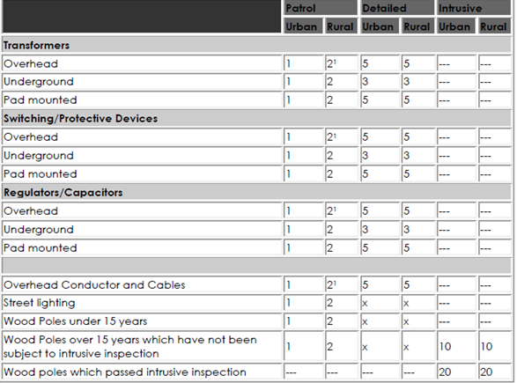

  - Emergency Event Procedures– Emergency Management Unit
IID Objective
Ensure the Emergency Management Unit applies all procedures in place to address emergencies.
IID Practice
As a local governmental agency, Imperial Irrigation District has planning, communication, and coordination obligations pursuant to the California Office of Emergency Services’ Standardized Emergency Management System (“SEMS”). Applicable standard operating procedures specify roles, responsibilities, and communication for field response, local government, operational area, regional, and state.
  - Emergency Event Procedures – System Operations Center
IID Objective
Maintain electric system situational awareness to detect abnormal electric system operation.
IID Practice
The Imperial Irrigation District, Energy Department, System Operations Center maintains electric system situational awareness using the operations center SCADA system which includes synchro-phasor phase angle measurement units used to detect abnormal operation of the electric system. Abnormal electric system operation may load equipment to higher than normal levels.
  - Service Restoration After Major Events – System Operations Center
IID Objective
Ensure the System Operations Center restores service after major events following the latest version of the IID System Restoration and Black-Start Plan
IID Practice
Imperial Irrigation District System Operations Center restores service after major events following the latest version of the Imperial Irrigation District System Restoration and Black-Start Plan. This plan was developed using the Reliability Coordinator guideline document, General Guidelines for Transmission Operators to Use in System Restoration.
  - Standardized Emergency Management System – Emergency Management Unit
IID Objective
Ensure IID follows planning, communication, and coordination obligations pursuant to the California Office of Emergency Services’ Standardized Emergency Management System (“SEMS”).
IID Practice
As a local governmental agency, Imperial Irrigation District has planning, communication, and coordination obligations pursuant to the California Office of Emergency Services’ Standardized Emergency Management System (“SEMS”). Applicable standard operating procedures specify roles, responsibilities, and field response communications at the local government, operational area, regional, and state levels.
Major Incident Management, Imperial County
The Imperial Irrigation District, Energy Department, Emergency Management Unit provides emergency and disaster preparedness services for all district departments. Those services include emergency and disaster preparedness, mitigation and recovery through Emergency Operation Plan development, training, exercises, and mutual aid implementation.
The Imperial Irrigation District, Emergency Management Unit coordinates major event response with the Imperial County Office of Emergency Services (OES) which provides emergency management services for the County/Operational Area including its seven cities/towns and special districts. Imperial County Office of Emergency Services coordinates emergency operations activities among all the various local jurisdictions and develops written guidelines for emergency preparedness, response, recovery, and mitigation to natural / man-made disasters, and technological disasters.
The Imperial County Office of Emergency Services establishes the Imperial County / Operational Area Emergency Operations Center (EOC) when directed by County emergency management authority.
Major Incident Management, Riverside County
The Imperial Irrigation District, Human Resources Department, Office of Emergency Planning also provides similar coordinating activities with Riverside County Emergency Management Department.
  - Utility Mutual Aide Agreements – Emergency Management Unit
IID Objective
Ensure IID fulfils mutual aid agreements are in place with neighboring utilities.
IID Practice
Imperial Irrigation District has mutual aid agreements in place with several neighboring utilities. These agreements provide a mechanism to request assistance from member utilities in case of an emergency.
One mutual aid agreement is the Mutual Assistance Agreement, Electric and Gas, Members of the California Utilities Emergency Association. This agreement includes several neighboring utilities: San Diego Gas and Electric, Southern California Edison, and Western Area Power Administration.
An additional similar agreement is in place with Arizona Public Service.

  - Disabling Re-Closer Procedure – System Operations Center
IID Objective
Develops a disabling re-closer procedure as needed.
IID Practice
Due to the low wildfire threat in the Imperial Irrigation District Service territory, Imperial Irrigation District does not disable re-closers due to anticipated wildfires. Imperial Irrigation District does not have a formal procedure identified for disabling re-closers.
  - Public Safety Power Shutoff – Emergency Management Unit
IID Objective
Develop Public Safety Power Shutoff procedure.
IID Practice
Imperial Irrigation District recognizes that there may be rare occasions when a fire puts our infrastructure and our customers’ safety at risk. During such events, selective de-energization of power lines may be necessary to preserve public safety, or to protect the stability and reliability of the power system.
Due to the low wildfire threat in the Imperial Irrigation District Service territory, Imperial Irrigation District does not have a formal PSPS procedure.
  - No New Power Lines in High or Very High Fire Hazard Severity Zones – IID Regulatory and Environmental Compliance Unit
IID Objective
Ensure that IID will work with city and county planning departments to prevent land use changes in high fire threat areas where changes require building power infrastructure in CAL FIRE designated High or Very High Fire hazard areas (as needed only)
IID Practice
Imperial Irrigation District works with city and county planning departments to prevent land use changes in high fire threat areas where changes require building power infrastructure in CAL FIRE designated High or Very High Fire Hazard Severity Zones.
  - Relay Protection – System Protection Unit
IID Objective
Review all system disturbances for correct operation. In the event of an incorrect operation, disturbance analysis is performed on the protection settings, relay protective devices, and or associated hardware and equipment until root cause of event is identified and corrective measures are implemented.
IID Practice
Relay Protection Engineering reviews all system disturbances for correct operation. In the event of an incorrect operation, disturbance analysis is performed on the protection settings, relay protective devices, and or associated hardware and equipment until root cause of event is identified. Once root cause is determined, corrective measures are implemented.
  - Power Line and Substation Design – Electrical Engineering Section
IID Objective
Ensure IID electric facilities are designed and constructed to meet or exceed relevant federal, state, and industry standards such as National Electrical Safety Code, IEEE Standards, and industry best practices such as CPUC General Order 95.
IID Practice
Imperial Irrigation District electric facilities are designed and constructed meeting or exceeding relevant federal, state, and industry standards such as National Electrical Safety Code, and IEEE Standards.
Imperial Irrigation District meets or exceeds industry practices such as CPUC General Order 95.
  - Addressing SB 901 Section 43 Biomass Power Purchase Requirement - Energy Business and Regulatory Compliance Programs Unit
IID Objective
Continue participating in procurement activities with other member agencies through the Southern California Public Power Authority with regard to requirements established by Public Utilities Code §8388.
IID Practice
SB 901 Section 43 requires utilities with existing biomass procurement contracts that meet certain criteria, to amend or establish a new contract. Statute requires that the generating facility of the existing contract be operative at any time in 2018 with a contract expiration date on or before December 2023.
Pursuant to Section 43, these requirements do not apply to facilities located in federal severe or extreme nonattainment areas for particulate matter or ozone.
The figure on the page below shows that the majority of the Imperial Irrigation District Service Territory is in the federally classified nonattainment areas of Imperial County and the Coachella Valley in Riverside County. Therefore, Imperial Irrigation District is exempt from Section 43 biomass generation procurement requirements.
Reference: EPA Ozone Designations 2015 Standards, California State Recommendations and EPA Response, California State Recommendation, California Air Resources Board Air Quality Planning and Science Division, Air Quality Analysis Section, Recommended Area Designations for the 0.070 PPM Federal 8-Hour Ozone Standard
https://www.epa.gov/sites/production/files/2016-11/documents/ca-rec-enclosures.pdf
Notwithstanding section 10.9.3, IID is participating in procurement activities with other member agencies through the Southern California Public Power Authority with regard to requirements established by Public Utilities Code §8388.
  - Power Lineman Training Program – Energy Compliance and Vegetation Unit
IID Objective
Ensure IID implements and adheres to the Power Lineman apprenticeship program in partnership with the local community college
IID Practice
Imperial Irrigation District has developed a comprehensive Power Lineman apprenticeship program in partnership with the local community college. This program is an apprenticeship program administered by the Apprenticeships Program, Economic, and Workforce Development Division, of Imperial Valley College.
Aspiring Power Linemen are required to complete two levels of coursework. The first level is required of all electrical apprenticeships and a second level is specific for the power linemen apprenticeship. In addition, students are required to complete 7,200 hours of on-the-job training at Imperial Irrigation District.
After successfully completing the program, students receive; an Imperial Valley College Certificate of Completion, a State of California Journeyman Electrician Certificate of Completion, and a State of California Journeyman Electrician Card.
The first level of course work imparts basic electrical and electrical theory. The first level includes classroom lecture hours and is composed of the following classes:
Electrical Trades I 72 lecture hours
Basic electricity and electronics mathematical functions, computations, principles of electricity, AC/DC, electro-magnetism, symbols, schematic diagrams, safety skills, impedance, current, resistance, amperage, voltage, and circuitry
Electrical Trades II 72 lecture hours (offered Spring 2022)
Overview of transmission and distribution systems, various utility industry components, high voltage AC power, electrical diagrams, workplace safety, rope rigging and hand signals, substations, switchyards, three phase systems, delta wye configurations, electrical diagrams, safety rules, CAL-OSHA
Electrical Trades III 72 lecture hours
Introduction to framing, setting, guys, installation of conductors and grounds, laying out of underground line systems, assembly and installation of cross arms, pins and insulators, conductor splicing, sagging and tying, manhole and vault construction, residential underground installations
Electrical Trades IV 72 lecture hours (offered Spring 2022)
Introduction to maintenance of distribution and underground systems, safety procedures, hazardous materials, operation and maintenance of bucket truck, connecting pole top transformers, trouble shooting and replacement of equipment, transformers, cutouts, switches, capacitors, voltage regulators; troubleshooting and locating faults
The second level of course work imparts the knowledge necessary to perform power lineman activities successfully. The program includes classroom lecture hours and is composed of the following classes:
Power Lineman V 72 lecture hours
AC theory, distribution line maintenance, transmission structures, transmission line installation, climbing steel poles, de-energizing lines, rigging, high voltage, gloves, hot sticks
Power Lineman VI 72 lecture hours
Basic principles, construction, operation, maintenance procedures associated with substations and switchyards, inspect and test transformers, circuit breakers, and relays
Power Lineman VII 72 lecture hours
Theory and procedures for commercial and residential connections, watthour installations, series and multiple circuit street lighting systems, resolve outages, watt hour meter installation, complete residential commercial installation, analyze, troubleshoot and repair lighting and power loss
Power Lineman VIII 72 lecture hours
Advanced theory on the use of hot sticks, energized, de-energized repair and maintenance of poles and lines, safety practices, local and state requirements, lineman mathematics, overhead construction, line construction, general orders and electrical codes
2023-2025 Plan
Continue working with local community college to provide power lineman training.
- IID SB901 Practice
  - Service Territory Survey by Independent Evaluator
Public Utilities Code section 8387(c) requires Imperial Irrigation District to contract with a qualified independent evaluator with experience in assessing the safe operation of electrical infrastructure to review and assess the comprehensiveness of this Wildfire Mitigation Plan.
IID recurrently contracts an Independent Evaluator to perform Service Territory Surveys.
The main purpose of the survey is to identify any geographic area in the IID service territory that has a higher wildfire threat than is identified in the CAL FIRE, Fire Hazard Severity Zone map.
If such a zone is identified, the Evaluator will communicate the finding to the IID, and to CAL FIRE.
With each survey, IID plans to inspect different areas of the service territory. Currently, there is a four (4) year inspection rotation:
- Survey Plan Year 1
  - Selected areas where power infrastructure is located adjacent to CAL FIRE high or very high fire hazard zones,
  - Selected areas where power infrastructure is located in areas with a history of fire ignitions
  - Other areas, and power infrastructure identified by IID staff
  - Other areas, and power infrastructure identified by the Independent Evaluator
- Survey Plan Year 2
  - Selected areas where power infrastructure is located adjacent to CAL FIRE high or very high fire hazard areas,
  - Selected distribution line sections
  - Other areas and power infrastructure identified by IID staff
  - Other areas, and power infrastructure identified by the Independent Evaluator
- Survey Plan Year 3
  - Selected areas where power infrastructure is located adjacent to CAL FIRE high or very high fire hazard areas,
  - Selected transmission line sections
  - Other areas and power infrastructure identified by IID staff
  - Other areas, and power infrastructure identified by the Independent Evaluator
- Survey Plan Year 4
  - Selected areas where power infrastructure is located adjacent to CAL FIRE high or very high fire hazard areas
  - Selected generation stations, major substations, and cranking paths
  - Other areas and power infrastructure identified by IID staff
  - Other areas, and power infrastructure identified by the Independent Evaluator
  - IID SB901 Wildfire Mitigation Annual Status Report
IID produces the draft SB901 Wildfire Mitigation Annual Status Report during the first quarter each year. The status report provides project status from the previous calendar year.
The draft is submitted to responsible managers for review and comment during the first quarter of the year.
Once internal department reviews are complete the status report is submitted to the IID Board.
Finally, the status report is expected to be submitted to the Wildfire Safety Advisory Board by July 1 each year.
  - Annual WSAB Submittal
The annual WSAB draft submittals includes the SB901 Status Report, a cover letter, and may include the Independent Evaluator service territory findings report.
These documents are posted on the IID public website for public review and comment for approximately thirty (30) days. The IID public website features a comment area where the public can provide written comments during the public comment period.
After the thirty (30) day period, the draft submittals are presented to the IID Board of Directors at a public meeting, where public comments are also accepted.
Once the IID Board, approves the submittals, the documents are posted on the WSAB document management site.
  - Annual Funding of Projects
Projects included in the annual status report are normal operational projects with components that may help reduce the risk of fire ignitions caused by IID infrastructure. There projects are usually not uniquely identified as a line item in the IID published budget. Projects are usually included in larger budget line items.
The first draft of the proposed annual budget is usually complete by late summer each year.
The proposed annual budget is reviewed and adjusted by Energy Department management staff, Energy Department Manager, Chief Financial Officer, and by the IID General Manager.
Subsequently, budget workshops are held in the fall with the IID Board of Directors in meetings open to the public.
The annual budget is usually approved by the Board of Directors in December each year.
  - Comprehensive Wildfire Plan Update - every three (3) years
Imperial Irrigation District performs a Comprehensive Update of the IID SB 901 Wildfire Mitigation Plan every three (3) years.
Once the initial draft plan is complete, an Independent Evaluator performs an assessment of the new plan to assure the plan meets California SB 901, AB 1054, and AB 111 requirements.
Secondly the Independent Evaluator performs a Regulatory Requirement Alignment Assessment of the draft plan to assure the IID plan has no conflicts, and there is alignment with the following regulatory requirements:
North American Electric Reliability Corporation (NERC) regulations
Western Electric Coordinating Council (WECC) requirements
California Public Resource Code regulations 4292 safety requirements
California Public Resource Code regulation 4293 safety clearance requirements,
Imperial Irrigation District Energy Department, Power Line Corridor Clearance Regulation 23
Next the Independent Evaluator performs the following:
- Review of IID Wildfire Mitigation Plan performance metrics
- Review of the current and archive status reports, as required
- Review of new WSAB requirements
- Produces a plan assessment and recommendations report.
Lastly the draft plan and Independent Evaluator Report are submitted to responsible IID managers for review and comment.
  - Comprehensive Wildfire Plan Update Approval
Upon management approval, the proposed Imperial Irrigation District SB 901 Wildfire Mitigation Plan and the Independent Evaluator assessment are posted on the Imperial Irrigation District public website for a period of approximately thirty (30) days.
The IID public website features a comment area where the public can provide written comments during the public comment period.
After the thirty (30) day period, the draft IID SB 901 Wildfire Mitigation Plan submittals are presented to the IID Board of Directors at a public meeting, where public comment is also accepted.
Based on Board and public comments, plan adjustments are completed as required.
Once the IID Board approves the plan, documents are posted on the WSAB document management site.
  - Monitoring the Plan and Performance Metrics
Plan oversight is performed by the Imperial Irrigation District, Manager Operations and Energy Infrastructure, Energy Department.
Periodically the Imperial Irrigation District, Manager Operations and Energy Infrastructure, Energy Department, is responsible to review activities to identify deviations from desired results.
During first quarter of each year, the Imperial Irrigation District, Manager Operations and Energy Infrastructure Energy Department will conduct a review of the previous year’s annual status report to identify deviations from desired results.
The annual IID SB901 Status Reports include plan performance metric results.
Deviation from desired results will trigger a review of operations to identify possible improvements by the Manager of Operations and Energy Infrastructure.
Examination of metric information gathered during the 2020-2022 plan period shows metric information for poles down, lines down, and fire incidents need additional detail to identify actionable improvements.
Fire incidents do not indicate if the fire incident was caused by IID infrastructure, or caused by others. Currently, only the number of fore incidents is tracked. A project is identified in Section 13 of this plan to correct this issue.
Poles down incidents do not indicate the number of poles down involved in the incident. Currently, only the number of incidents is tracked. A project is identified in Section 13 of this plan to correct this issue.
  - Performance Metrics
Performance Metrics – The Imperial Irrigation District SB 901 Wildfire Mitigation Program identifies several performance metrics. The metrics include the following:

    - Number of Encroachment Violations
Metric: Total number of Encroachment Violations reported for the calendar year.
Assumptions: Encroachment Violations are identified where vegetation or obstructions have entered the power line corridor, where the obstruction causes a ground clearance violation, or has the possibility of impeding Imperial Irrigation District operations. Encroachment Violations include situations where equipment, structures, material, crops, haystacks are in or are adjacent to the power line corridor, or obstructions are located where they may impede Imperial Irrigation District Energy Department operations. Some Encroachment Violations may materialize into a fault, and may result in a fire ignition with the appropriate conditions present.
Indicator Type: This is a leading indicator of fire ignitions inside the IID service territory.
Metric Goal: The goal is zero (0) incidents for the calendar year. An increasing rate is a trigger to investigate and determine the root cause, and to determine operational adjustments, public education, and outreach adjustments.
    - Number of Imminent Threat Violations
Metric: Total number of Imminent Threat Violations reported for the calendar year. An Imminent Threat Violation is where an energized conductor clearance distance violation, occurs. This is where equipment, crops, material, or people, breach the outer edge of the danger zone, and are closer than safety regulations permit.
Assumptions: Imminent Threat Violations are identified where vegetation or obstructions have entered into the danger zone space around energized equipment and power lines. The danger zone is to remain clear at all times. Some Imminent Threat Incidents may materialize into a fault resulting in a fire ignition with the appropriate conditions present.
Indicator Type: This is a leading indicator of fire ignitions caused by Imperial Irrigation District power infrastructure.
Metric Goal: The goal is zero (0) incidents for the calendar year. An increasing rate is a trigger to investigate and determine operational adjustments, public education, and outreach adjustments.
    - Number of Lines and Poles Down Incidents
Metric: Total number of lines-down, and poles down reported for the calendar year.
Assumptions: Poles and lines down are a potential cause for fire ignitions. Incidents may not result in a fire ignition.
Indicator Type: This is a leading indicator of fire ignitions caused by Imperial Irrigation District power infrastructure.
Metric Goal: The goal of zero (0) incidents per calendar year. An increasing rate is a trigger to determine the root cause of incidents, and possible development of engineering, equipment, and operational adjustments.

    - Number of Fire Ignitions per Year
Metric: Total number of fire ignitions caused by Imperial Irrigation District power infrastructure located in the Imperial Irrigation District Service Territory for the calendar year.
Assumptions: Fire ignitions have several causes, such as lightning strikes, campfires, cigarettes, arson, vehicle accidents, and power infrastructure failures. Imperial Irrigation District will track the number of preventable and non-preventable fire ignitions reported adjacent to Imperial Irrigation District Power Infrastructure. Imperial Irrigation District will record ignitions caused by other sources but these are not included in the metric total.
Indicator Type: This is a lagging indicator of fire ignitions caused by Imperial Irrigation District power infrastructure.
Metric Goal: The goal is zero (0) incidents per calendar year. An increasing rate is a trigger to determine the root cause, and possible development of engineering, equipment, and operational adjustments.
- IID Wildfire Mitigation Plan Roles and Responsibilities
  - Imperial Irrigation District, Manager Operations and Energy Infrastructure Energy Department is responsible to implement, own, and manage the Imperial Irrigation District Wildfire Mitigation Plan. The Manager is responsible to coordinate with federal, state, and local fire management personnel as necessary or appropriate, to implement Imperial Irrigation District’s Wildfire Mitigation Plan. The manager must take reasonable actions to reduce the fire risk caused by Imperial Irrigation District electric facilities.
  - Chief Electrical Engineer is responsible to identify construction standards and engineer transmission power lines and substations that comply with relevant federal, state, and industry standard requirements, including the industry standards established by the California Public Utilities Commission. The Chief Electrical Engineer shall design new transmission power lines, and substations, consistent with the objective to reduce the fire risk caused by Imperial Irrigation District electric facilities.
  - Manager Energy Management and Strategic Marketing is responsible to assure compliance to the SB 901 biomass generation requirements.
  - Manager, Planning and Engineering/Chief Electrical Engineer is responsible to identify construction standards, engineer distribution power lines that comply with relevant federal, state, and industry best practices. The Distribution Engineering Manager shall design new distribution power lines and other distribution infrastructure consistent with the objective to reduce the fire risk caused by Imperial Irrigation District electric facilities. The Manager will work with county and city planners to avoid building new power infrastructure in CAL FIRE High or Very High Fire Hazard Severity Zones.
  - Energy Compliance Administrator is responsible to assure this plan is consistent with and does not conflict with Federal regulatory requirements. The Energy Compliance Administrator is responsible this plan complies with SB 901 and SB 1054 regulatory requirements.
  - Manager of System Operations is responsible to maintain operational procedures in support of the Imperial Irrigation District wildfire mitigation plan. The Manager of System Operations is responsible to operate the electric system in a manner that will minimize potential fire risks by taking reasonable actions to minimize the risk of a fire is caused by Imperial Irrigation District electric facilities.
  - Power Line Construction and Maintenance Scheduler is responsible to take corrective actions when the staff witnesses or is notified of fire ignitions under or adjacent to Imperial Irrigation District owned power lines. The Power Line Construction and Maintenance Scheduler is responsible to process power line inspection findings to address potential power infrastructure fire ignition sources and construction non-conformance infractions.
  - Public Information Officer, General Managers Office is responsible to maintain the IID SB901 Wildfire Mitigation Plan and related information posted on the IID.com website in a prominent location for easy public access. The officer is responsible for public information and social media communication of large fire incidents.
  - Superintendent Energy Construction and Maintenance is responsible to manage the Imperial Irrigation District Power Line Inspection Program. The superintendent must immediately report fires following existing Imperial Irrigation District standard operating procedures and practices. Inspect power lines and report all infractions.
  - Supervisor Emergency Management is responsible to respond to major fire incidents and activate field commence centers following established procedures.
  - Supervisor of Geographical Information System Administration IT Department is responsible to maintain current the California High Fire Hazard Severity Map information on the Imperial Irrigation District geographic information system. The Supervisor of Geographical Information System Administration is responsible to maintain new High Fire Threat area information identified by Imperial Irrigation District, on the Imperial Irrigation District geographic information system.
  - Superintendent Energy Compliance and Vegetation Management is responsible to manage the Imperial Irrigation District Distribution Vegetation Management Program and the Transmission System Vegetation Management Standard Work Procedure. The Vegetation Management Supervisor is responsible to manage power corridor vegetation, to prevent fire ignitions caused by vegetation encroaching into the danger zone, violating clearance distance requirements.
- Projects Expected to Reduce Fire Ignitions Caused by IID Infrastructure
Although the Imperial Irrigation District does not have infrastructure located inside a CAL FIRE designated High Fire Hazard, or Very High Fire Hazard Severity Zone, the Imperial Irrigation District is submitting this plan that identifies projects expected to reduce the risk of fire ignitions caused by Imperial Irrigation District power infrastructure.

  - Relay Modernization Program – Relay Protection Unit
IID plans to replace existing electromechanical and solid-state relays with microprocessor relays, per Board of Directors approved scope, schedule, and funding. New microprocessor relays include relays that have the ability to detect power line breaks before a high amperage power line fault to ground occurs.
Imperial Irrigation District budgets annually for relay modernization. These monies are subject to change annually depending on Imperial Irrigation District Board of Directors approval.
Currently Imperial Irrigation District has an installed base of 3967 relays. Of this total, 47% are Electromechanical, 14% are solid-state, and 39% are microprocessor relays.
For the Relay Modernization Program, Imperial Irrigation District has standardized on Schweitzer Engineering Laboratories (SEL) relays. SEL products offer modern, fast acting, communication assisted, microprocessor relays, with traveling wave technology, that quickly detect and act upon power line disturbances.
IID expects to complete the relay modernization program by the early 2030’s.
  - Distribution Power Line Bird Deterrents – Electrical Engineering Section
IID is currently installing on an as-needed basis power line bird deterrents to reduce power line outages due to bird strikes.
  - Fire Ignition Metric Improvement
IID plans to adjust software systems to add searchable fields to identify fire ignitions caused by IID infrastructure and caused by others. Currently work management records do not have a searchable field to identify fire ignition cause. IID expects to completed this work by 2024.
  - Poles Down, Lines Down Metric Improvement
IID plans adjust software systems to identify the number of poles for each poles-down incident. IID also plans to have the ability to report the total number of poles down for a selected date range.
In addition, IID expects to have the ability to report the number of lines down incidents for a selected date range.
IID expects to complete this work by 2024.
  - Imminent Threat and Encroachment Metric Improvement
Requirements
IID plans to adjust software systems to record and report various types of powerline corridor encroachments. IID will have the ability to produce incident reports for a selected date range.
IID expects to complete this work by 2024.

- Revision History
Date Revised | Ver. Section Number | Section / Item Numbers Changed | Revision By
10-14-2019 | Original | Original | Angel Marcial
09-29-2022 | Various | Comprehensive wildfire plan update for calendar years 2023-2025  Add Sec 15 Appendix 16 Independent Evaluator review | Angel Marcial

- Approval

______________________________________________________
Jamie Asbury
Imperial Irrigation District
Energy Department Manager

16 Appendix A Independent Evaluator Review

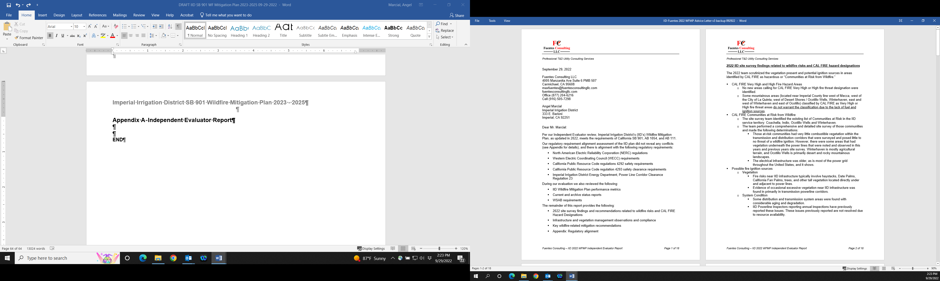

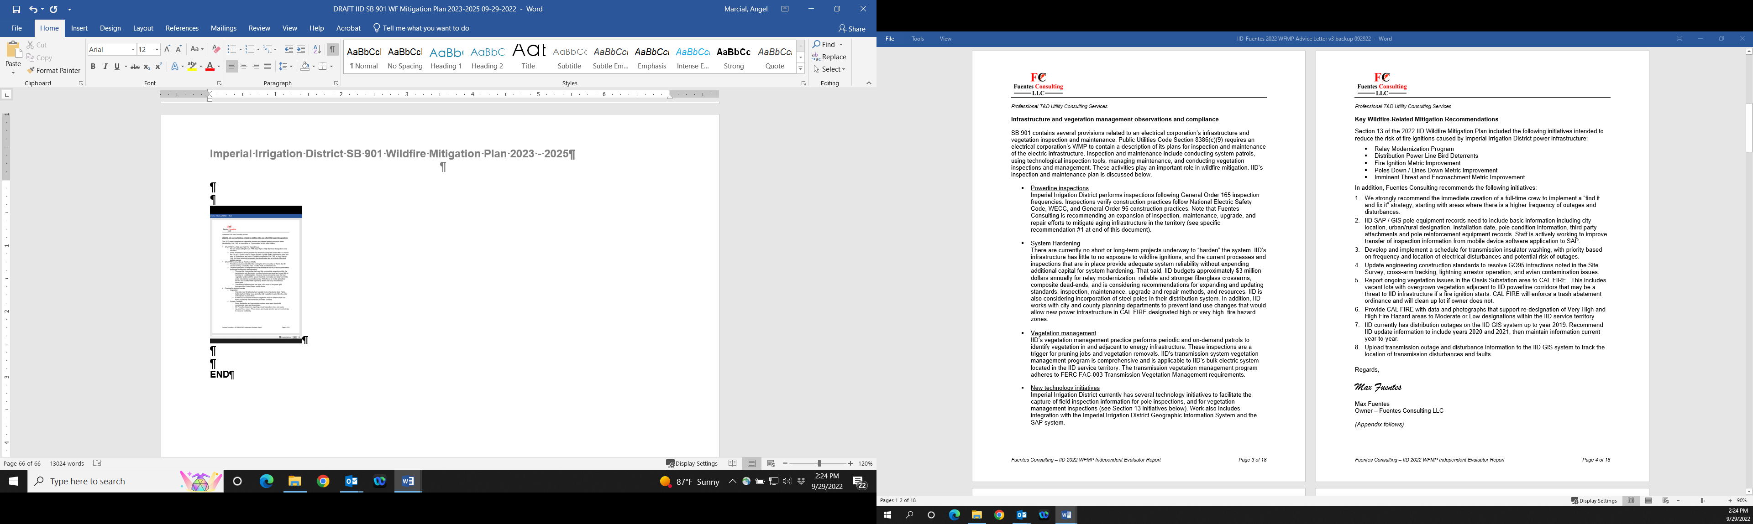

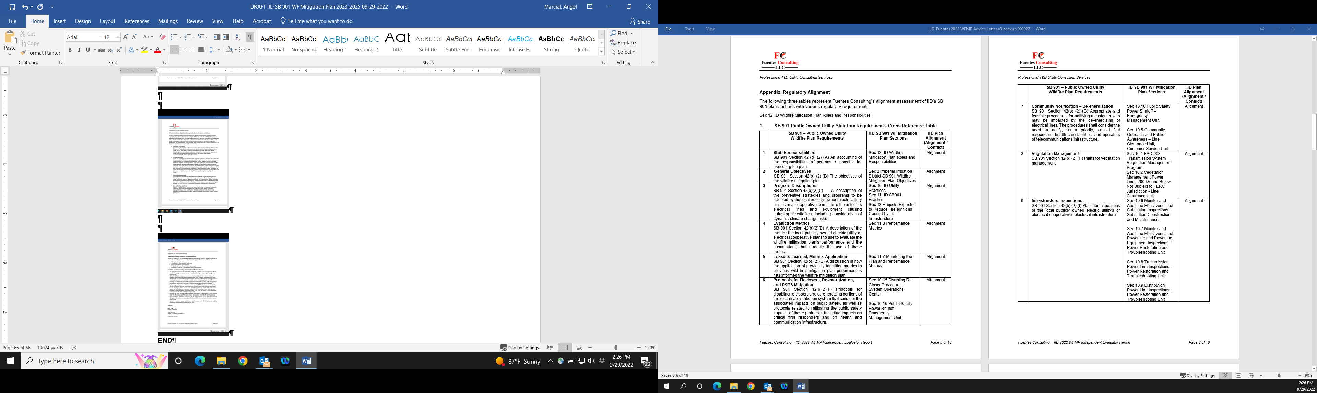

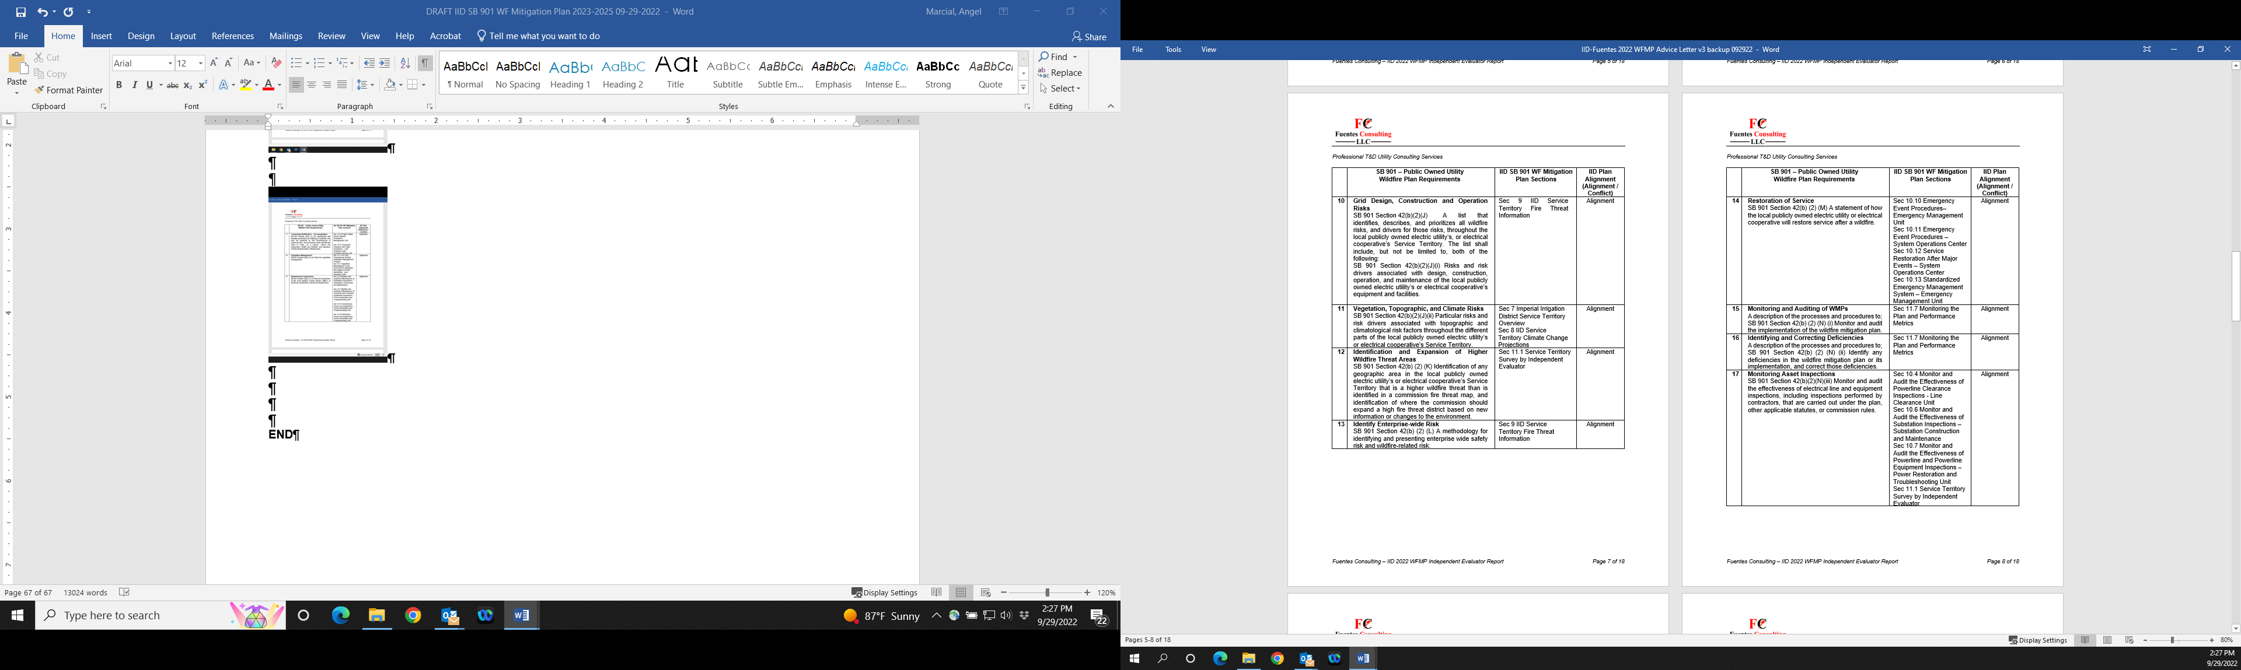

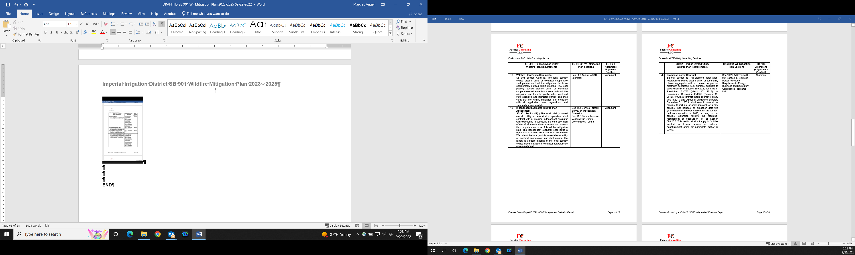

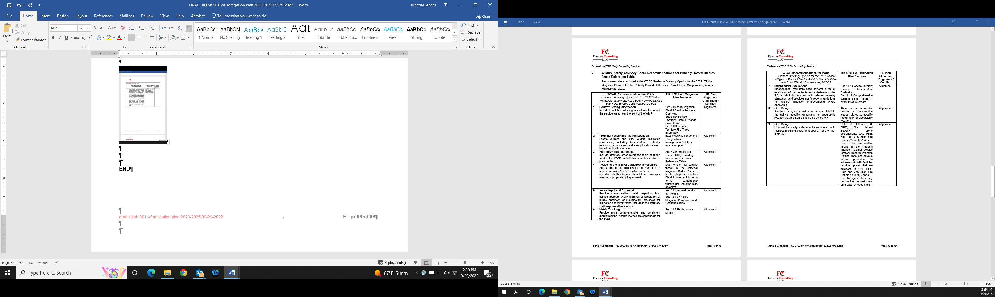



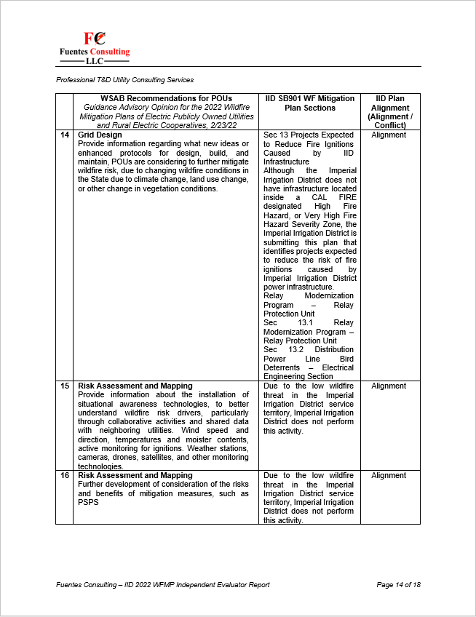

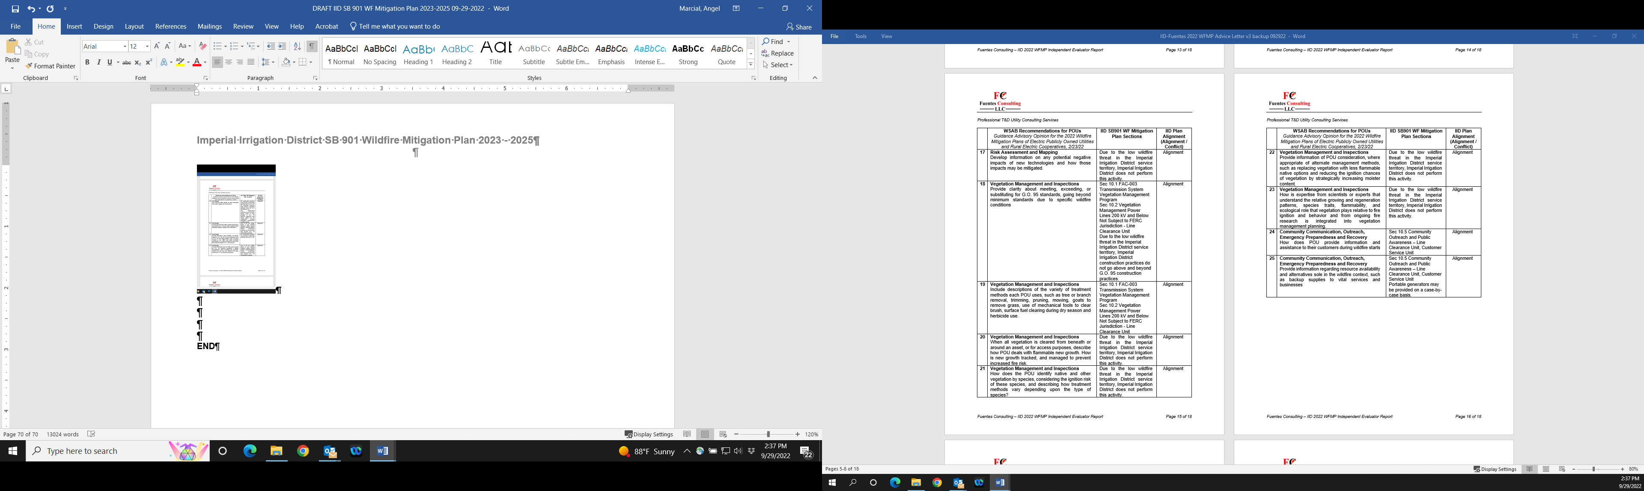



END

