  Wildfire Mitigation Plan  2023 Update | Abstract  This document was developed for the purpose of establishing protocol to mitigate the risk(s) associated with wildfires. This document takes the latest and mandatory elements for a wildfire mitigation plan under consideration. However, readers should seek the advice of an attorney when confronted with legal issues, and attorneys should perform an independent evaluation of the issues raised in this document.  _________________________  Reviewed by: xx  _________________________  Independent Evaluation by:  xx  _________________________  Approved by: Board of Public Utilities

Table of Contents
II. Executive Summary 5
III. Utility Overview and Context 5
A. Utility Description and Context Setting Table 5
B. Statutory Cross-Reference Table 6
C. Process for Utility Adoption and Submittal of Annual WMP and Opportunities for Public Comment 9
D. Description of Where WMP Information Can Be Found on Utility Website 9
E. Purpose of the Wildfire Mitigation Plan 9
F. Organization of the Wildfire Mitigation Plan 10
IV. Objectives of the Wildfire Mitigation Plan 10
A. Minimizing Sources of Ignition 11
B. Resiliency of the Electric Grid 12
C. Minimizing Unnecessary or Ineffective Actions 12
V. Roles and Responsibilities 12
A. TPUD Roles and Responsibilities 12
Plan Accountability 13
Operating Unit Responsibility 14
B. Coordination with Water Utilities/Department 15
C. Coordination with Communication Infrastructure Providers 15
D. Standardized Emergency Management System 16
VI. Wildfire Risks and Drivers Associated with Design, Construction, Operation, and Maintenance 16
A. Particular Risks and Risk Drivers Associated with Topographic and Climatological Risk Factors 16
Red Flag Warning Conditions 17
Foreign Contact 17
Equipment Failure 17
Wire-to-Wire Contact/Contamination 18
Other Potential Risk Factors 18
B. Enterprise-Wide Safety Risks 19
Key Risk Impacts 19
C. Changes to CPUC Fire Threat Map 20
High Fire-Threat District (HFTD)5 20
Tier 1 High Hazard Zones (HHZs) on the U.S. Forest Service 20
Tier 2 and Tier 3 Fire-Threat Areas on the CPUC Fire-Threat Map 20
VII. Wildfire Preventative Strategies 22
A. High Fire-Threat District 23
B. Weather Monitoring 24
C. Climate Change 24
D. Design and Construction Standards 24
Wildfire Risk Reduction, Reliability, and Asset Protection Project (WRAP) 25
Supervisory Control and Data Acquisition (SCADA) 25
Advanced Radio Communications and Automated Vehicle Location (AVL) 25
E. Vegetation Management 25
Annual Pole Clearing Program 26
Vegetation Inspection and Maintenance 26
TPUD Tree Trimming and Removal Guidelines 26
T&D System Vegetation Management Standards 28
F. Inspections 28
Sub-Transmission Line Inspections 29
Infrared Inspections 29
Ground Patrols and Inspections 29
Aerial Patrols (Drone) 30
Wood Pole Intrusive Inspections 30
Sub-Transmission and Distribution Line Inspections 30
Inspections 31
Line Patrols 31
Wood Pole Intrusive Inspections 31
Instruction to Inspectors 31
Standards for Record-Keeping and Reporting 32
Satisfactory Conditions 32
Substation Inspections 32
Visual Inspections 32
Detailed inspections 33
G. Workforce Training 33
H. Recloser Policy 33
I. Deenergization 33
VIII. Community Outreach and Public Awareness 35
IX. Restoration of Service 36
A. Service Restoration Process 36
X. Plan Evaluation 36
A. Metrics and Assumptions for Measuring Plan Performance 36
B. Monitoring and Auditing the Plan 37
C. Identifying and Correcting Deficiencies in the WMP 39
D. Monitoring the Effectiveness of Inspections 40
Written Processes and Procedures 40
Distribution System Inspections 40
Vegetation Management (VM) 41
XI. Independent Auditor 41

Executive Summary
Trinity Public Utilities District (TPUD or District) Wildfire Mitigation Plan (WMP or Plan) is a structured protocol to mitigate the risk of TPUD’s electric utility infrastructure causing a wildfire. Included are the steps, programs, policies, and procedures implemented by TPUD to reduce these risks and minimize impacts to customers. It complies with the requirements of Public Utilities Code Section 8387 for publicly owned electric utilities to prepare a wildfire mitigation plan by January 1, 2020, and update/review the plan annually thereafter.

Utility Overview and Context

Utility Description and Context Setting Table
CP National, a small private utility, had been supplying retail electric service to the residents of Weaverville since the 1930s. At that time, CP National’s electric rates were the highest in the state. To reduce the relatively high cost of electricity, TPUD was formed in 1981. In 1982, the newly formed Trinity Public Utilities District purchased CP National facilities. Since TPUD’s creation, area customers have gone from paying the highest rates in the state to paying the lowest.
TPUD operates out of an office located in Trinity County, in the county seat of Weaverville, California. TPUD transmits and distributes electricity within a 2,200 square-mile territory that includes the principal parts of Trinity County. As a public utility, TPUD is governed by a five- member popularly elected Board of Directors that determines policy and appoints the General Manager (or his or her designee), who is responsible for TPUD’s overall management and operations.
TPUD owns, operates, and has ownership interests that are critical to maintaining the flow of power from generating facilities through the transmission lines to TPUD’s service area.
Located in the lower reaches of the Cascade Range in Northern California, TPUD is the primary distributor of electric power within an area of approximately 2,200 square miles, which is about 95% of Trinity County’s habitable area. Located midway between Redding in Shasta County and the Northern Redwood Coast, the service area is the fourth least populous county in the state.
TPUD’s electric system supplies power to a population of approximately 13,000 with a total annual retail load of approximately 121 million kilowatt hours (kWh) for the year ending December 31, 2023. TPUD’s annual peak load has averaged 24 Megawatts (MW) over the last three years.
Timber harvesting, government employment, and recreational tourism serve as the major sectors of employment and industry in the area. Customer classes include residential, government, agricultural, commercial, industrial, and high impact in a largely rural/forested service territory.

Table 1: TPUD Context Summary
 | TPUD
Service Territory Size | 2,200 square miles
Owned Assets | - Sub-Transmission  - Distribution
Number of Customers Served | 7,296 of electric customer accounts as of 4/30/2024
Population within Service Territory | Approx. 13,000
Customer Class Makeup | Number of Accounts 7,296 | Share of Total Load (MWh) 100%
Customer Class Makeup | Residential  Government  Agricultural  Small/Medium Business  Commercial/Industrial | Residential  Government  Agricultural  Small/Medium Business  Commercial/Industrial
Service Territory  Location/Topography | Agriculture  Conifer Forest  Conifer Woodland | Hardwood Woodland  Herbaceous  Shrub
Service Territory  Wildland Urban Interface  (based on total area) | Wildland Urban Interface  Wildland Urban Intermix
Percent of Service Territory in CPUC High Fire-Threat Districts (based on total area) | - Includes maps  Tier 2: 100%  Tier 3: 0%
Prevailing Wind Directions & Speeds by Season | Wind direction is northwestern.
Miles of Owned Lines Underground and/or Overhead | Overhead Distribution: 559 miles  Overhead Transmission: 30 miles  Underground Distribution: 155 miles  Underground Transmission: 0 miles
Percent of Owned Lines in CPUC High Fire-Threat Districts | Overhead Distribution Lines as % of Total Distribution System (Inside and Outside Service Territory) |  | Tier 2: 100%  Tier 3: 0%
Percent of Owned Lines in CPUC High Fire-Threat Districts | Overhead Transmission Lines as % of Total Transmission System (Inside and Outside Service Territory) |  | Tier 2: 100%  Tier 3: 0%
Customers have ever lost service due to an IOU PSPS event? |  |  | Yes
Customers have ever been notified of a potential loss of service due to a forecasted IOU PSPS event? |  |  | Yes
Has developed protocols to pre-emptively shut off electricity in response to elevated wildfire risks? |  |  | Yes
Has previously pre-emptively shut off electricity in response to elevated wildfire risk? |  |  | No

Statutory Cross-Reference Table
Table 2 below summarizes the elements required in PUC Section 8387 and their location within the WMP.
Table 2: Compliance with Public Utilities Code Section 8387(b)
Requirement | Statutory Language | Plan Section
Persons Responsible | PUC § 8387(b)(2)(A): An accounting of the responsibilities of persons responsible for executing the plan. | Sec. III. E.; Sec. V. A.
Objectives of the Plan | PUC § 8387(b)(2)(B): The objectives of the wildfire mitigation plan. | Sec. IV.
Preventative Strategies | PUC § 8387(b)(2)(C): A description of the preventative strategies and programs to be adopted by the local publicly owned electric utility or electrical cooperative to minimize the risk of its electrical lines and equipment causing catastrophic wildfires, including consideration of dynamic climate change risks. | Sec. VII. A. – I.
Evaluation Metrics | PUC § 8387(b)(2)(D): A description of the metrics the local publicly owned electric utility or electrical cooperative plans to use to evaluate the wildfire mitigation plan’s performance and the assumptions that underlie the use of those metrics. | Sec. X. A.
Impact of Metrics | PUC § 8387(b)(2)(E): A discussion of how the application of previously identified metrics to previous wildfire mitigation plan performances has informed the wildfire mitigation plan. | Sec. X. B.
Deenergization Protocols | PUC § 8387(b)(2)(F): Protocols for disabling reclosers and deenergizing portions of the electrical distribution system that consider the associated impacts on public safety, as well as protocols related to mitigating the public safety impacts of those protocols, including impacts on critical first responders and on health and communication infrastructure. | Sec. VII. I.
Customer Notification Procedures | PUC § 8387(b)(2)(G): Appropriate and feasible procedures for notifying a customer who may be impacted by the deenergizing of electrical lines. The procedures shall consider the need to notify, as a priority, critical first responders, health care facilities, and operators of telecommunications infrastructure. | Sec. VII. I.  Sec. VIII.
Vegetation Management | PUC § 8387(b)(2)(H): Plans for vegetation management. | Sec. VII. E.
Inspections | PUC § 8387(b)(2)(I): Plans for inspections of the local publicly owned electric utility’s or electrical cooperative’s electrical infrastructure. | Sec. VII. F.
Prioritization of Wildfire Risks | PUC § 8387(b)(2)(J): A list that identifies, describes, and prioritizes all wildfire risks, and drivers for those risks, throughout the local publicly owned electric utility’s or electrical cooperative’s service territory. The list shall include, but not be limited to, both of the following:  - Risks and risk drivers associated with design, construction, operation, and maintenance of the local publicly owned electric utility’s or electrical cooperative’s equipment and facilities.  - Particular risks and risk drivers associated with topographic and climatological risk factors throughout the different parts of the local publicly owned electric utility’s or electrical cooperative’s service territory. | Sec. VI. A.
CPUC Fire-Threat Map Adjustments | PUC § 8387(b)(2)(K): Identification of any geographic area in the local publicly owned electric utility’s or electrical cooperative’s service territory that is a higher wildfire threat than is identified in a commission fire threat map, and identification of where the commission should expand a high fire-threat district based on new information or changes to the environment. | Sec. VI. C.
Enterprise-wide Risks | PUC § 8387(b)(2)(L): A methodology for identifying and presenting enterprise-wide safety risk and wildfire-related risk. | Sec. VI. B.
Restoration of Service | PUC § 8387(b)(2)(M): A statement of how the local publicly owned electric utility or electrical cooperative will restore service after a wildfire. | Sec. IX. A.
Monitor and Audit | PUC § 8387(b)(2)(N): A description of the processes and procedures the local publicly owned electric utility or electrical cooperative shall use to do all the following:  - Monitor and audit the implementation of the wildfire mitigation plan.  - Identify any deficiencies in the wildfire mitigation plan or its implementation and correct those deficiencies.  - Monitor and audit the effectiveness of electrical line and equipment inspections, including inspections performed by contractors that are conducted under the plan, other applicable statutes, or commission rules. | Sec. X. C., D.
Qualified Independent Evaluator | PUC § 8387(c): The local publicly owned electric utility or electrical cooperative shall contract with a qualified independent evaluator with experience in assessing the safe operation of electrical infrastructure to review and assess the comprehensiveness of its wildfire mitigation plan. The independent evaluator shall issue a report that shall be made available on the Internet Web site of the local publicly owned electric utility or electrical cooperative and shall present the report at a public meeting of the local publicly owned electric utility’s or electrical cooperative’s governing board. | Sec. XI.

Process for Utility Adoption and Submittal of Annual WMP and Opportunities for Public Comment
The initial draft of the updated 2023 WMP was posted on TPUD’s website and made available for public comment for 30 days. The public and interested parties were invited to comment on the Plan at the time it is presented to TPUD’s Board of Directors in a properly noticed public meeting. The General Manager (or his or her designee) will at least, on a semi-annual basis, identify deficiencies or recommendations for updating the Plan.

Description of Where WMP Information Can Be Found on Utility Website
Customers can visit the Trinitypud.com website for information where they will be able to find the following:
- Generator safety information
- Links to the National Weather Service
- Links to additional resources
- Fire safety and preparedness
- CodeRED emergency alert system
- Trinity County website
- Caltrans

Purpose of the Wildfire Mitigation Plan
This Plan describes TPUD’s strategies and programs to mitigate the threat of power line-ignited wildfires. It addresses the unique features of TPUD’s service area such as topography, weather, infrastructure, grid configuration, and potential wildfire risks. This plan is subject to direct supervision by TPUD’s Board of Directors, and primary responsibility for its implementation resides with the General Manager (or his or her designee). This plan meets or exceeds the requirements of PUC Section 8387 for publicly owned electric utilities to prepare a WMP by January 1, 2020, and to evaluate and update annually by July 1 beginning in 2021 thereafter. Table 2 outlines the WMP’s code compliance with 8387 and the corresponding sections within the Plan.

Organization of the Wildfire Mitigation Plan
This wildfire mitigation plan includes the following elements:
- Executive summary
- Utility overview and context
- Objectives of the plan
- Roles and responsibilities for conducting the plan
- Identification of key wildfire risks and risk drivers
- Description of wildfire mitigation strategies
- Metrics for measuring the performance of the plan and identifying areas for improvement
- Annual and historical results for metrics
- Description of community outreach and education

Objectives of the Wildfire Mitigation Plan
The main objective of the WMP is to implement an actionable plan that will create increased reliability and safety while minimizing the probability that TPUD assets may be the origin or contributing factor in a wildfire ignition. The plan embraces safety, prevention, mitigation, and recovery programs that are consistent with California State Law.
As part of the plan development, TPUD assessed new industry practices and technologies that will reduce the likelihood of an interruption in service and reduce the duration of an outage.
The Plan also addresses policies related to customer outreach and assistance programs, communications with local agencies, and service restoration after a disaster event.
The secondary objective is to measure, through the annual evaluation of the matrix, the effectiveness of the specific wildfire mitigation strategies as they apply to TPUD. Where a particular action, program component, or protocol is determined to be unnecessary or ineffective, TPUD will assess whether modification or replacement is suitable.
Included within this Plan are the various programs, practices, and procedures that TPUD utilizes to comply with PUC Section 8387, which requires publicly owned electric utilities to prepare a wildfire mitigation plan by January 1, 2020. After January 1, 2021, a local publicly owned utility shall submit the WMP to the California Wildfire Safety Advisory Board on or before July 1of each year. Each local publicly owned electric utility and electric cooperative shall update its plan annually and submit the update to the California Wildfire Safety Advisory Board by July 1 of each year. At least once every three years, the submission shall be a comprehensive plan revision.
PUC Section 8387(c) requires TPUD to contract with a qualified independent evaluator with experience in assessing the safe operation of electrical infrastructure to review and assess the comprehensiveness of this WMP.
TPUD shall accept comments on its WMP and the third-party assessment from the public, other local and state agencies, and interested parties, in an appropriately noticed public meeting and shall verify that the WMP complies with all applicable rules, regulations, and standards as appropriate.

Minimizing Sources of Ignition
The State of California has experienced some of the most devastating and catastrophic wildfires in the nation’s history. Due to the fatalities and damages resulting from these catastrophic wildfires, the State of California signed Senate Bill (SB) No. 901 into law on September 21, 2018, which amended Public Utilities Code (PUC) Section 8387, requiring every local publicly owned electric utility to prepare a wildfire mitigation plan. To safeguard their electrical systems, utilities are now required to implement a WMP to comply with the state’s Public Utility Code Division 4.1, Chapter 6, Section 83871 by January 1, 2020. Section 8387 requires every publicly owned electric utility (POU) to construct, maintain, and operate its electrical facilities and equipment in ways that minimize the risk of wildfire posed by those facilities and equipment to be adopted by January 1, 2020, and annually thereafter.
Fire mitigation has been an integral part of TPUD’s operational practices for years, and TPUD has several existing policies, programs, and procedures in place that directly or indirectly manage or reduce this risk. Over time, TPUD has adopted additional fire mitigation programs to adjust to changes in fire-related conditions as well as technological advances and improved operational practices. TPUD continues to evaluate and implement new technologies and operating practices to further mitigate the potential for ignitions and to better respond to high wildfire risk conditions.
The strategies, programs, and activities included in this WMP with associated goals and metrics are an effective approach to reduce fire-related risk for TPUD’s customers in the near term and will allow for refinement and improvement over time. As new information is obtained and experience is gained by implementing these mitigation programs in this WMP, the District will assess, evaluate, and enhance its wildfire risk mitigation strategies. This plan will also describe vegetation management, asset inspection and maintenance, recloser setting protocols, and communication plans as well as the service-restoration process. Plan ownership, performance metrics, and deficiency identification are included, as well as the plan audit and approval process.

Resiliency of the Electric Grid
TPUD owns and operates an electric system that includes sub-transmission and distribution facilities. TPUD has been providing 100% renewable hydroelectricity to its customers since 1982. The Western Area Power Administration (WAPA) supplies power to TPUD bulk power substations through a 60 kilovolt (kV) transmission system. This system receives power from the 140 kW US Bureau of Reclamation generation plant at the Trinity Dam and is wheeled by WAPA transmission lines. Power is distributed throughout Trinity County via a 60kV, 21 kV, 12.47 kV, 12 kV, and 7.2 kV distribution system. The distribution system serving TPUD’s service territory is comprised of 60 kV and 115 kV substations with overhead and underground distribution circuits.
Since 1982, TPUD has provided safe, dependable, and affordable electricity; excellent customer service; community value; innovation; and environmental leadership to its customers.
The Board has adopted a set of Strategic Directions (SDs) with related metrics, which it considers essential to the organization’s continued success and its customer service. These include safety, reliability, competitive rates, enterprise risk management (ERM), customer relations, environmental leadership, and resource planning. The SDs are used as a guide in the decisions made about TPUD’s policies and operations. The Board continually reviews and refines these guidelines to make sure customer energy needs are met both now and in the future.

Minimizing Unnecessary or Ineffective Actions
Another objective is to measure, through the annual evaluation of the matrix, the effectiveness of the specific wildfire mitigation strategies as they apply to TPUD. Where a particular action, program component, or protocol is determined to be unnecessary or ineffective, TPUD will assess whether modification or replacement is suitable.

Roles and Responsibilities

TPUD Roles and Responsibilities
TPUD is designated a Special District and is considered a local government agency. As such, TPUD has planning, communication, and coordination obligations pursuant to the California Office of Emergency Services’ Standardized Emergency Management System (SEMS) Regulations. The standard organizational model is based on an approach called the Incident Command System (ICS) that fire departments developed to give them a common language when requesting personnel and equipment from other agencies and to give them common tactics when responding to emergencies. CCR, Title §2403 specifies five levels of the SEMS organization, which are activated as necessary. The five levels are outlined briefly below:
Field Response: Local emergency response personnel and resources, under the command of an appropriate authority, conduct tactical decisions and activities in direct response to an incident or threat.
Local Government: Local governments manage and coordinate the overall emergency response and recovery activities within their jurisdiction. CCR, Title 19, §2407 states that SEMS shall be utilized when the local government Emergency Operation Center (EOC) is activated and when a local emergency is declared or proclaimed.
Operational Area: OA means an intermediate level of the state’s emergency services organization that encompasses the county and all political subdivisions within the county, including Special Districts.
Regional: The state has been divided into six mutual aid regions to provide for more effective application and coordination of mutual aid and other emergency-related activities.
State: This level manages state resources in response to the emergency needs of the other levels and coordinates mutual aid among the mutual aid regions and between the regional level and state level. It serves as the coordination and communication link between the state and the federal disaster response system.

Plan Accountability
The Board of Directors makes policy decisions relative to TPUD; they are responsible for approving and adopting the Wildfire Mitigation plan. The GM directs management staff responsible for operations, customer service, and finance. The Electric Superintendent supervises the System Engineer and Supervising Foreman. The Administrative Services Manager supervises customer service, billing and accounting clerks. The Vegetation Program Manager supervises the contract tree crews, the meter technicians and the District’s drone program. The Chief Financial Officer is responsible for District finances.
The GM is responsible for executing the WMP. Staff will be directed as to their roles and responsibilities. The GM, or designee, is responsible for communicating with public safety, media outlets, public agencies, first responders, local Office of Emergency Services, and health agencies during an emergency or planned maintenance outages. The GM determines when and how to notify outside agencies in cases of wildfire emergency events.

Operating Unit Responsibility
Table 3 identifies the Departments responsible for tracking and implementing the various components of the WMP.
Table 3. Accountability of Plan Information
MITIGATION ACTIVITIES | RESPONSIBLE DEPARTMENT AND WORKGROUP
Risk Analysis | General Manager
Fire threat assessment in service territory | Distribution System Operations &  Maintenance Planning
Wildfire Prevention Strategy Programs
- Disable reclosers  - Weather station monitoring  - Planned de-energization | Grid Strategy & Operation: Grid Operations T&D System Operations, Distribution System Operations
- T&D line patrols  - Aerial patrols  - 60 kV & sub-transmission line infrared inspections  - Wood pole intrusive inspection  - Detailed line inspections | Grid Assets: Line Assets,  Distribution System Operations, Vegetation Management
- Substation visual and detailed inspections  - Substation infrared inspections | Grid Assets: T&D Substation Maintenance
- Vegetation management  - Pole clearing program  - Line Patrols | Grid Assets: Vegetation Management
- Aerial LiDAR inspections | Grid Assets: Vegetation Management;
Fire Mitigation Construction
- Ester Based Cooling Fluid  - Non-expulsion equipment  - Legacy Tree Attachment  - SCADA | Distribution System Operations Maintenance: Design & Standards

MITIGATION ACTIVITIES | RESPONSIBLE DEPARTMENT AND WORKGROUP
System Enhancement Capital Projects
- Install non-expulsion equipment in high-risk areas | Distribution System Operations &  Maintenance: T&D Maintenance Planning, Grid Assets: Line Assets
Pilot Projects
- SCADA | Distribution System Operations & Maintenance: T&D Maintenance Planning, Grid Strategy & Operations
- Radio communications | Grid Strategy & Operation: Grid Operations

Emergency Preparedness
- TPUD Emergency Operations Center | Workforce and Enterprise Services: Facilities  Operations
- Public and agency communications for wildfires | Customer & Community Services: Revenue  Operations, Communications Marketing & Community Relations

Coordination with Water Utilities/Department
TPUD coordinates emergency response efforts with Trinity County Office of Emergency Services who then coordinate efforts with other county departments.

Coordination with Communication Infrastructure Providers
TPUD understands the importance of proactive planning and coordinating closely with local governments, agencies, and customers. Several stakeholders engage in emergency preparedness and response. The key stakeholders include local governmental agencies as well as location-specific organizations, including critical facilities, resorts, customers, and business groups.
Table 4: TPUD Emergency Preparedness and Response Stakeholder List
STAKEHOLDER GROUP | DESCRIPTION
Critical Agencies | - Primary Care Hospitals  - Schools  - Water Districts  - Public Safety Dispatch Centers  - Local Emergency Planning Committees  - California Department of Transportation  - CPUC Safety and Enforcement Division
Communications | - Local radio station/equipment  - Telecommunications companies/equipment  - Local news stations/equipment
First Responders | - Law enforcement/holding facilities  - Fire operations facilities  - CAL FIRE stations  - USFS (US Forest Service-Pacific Northwest)  - Local Volunteer Fire Departments
Local Government | - Towns (Weaverville, Douglas City, Junction City, Lewiston, Hayfork)  - Trinity County
Safety Councils | - Trinity County Fire Safe Council
Customers | - Any person, organization, or critical facility receiving electricity from TPUD

Standardized Emergency Management System
TPUD coordinates with its local emergency response agencies as well as other relevant local and state agencies as a peer partner during emergencies. In response to all emergency events, TPUD collaborates with the local OES and provides an agency representative to ensure effective communication and coordination. TPUD’s two primary coordination points are Trinity County OES and the Trinity County Sheriff’s Office. TPUD participates in the Trinity County Disaster Council and the Cal OES Mutual Aid Region Advisory Committee.

Wildfire Risks and Drivers Associated with Design, Construction, Operation, and Maintenance
Some of the risks and risk drivers associated with design, construction, operation, and maintenance of TPUD’s equipment and facilities is infrastructure age. The use of expulsion-type fuses as well as mineral oil used in transformers are other examples. TPUD is in the on-going process of replacing all expulsion-type fuses with non-expulsion fuses. The demand for this equipment is very high, due to the widespread use of many electric utilities with operations in high fire-threat areas. The District has replaced approximately 27% of its fuses with the CAL FIRE-exempt fuses and will continue the replacement program moving forward. In 2024, the District applied for a Community Facilities Grant in the amount of $300,000 to fund the purchase of the remaining expulsion fuses needed to complete this work.

Particular Risks and Risk Drivers Associated with Topographic and Climatological Risk Factors
TPUD staff evaluated other utilities’ fire causes and applied its own field experience to determine potential risk drivers. Five categories were identified as potential for causing powerline sparks and ignitions:
- Red Flag Warning (RFW) Conditions
- Foreign Contact
- Equipment/Facility Failure
- Wire-to-wire Contact/Contamination
- Other
TPUD staff identified the following drivers associated with each category. These are discussed below but may not be limited to the following.

Red Flag Warning Conditions
The National Weather Service issue RFW and Fire Weather Watches to alert fire departments of the onset or possible onset of critical weather and dry conditions that could lead to rapid or dramatic increases in wildfire activity. An RFW is issued for weather events that may result in extreme fire behavior that will occur within 24 hours. A Fire Weather Watch is issued when weather conditions could exist in the next 12-72 hours. An RFW is the highest alert. Vegetation management (VM) and line crews have on-site fire suppression equipment, including water backpacks, shovels, and fire rakes. Work crews conduct tail-gate meetings to confirm the location and readiness of the fire suppression equipment.

Foreign Contact
As is the case for most electric utilities, most overhead powerlines are installed with bare wire conductor on insulated structures. The benefits of this type of conductor are that it is much lighter and easier to work with, as well as a much more cost-effective method of delivering energy compared to insulated/covered wire. The downside to bare wire is its susceptibility to contact from foreign objects such as wildlife, vegetation, and third-party equipment. Protection equipment is utilized to isolate faults, but there are time delays associated with circuit breakers, reclosers and fuses. These time delays are not fast enough, in many cases, to prevent all sparks prior to tripping. Ejected molten metal, sparks, or burnt foreign objects can potentially ignite any fuels in the vicinity of the fault. Vehicles leaving the roadway and contacting a pole is a common source of faults. Such an impact with poles or guy wires can break poles and/or crossarms, creating enough stress on the conductors to break them. The results can be ground contact, potentially emitting sparks.

Equipment Failure
There are many reasons equipment failure can occur during its service life. Most equipment requires regular maintenance for optimal performance. Even though TPUD’s qualified personnel perform regularly scheduled inspection and maintenance on all system equipment, internal defects that are not visible or predictable can be the cause of destructive equipment failure, resulting in ejection of sparks and/or molten metal. The failure of components such as hot line clamps, connectors, and insulators can result in wire failure and wire-to-ground contact. Transformers and capacitor banks can have internal shorts, potentially resulting in the ejection materials, which could be a fire source.

Wire-to-Wire Contact/Contamination
High wind events and storms are potential causes of wire-to-wire contact referred to as contamination. Conductors can sway under these conditions, and if extreme, wire-to-wire contact can occur. When two or more energized conductors come into contact with each other, they will generally emit sparks or cause breakers to trip, emitting sparks and ejecting material. A vehicle impacting a pole or livestock rubbing on guy wires are also potential causes for contamination. Certain processes of reenergization of conductors can cause a “galloping” condition that may result in contamination.

Other Potential Risk Factors
Construction projects by non-TPUD crews are another possible cause of ignition. Boom trucks working near power lines can contact conductors, causing a fault. Digging without first locating power lines is another hazard, as the District has many miles of underground distribution lines in its service area. These situations would most likely not be the source of an uncontrolled wildfire, as this type of event would be observed, and responsive actions immediately taken.
TPUD employs a professionally trained and well-informed workforce. Switching, construction and maintenance activities are performed daily. Tools and vehicles can be sources of sparks or ignition as well. For example, driving a vehicle over dry grass/brush can cause the dry grass/brush to ignite when contacting hot surfaces. For these reasons, TPUD vehicles are equipped with fire suppression equipment, and District staff are trained to respond to fires and in the proper use of fire suppression equipment. Tailgate meetings are held before work to discuss the potential for fire and to confirm the location and condition of on-board fire suppression equipment.

Enterprise-Wide Safety Risks
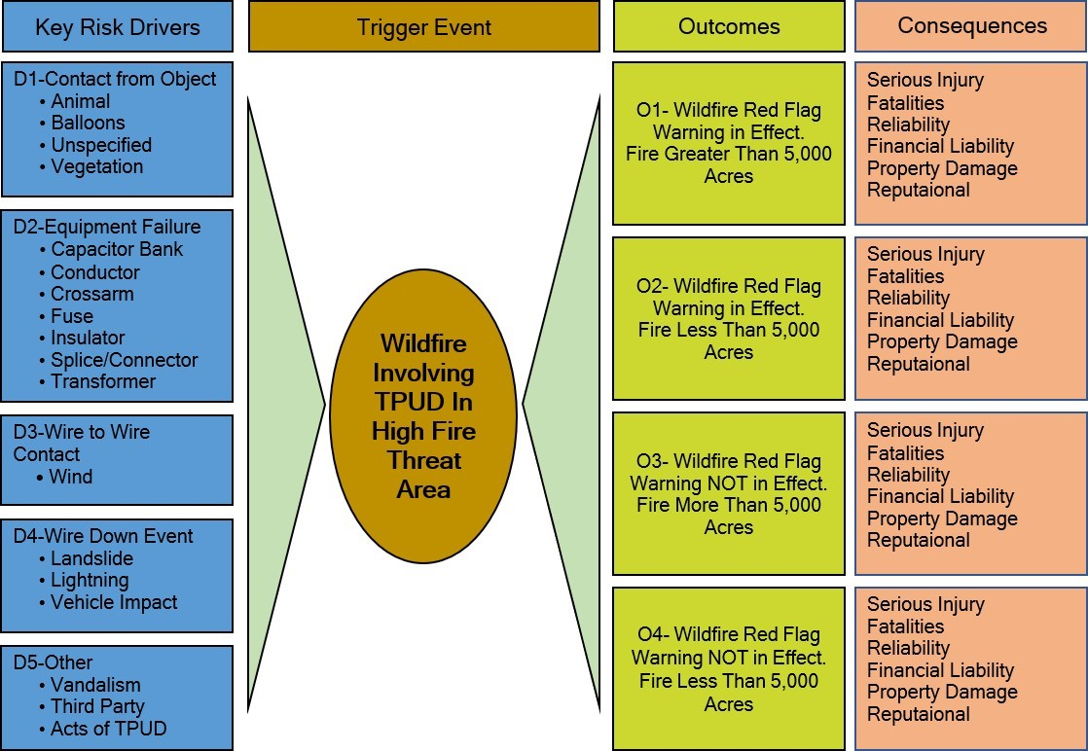
TPUD utilizes the bowtie method for assessing wildfire risk. The left side of the bowtie identifies most if not all identified RPU-risk factors that could trigger a wildfire. The right side identifies the possible impacts of these risks.
Figure 1: TPUD Risk Factor Bowtie Analysis.

Key Risk Impacts
The aforementioned risks have many possible outcomes. The list below outlines some of the worst-case scenarios and consequences:
- Personal injuries or fatalities to the public, employees, and contractors
- Damage to public and/or private property
- Damage and loss of TPUD-owned infrastructures and assets
- Impacts to reliability and operations
- Damage claims and litigation costs, as well as fines from governing bodies
- Damage to TPUD’s reputation and loss of public confidence
- Environmental and ecological damage
- Customer and community impacts
- Financial liability

Changes to CPUC Fire Threat Map
The State of California Public Utilities Commission (CPUC) has designated most of TPUD’s service territory as Tier 2, with a small area designated Tier 3 and a small fraction Tier 1. The “In town” areas of Hyampom, Hayfork, Lewiston, and Weaverville are located outside of the high fire-threat districts.
TPUD provided input in the development of the CPUC’s Fire-Threat Map, which the Commission adopted on January 19, 2019. This map identifies Statewide High Fire-Threat Districts (HFTD).
The HFTD map has been incorporated into the construction inspection, maintenance, repair, and clearance practices, where applicable.

High Fire-Threat District (HFTD)5
The HFTD identifies areas of elevated and extreme fire risk related to electric utility facilities. These areas are reflected in a map the CPUC adopted after an extensive public process. It is a composite of two maps:

Tier 1 High Hazard Zones (HHZs) on the U.S. Forest Service
CAL FIRE joint map of Tree Mortality HHZs (“Tree Mortality HHZ Map”). Tier 1 HHZs are zones in direct proximity to communities, roads, and utility lines and are a direct threat to public safety.

Tier 2 and Tier 3 Fire-Threat Areas on the CPUC Fire-Threat Map
Tier 2 fire-threat areas depict areas where there is an elevated risk (including likelihood and potential impacts on people and property) from utility-associated wildfires. Tier 3 fire-threat areas depict areas where there is an extreme risk (including likelihood and potential impacts on people and property) from utility-associated wildfires.
Based on TPUD’s knowledge of historic wildfire events, the existing environment and current information, TPUD believes that the HFTD map approximately identifies the level of wildfire risks within TPUD’s service territory. TPUD will continue to evaluate factors that may indicate the CPUC should modify the HFTDs. The CPUC Fire-Threat Map identifies Tier 3 (extreme fire risk), Tier 2 (elevated fire risk), and areas outside of the HFTD. The majority of TPUD service area falls within the Tier 2 areas. Portions of the District’s assets located in the more densely populated and developed areas fall outside the HFTD areas. These areas include portions of Lewiston, Weaverville, Hayfork, Hyampom, and Trinity Center.
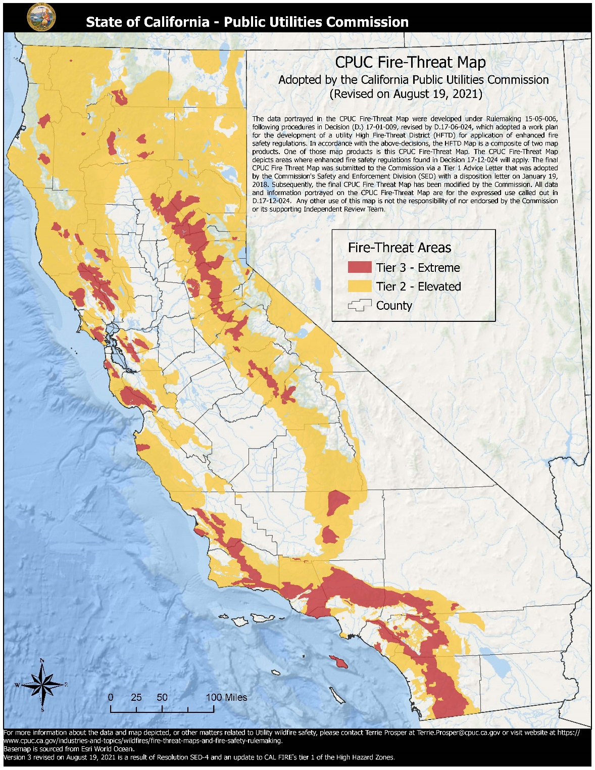
Figure 2. Depicts the CPUC Fire-Threat Map and TPUD’s service area within the map. As shown, TPUD’s service area is not comprised of Trinity County in its entirety.

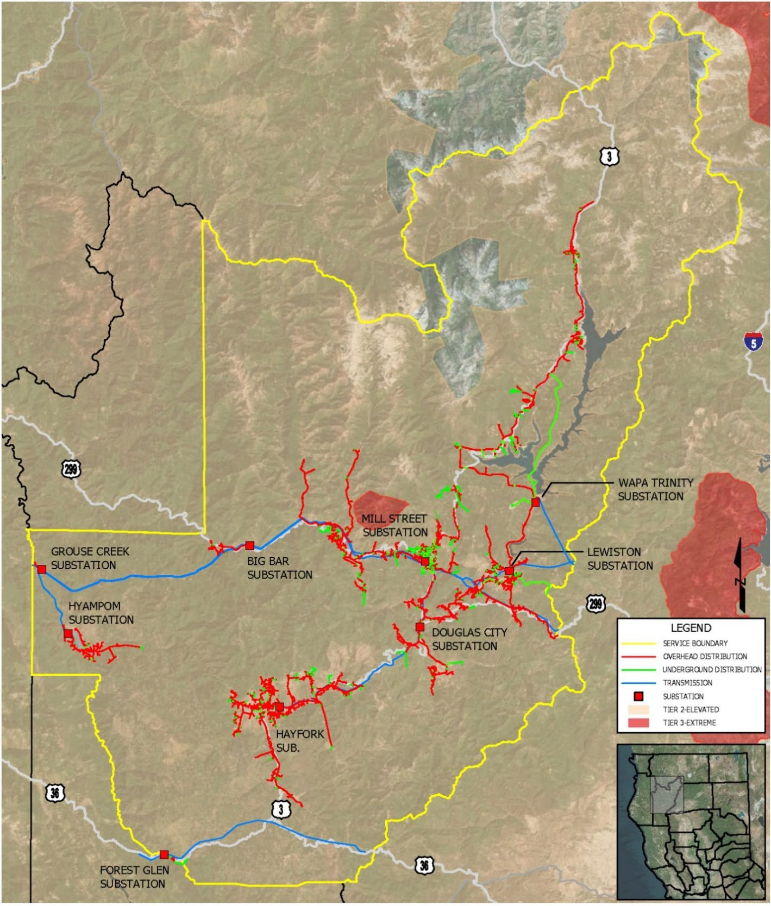
Wildfire Preventative Strategies
Figure 3. A high-level diagram of TPUD assets in relation to the threat level tiers. As illustrated, most of TPUD’s T&D lines and substations are in “Tier 2 – Elevated” fire-threat areas. Portions of the distribution system are located outside of the High Fire-Threat Districts, as well as three substations.

High Fire-Threat District
This WMP was built upon a sound foundation, as TPUD has been proactive in implementing measures to address potential wildfire risks for many years. The Plan outlines existing fire mitigation efforts and identifies new processes the District will employ moving forward.
In general, this WMP describes certain programs that TPUD will attempt to complete on an accelerated basis to mitigate wildfire risks as quickly as possible. However, many of the programs are multi-year and programmatic in nature, i.e., there is a startup period with limited initial implementation followed by full implementation that expands as processes and methods mature.
TPUD also has robust inspection and maintenance programs that include aerial patrols with a TPUD-owned drone employing infrared (IR) technology, along with high resolution photography. Regular ground inspections of all facilities, including core testing of the wood poles, are another part of the preventive maintenance program.
The District has already begun the process of replacing standard fuses with non-expulsion type fuses throughout its service area. Protocols are in place for disabling automatic reclosers and for deenergizing lines to protect public safety. Some of the conditions that factor into these protocols may include RFWs, forecasted temperatures above 100 degrees, winds exceeding design standards, and low humidity.
TPUD is researching the implementation of radio communications with its reclosers and other equipment to enable immediate setting adjustments to react to quickly changing conditions on the ground.
Several of TPUD’s strategies and programs in use now are not limited to any timeframe and are instead situational and based on certain real-world events, such as RFWs and other high fire-risk conditions. For example, TPUD’s Public Safety Power Shutoff (PSPS) protocols are only triggered when conditions pose a significant threat to the public. These conditions are predominantly weather and vegetative fuel-related and not associated with time periods (e.g., in 2019, or within 5 years). Similarly, TPUD’s emergency preparedness and response plans, post-incident recovery, restoration, remediation activities, and programs to support customers impacted by a wildfire are event-driven and are not timeframe-dependent. TPUD’s operational practices are also not time-dependent, and certain practices are triggered by RFW and other high fire-risk conditions. Additionally, these practices are updated as TPUD gains the latest information and adopts improved practices.
Furthermore, all administrative-related programs such as risk analyses, performance metrics, and monitoring of this WMP will be performed at regular or annual intervals.
TPUD regularly coordinates with local Fire Safe Councils and first response agencies. TPUD also participates in emergency operations activities in its system areas. TPUD has robust VM programs with accelerated VM Trimming Cycles.
The Outage Communications Plan includes methods to address potential deenergization events with targeted messaging for affected areas.

Weather Monitoring
TPUD relies on weather data from various sources, including the National Weather Service, CAL FIRE, and PG&E weather station data.

Climate Change
The fourth California Climate Change Assessment has concluded that climate change will make forests more susceptible to extreme wildfires. One study has found that the frequency of fires over 25,000 acres would increase by nearly 50 percent and that the average area burned would increase by 77 percent by the end of the century if greenhouse gas levels continue to rise. Increasing temperatures and rising sea-levels will have direct impacts on public health and infrastructure. Drought, coastal and inland flooding, and wildfire will continue to affect people’s livelihoods and local economies.
In TPUD’s service territory climate cycles range from very dry years to above average wet years and droughts can last for several years in a row. The most recent California drought lasted from December of 2011 to March of 2017. Although the dry spell ended in 2017, after many consecutive dry years several species of trees seem to now have root fungus, adding to the overall tree mortality rate. Additionally, these drought stressed trees are more susceptible to bark beetle infestations. 2020, 2021, 2022 and 2023 were also considered drought years in California.
For decades, TPUD has designed its electric system with the primary goal of providing safe, dependable, and affordable power. These designs stem from many decades of engineering experience and the adoption of emerging technologies. TPUD’s design practices continue to advance with the addition of newer safety and reliability-related technologies. As part of this advancement, it is important to understand and adapt to the new normal and the challenges climate change brings. The greater intensity and year-round frequency of fire danger is driving the need for further evolution, hardening, and strengthening of the grid-particularly as portrayed in the High Fire-Threat District (HFTD) Map of TPUD’s service territory.

Design and Construction Standards
TPUD initiates pilot projects to explore technologies and practices that are new to TPUD. These projects are intended for TPUD staff to evaluate the effectiveness and benefits of the technologies or practices. Based on the results of the pilots, TPUD may elect to integrate the technologies or practices into its various ongoing maintenance programs.
TPUD has purchased CAL FIRE-exempt lightning arrestors that are the standard for any new construction; TPUD is replacing old styles with exempt models as identified.
Vibration dampeners are installed where engineering requires them.
TPUD installs raptor protection and covered conducting jumpers where problem areas are identified.
TPUD has some legacy secondary voltage-tree attachments that are being phased out whenever they are identified.

Wildfire Risk Reduction, Reliability, and Asset Protection Project (WRAP)
The District has undertaken an enhanced Right-of-Way clearing project on federally managed lands within TPUD’s Service Territory. The WRAP Project is in the planning phase, with an Environmental Impact Report expected in January of 2025. The District has partnered with the Western Area Power Administration on this project, with a goal of increasing rights of way from 20’ to 130’ to reduce tree contacts and wildfire risk.

Supervisory Control and Data Acquisition (SCADA)
SCADA is a control and monitoring system of gathering data and sending control commands remotely to field connected devices. An important part of most SCADA implementations is alarm handling. The system monitors whether certain alarm conditions are satisfied to determine when an alarm event has occurred. SCADA systems have traditionally used combinations of radio and direct-wired connections. The District is currently looking to integrate this technology into its recloser setting program using radio communications systems. This will allow TPUD to react to quickly changing conditions, conserve labor, and increase customer and TPUD employee safety.

Advanced Radio Communications and Automated Vehicle Location (AVL)
Because cellular service is less than optimal in the TPUD service area, the District is looking at implementing a radio communications system that will assist in automatically tracking vehicle locations. Traditional cellular GPS tracking does not provide consistent and reliable information due to the terrain and “cellular dead zones.”

Vegetation Management
TPUD’s Vegetation Manager is responsible for the patrol, work plans, and quality control (QC) audits of the actual tree work in TPUD’s service territory. Circuits are patrolled and maintained on an ongoing basis, enabling the District to cover all lines on a rotating three-year cycle.
Contractors perform TPUD’s vegetation management (VM) work. This VM work is quality control (QC)-audited by TPUD’s Vegetation Manager. Approximately 10% of the distribution system-related clearing and pruning is field audited. Quality assurance (QA) efforts are tracked to monitor program effectiveness and overall tree work performance. TPUD VM staff performs a QC audit of 100% of the sub-transmission system-related work performed by the contractor. For both T&D QA efforts, all deficiencies are recorded, and work reissued to the contractor for corrective action. Distribution QC is only on TPUD contractors and consists of approximately 10% sample of tree work.
Contracts are awarded to outside vegetation management contractors to conduct this work. These processes follow Federal FAC 003-4 and State regulations, including Public Resources Codes section 4292 and 4293; they also meet or exceed the standards in CPUC GO 95 Rule 35. TPUD utilizes the 2020 “Power Line Fire Prevention Field Guide” in establishing its pole clearing practices. Contracts for vegetation management are signed for one year, with up to three, one-year extensions. TPUD has approximately 12,000 poles in its service area, making the tree trimming budget the largest contract expense for the District.
In 2024, TPUD was notified by the United States Department of Agriculture, Community Wildfire Defense Grant funding agency of the award of $9.5 million to amplify vegetation management efforts in its Service Territory. Once implemented, hazard tree identification and abatement on private property will be accelerated over a period of five years, and shaded fuel breaks installed over a period of three years.

Annual Pole Clearing Program
The pole clearing program is an annual requirement to clear vegetation around poles that have certain CAL FIRE non-exempt equipment on them. This program follows California Public Resource Code 4292. The code calls for clearing vegetation within a 10-foot radius of a pole or tower on which non-exempt equipment is attached, unless such pole or tower meets certain criteria that make it exempt from the clearance requirements. TPUD contracts this activity out along with the Vegetation Clearing and Removal Contract.

Vegetation Inspection and Maintenance
When conducting routine maintenance that involves preventative inspection, TPUD responds to high-risk fuel sources with efforts to remove identified vegetation, as needed. This maintenance work occurs once every three years per circuit. TPUD also performs inspections of vegetation concerns when either service calls are made, or utility employees or vegetation management contractors identify at-risk vegetation while performing day-to-day operations.
Future considerations are being evaluated to enhance inspection procedures. In 2021, TPUD invested in technology which utilizes satellite imagery to capture and record vegetation along its rights-of-way and is implementing this technology into its Vegetation Management efforts. Satellite imagery reveals encroachments, hazard trees and with future data collections will have the ability to help predict tree mortality.

TPUD Tree Trimming and Removal Guidelines
Circuits are patrolled for vegetation work on a three-year cycle and are maintained to PRC 4292 and PRC 4293 standards.
- Any tree or portion of a tree that will be within four feet of energized conductors within three years will be trimmed or removed to achieve maximum clearance possible while taking into consideration the tree’s health, documented rights, and proper arboricultural practices.
- Any tree with a diameter at breast height (DBH) of 10 inches or less and that is located in or out of the rights-of-way (ROW) can be removed if it is in conflict with the conductors. The District will attempt to notify the property owner prior to removal, however, no notification or permission is required for this class of tree.
- Any tree located in the ROW may be removed if it is or in the future will conflict with conductors.
- Any tree that is located outside of the ROW and is deemed a hazard tree will be removed or topped to make it safe for conductors. Location, DBH, and height of all such trees will be provided to property owners within three days of inspection. The property owners have 15 days to respond for comment, otherwise work will proceed as scheduled. Hazard trees are considered any tree or portion of tree that is dead, rotten, decayed, or diseased and which may fall into or onto the overhead lines or trees leaning toward the lines.
- Poles subject to section 4292 of the California Public Resource Code will have all vegetation cleared to a ten-foot radius of the pole as illustrated in Figure 13.
- Best management practices (BMP) will be used on ROW maintenance.
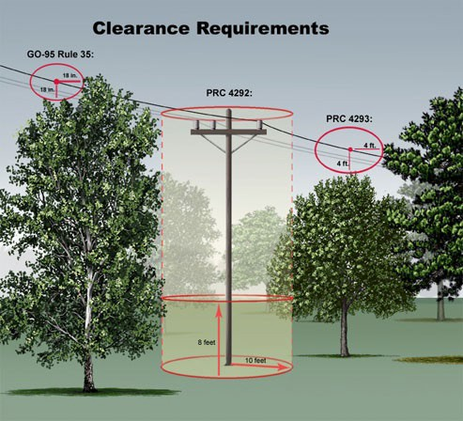
Ground Level Vegetation Clearance and Removal
Figure 4. Pole Clearance Requirements.
TPUD maintains firebreaks around bases of certain power poles throughout the OH distribution system. The projected work product consists of providing a firebreak by removing all vegetation at ground level around and adjacent to specific poles or structures as identified by location and pole number. See Figure 6 Poles Requiring Ground Level Vegetation Clearing
Ground level Vegetation Clearance and Removal is performed to provide the required firebreaks Work begins after plants and grasses have matured to minimize new spring growth. Work is completed as soon as is practicable by the beginning of the fire season if possible. It is anticipated the work cycle will occur between April 15 and October 15 of each year.
Currently 1059 poles are identified as part of the annual ground-clearance work cycle. Number of poles to be cleared listed by designated area: Total of all areas = 1059.
Table 5. Poles Requiring Ground Level Vegetation Clearing
AREA | NUMBER OF POLES
Area 1:  Hayfork  Hyampom  Forest Glen  Grouse Creek | 294  48  6  0
Total: Area 1 | 348
Area 2:  Weaverville | 258
Total: Area 2 | 258
Area 3:  Lewiston  Lewiston/Trinity Center  Douglas City  Big Bar  Sub-Transmission | 160  184  95  9  5
Total: Area 3 | 453
Total for All Areas | 1,059

T&D System Vegetation Management Standards
TPUD VM crews perform ground-based inspections of trees and conductor clearances and hazard tree identification. Patrols are scheduled to ensure all lines are inspected for vegetation hazards on a three-year timeline. The results of the patrols are targeted areas for vegetation pruning or removal. Annual ground-based field patrols ensure compliance with state and federal regulatory requirements (Public Resource Code 4293) and alignment with standards in CPUC GO 95 Rule 35. During tree work, contractors aim to achieve up to 12 feet of clearance, unless otherwise directed by TPUD VM staff. The contractor also clears vegetation from TPUD’s secondary voltage, service drops and pole climbing space on an as needed basis. TPUD’s contractors follow American National Standards Institute (ANSI) A300 concepts and utility directional pruning, which supports proper pruning/tree health while achieving and maximizing the pruning cycle.

Inspections
TPUD performs multiple time-based inspections on its T&D facilities. Inspections play a significant role in wildfire prevention. Recognizing the hazards of equipment that operate high voltage lines, TPUD maintains a formal inspection and maintenance program for T&D facilities. In 2022, TPUD completed a Global Positioning System (GPS) re-survey and Geographic Information System (GIS) import of all utility poles in its system to accurately document infrastructure locations. The system infrastructure map is always available to field and office staff via desktop and mobile devices.
Qualified personnel perform all inspections. System equipment in need of maintenance or repair is categorized according to the severity of the condition. Repairs are done in order of rating. Items rated Priority #1 are reportedly immediately to the appropriate Manager (Electric Superintendent, Supervising Foreman, or Vegetation Manager) and are addressed to prevent failure or service interruption. Items rated Priority #2 are scheduled for maintenance to be performed within 30 days. Priority #3 Items are scheduled for maintenance to be performed within six months or as determined by the Electric Superintendent. Inspections are imported into the GIS Mapping System monthly. Work Orders are generated and then fielded by the Supervising Foreman to Line Staff. Completed Work Orders are returned and mapped by the System Engineer.
The following sections outline practices for inspection of TPUD assets.

Sub-Transmission Line Inspections
TPUD’s Sub-Transmission Lines are grouped into three inspection areas: The Weaverville 60 kV tap, the Hayfork 60 kV tap, and the Hyampom 60kV tap. The overhead sub- transmission system (60 kV) is visually inspected annually to report any conditions that may have potential for circuit interruptions.

Infrared Inspections
TPUD is using infrared (IR) technology to identify problem areas within Substations. An IR inspection uses a device that determines the relative temperature of equipment on the electrical system. Using temperature readings, the IR Inspection can detect equipment that may fail in service. Abnormal temperatures indicate a possible internal malfunction or loose connection, which has the potential to lead to equipment failure. Reports are generated and further investigation and/or repairs are scheduled and prioritized based on the hazard level.

Ground Patrols and Inspections
All TPUD facilities lie within Tier 2 HFTD. TPUD has a robust inspection and testing program. Intrusive testing of poles follows strict adherence to General Order (GO) 95 requirements with additional visual pole inspections every two years.
TPUD has a detailed system patrol process complying with GO 165 requirements, which includes bi-annual drone and/or foot patrols for overhead circuits. Inspections include both equipment and vegetation patrols.
Line patrol inspections occur biannually throughout the system and consist of walking, driving, and using drone technology to access infrastructure. Police officers look for obvious signs of defects, structural damage, broken hardware, sagging lines, and vegetation clearance issues. Any damage detected is reported and addressed based on the severity of the defect.
TPUD is currently in the process of replacing non-expulsion type fuses and anticipates completing replacement work in approximately five years.

Aerial Patrols (Drone)
TPUD currently has an in-depth drone program used for inspections. IR and LiDAR are also part of TPUD’s arsenal.
TPUD utilizes drone technology to perform patrol inspections of both equipment and vegetation. TPUD employs seven FAA-licensed drone pilots. Drones are utilized for quickly identifying downed lines and provide situational awareness during emergency situations. Drone technology provides more timely responses than the traditional methods of hiking, driving, or use of all-terrain vehicles to access remote areas in rugged terrain. Drones are equipped with high-resolution cameras, which allow for detailed inspections of cross arms, hardware, and equipment not visible from the ground.
LiDAR (Light Detection and Ranging) and remote sensing can supplement or enhance traditional “boots on the ground,” vegetation patrols, and infrastructure inspections. TPUD has a drone-equipped with LiDAR technology that can be utilized to capture information on both vegetation and infrastructure. TPUD contracts with third parties to collect and process LiDAR data, using either drones or satellite imagery, to identify vegetation hazards and growth patterns and prioritize vegetation management work. These programs are in the exploratory/developmental stages.

Wood Pole Intrusive Inspections
Wood poles that are either (a) more than 15 years in age, or (b) have previously passed an intrusive inspection more than 20 years ago are identified for intrusive inspection in the District’s Mapping and Inspection Program. Intrusive inspections require sample material to be taken for analysis to identify problems such as rot and decay.

Sub-Transmission and Distribution Line Inspections
Inspection of the overhead 60 kV sub-transmission, and overhead and underground electric distribution system with primary operating voltages of 12.4 ,12 kV, 7.2 kV and secondary voltages of 480/277, 208/120 and 240/120 are performed on a cycle to ensure that all equipment is inspected on a regular schedule. Inspections and maintenance are performed employing measures that are intended to protect the worker, general public, and system reliability. The inspection cycles are designed to ensure safety and reliability and are based on standards found in CPUC GO 95, GO 128, and GO 165.
Qualified personnel perform all inspections. System equipment that is found in need of maintenance or repair is categorized depending on the severity of the condition. Repairs are done in order of rating. Items rated Priority #1 receive immediate attention to prevent failure or service interruption. Items rated Priority #2 are scheduled for maintenance to be performed within 30 days. A record of the inspections and maintenance performed will be submitted to the Electric Superintendent and maintained by the appropriate office personnel.
- Poles supporting electrical facilities that have been in service for 15 years and longer will be given an intrusive inspection (Drill test below ground level).
- Overhead line apparatus will have a detailed inspection every five years.
- Underground line apparatus will have a detailed inspection every three years.

Inspections
Detailed inspections occur every five years and consist of accessing infrastructure by walking or driving. Binoculars may be used to detect and evaluate damage to above-ground components. Poles may be given a “sound” test to detect decaying or rotten wood. Inspectors look for the following:
- Mechanical damage
- Loose hardware
- Guy wire and anchor condition
- Disconnects and fuse holder condition
- Insulators and conductor condition
- Condition of transformers and reclosers
- Ground conductors and moldings
- Pole ID signs and other minor hardware
- Raptor nests
- Vegetation clearance issues

Line Patrols
Inspection progress is tracked using computer tablets loaded with GIS-enabled visualization tools and software. The use of these tools ensures that all assets within TPUD’s service territory are patrolled. Police officers look for obvious signs of defects, structural damages, broken hardware, sagging lines, and vegetation clearance issues. Line inspectors may climb towers identified with severe corrosion or deformation to determine the corrective action required. Any anomalies found are addressed based on severity of the defect. Line patrols are performed bi-annually on all distribution lines and equipment.

Wood Pole Intrusive Inspections
Distribution wood pole intrusive inspections follow the same criteria as Sub-Transmission wood poles.

Instruction to Inspectors
The Preventative Maintenance Plan is designed to provide safe reliable service. The plan is based on sound industry principles and practices. Maintenance work shall be prioritized considering the most urgent need due to compromised safety and reliability.
The inspector will document the condition of the overhead and underground systems, recording defects, deterioration, violations, safety concerns, or any other conditions that require attention on the inspection tags. The inspection’s focus shall be on any hazards that could affect system integrity, line-worker safety, and the public.

Standards for Record-Keeping and Reporting
General Instructions: Current inspections of the electrical systems will be documented in the GIS mapping system. If the condition of the system being inspected is satisfactory, no further documentation is needed. Conditions other than satisfactory are imported and a list of poles with deficiencies is generated for the System Engineer, who will generate a work order.

Satisfactory Conditions
Facilities that are found to be within standards and do not require maintenance will be documented in the GIS Mapping System with the associated feature. Records are updated on a continual basis.

Substation Inspections
The Preventive Maintenance plan provides for regular inspections of substations. Qualified personnel will use prudent care while performing inspections, following all required safety rules to protect themselves, other workers, the public, and system reliability.
TPUD performs various inspections on substations to ensure safety and reliability. TPUD inspections meet or exceed standards in CPUC GO 174. A “Detailed” inspection shall be defined as one where individual pieces of equipment and structures are carefully examined visually and through use of routine diagnostic tests, as appropriate. If practical and useful information can be gathered, equipment is opened and the condition of each piece of equipment is rated and recorded.
- Substations shall be visually inspected once a month and a detailed inspection performed four times a year.
- All overhead line equipment shall be visually inspected once a month and a detailed inspection performed every six months.

Visual Inspections
Substation inspectors visit each TPUD substation to visually inspect the facility and all equipment within. A visual inspection is a simple quick look at the system to assure that there are no obvious structural problems, hazards, or tree trimming requirements.
The inspectors look for the following:
- Broken or loose hardware
- Vandalism or damage to any equipment
- Oil or gas leaks
- Perimeter fence security
- Condition of the buss insulators and other hardware
- Condition of the control house
- Conditions of the poles/structures and lines exiting the substation
- Condition of the disconnects and fuses for signs of damage and connectivity
Visual inspections are performed 12 times per year.

Detailed inspections
A detailed inspection of substation assets includes all items listed in the Visual Inspection section, as well as mechanical damage to any component, including the following:
- Condition of insulators and conductors
- Condition of risers and conduits
- Condition of transformers, reclosers, and cap banks
Similar inspections are performed on pad-mounted equipment and equipment installed below grade in vaults or building basements. Underground system vaults, transformers, and switch cabinets will be opened and closely inspected. All substations receive infrared inspections annually. Detailed Inspections are performed quarterly.

Workforce Training
The District has developed rules and complementary training programs for its workforce to reduce the likelihood of an ignition. All field staff will be involved in the following:
- Trained on WMP content
- Trained in proper use and storage of fire extinguishers
- Required, during pre-job briefings, to discuss the potential(s) for ignition and environmental conditions (current and forecasted weather that coincides with the duration of work for the day)
- Required to identify the closest fire extinguisher and other fire abatement tools
- Required to report all ignition events to management for follow-up
- Encouraged to identify deficiencies in the WMP and bring such information to management

Recloser Policy
There are 43 feeder bays and reclosers on various distribution lines in TPUD’s system. During Extreme Weather Events at the start of the fire season, or as low fuel moisture conditions dictate, the District may disable automatic reclosing functions at District Substations and in the field. In some cases, the reclosers are completely bypassed if automatic reclosing cannot be disabled. To disable, District personnel will physically go to each device and place the unit on the alternate setting, blocking the reclosing function. After the first substantial precipitation in the fall, the devices are reset to the normal operating mode.
The District is currently investigating the feasibility and cost of using radio communication to change recloser settings remotely. This will allow TPUD personnel to react quickly to changing conditions on the ground, as well as reserve labor for other critical operations.

Deenergization
While initiation of a public safety power shut-off (PSPS) is regarded as a last resort, there may be situations where it may be the safest approach if the risk of a wildfire starting and spreading is severe. In the event of a PG&E-initiated PSPS for its transmission lines, the Big Flat, Forest Glen, Grouse Creek, and Hyampom substations could be affected. Customers in these areas are encouraged to enroll in PG&E’s zip code notification system for a direct notification from PG&E regarding PSPS events. TPUD will also use its Outage Management System to notify affected customers when PG&E has made notification.
TPUD proactively communicates to customers and key stakeholders through multiple channels about preparing for potential curtailments and the power restoration process. TPUD recognizes that many entities and individuals are particularly vulnerable during extended power outages and makes every effort to provide up-to-date information to these populations prior to, during, and after an event.
This initiative-taking communication is utilized for the following:
- A wildfire threat to localized circuits within the TPUD service territory that results in localized deenergization
- A wildfire threat to TPUD’s sub-transmission system that results in a deenergization event causing a capacity/energy shortage (rotating outages)
- A deenergization by PG&E of its transmission circuits
TPUD’s Weaverville Office provides ongoing and available resources for communication with the overall customer base. TPUD’s General Manager (or his or her designee) will provide ongoing mass media communication via traditional news media channels to provide customers and the community with information about an emergency or potential emergency.
Trinity County OES utilizes the CodeRED App and the IPAWS systems to notify citizens of emergency information. The information can be targeted based on geography. TPUD’s General Manager (or his or her designee) will reach out to the elected officials and executive staff of local governments, TPUD’s state delegation, federal representatives, and appropriate agency staff to provide initial contact and ongoing communications by email and phone with messages for their constituents.
Customers can visit the Trinitypud.com website for information, including the following:
- Information on generator safety
- Links to the National Weather Service
- Links to additional resources
- Fire safety and preparedness
- CodeRED emergency alert system
- Trinity County website
- Caltrans
- A live outage map
In the time leading up to potential or imminent safety shutoffs, TPUD does its best to establish or maintain contact with customers it believes may be impacted (via the various channels mentioned above) and keep the media, local agencies, and the public aware of the number of customers affected and TPUD’s activities and restoration efforts.
The General Manager (or his or her designee) is responsible for contacting key stakeholders, federal, state, and local elected officials, County executive staff, critical customers, and first responders via a variety of channels. Critical customers include water, telecommunications utilities, and medical facilities potentially affected by a shutoff.
The following customer categories are considered essential and/or critical service providers:
- Jurisdictions and functional agencies providing essential fire, police, and prison services
- Hospitals and skilled nursing facilities
- Communication utilities, as they relate to public health, welfare, and security, including telephone utilities
- Radio and television broadcasting stations used for broadcasting emergency messages, instruction, and other public information related to the electric curtailment emergency
- Water and sewage treatment utilities identified as necessary for services such as firefighting

Community Outreach and Public Awareness
TPUD has a comprehensive plan for communicating with its customers during emergencies, especially during outages. TPUD utilizes the services of a call center specifically geared for utilities during non-business hours and provides extended local office hours to respond to customer phone calls during lengthy and/or widespread outages. A live outage map is available on TPUD’s website. For scheduled maintenance outages, TPUD provides as much notice as possible to customers, utilizing an Outage Management System to contact account holders via phone, text, and/or e-mail.
Examples of TPUD’s communication and engagement with elected officials, government agencies, and commercial customers include the following:
- Regular in-person briefings with federal, state, and local elected officials and key staff on wildfire risk mitigation and other utility-related issues with comprehensive “leave-behind” materials
- Meetings with regional and local government staff and elected officials focused on individual districts, communities, and neighborhoods and mitigation opportunities
- Regular in-person and/or digital communication with critical facilities and key customers
- Interagency projects, collaborative staff training efforts, and regular communication with first responders and essential service providers
- Ongoing communication, collaboration, and support for local Fire Safe Councils and other fire prevention agencies and nonprofits
The Trinity County Office of Emergency Services, in conjunction with the Trinity County Sheriff’s Office, strongly encourages all Trinity County residents to sign up for a CodeRED account and to load CodeRED phone numbers into their phones to receive Trinity County Emergency Notifications. The Trinity County Sheriff’s Office conducts County-Wide testing of the CodeRED and Integrated Public Alert Warning System (IPAWS) to confirm customers that have opted in to CodeRED receive emergency notifications. IPAWS notifications will be sent to alert all cell phones in the County with cell service in the event of a catastrophic wildfire. While this system can quickly alert a substantial number of residents, poor cell phone coverage in many areas will prevent complete notification with this system. A link to the County’s CodeRED sign-up can be found on TPUD’s website.

Restoration of Service

Service Restoration Process
TPUD work crews will take the following steps prior to restoring electrical service after a deenergization event. These measures are intended to protect the worker, public, and system reliability.
- Patrol: If the deenergization was a PSPS, lines are patrolled to ensure no hazards have affected the system during the outage. If an outage is due to wildfire, as soon as it is deemed safe by fire officials, lines and equipment are inspected for obvious damage or foreign objects. Many of the lines are in remote and rugged terrain with limited access, making this process potentially lengthy. VM crews are called on to assist in clearing downed trees and limbs as needed.
- Repair: After the initial assessment, TPUD supervisors, managers, and engineers meet to plan the needed work. Re-building will commence as soon as affected areas become safe. Repair plans prioritize circuits that serve the most critical infrastructure needs. While the goal is to reenergize all areas as soon as possible, emergency services, medical facilities, and utilities are given first consideration when resources are limited.
- Test: After repairs are completed and the equipment is safe to operate, line segments are energized and tested.
- Restore: After successful line testing, power is restored to homes and businesses as quickly as possible. Customers, local news, and other agencies are then notified of the restoration of electric service. Periodic customer and media updates of restoration status prior to full restoration will be made. After the initial power restoration, further demolition and rebuilding will likely take place.

Plan Evaluation

Metrics and Assumptions for Measuring Plan Performance
The information below explains plan-performance evaluation monitoring efforts.

Monitoring and Auditing the Plan
The WMP will be included as a discussion item on the agenda of regularly scheduled management meetings. TPUD will monitor efforts of the WMP quarterly and report on its effectiveness to the Board of Directors on an annual basis. Quarterly reports of the Plan’s current progress and risk reduction impact will be developed and circulated to appropriate utility staff to engender collaborative discussion to update approved strategies. The General Manager (or his or her designee) will update leadership with recommendations or proposed action in enhancing the Plan’s objectives over time.
The WMP annual review will align with TPUD’s existing business planning process. This review will include an assessment of the WMP programs and performance.
TPUD’s business planning process includes budgeting and strategic planning for a three-to-five-year planning horizon.
Table 6. Programmatic Metrics
PROGRAM | TARGET | METRIC DESCRIPTION |  | 2020 | 2021 | 2022 | 2023
T&D overhead line, wood pole and vegetation Patrol inspections | 95-100% | Perform all annual distribution line patrols within the compliance period set in GO 95/165. See Chapter 6 for a detailed description of the program. |  | 5,517 patrol inspections  Goal of 6,131 annually  (89.9%) | 2,203 patrol inspections  Goal of 6,131 annually  (35.9%) | 2,714 patrol inspections  Goal of 6,131 annually  (44.3%) | 3,888 patrol inspections  Goal of 6,131 annually  (63.4%)
T&D overhead line, wood pole and vegetation Detail inspections | 95-100% | Perform all detailed line inspections within the compliance period set in General Order (GO) 95/165 by the end of the year. The inspections must be completed within the specified time intervals set for each inspection type. Detailed Line Inspections on equipment are performed once every 5 years. (Chapter 6) |  | 3,510 detail inspections,  Goal of 2452 annually  (143%) | 896 detail inspections,  Goal of 2452 annually  (36.5%) | 2,254 detail inspections,  Goal of 2452 annually  (91.9%) | 2,662 detail inspections.  Goal of 2452 annually  (109%)
T&D Wood Pole Intrusive Inspections | 95-100% | Perform all wood pole intrusive tests scheduled for the year. TPUD’s goal is to perform wood pole tests within 15 years of installation and 20 years thereafter. (Chapter 6) | 3,510/8,046  (43.6%) |  | 896/4,536  (19.7%) | 2254/3718  (61. %) | 2689/2441  (110%)
Distribution Vegetation Pruning/Clearing | 95-100% | Complete scheduled respective tree work to ensure compliance with PRC 4293 to prevent ignition and propagation of fire caused by TPUD electric overhead assets. |  | All open vegetation work orders were competed by end of calendar year | All open vegetation work orders were competed by end of calendar year | All open vegetation work orders were competed by end of calendar year | All open vegetation work orders were completed by end of calendar year
Annual Pole Clearing Program | 95-100% | Complete all vegetation clearing activities) in fire season of each year. (Chapter 6) |  | All poles identified requiring vegetation clearing were complete | All poles identified requiring vegetation clearing were complete | All poles identified requiring vegetation clearing were complete | 1128/1128  (100%)
Infrared Inspections of Substation Electrical Equipment | 95-100% | IR Inspection to detect abnormal temperature readings. |  | All substations were inspected with infrared | All substations were inspected with infrared | All substations were inspected with infrared | All substations were inspected with infrared
Legacy Tree Attachments Replaced | 100% | Replace secondary attachments on trees with poles |  |  |  |  | 10 Tree Attachments were identified and 10 were replaced
Fault Tamer Installations | 25% | Replace fuses with non-expulsion type |  |  |  |  | 351/1251 installed  (28%)
GO128 Underground Inspections | 95-100% | Perform all detailed line inspections within the compliance period set in General Order (GO) 128 by the end of the year. The inspections must be completed within the specified time intervals set for each inspection type. Underground Inspections on equipment are performed once every 5 years. (Chapter 6) |  |  |  |  | 44/1004  (4%)

Identifying and Correcting Deficiencies in the WMP
The General Manager (or his or her designee) will be responsible for ensuring that this WMP meets all the State of California guidelines to mitigate the risk of its assets becoming the source or contributing factor of a wildfire. Staff responsible for assigned mitigation areas have the role of vetting current procedures and recommending changes or enhancements to build upon the strategies in the WMP. Either due to unforeseen circumstances, regulatory changes, emerging technologies or other rationales, deficiencies within the WMP will be sought out and reported to the Board of Directors in the form of an updated WMP on an annual basis. The General Manager (or his or her designee} will be responsible for spearheading discussions on addressing deficiencies and collaborating on solutions when updating the WMP for its annual filing. At any point in time when deficiencies are identified, the Supervisors or their delegates are responsible for correcting the deficiencies.
TPUD staff and qualified stakeholders are encouraged to bring any potential deficiencies to the attention of the General Manager (or his or her designee). The General Manager (or his or her designee), along with the appropriate staff, will evaluate each reported deficiency, and if determined to be valid, shall record the deficiency for further action.

Monitoring the Effectiveness of Inspections
TPUD’s compliance with Commission regulations ensures that facilities are inspected and repaired in accordance with GO 165 program standards. Any issues found impacting safety and reliability are addressed as outlined in that program. In addition to this maintenance program, TPUD is constantly evaluating its facilities while performing other activities such as outage patrols, new business planning, replacements, and related field work.
Monitoring the effectiveness of inspection practices will occur through ongoing tracking and annual review of findings resulting from internal processes. The Electric Superintendent or his or her designee supervises the Vegetation Manager and will review concerns found during routine field work and equipment and line inspections. TPUD will use this information as a method to assess the effectiveness of inspection procedures. The review process will take place annually where inspection records will be reviewed, deficiencies identified, and corrective actions determined. An internal report will be provided to the utility’s leadership in deliberation of future strategies.
Related strategies that mitigate wildfire risk will then be identified and proposed within the next Plan iteration. Aggregating this data will guide future decision-making on the direction of wildfire mitigation strategy with the intention that incidents will become less frequent or hazardous system-wide.
TPUD has quality control processes embedded in its existing customary practices. However, for certain programs, there is a formal quality control process. The following depicts a few of these programs.

Written Processes and Procedures
TPUD documents its operational procedures and processes to maintain consistent and thorough implementation at all levels. Processes are reviewed and updated as needed to maintain the most efficient, effective, beneficial, and safety-driven methods and protocols.

Distribution System Inspections
The Electrical Superintendent (ES) manages T&D line and substation assets and develops the comprehensive inspection and maintenance programs. These programs are driven by the need to ensure the safe operation of T&D line and substation facilities.
Key imperatives are as follows:
- Reduce the risk of power-related wildfire
- Meet federal and state regulatory requirements
- Achieve reliability performance within mandated limits and to optimize capital and O&M investments
In addition, the ES or designated managers regularly monitor inspection and corrective maintenance records, as well as diagnostic test results to adjust maintenance plans and develop new programs. The best industry practices are used in the development of the maintenance programs.
TPUD’s Grid Assets group is responsible for performing the inspections and corrective maintenance. When deficiencies are found, the System Engineer creates work orders. The priority for corrective maintenance is to remove safety hazards immediately and repair minor deficiencies according to the type of defect, severity, and HFTD tiers. Work orders are monitored throughout the year to ensure timely completion via regular internal reports.

Vegetation Management (VM)
Contractors perform TPUD’s vegetation management work. This VM work is QC audited by TPUD’s Vegetation Manager. Approximately 10% of the distribution system related clearing and pruning is field audited. QA efforts are tracked to monitor program effectiveness and overall tree work performance. TPUD VM staff perform a QC audit of 100% of the sub-transmission system related work performed by the contractor. For both T&D QA efforts, all deficiencies are recorded, and work reissued to the contractor for corrective action. Distribution QC is only on TPUD contractors and consists of approximately 10% sample of tree work.

Independent Auditor
PUC Section 8387(c) requires TPUD to contract with a qualified independent evaluator with experience in assessing the safe operation of electrical infrastructure to review and assess the comprehensiveness of this WMP. TPUD will issue a public request for qualification, consistent with TPUD’s current procurement practice, to select an independent evaluator. The independent evaluator will provide a report that will be posted to TPUD’s website and made available for review at the TPUD office. The Independent Assessment and WMP will be available for public review and comment prior to plan adoption at a properly noticed TPUD Board of Directors meeting.
TPUD will seek a minimum of three proposal bids from highly recommended organizations to perform an independent evaluation of the TPUD Wildfire Mitigation Plan. Based on the proposal bids received, TPUD will contract with the organization that best meets the needs of the District.

- Public Hearing – July 13, 2023
President Rourke opened the Public Hearing to receive input on the 2023 Trinity Public Utilities District Wildfire Mitigation Plan Update at 2:02 p.m.

Skylar Fisher and Bethany Lewellen with the Trinity County Resource Conservation District thanked the Board for conducting the Public Hearing and providing the opportunity to provide the following suggestions:

- Page 16 - Add Volunteer Fire Departments as Emergency Responders.
- Page 16 - Correct Fire Safety Council to Fire Safe Council.

- Page 21 – Address footnotes on map to make more legible in a printed version.

- Page 22 – Map of CPUC High Fire Threat Areas – improve legend in map to make more readable in a printed version.

- Page 23 – Last paragraph of page, strike the word “other” before “first response agencies.”

- Page 37 – Include strategies the District is using to meet targets that are not being met.

- Page 25 – Provide a timeline of implementation of topics being researched

- Identify areas that inspections or the public have identified as particularly hazardous, other agencies, such as the Trinity County Resource Conservation District or the Watershed Center may be able to perform fuel reduction work.

Jeff Morris with Trinity County Office of Education provided the following suggestions:

- Perhaps assessed risk could be in terms of tree failure or falling. Mr. Hauser advised that access drives risk.

- Requested that Trinity County Office of Education be included in Communications in terms of emergency events in order to facilitate communication with School Districts affected by power outages. Mr. Morris also inquired if the District has a social media presence.

- Suggested that perhaps a Trinity County Phone Tree would be a strategy for communicating with families.

Joseph Bowers provided the following suggestions:

- Page 26 – Suggested communicating with private property owners prior to removal of hazard trees.

President Rourke closed the Public Hearing at 2:31 p.m.

Amended by Stats. 2018, Ch. 626, Sec 42. (SB 901) Effective January 1, 2019
Ch 7 of Div. 2 of §8607
SEMS Guidance for Special Districts
https://www.fire.ca.gov/programs/communications/red-flag-warnings-fire-weather-watches/
Adopted by CPUC Decision 1-24-024

